Grace Church Prayer List: We hold the following people in prayer: Lee Aldrich, Bernice Burton, Oscar Bunche, The Family of Charles & Barbara Wiggins, Cynthia Cole, Family of William J. Davis, Jean Beyer(Fr. Chip’s Father-In-Law), Kimberly Corelli, Darlene and Johnny Peoples, Inez Dale, Carol DiGilio, Bill Dunphy, Cathy Dunphy, Cecile Fray, Corselli Family, Delaney Family, Sandra Esannason, Cindy Etheridge, Gregory Fucci, Laura Fields, Laurie Noone, Sid Fromm, Leigh Burton, Lydia Green, Michael Nissman, Sylvia Howard, Linda Heusser, Jackie Jansky, Evgeniy Kaufman, Nellie King, Manoris Long, Donna Louis, Paxton Louis, Dorothy Lynch, Janice Moore, Nicholas Furmoso (age 7), Selena Perry, Gladstone Reid, Leroy Reid, Renee Reid, Uriel Reid, Al Sargent, Esteban Silvera, Sonia P. Smith, Norman Stanton, Susan Stanton, Dominick Vita, Natasha Vodyanitskaya, Ray Williams, Giovanna Romeo (Late Mother of Maria Romeo, Grace Church Bookkeeper)

Cedar Manor, Ossining: Robert Auld

Serving in the Armed Forces: Kenny Duffy, Denny J. Edmondson, Christopher P. Halstead, David Packer, Sgt. Christopher Vigliotti, Gunnery Sgt. Les Yearwood

Birthdays – January

2nd Ronald Espican
3rd Kassie Muñoz
4th William J. Carson
7th Hon Delores Braithwaite, Esq
8th James Benz
8th Michael Heffner
10th Victoria Carder
10th Aaron R. Woodberry
12th Taylor A. Cunningham
13th Sorraya Sampson Elliott
13th Carolyn Henderson
13th Samuel D. Brown
14th Joseph Gallo
15th Claudia Walker
15th Bernice Burton
16th Linsa Gallo
16th Eric Woodberry
17th Carolina Rivas
17th Alba Juarez
19th Alex Herrera
19th Gladstone Reid
25th Margaret Broomfield Parkinson
27th Marlene Walkes
30th Gloriana Grant
30th Lisa Daley
30th Sandra L. Esannason

Weddings - January

1/4/1969
Olivet & Raywald Williams

1/21/1978
Kathleen & Oscar Bunche

Readers

8:00 A.M. Service – Brinda Bradley and Stuart Madden

10:00 A.M – Michael Heffner 1st Lesson & the Psalm, Margaret Broomfield Parkinson – 2nd Lesson and the Prayers of the People

How to Pledge to Grace/La Gracia 2020-2021

The church is flexible in receiving your generosity during this challenging period of time. Blessings.

Option 1: The standard way of staying current with your pledge still applies.

Feel free to put a check in the mail and send it to the address below (Attention: Office Administrator). Bundling for a few weeks is fine.

Grace/La Gracia Episcopal Church
33 Church Street - 2nd Floor
White Plains NY 10601.

Option 2: There is a secure drop box on the red door at the front of Grace. The box will be checked regularly for financial contributions, including cash (which will be recorded). Kindly put your donation in an envelope with your contact info written clearly.

Option 3: Visit us on the web to donate electronically. www.gracewhiteplains.org
Look for the “Pledging” tab across the top and click on it. Then, you’ll see a yellow "Donate" button; clicking on that will take you to the site for electronic giving. You may use a credit card or with a PayPal account. For more details on PayPal, feel free to visit: (www.paypal.com).
If you’re interested in creating an account with PayPal, Michael Heffner is available to help explain or set up your account - michaelheffner08@gmail.com.
Please note – PayPal charges a fee to the church for these transactions (which is why a check in the drop box or sent by mail is preferable.).

Go deep and have fun
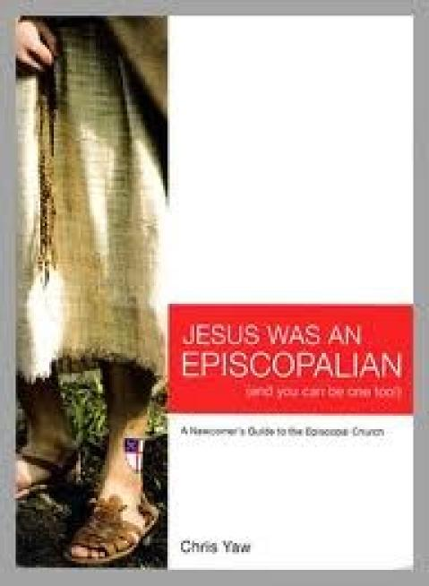
with this Monday
Night Study Series
In early 2021!
Come learn about the Episcopal Faith in this one hour class held every Monday night on zoom! Phone in or zoom in from a phone or computer.
According to the Author, “The point of this audaciously anachronistic title is not to claim Jesus as our own (how very un-Episcopalian that would be!) but to inspire us to see how Jesus is found in the many and varied expressions of faith that two thousand years of Christendom has birthed.
Today is an exciting time to be an Episcopalian. We have a renewed commitment to feeding the hungry and clothing the naked - standing up for equal rights and radical hospitality - worshiping in the beauty of holiness and making disciples who take Christ into the world.
Register for this class so that the church can provide you with the book. You don’t have to read the book to enjoy the class –but it may add to your enjoyment if you do.
This is a class for members and friends of St. John’s Episcopal Church Tuckahoe and Grace Church/La Gracia White Plains. Email your church to register: St Johns: theparishoffice@aol.com. Grace/La Gracia: therevchipgraves@gmail.com. Registrations due by January 4th, 2020.
This class meets online for 3 weeks every month from January through April. Books are available from the church, or at any online bookseller. The book is $10.
Jan. 11th Monday at 7 p.m. | Chapter 1 | Mar.8th Monday at 7 p.m. | Chapter 8-9
Jan. 18th Monday at 7 p.m. | Chapter 2 | Mar. 15th Monday at 7 p.m. | Chapter 10
Jan. 25th Monday at 7 p.m. | Chapter 3 | Mar.22th Monday at 7 p.m. | Chapter 11
Feb.8th Monday at 7 p.m. | Chapter 4-5 | April 12th Monday at 7 p.m. | Chapter 12-13
Feb. 15th Monday at 7 p.m. | Chapter 6 | April 19th Monday at 7 p.m. | Chapter 14
Feb. 22th Monday at 7 p.m. | Chapter 7 | April26 ^{th} Monday at 7 p.m. | Chapter 15-16

Invite your friends to zoom with you from wherever they live!

