
Hello Precious Praying Friends,
Please remember Hope Alive Haiti in your prayers. The babies and staff need rain, because our well dried up decades ago, and no water trucks can travel near us any longer. Our water system cleans the rain water collected on the roof, accumulated in our cistern.
Kenya-led forces were expected on May 24, but have been delayed about another three (3) weeks. Gangs “sent a message to Biden” 9:00 pm on May 24 by murdering a US missionary couple. Please pray for the Lloyd and Baker families.
Hope Alive, full of innocent babies, is precariously situated between two (2) very dangerous cities where gangs are ruthless and desperate. Besides water and comfort for the families, Solace babies need to be covered by the Lord's divine protection.
We need your prayers! Thank you in advance for praying.
In Christ Alone, Leslee and Frank Jacobs www.hopealivehaiti.org
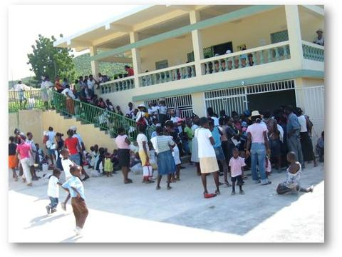

Penny's Sewing Academy
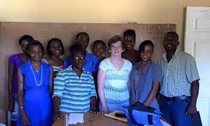
Pam (Penny) Miller, a Registered Nurse from New Jersey, came to Hope Alive Clinic in Haiti in 2011 to share her nursing skills. She brought some dresses she'd sewn to bless the women. When she came back to help at the medical clinic again in 2012, she brought fabric, needles, and thread to teach them to sew their own dresses. In 2013, Penny founded her sewing school at Hope Alive.
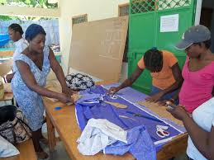
Chinese philospher Lau Tzu, "Give a man a fish and feed him for a day. Teach him how to fish and you feed him for a lifetime."

“STITCHES OF HOPE” QUILT SILENT AUCTION FOR HAITI RELIEF
QUILT FINISHED BY GLORIA BROSCIOUS
Measures 70” X 60”
Minimum bid $140
Bidding ends Sunday, July 7th at 11 AM
Name _____________________  Ph. No.____________________  Bid(Minimum $140)__________ | Name _____________________  Ph. No.____________________  Bid(Minimum $140)__________
Name _____________________  Ph. No.____________________  Bid(Minimum $140)__________ | Name _____________________  Ph. No.____________________  Bid(Minimum $140)__________
Name _____________________  Ph. No.____________________  Bid(Minimum $140)__________ | Name _____________________  Ph. No.____________________  Bid(Minimum $140)__________
Name _____________________  Ph. No.____________________  Bid(Minimum $140)__________ | Name _____________________  Ph. No.____________________  Bid(Minimum $140)__________
Name _____________________  Ph. No.____________________  Bid(Minimum $140)__________ | Name _____________________  Ph. No.____________________  Bid(Minimum $140)__________
Name _____________________  Ph. No.____________________  Bid(Minimum $140)__________ | Name _____________________  Ph. No.____________________  Bid(Minimum $140)__________
Name _____________________  Ph. No.____________________  Bid(Minimum $140)__________ | Name _____________________  Ph. No.____________________  Bid(Minimum $140)__________
Name _____________________  Ph. No.____________________  Bid(Minimum $140)__________ | Name _____________________  Ph. No.____________________  Bid(Minimum $140)__________
Name _____________________  Ph. No.____________________  Bid(Minimum $140)__________ | Name _____________________  Ph. No.____________________  Bid(Minimum $140)__________

PLEASE PLACE YOUR BID HERE:
(MINIMUM BID $140)



