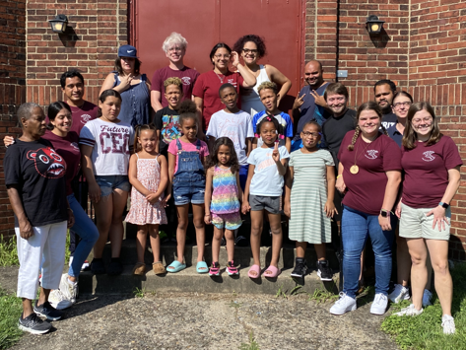
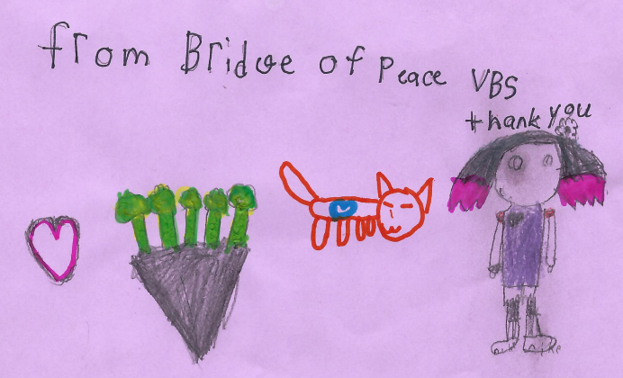
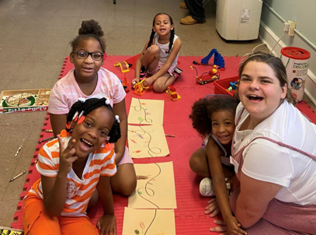
Dear Friends from Lord of Life,
Thank you for helping to make our Vacation Bible School a success! We had an amazing week and served a total of 22 children and youth ages 5-23! Your support enabled us to serve many hungry children throughout the week.
Thanks for your continued support!
In Christ’s Love,
Your Bridge of Peace Partners in Mission

