CHRISTMAS SERVICE PROJECT
10 AM Monday, December 6th
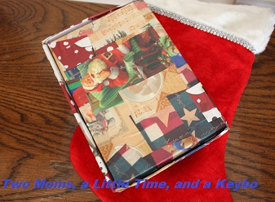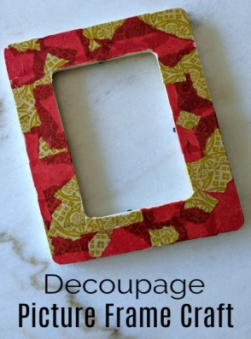
Decoupage boxes, window ornaments and picture frames

Rock painting in October was such fun! So, we have a new project. Beth Gebhart from Lutheran Social Ministries will help us create Christmas gifts for hospice patients. All you need to do is cut or rip pretty Christmas napkins and paint them on to a box, ornament or picture frame with Med Podge. All equipment will be provided. You provide the helping hands. And friends are always welcome.

Name
- _________________________________
- _________________________________
- _________________________________
- _________________________________
- _________________________________
- _________________________________
- _________________________________
- _________________________________
- _________________________________
- _________________________________
- _________________________________
- _________________________________
- _________________________________
- _________________________________
- _________________________________
- _________________________________
- _________________________________
- _________________________________
- _________________________________
- _________________________________
- _________________________________
- _________________________________
- _________________________________
- _________________________________
- _________________________________
- _________________________________
- _________________________________
- _________________________________

