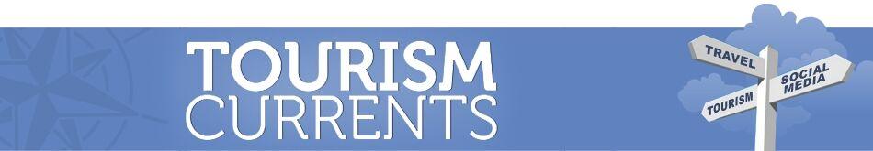

Getting Solid with Your Online Marketing Fundamentals

Stay focused in a world of constant change. Your anchors are a strategy and plan, the tools that YOU control (website, blog, email list) plus a critical item for Google Search and Maps, and the one social media platform where you need to be... for now.

1) A Strategy and a Plan

- An overall vision, mission, and strategy for your business or organization. What’s your “elevator speech” answer when someone asks what you do?
- Specific marketing goals that support your overall strategy and vision. Example: “In the next 1-2 years, we want to increase the number of customers who come to us for XYZ product or service, and measurably increase sales of that product or service.”
- Plan and create content on your website, in your blog posts, in your emails to your list, and on your social media that gets the attention of those particular customers. Know what you are going to post or email. Know why you are posting it.
- Each social media post should track back to supporting one or more of your specific marketing goals.

2) A Website

- Own your business or organization domain name online and have a website – even a very simple one – that is yours. Own your own online “real estate.”
- Keep your website updated. It should be simple enough for you to do basic updates yourself, like updating your hours or adding a menu.
- Keep your website updated in terms of look and design. Refresh it every few years. Fast-loading and mobile-friendly (“responsive” no matter which device anyone uses to look at it) is an absolute must. Install Google Analytics.
- Content on your site should give people what they’re Googling for, in the words that they’re using to find you and decide if you have what they want.
- Reminder – a Facebook Page is not a website. It supplements a website. Don’t “decorate a room in someone else’s hotel” and lose control of your own business or organization’s communications.

3) Google Business Profile

- Claim it, fill it ALL out especially ensuring correct name, address, and phone number. Add photos, keep hours updated including holiday hours, and respond to reviews.
- It feeds Google Maps and Google Search. Even if you know nothing about SEO (Search Engine Optimization) having a good Business Profile can ensure that you are find-able online.
- Remember Yellow Pages? This is that, only WAY more powerful AND it is free.

4) Facebook Page

- If you only have time to do one social channel well, make it this one. Better to be really good at one, than terrible at a bunch of them.
- Complete every Page section, review quarterly for accuracy, and swap out your Page header photo at least seasonally. Have a backup Page Admin or two, and turn on two-factor authorization for logins, with strong passwords.
- Post at least 3-5 times per week, including possibly one weekend day if your followers are active then. Posts should support your specific marketing goals. Mix up link posts, just short text, photos, and video, including Facebook Live. Engage when someone comments or tags you, and answer on FB Messenger.
- Review Page Insights to see which content does well, then do more of that. To see when your Page followers are most active, go to Insights - Posts - When Your Fans Are Online.
- Consider budgeting for ads/Sponsored posts. You can do a lot with $30-$50.

Tourism Currents: online and in-person training in social media for tourism, hospitality, and economic development at https://www.tourismcurrents.com/. We help you bring more visitors, guests, and customers to town through better digital destination marketing.

