Oak Middle School
INTERVENTIONS

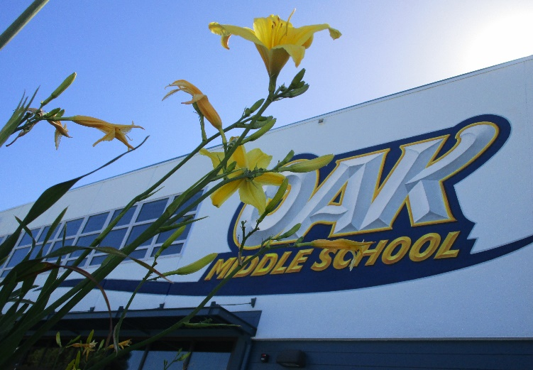

6th Grade

Academic Area(s) | Days | Time | Teacher | Room Number
General | Tuesday/Thursday | 7:45 – 8:30 | La Vache | 35

7th Grade

Academic Area(s) | Days | Time | Teacher | Room Number
General | Tuesday/Thursday | 7:45 – 8:30 | Uy | 23
Math | Monday/Friday | 8:00 – 8:30 | Berthon | 25

8th Grade

Academic Area(s) | Days | Time | Teacher | Room Number
General | Tuesday/Thursday | 7:45 – 8:3 | Maya | 75
Math | Monday/Friday | 8:00 – 8:30 | Berthon | 25

6th - 8th Grade

Academic Area(s) | Days | Time | Teacher | Room Number
Reading | Monday – Friday | 7:45 – 8:30 | Murray | Computer Lab

