
Unitarian Universalist Young Adult Network Long Beach
This group gathers for small group ministry discussion, social action and to build a beloved young adult community. Meetings are 3rd Sundays – check the uuclb.org/calendar and weekly announcements for updates. Kathy Adams at katole@uuclb.org for more information.
Resources for Young Adults – UUA Denomination
https://www.uuyarn.org/ministries
Welcome to the Young Adult Revival Network. We are the one stop shop, the central hub, the town square, the place for all things Unitarian Universalist young adult ministry. We are here to help young adults connect into community, create the ministries of their dreams, and grow the future leaders of our faith community. So let's begin your journey with YARN today! Click “Home" or scroll down and choose an option that resonates with you. If one of these options doesn’t resonate with you, then send an email to yarn@uusf.org.
Pacific Southwest Area: Camp de Benneville Pines,
UUCAMP.org
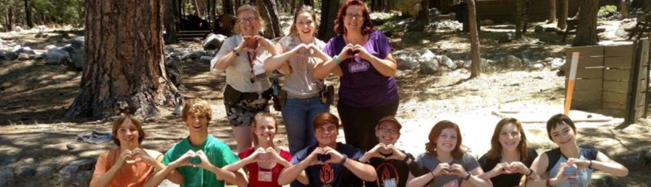
Unitarian Universalist Association – Womens Federation
UUWF.org

Building covenantal relationships among Unitarian Universalist women that equip us all to be better co-conspirators and allies in the movement for collective liberation.

