Providing a low- cost dental care clinic at

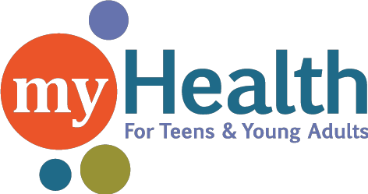

15 8th Avenue South Hopkins, MN 55343

Wednesday December 15th 9-4

These services are for children from birth to age 26 and pregnant women
¡También se habla español!

Exams
X -Rays Cleanings Fluoride
Sealants
Oral health education

Fillings Crowns Extractions

Please call Children’s Dental Service 612-746-1530
to set up your appointment
Childrens Dental accepts all forms of insurance and offers reduced cost care under an income- based sliding fee scale.
Ask to have your appointment at the
myHealth For Teens & Young Adults location.
www.myhealthmn.org

