ONLINE FESTIVAL BULLETIN – Selina Chu, WSFMC Festival Chair
The Online Bulletin is full of bold blue hyperlinks that are very easy to navigate.
General Festival Rules contains information that applies to all entrants (Juniors and Adults) and all events. It’s a good idea to read these first! Click on the hyperlink that takes you to the section you need to review. Click “return to top” to get back to the top of the page.
Section Rules contain information specific to each event. Questions about time limits, “choice piece” requirements, progression through classes? Just follow the links.
Required Repertoire contains the list of required pieces in each event and class. Navigate to the event and class you need in the same manner as you would in Vivace. You have the option to view the required pieces one class higher and lower than the chosen class – look next to the search box
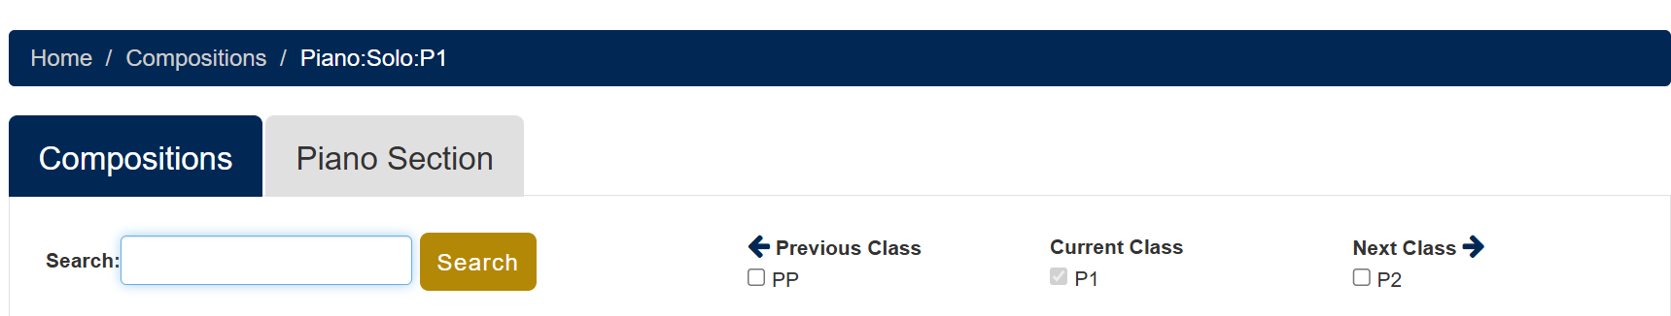

Federation Cup Plan explains how entrants can earn Federation Cups. There is information on how entrants can earn cup points more quickly by combining points.
Publishers contains a list of the publishers, the publisher code, and publisher contact information.
Resources takes you to repertoire lists that can be downloaded and printed out, theory sample tests and answer keys, and materials for improvisation and sightreading.

