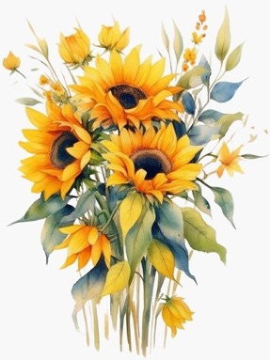
Greetings
There is something about September that makes me want to slow down and take note of my surroundings. It’s finally cool enough for an early morning walk and to breathe fresh air, so go outside and enjoy God’s gift of nature.
~ Deborah Freeman, NFMC President

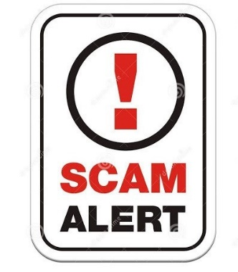
NFMC Scam Emails
The NFMC President will not solicit you for funding. Always check the email source for my correct address. If you have received an email from anyone requesting gift cards please disregard and DON’T buy them! NFMC will never solicit gift card donations or contributions! All correspondence from NFMC regarding donations, contributions, etc will come on official letterhead from the President, Headquarters Office or Chair relating to a specific award. If you receive a questionable email please ask before purchasing anything!

125th Celebration
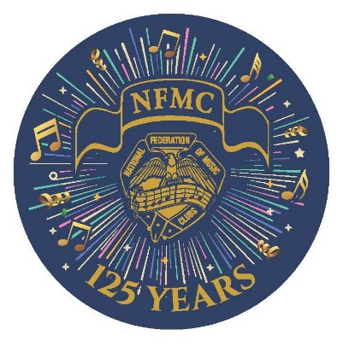
Now that we’ve finished our 125th Celebration, we can see the benefits of preserving our history on a regular basis. Luckily we are fortunate to have documentation for our first 100 years through Lucile Parish Ward’s book, A Legacy of 100 Years. The 125th Celebration Committee will move forward by digitalizing Lucile’s book and researching our past twenty-five years with personal videos, photos, and documents. We invite interested individuals and State Historians to join us in this important effort. Our next meeting will be Friday, September 13th at 11:00 am EST. If you are interested in attending, or if you have photos to share, please send an email to Julie Watson nfmc.pr@gmail.com for a meeting link.

NFMC Publications
Most of the NFMC publications have been revised and are now on the NFMC website. The Competitions & Awards Chart will be published to the website in mid-September.
We appreciate your patience with the 2024-2028 Bulletin adjustments. Please check regularly for updates before assigning repertoire here
Share this newsletter link with prospective members - https://www.nfmc-music.org/nfmc-newsletter-signup/

Division News
American Music Division - Ruth Morrow, Chair
I know that all the Music Clubs have their American Music planned for the year. So, I hope that your club has made sure that American Music is well represented. The first entry will be for the R. A. Schramm Parade of American Music in November. This has become a very popular November meeting with many kinds of American Music, and I always have many entries. It is so wonderful to read all the fabulous programs and to see the pictures of all the exciting Parade of American Music that is happening all over the USA! Please send me your entries for American Music showing all the great American Music in your Parade! You may send your entry by March 1st by e-mail to me at morrowrm@charter.net or by mail- 138 Waddell Road, Greenville, SC, 29609. The entry form number is AM -1-1. I hope to hear from you soon.
Competitions & Awards Division - Lucinda Lear, Chair
Deciphering Competitions & Awards Chart
With over 78 separate awards in the C&A Chart—where to begin? Is it mind-boggling? Like wading your way through a jungle of information?
It could be, but then so too could a large smorgasbord look at first glance. So, let’s break it down like one would a Mozart Sonata.
Dessert first! At the end of the C&A chart (pages 13-15) is an index. Just like the chart, the index is provided by age category starting first with Junior Awards. Is there a school-age (under age 19) student who is interested in composing? Those pages are listed first. From there you can see if there is an instrument and/or category of interest. Piano? Voice? Strings? Writing? Check out the index and it will tell you right away the page to look at as well as if the award is an annual award or biennial. 2025 is a biennial year so all the awards should be available for the asking.
In the index, following the Junior is the Student-Collegiate Awards for ages 19-26. Again, look for the area of interest—composition, music education, music therapy, pedagogy, performance? Especially check out the 11 categories of Student-Auditions offered in 2025. Preparations for this literature needs to be in the works now to meet the March 1 application deadline.
Senior Awards, Summer Music Center awards and then club awards finish off the Index. Just like our Federation Bulletin the opening page holds important information for all awards. Although there are rules that must be followed, there are also exceptions to the rules in almost every requirement. Use this page as a checklist. Is American citizenship required? Is NFMC membership required? Almost every award form gives information on how to become an Individual member with online payment of dues. Can one compete again in the same category after winning a top prize?
The chart itself starts with the largest monetary awards offered—Young Artists. The requirements for this have changed drastically since the last competition in 2023 so it is important to review the brochure available on the website: https://www.nfmc-music.org/wp-content/uploads/2024/04/2023-YA-Brochure.pdf
How does one get to the brochure (or other award requirement forms)? Every award has a hyperlink that will take you to the specific requirement page for that award. Click on it and you should find yourself on the page that you need to read and/or download and hand to a potential award applicant. The overall specifics are on the chart—what’s the age, performance category (piano, strings, voice, conducting, etc.), award amount, entry fee, application deadline. And if that’s not enough, the award chair is just an email away with another click on the email address.
You cannot eat everything (nor would you want to) at a Pizza Ranch. But you can choose and select what interests you and what you would like to spend your time eating. Take time to peruse the C&A Chart (CA 20-1) and decide what you would like to devour and become better acquainted with. Let’s delight in offering and awarding every award possible in 2025!
Bon appetite!
Junior Division - Laurie Marshall, Chair
Junior Club meetings are upon us with a quick message from the NFMC Junior Achievement Chair, Sally Palmer:
Every Junior Club deserves credit for their achievements!
· Have you stressed courtesy in your Junior Club? You deserve credit!
· Do any of your Junior members receive the Junior Keynotes magazine? Credit is due!
· Participation in a Junior Festival? You deserve credit!
· Submission of poetry to the Angie Greer Music In Poetry or an essay to the Essay Contest? You definitely deserve credit!
· Have you, or will you, study American Composers or International Composers or basic Music History? These achievements deserve credit!
These are just a few of the achievements listed on the JR1-1 Summary Form in which credit is due. With that credit you receive a professional certificate to hang in your music studio. Be sure to fill out the JR1-1 Junior Club Annual Achievement Summary Form and send it to me with a postmark no later than May 1st. This is a NEW deadline date so please make note of it. If you want to save a stamp, you can email it to me. All of my contact information is on the form. Congratulations on ALL your achievements! Now, let’s give you some credit! (I recently resigned from this position to take on an award chair position in the Student/Collegiate Division)
For Junior Awards, PLAN NOW for Award due dates. Visit the NFMC website for the Competitions and Awards Chart. The chart will be updated and available by September 15.
A message from NFMC Claire Whitehurst Piano Award Chair, Marcia Chaplain: Teachers! Are your students stressed out about preparing for a national competition that takes place soon? Do they want more time to practice? Do you feel they need more work? I have the solution – NFMC Claire Whitehurst Piano Award takes place in March 2026. That is almost 2 years away! That means more time for preparation! Please visit the NFMC website under Competitions and Awards/Junior Division for more information.
From your Festival Leadership:
NFMC Festival Chair, Lori Jessen: Let's all dive into a new Festival event this year. Maybe you have students who are great at theory...Let them earn some trophies in the theory event. Or maybe you have students who want to try their hand at improvising. Perhaps it's time for them to try their hand at a larger work like a concerto. Don't forget about sight singing/playing! What new event will benefit your students? Reach out for more information if you're not quite sure about something. Let us know what you need to make your Festival year the best one ever!
NFMC Bulletin Editor, Janice Flinte: Festival Area Admins, do you have new teachers in your Area? If so, we suggest that you call their attention to Page v. of the new Bulletin. This all-important "How to Use the Bulletin" page is designed to help take the mystery out of trying to find one's way through 7,000+ pieces of repertoire and the rules associated with each section. Thank you for being an Admin, encouraging teachers and students, and promoting Festival in your "musical corner" of the world!
NFMC Vivace Chair, Sandra Preysz: Two new features in Vivace requested by admins have now been added. The approval module will display the arranger where applicable. The scheduling module pre-schedule section will display time duration (when the time is entered at registration).
Membership & Education Division - Natlynn Hayes, Chair
Prior to reading comments on the NFMC FB page, I had no idea what I should include in this publication. I was really encouraged to see that people are actually reading this newsletter and asking questions!!
Many of us that have been involved with music clubs for most of our lives, forget what it’s like being a new member. We just think everyone knows what we know. That’s not true!
I know that everyone is tired of being referred to the NFMC website but there really is great information on the site. One area that you might check out is on the membership page. If you look under the link that reads “download Associate Membership Form,” you can click here for a list of existing College and University members. This helps students know if their university/college is a member of NFMC. Other membership form updates should be online after September 15th.
I also know that contact with people is the best way to share information. Our clubs allow us to continue to interact with others that love music. Also, being a part of the NFMC FB page has been a great tool for encouraging our membership. If you do have a specific question on membership, please feel free to contact the Membership Division. We will do our best to help you make your next step as NFMC members. Whether you’re a junior or senior club member, associate member, or individual member, we celebrate YOU!! Thank you for being a part of this great music organization that has many levels of membership and award opportunities.
Public Relations Division - Julie Watson, Chair
As club years are beginning, we want to remind you this is a biennial year - of which some exciting awards are available. We have the $20,000 Young Artist & Ellis Duo competitions and the $3,000 Student Collegiate Auditions. Additionally, there are the Mayfield Opera Award, Glad Robinson Youse Composition Award, Lynn Freeman Olson Piano Pedagogy & Composition Awards and Wiegand Music of the Faiths Award. The best way to have a National winner in your area is to have your talented musicians apply!
Additionally, your club has the opportunity to nominate someone for an NFMC Citation. Nominees who have won nationwide prominence through distinguished service to the cultural, musical and artistic life of the nation should be nominated. What better way to raise awareness for NFMC and all we offer then by recognizing someone very important for their contributions! Please note that they must be present at the convention in Austin in order for them to receive the award. The nomination deadline is November 15th to Karen Greenhalgh on PR 9-1.

NFMC Elections
2025 is an election year. If you are running for an NFMC office or Member at Large, information must be received by October 1.
Officer Nominations: Dr. Zuill Bailey ZBLB@verizon.net
Member at Large: Lucinda Lear LMlear@mchsi.com

