National Federation of Music Clubs
In Tune with NFMC
December 2024

Greetings 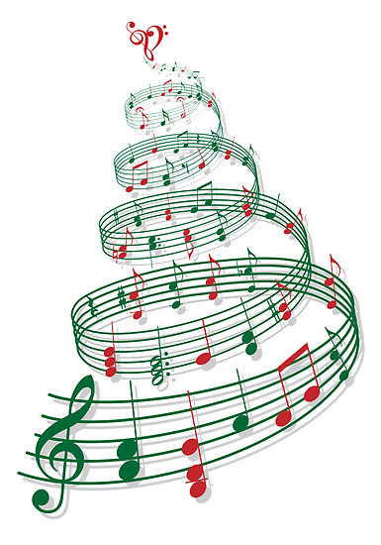
Tis the season of joy!
As we welcome December and the festive spirit that accompanies it, let us also reflect on the joys and blessings of the past year. A heartfelt thank you to our volunteers, supporters, and staff. We could not carry out the mission of NFMC without all of you.

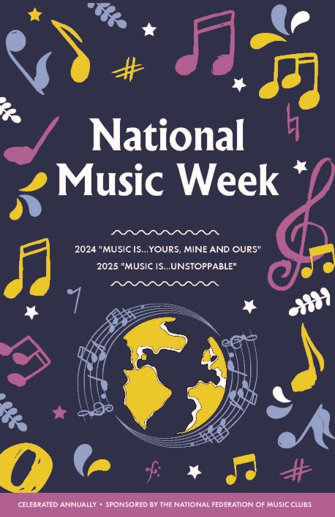
National Music Week Essay Contest
Deadline is January 10
Music…is unstoppable
Contest open to 7-12th grade students. Essay must be typed and no longer than 500 words. Essay is judged on relation to theme, continuity of thought, completeness of application. Membership in NFMC is NOT required to enter.
Information form with student name, grade level, name and address of teacher, email addresses for student and teacher, essay, and quality photo of student with deadline date is January 10, must be uploaded to the NFMC website (www.nfmc-music.org/applicant-fileupload).
The current year’s theme and entrant’s name must be typed at the top of the first page. The teacher’s email address or telephone number must be included.
Email regional chair: name and contact info after upload is completed.
The essays become the property of the NFMC and will not be returned and may be published in Junior Keynotes. Teachers and state presidents will be notified in the winning states
Apply here!!

Headquarters Office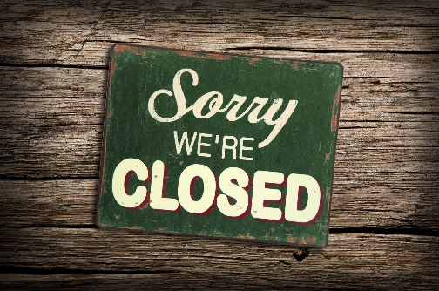
The Headquarters office will be closed Tuesday, December 24, 2024 through Wednesday, January 1, 2024.

Congratulations on 100 Years!
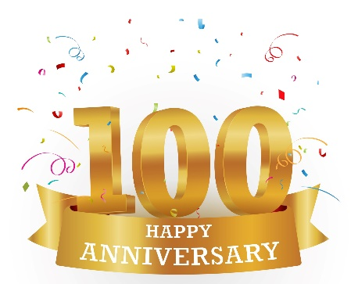The Barron Federated Music Club in Wisconsin and Royal Oak Musicale in Michigan recently celebrated their centennial years.
Let us know when you’re celebrating!

Scam Emails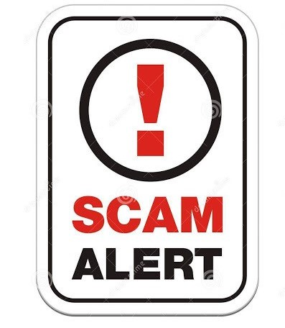
We’ve had several questions regarding emails pretending to be from various NFMC personnel. If you have received an email from anyone requesting gift cards please disregard and DON’T buy them! This is a phishing attempt from an outside source and not from anyone representing NFMC! We never solicit gift card donations or contributions! All correspondence from NFMC regarding donations, contributions, etc will come on official letterhead from the President, Headquarters Office or Chair relating to a specific award. There really isn’t anything that can be done to stop this, so if you receive a questionable email please ask before purchasing anything! Always check the email address in which it came from. Most times, you can tell that it's spam just by the email address. Please report the email address through your provider immediately.

United Nations
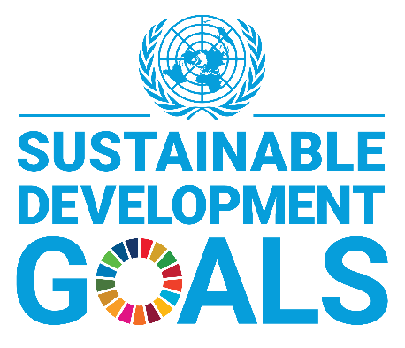80 Years of Global Partnerships
2025 will mark the 80th anniversary of the creation of the United Nations
The United Nations is the one place where the world’s nations can gather together, discuss common problems, and find shared solutions that benefit all of humanity. How can you and your students mark this important anniversary? Learn about the United Nations 2030 Agenda for Sustainable Development (https://sdgs.un.org/goals) and plan events to support your communities. You and your students might consider performing a fundraising concert to assist a local shelter or charity, organize a music and instrument swap to ensure that materials you have outgrown can be shared with others, start a peer-led tutoring center for younger musicians, or bring live or recorded music to a local senior or community center. The possibilities are endless.
Share your experiences with your UN Representative, Dr. Liana Valente (Liana@omegatower.com), so your work can be celebrated and serve as an inspiration to your NFMC colleagues.

Division News
Junior Division - Laurie Marshall, Chair
Season’s Greetings! Throughout December, we celebrated three cultural American Holidays including Hanukkah, Kwanzaa, and Christmas. Music fills our minds and hearts as we share in this special time. From the Junior Division, please let us assist you in exploring all the gifts that are NFMC Junior Awards and Festival!
From the NFMC Lana M. Bailey Piano Chair, Lana M. Bailey
AWARD OPPORTUNITY for graduating Seniors who plan to major in music! Record the first or last movement from one of the Senior Class Piano Concertos in the current Festivals Bulletin for an opportunity to win $1500 first place or $500 second place in the NFMC Lana M. Bailey Piano Concerto Award. Go to the NFMC website for details and application. May 1st deadline.
From the NFMC Angie Greer Poetry Chair, Debra Hughes
Angie Greer Poetry Contest
Fast approaching is February 1!
It's the due date of junior writing.
Please remind your students
Their poem we want to be sighting!
Angie Greer is the event-
Any poetic genre is acceptable
As long as a musical theme
Is easily perceptible.
Download the finished masterpiece
And pay five dollars entry fee
Online at NFMC-music.org.
You'll find it is rather very easy!
From the NFMC Dance Chair, Lisa Moore
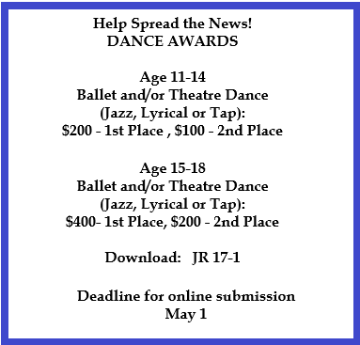
From the NFMC Festival Chair, Lori Jessen
Hello from the Festivals team! Remember to utilize the chair chain when you have questions about anything dealing with the Festival: First contact your Area Admin/Chair. If they don't know, they will reach out to the State Admin/Chair. If they don't know, they'll reach out to the Regional Admin/Chair. And if they don't know, it comes to me. Contact information for the regional chairs is located in your Junior Keynotes.
Be sure to check the latest round of updates before assigning pieces. More repertoire has been added to Musical Theatre Solo and Duet, Sacred Music Piano Solo, Piano Hymn Playing, and the APFS Event. Some of you have already hosted fall Festival events but all of us are looking forward to spring Festivals. And while we are helping our students prepare for those Festival performances, take time to enjoy the music of the season that speaks to your own heart. Happy holidays!
From the NFMC Bulletin Chair, Janice Flinte
Greetings to all of our Festival teachers! The Bulletin provides pieces which are utilized, not only for Festival adjudications, but many which also can be performed in seasonal recitals and events we hold during the holidays. There’s still time to choose a dazzling or sacred piece. Key words: turkey, snow, stars, sleigh bells, Sugar Plum Fairy, It Came Upon the Midnight Clear, etc. Your Bulletin is a valuable resource! Use its contents to give your students an extra performance opportunity while enhancing your musical events in December. Warmest wishes to you for a wonderful holiday season.
Membership & Education Division - Natlynn Hayes, Chair
From the Senior Club Report Chair, Linda Flick
I want to remind all State Presidents to appoint a State Senior Club Report Chair who can send reminder letters out in the fall and spring to all the senior clubs in their state to complete the Senior Club Report form (ME 7-1) which is to be sent back to the State Chair or the State President who then completes the state Senior Club Report form (ME 7-2) and sends them on to the National Senior Club Report Chair in July. The National Chair then takes all the state reports and compiles them into a report which is then sent on to the National Division Chair.
If your club is completing a report (ME 7-1), it can be sent to your State President if there is no State Chair. Your State President would then complete a state report (ME 7-2) and then send it to the National Chair. The Club Report is due by July 1 of each year to give clubs time to get their reports finished since some clubs don’t end their club years until June. The State report is due by July 15 of each year.
Your club can receive points for performing club and community programs of sacred music, American music, opera, etc. Your club can also receive points if members attend Local, State, and National meetings.
The Senior Club Rating Sheet can be completed by the club president, a Senior Club Rating and Evaluation Chair, or a committee. It could even be done at a club meeting as an orientation program to assist members in understanding the full scope of your state’s work. A notebook could be provided at each club meeting to record the volunteer hours given by each club member in the community, church, or any other organization. Also remember that deserving clubs could receive a National Award.
I would encourage everyone to go to the NFMC website and look at the Senior Club Rating Sheets (ME 7-1) and (ME 7-2) and it lists all the activities your club can receive points for.
The Senior Club Rating Sheets can be found on the NFMC website at www.nfmc-music.org.
Public Relations Division - Julie Watson, Chair
Seasons Greetings to you! Hard to believe we're at the end of 2024. The years go by so quickly - but this is only halfway through your club year. Great time to redouble your efforts to invite someone new to your next event!
Both fall magazines have hit mailboxes. If you haven't received yours, please contact headquarters at info@nfmc-music.org. Also, please let them know any address changes.
As we turn our calendars to 2025, all NFMC award deadlines swiftly approach! Be sure to share the details now so your talented musicians can be ready to submit! Junior Division, Senior Division, and Student/Collegiate Division. Club Awards are also available. The black & white PDF versions are available the national website (pro tip: search "poster").
Student/Collegiate Division - Sheila Shusterich, Chair
Happy December! The cooler temps are here and with it, the season of sniffles and sneezes. I hope everyone is doing their best to stay healthy! In my corner of the world—working with Kindergarten children daily—there are lots of germs being shared!
In continuing with the idea of highlighting one NFMC Student/Collegiate Award each month, I have selected the Gretchen E. Van Roy Music Education Scholarship chaired by Sally Palmer. This award is specifically for a college junior music education student with a $1,500 first place award and a $500 second place award. There is a $10 entry fee by March 1, and the applicant must be a member of the NFMC either as an individual member or as a member of an NFMC—affiliated collegiate student organization. In 2024, both the first and second place monies were awarded! As a music educator, this award is near and dear to my heart. I had the pleasure of knowing Gretchen E. Van Roy while I was the Minnesota Federation of Music Clubs president,
twenty+ years ago. She was a passionate lady who left a beautiful legacy with this special award.
Sally Palmer, the Gretchen E. Van Roy Chair and our newest Student/Collegiate Award Chair, sent the following information for this month’s article.
MUSIC EDUCATION SCHOLARSHIP!
If you answer yes to any of the following, your support could make a difference in reaching prospective applicants for the Gretchen E. Van Roy Music Education Scholarship:
• Did you attend a college or university with a music program?
• Were you involved in any way with music during your college years?
• Are you currently affiliated with a local college or university music department?
If any of these apply, here’s how you can help:
1. Share a Contact: If you know someone involved in the music department at your alma mater or a local college/university, please send me their contact information, and I can reach out to them directly to discuss this opportunity.
2. Make the Connection: If you prefer, feel free to reach out to your contact and share this scholarship information with them directly.
The NFMC Gretchen E. Van Roy Music Education Scholarship is an annual award for a junior majoring in music education at an NFMC-member college or university offering a degree in this field. For non-member schools, individual NFMC student/collegiate membership is required. Please note, membership in the National Association for Music Education (NAFME) is not a substitute for NFMC membership.
The scholarship is awarded at the start of the senior year and funds are paid to the recipient's institution. Full eligibility details and application requirements are available on form ST 9-2 at NFMC-music.org. March 1st is the application deadline.
Thank you for helping to spread the word about this meaningful opportunity! Please reach out to Sally via email: spalmer19@hotmail.com or by phone: 425-442-1830.
In closing, I want to wish everyone a lovely holiday with family and friends. Soak in all the beautiful music, love, and warmth the season offers.

In Closing
I wish you a December filled with warmth, joy, and many cherished moments. May your holidays be bright, and may the new year bring you peace and prosperity!


