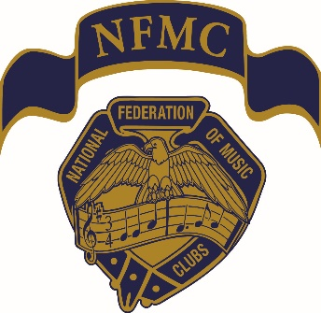
National Federation of Music Clubs
In Tune with NFMC
January 2025

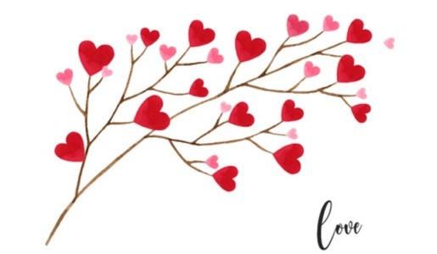
Greetings
Valentine’s Day: “Celebrating love, friendship, and connection. It’s a time for expressing appreciation for loved ones, whether through gifts, gestures, or acts of kindness.” Although these are things we should do each day, we often need a reminder. I appreciate the many volunteers in NFMC. Ninety-nine % of those I’ve asked to volunteer have accepted, and I thank you for your support and encouragement.
Our award chairs are busy promoting awards and accepting entries – many are due today! Take a look at our Award chart and spread the word about the opportunities provided by NFMC.
https://www.nfmc-music.org/wp-content/uploads/2024/12/CA-20-1.pdf
2025 is Election year for NFMC. If you are interested in volunteering, get in touch with me immediately. The president is to submit an election sheet for chairs and committees during our Convention in Austin.
SPAM: Please check the email address for validation. I will never use an alternate email address.

2025 NFMC Convention - Lynn McNew, Chair
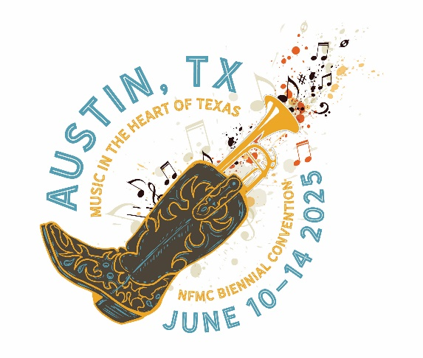
"Get your coat and grab your hat. . ."These are the opening lines to an old familiar song. I prefer to say "Get your boots and grab your hat(cowboy, that is)" for a real Texas Experience on Tuesday night, June 10th at the National Convention in Austin, TX, at the Hilton Austin Airport Hotel.
From bar-be-cue and line dancing to a touching Memorial Service you will enjoy a wonderful week of "Music in the Heart of Texas."
Ya'll come, ya' hear?

Insignia - Dr. Janie Gilliam
NFMC Merchandise
Always makes a nice
Gift or award,
At a reasonable price!
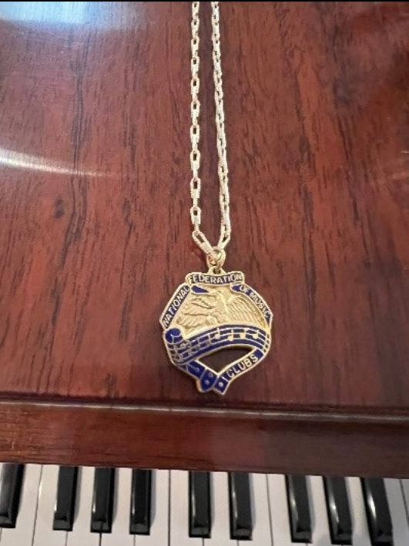
Worn around the neck
Or on the arm,
This Insignia item
“Works like a charm!”
https://www.nfmc-music.org/publicationcategory/insignia/

Division News
American Music Division - Ruth Morrow, Chair
Its February and this is the time for American love songs! One year my husband took me to the Greenville Theater to see a performance of Love songs from Broadway Musicals! Some of my favorites:
Somewhere- West Side Story
If I Loved You-Carousel
Til There Was You- Music Man
People Will Say We’re in Love- Oklahoma
Some Enchanted Evening-South Pacific
So, sing, play or listen to your favorite American love songs with your sweetheart!
In the coming months remember to use Jazz, Folk Music, American Women Composers, and American Music in your programs.
he deadline for the American Parade of Music is March 1. The reports should be sent to the regional chair in your state.
For entries to be judged send or email directly to:
Ruth Morrow
138 Waddell Road
Greenville, SC, 29609
Phone- 864-322-9224
morrowrm@charter.net
For entries to be returned, return postage must be included along with a self-addressed envelope. Clubs cannot win in consecutive years.
Awards: 1st-$300, 2nd-$125, 3rd-$75
I am excited to read and see all the American Music your club has done for the Parade of American Music this past November.
Arts Division - Ellen Leapaldt, Chair
National Music Week Essays were received from 20 states and are being judged for state winners! A total of 47 essays were entered by students 7th through 12th grades. Chair Gloria Lien reminds us that National Music Week will be celebrated May 4-11, 2025 with the theme of "Music is ...unstoppable ". She encouraged all senior and junior clubs to plan activities for the week: recitals, guest artists, workshops, lectures; any activity that encourages participation or learning of music. Then remember to report your celebrations to your state and regional chairmen..
It is time to begin to gather reports of activities for the last year in clubs regarding Music Outreach, Celebrate Strings, Music in Poetry, Music in Song, Music in Schools and Colleges, Chamber Music, International Music Relations, Choral Music, Sacred Music, and Opera.
Has your club encouraged students to apply for Summer Music Programs that offer financial assistance to young vocalists, wind and string players, piano and composition students? Many of the Arts Division awards include our juniors; who in turn may become our Senior Club members or even Young Artists! Look at all the Publications in the Arts Division. Most Club reports are due by April 1 to state chairs so you have less than 2 months to fill in any blanks in your programs and get your reports in on time and possibly earn financial awards to help next year's programming!
Competitions & Awards Division - Lucinda Lear, Chair
And the winner is…….
Award season has begun, in Hollywood and at NFMC. The first award deadline (Jan. 15) has come and gone. As you get this newsletter, many more awards have a February 1 deadline and many performance awards (that have required repertoire to polish) have March 1 deadlines. Any award that states it is a Biennial award will be given in 2025.
Each year award dollars go unused because of lack of entries, missed deadlines, and inaccurate or missing requirements. The C&A Chart (CA 20-1) can be a great help in tracking down awards that are specific to age groups—adult, student-collegiate and junior (under age 19). The chart also provides the chair responsible with contact information for the details of the awards.
We are also in NFMC Festival mode around the U.S. Many events in festival, where there is NO monetary attachment, have a counterpart that does have an award attached to it. It is important to recognize the differences between applying for a monetary award on the C&A Chart and participating in Festival.
This past week I have been fielding questions about awards and eligibility. BE AWARE that awards are applied for by the eligible applicant. Some require membership, some do not. There is no mention or requirements for teachers with these awards—only the applicant. Check out the online requirements for the award first. The ‘experts’ for these awards should be the award chair and contacting them by email is the best way to get answers to specific questions. If a response from the chair does not come in 48 hours, contact the appropriate Division chair (Adult, Student-Collegiate, Junior). If satisfaction is not received or questions remain after trying to contact the award chair, please feel free to contact myself as C&A Division chair and I will do my best to tract down answers for you.
In much the same way as the Festival Bulletin is the guide for NFMC Festival, so too, the C&A Chart is the guide for monetary awards. The first page of the chart has Instructions for Award Applicants and should be read before proceeding with application. Almost all the awards now have online applications with required submissions (documents, video) uploaded to the NFMC website. Almost all have entry fees. All membership and entry fees must be paid prior to the application being “green-lighted” into the adjudication process.
Come June 1 when annual reports are provided, I would love to announce for EVERY NFMC Award, “And the winner is……….” Let’s do it!
Junior Division
From the Junior Division Chair, Laurie M Marshall:
First, thank you for your calls, emails, and text messages with exciting news on your students, especially those already in Festival and preparing for the Junior Division Awards.
Please remember award applications and registration payments are uploaded via the NFMC website, which closed on those posted deadline dates.
Next, YES, please send updates and photos for Junior Keynotes: We LOVE to post short articles on active Junior Clubs from all over!
A quick message from the Festival team: Remember to contact your Festival Admin/Chair for assistance as they are your first contact on all things Festival. However, Admins, please contact your state Festival chair, who works directly with Lori Jessen, NFMC Festival Chair, Sandra Preysz, NFMC Vivace Chair, and Mary Jane Timmer, NFMC Festival Cup Chair.
Now a message from the Bulletin Chair:
Online Bulletin News! Great strides are being made as we inch closer and closer to the debut. The membership module, rules, repertoire, tabs, links, buttons, navigation, and literally miles and miles of code which enable all that “magic” to happen are being reviewed and tested so that members can have the best experience ever. Just think—rules, repertoire, and registration—all in one convenient place!
Speaking of registration . . . are you experiencing difficulty finding a Choice Piece composer? Just remember, “Less is best.” 1. Start with a really short, unusual part of the name. For instance, if the composer is named Persimmon Pedagog, just type in “mmo” for the first name or perhaps “gog” for the last. 2. Never include a diacritic/accent in the search. (Unless you enter the correct keystrokes to get the accent, the result will be zero.) 3. If you find nothing after careful research, send the composer’s name, DOB, birth country, and current citizenship to this editor to be added to the Vivace database.
We trust your Festival is running smoothly!
Public Relations Division - Julie Watson, Chair
As we start the month of love (February), I hope you are keeping warm. Junior Keynotes magazines should be hitting mailboxes. The Music Club Magazine should come soon. If you have moved or haven't received your magazine, please reach out to headquarters. The submission deadline for the next issue is February 1st (today).
How did you get this newsletter? If this didn't show up in your mailbox, please sign up today here: https://www.nfmc-music.org/nfmc-newsletter-signup/. These monthly newsletters have a lot of great, timely information that we don't want you to miss.
Would you like to have a national winner from your area? Be sure to have your talented musicians apply for NFMC awards. That's the best way to get bragging rights.
Student/Collegiate Division - Sheila Shusterich, Chair
Happy Hearts Month! Valentine’s Day is a time to remind all the important people in my life just how much they mean. Thank you for the love you pour into promoting the National Federation of Music Clubs! It doesn’t go unnoticed. Wishing all of you a very Happy Valentine’s Day!
February’s featured award is the NFMC Student/Collegiate Biennial Auditions honoring Agnes Fowler and Mary V. Thiesen. As the chair, Dr. Liana Valente does an amazing job promoting these auditions. I was excited when Dr. Valente shared the following information for this article. “Every two years, NFMC conducts the Student/Collegiate Biennial Auditions, an opportunity to recognize young artists who are honing their skills and preparing for careers in the performing arts.” As with the other awards in the Student/Collegiate Division, applicants must have reached the 19th, but not the 26th birthday by the application deadline of March 1. The entry fee is $30 in each of the 19 categories. Awards are given in odd-numbered years: $3,000 First place; $1,000 Second place. Click the link for more information: NFMC Student/Collegiate BiennialAuditions
There is something so gratifying about receiving correspondence from past award winners. Dr. Valente shared the following update recently received from the 2023 Trumpet award recipient Bjorn Kydland. “Bjorn is now a member of the Brockton Symphony Orchestra (https://www.brocktonsymphony.org/season_current.php) and he shared the following: ‘The NFMC award helped me by pushing me over the line between scraping by and passing by with a little margin, freeing me up to take on some lower paying gigs to bolster my experience and improve my ensemble playing during a time when I otherwise would be practicing by myself and slowly losing touch.’”
Dr. Valente reminds us that, “NFMC Awards make a profound difference in the lives of aspiring musicians. All Federation members are encouraged to promote scholarship and award opportunities to teachers and students throughout their communities. And for those of you in the greater Boston area, consider attending the Brockton Symphony concert on March 16th at 3:00 pm and seek out Bjorn after the performance.” Please click on the link to email Dr. Liana Valente with questions about the Biennial Auditions.

In Closing
The best and most beautiful things in the world cannot be seen or even touched - they must be felt with the heart.
Helen Keller
Deborah

