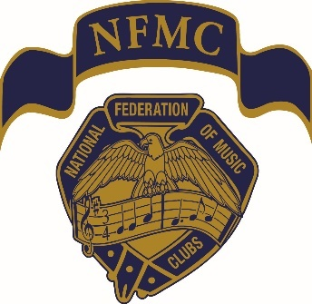
National Federation of Music Clubs
In Tune with NFMC
November 2024

Greetings 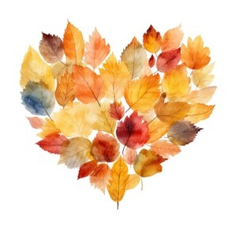
A grateful heart is an expression of humility, as it requires us to be present and aware of the positive aspects of our lives.
With Thanksgiving marking this season, November becomes a time for gratitude and appreciation for life’s blessings.
Wishing all of you a joyful Thanksgiving filled with joy, love and laughter.

American Music Month
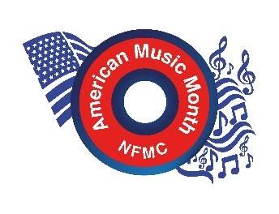
Get Ready, Go! It is time for you to march to the beat of the Parade of American Music for November! Remember to send in you reports of all your activities and programs for the Professor R. A. Schramm American Music Awards. It is form # AM-1-1. You can also download the forms for the Proclamations from your Mayor of your city or the Governor of your state. Please send them to me by mail or email by March 1st.
These are the awards:
1st Place- $300
2nd Place- $200
Two 3rd Place winners -$100 each.
The competition is fierce as this is the 2nd most popular award in American Music. So do your best and have wonderful, great programs for the Parade of American Music with plenty of pictures and biographies. March to the Beat!

Save the Date - NFMC 2025 Biennial Convention
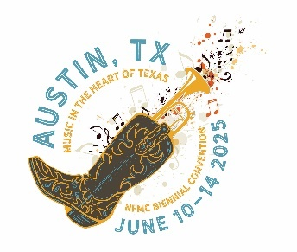
Christmas will be here sooner than you think and before you know it, June will be here also. And with June comes the NFMC National Convention. The NFMC Planning Committee invites you to come to the Hilton Austin Airport Hotel in Austin, Texas, June 10-14,2025, to celebrate "Music in the Heart of Texas."
The NFMC Convention is a great time to connect, learn, and get inspired. There will be insightful keynote speeches by industry legends to workshops and cutting-edge panels, the convention promises to be a rich blend of creativity and expertise. During the week, we will feature new NFMC Young Artist and Ellis Duo Winners. There will be workshops on membership education - What’s in this organization for Me, Finance and Fiduciary Finesse, Parliamentarians Workshop – Being Well Prepared, Bylaws and Standing Rules: A Necessity for all Clubs and more.
Mark your calendars—this is a convention you won't want to miss!
See you there!

Division News
Arts Division - Ellen Leapaldt, Chair
As your clubs (Senior and Junior) present their programs during the upcoming Holiday season, be sure to keep records of activities that should be reported on the Arts Division forms that will be due in the Spring. Are you adding strings, percussion, winds, or other instruments to your performances so that you have Chamber Music ensembles, have you invited ethnic performers or history of cultures so you meet the requirements of the International Music Relations awards, are you attending school and college music events, are you taking programs to shut-ins. There are financial awards available for participation! Remember to check the forms under Publications/ Arts Division for requirements and deadlines. First competition of 2025 is the National Music Week Essay for 7th-12th graders, uploaded to the nfmc-music.org website by January 10th. Theme is: “Music is unstoppable”
Music in Poetry updates from Karen Noorani:
Music in Poetry is a part of the NFMC Arts Division that is perhaps an area that many clubs may be less familiar with in comparison to some of the other areas for which reports are due each spring. The connection and creative synergy between Music and Poetry are many and stretch back into the earliest times of human history. They both stand independent of each other and yet both provide creative inspiration for each other. Composers from all periods have used poetry for inspiration. Thinking as performers or music appreciators, Vivaldi’s Four Seasons, Claude Debussy’s ‘l‘Apres midi d’un Faune or Marion Bauer’s ‘Up the Oklawaha’ come to mind as examples. Both poetry and music have rules of rhythm, phrasing and expression. Thinking as teachers, working with poetry can help our students have a clearer understanding of phrasing and pacing for a more expressive understanding of their music.
Our NFMC ‘Music in Poetry and Song’ is a wonderful resource for clubs to easily access poems to make a part of your meeting, whether you meet monthly or only gather together a few times in the year. For those that meet regularly, the Music in Poetry report form has a list of ideas for ways poetry can be a part of your meetings. For those clubs that are primarily focused on festival and their students, consider the many ways that including poetry in your activities can help to boost the experiences of your students. Next spring, after reports are in, we will endeavor to highlight ways that clubs have included Music in Poetry in their activities this year.
Junior Division - Laurie Marshall, Chair
Students throughout my community are so excited preparing new literature for their upcoming Festival season and other special events. Additionally, they are excited to explore all that the Junior Awards have to offer. Here is more information from our dedicated leaders:
From the NFMC Festival Chair, Lori Jessen:
The time of year is upon us where we pause to be thankful, and I trust that you are being thankful for NFMC. Our organization brings us together to form lasting connections, not only with one another, but with the communities we serve when sharing our love of music. The Festivals program is one way to help pass on our love of music to the next generation and show them how fulfilling sharing their music can be as they begin to "bring the spiritualizing force of music to the inner life of our nation." Happy Thanksgiving from the Festivals Team!
From the Junior Club Achievement Chair, Virginia Feitelson:
As the new Junior Club Achievement Chair, I am honored to continue the NFMC tradition of recognizing, and awarding Junior Clubs that turn in their Jr 1-1 Annual Achievement Form. I look forward to connecting with all of you and encouraging more participation in this truly amazing NFMC program. While the forms are not due until May, please reach out to me with questions, or to share your club’s recent accomplishments and upcoming goals. Let’s work together to support and encourage our hardworking Juniors.
From the Angie Greer Music in Poetry Award Chair, Deb Hughes:
Encourage your juniors to write about music. It helps to enhance vocabulary & cognitive abilities, develop their reading & writing abilities, as well as deepen their understanding of their own musical participation.
The deadline for entries remains the same - February 1st - for the Angie Greer Music in Poetry Award. All entries must be downloaded at NFMC-music.org under Junior Division of Competitions & Awards. The fee is $5 - also payable online. Any genre of poetry as long as it is on a musical theme from 8 - 30 lines long is eligible. "Writing improves students’ abilities to synthesize information in new ways and promotes connections between different concepts, as well as, learning in all subjects." - Youki Terada ("Why Students Should Write in All Subjects")
An award for poetry is the topic of the day
Nimbly writing about music, Juniors love will sway
Going for comic relief or rhyme to birth a smile
In waves of clever prose that also go a mile
Especially that it is original
Genres all are permissible
Regions each can have a winner
Each word for music, be it sweet or bitter
Enter the joy of word-smithing flow
Rules at NFMC-music.org you must go
Away now to help each Junior start
Work on their music in poetry part
And then watch to see how they will fare
Receiving their due reward: to care
Deeper... about music!
From the NFMC Thelma A. Robinson Award Chair, Beth Lee:
With another Nutcracker season approaching, please encourage your ballet and dance school colleagues and friends to identify a qualified young person for the NFMC Thelma A. Robinson Award. A single outstanding young person worthy of this award can impact an entire community of the importance of the “DANCE” Arts. Please see guidelines and submit!
From the Joyce Walsh Junior Award for Individuals with Special Needs Chair, Debbie Wiser:
Help spread the word! Do you know a junior musician with special needs? Or a teacher/school that teaches musicians with disabilities? This annual award provides financial assistance to any US citizen instrumentalist or vocalist (age 12-18) who is mentally or physically challenged. Awards are $2000 - 1st place, $1,500 - 2nd place and 1 award of $1,000 in each of the five NFMC regions. Please forward this JR 16-1 form to those you know and please share any names and contact information of schools or teachers with me. I’d love to send a personal invitation for their students to participate. Deadline: March 1st.
Membership & Education Division - Natlynn Hayes, Chair
Fall is in the air with Thanksgiving and Christmas gatherings on the horizon. Don’t forget to involve new people that might be interested in NFMC membership.
The NFMC Orientation and Leadership Training Chair, Ann Guest, wanted to remind everyone to report the many ways your clubs welcome new members this new club year. (See-Form ME-6-1) It’s always amazing to see the creativity and warmth in your ways of extending welcome to new music friends.
Ann is correct. So, invite, invite and then share your experience with others by using the NFMC reporting form for Orientation and Leadership Training.
Happy Thanksgiving!!
Public Relations Division - Julie Watson, Chair
Now that clubs are in full swing, I hope you are inviting your friends to meetings and concerts. That's the best way to grow our membership!
Do you know the best way to have a hometown national winner? Have your local talent APPLY for our awards. Please share these posters far and wide: Senior Division, Junior Division and Student/Collegiate Division. The black/white versions are also available on the website. (Pro tip: search "poster").
Please note the NFMC Citation deadline is November 15th. The nomination form can be found here. Nominees should have won nationwide prominence through distinguished service to the cultural, musical and artistic life of the nation.
Student/Collegiate Division - Sheila Shusterich, Chair
Happy November to all! The colors have been spectacular in Minnesota and it’s truly been one of the nicest fall seasons in recent memory. We’ve enjoyed the leaves longer than in most years—some spectacular reds, oranges and golds—with above average temps for most of October!
I thought this would be a good time to highlight one of the newest NFMC Student/Collegiate Awards—The Frances J. Nelson Tuba Award. This award like others in this division has an age requirement of 19-25, a $10 entry fee by March 1, and the applicant must be a member of the NFMC either as an individual member or as a member of an NFMC—affiliated collegiate student organization.
I was thrilled last year when this award was promoted and funded. It is in honor of past national president, Frances J. Nelson. Dr. Derek Bromme, a low brass professor at the College of St. Scholastica in my hometown of Duluth, Minnesota graciously agreed to chair the Nelson Award. Dr. Bromme spent a great deal of time in 2023 thinking about the repertoire for this award. The required repertoire he settled on is Capriccio by Mike Forbes and Hijazker Longa, anonymous, arr. by Gary Buttery. This $800 award is one of the newest in our division, so I am hoping that we can really promote it and get some entrants in 2025! Please encourage low brass musician friends and colleagues to look into this wonderful opportunity for the tuba players in their region! Best wishes for a very happy Thanksgiving holiday!

In Closing
“I am grateful for what I am and have. My thanksgiving is perpetual.”
Henry David Thoreau
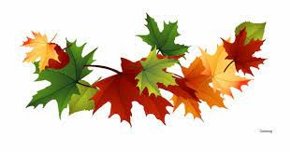
Deborah

