Opportunity for Prescribed/Wildland Fire Crew
Seeking Veterans for New Mexico Prescribed Fire Crew Members (GS-3/4)

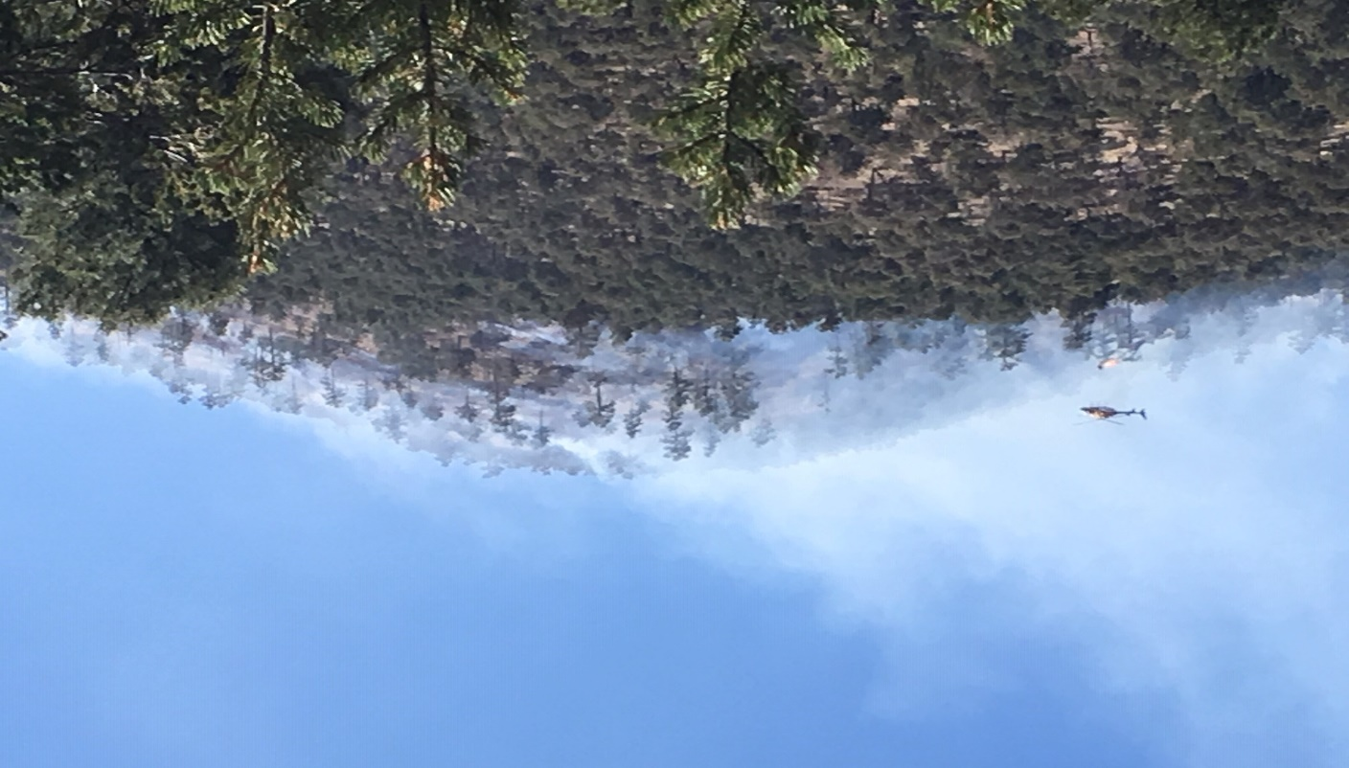

The Magdalena Ranger District of the Cibola National Forest in Southwestern New Mexico, Region 3, is seeking applicants qualifying for the Veterans Recruitment Authority (VRA) to build a veteran based fire crew with a primary mission of implementing prescribed fire on National Forests in New Mexico.

Position Information:

- 5- 7 applicants will be chosen.
- Selected applicants would start February 17, 2020.
- Duty Location is Magdalena, NM.
- Government housing is available.
- Applicants will need to submit a resume and a DD-214 to show VRA eligibility,
- Information of VRA eligibility can be found at:
https://www.usajobs.gov/Help/working-in-government/unique-hiring-paths/veterans/vra/
- No prior training is required, selected applicants will be expected to complete basic wildland fire training and pass the Work Capacity Test.
- Work Capacity Test (WCT) for Wildland Firefighters: This position participates in wildland firefighting activities. Based on the type of work performed, TAKING and PASSING the WCT at the ARDUOUS level is a ''condition of employment.'' The Arduous fitness (Pack) Test requires completing a three (3) mile hike within forty-five (45) minutes, while carrying a forty-five (45) pound pack.

Magdalena Fire Program:

- The fire program at Magdalena Ranger District consists of FMO, Operations AFMO, a public information officer, a prevention technician, 2 type 6 engines, 1 wildland fire module (Apache Kid), and 3 lookouts.
- The district fire season (April-July) is generally active with 20-40 fires during the season with monsoon season arriving by July. The district has an active fire program which utilizes managed fire and large landscape prescribed fire.
- The District houses new facilities which include Ranger District Office and Fire Center with exercise room, fire cache, training room, saw shop, tool shop and drive through engine bay.

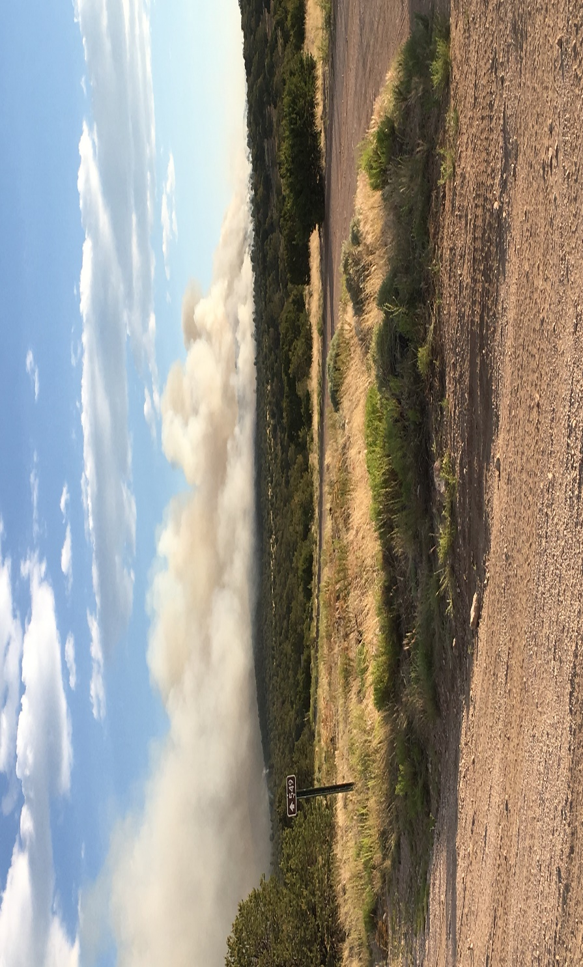

For further information or to contact
Ken Watkins, Fire Management Officer
505-681-8736
kenneth.watkins@usda.gov

Or
JJ Rue, Assistant Fire Managemnet Officer
575-838-7079
jesus.rue@usda.gov

ABOUT THE FOREST

The Cibola National Forest is 1,625,542 acres in size. Elevation ranges from 5,000-11, 301 feet. Our forest includes the Datil, Gallinas, Magdalena, Bear, Manzano, Sandia, San Mateo, Mt. Taylor, and Zuni Mountains. There are four wildernesses contained within our forest: the Sandia Mountain, Manzano Mountain, Withington, and Apache Kid. The Cibola National Grasslands are in northeastern New Mexico, western Oklahoma, and northwestern Texas, and are 263,954 acres in size.

THE DISTRICT

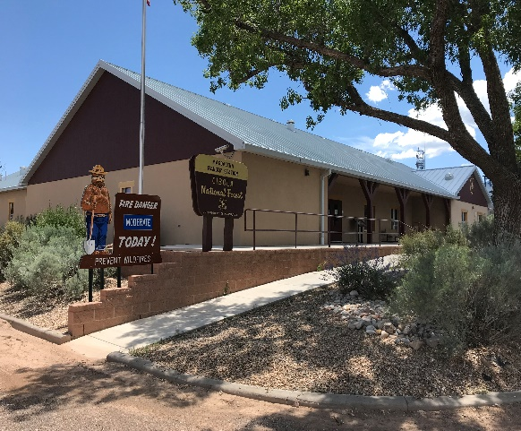
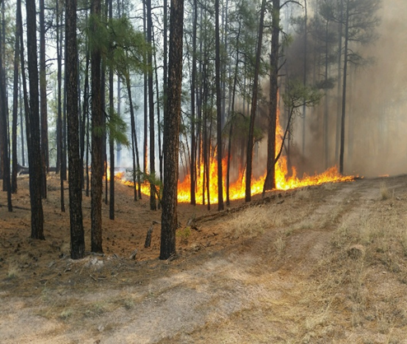

The Magdalena Ranger District covers approximately 800,000 acres, including four mountain ranges. Elevations range from 5,000 to nearly 11,000 feet ASL. The district has a large range program, with forty two grazing allotments. There are five developed campgrounds, approximately 200 miles of hiking trails, two wilderness areas, and boundless opportunities for dispersed recreation. Outfitter/guide permits comprise most of the recreation special uses. Although there is no active timber sale program, forest products are available in the form of fuelwood, pole and viga sales, and thinning for forest health improvement. The wildlife program includes threatened, endangered, and sensitive species management, and habitat improvement in the form of prescribed burning and wildlife water development. The minerals program administers a few active but small gold mining claims, as well as common variety minerals sales to the public. The fuels program includes prescribed burning and mechanical treatment to reduce hazardous fuels.

LIFE IN MAGDALENA
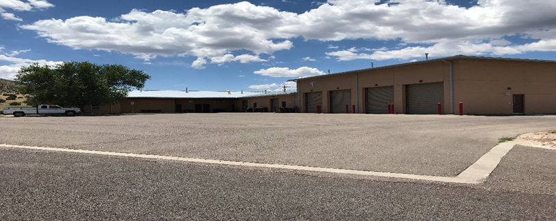

Magdalena, NM is located on U.S. Highway 60 in southwestern New Mexico, at an elevation of 6,500 feet above sea level. Climate consists of warm summers (high temperatures in upper 90s), pleasant autumns, cool winters (lows in the teens) with occasional snow, and windy springs. The rainy season occurs between July and September, with afternoon thunder showers almost a daily occurrence. Fall, winter, and spring seasons are normally dry, except for occasional snowfall, which usually melts off in a day or two. Average precipitation is about 12 inches per year.

The landscape around Magdalena consists of high plains grasslands and pinon/juniper woodlands. The town is surrounded by mountains with elevations exceeding 10,000 feet. As elevations increase, ponderosa pine and mixed conifer vegetation types are encountered. Socorro, in the Rio Grande valley, is twenty-six miles east of Magdalena at the intersection of U.S. Highway 60 and Interstate 25. There is a small airport with an unpaved landing strip in Magdalena. No services or fuel are available at this airport. There is an airport with paved landing strip in Socorro, which accommodates private and small charter aircraft. Fuel and telephone are available. The nearest airport serving the major commercial airlines is in Albuquerque, the largest city in New Mexico, about 100 miles to the northeast (1 ½ hours driving distance).

Current population is approximately around 950. Many residents are engaged in ranching or other activities which support ranching. There is a growing contingent of retirees and others who work in a variety of home-based occupations. Opportunities for employment are not abundant in the community, and many find employment in Socorro or at the National Radio Astronomy Observatory west of Magdalena.

Magdalena has one public school, which accommodates kindergarten through grade 12. Extension college level classes are offered by University of New Mexico on an irregular basis. New Mexico Institute of Mining and Technology and an extension campus of Eastern New Mexico University are located in Socorro.

Magdalena has an Area Medical Center, served by Presbyterian Medical Services, staffed by a Family Nurse Practitioner and a Registered Nurse. There are no other medical facilities in town, but a full complement of dentists, medical clinics, and a hospital are available in Socorro (twenty-six miles east of Magdalena).

The Village of Magdalena has one bank (Wells Fargo branch), two gas stations, two restaurant, one hardware store, three motels, 2 RV parks, a library, a family dollar, three churches, and a few other miscellaneous retail businesses. There is no grocery store in Magdalena. A greater range of retail outlets can be found in Socorro.

Few developed recreation/entertainment facilities are available in Magdalena. The rodeo grounds has activities perhaps seven months of the year. The public library and the city museum are open year around. Undeveloped recreation, in the form of hiking, hunting, camping, auto touring, photography, and off-road bicycling is readily available on the National Forest nearby.
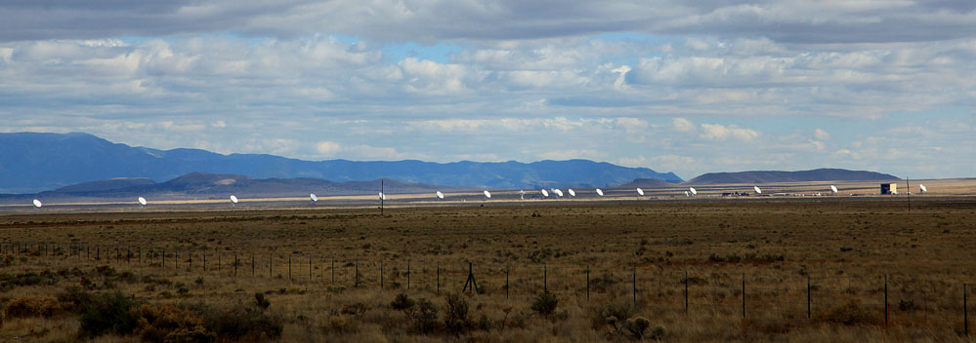

The U.S. Department of Agriculture (USDA) prohibits discrimination on all its programs and activities on the basis of race, color, national origin, gender, religion, age, disability, political beliefs, sexual orientation, and marital or family status. (Not all prohibited bases apply to all programs.) Persons with disabilities who require alternative means for communication of program information (Braille, large print, audiotape, etc.) should contact USDA's TARGET Center at (202) 720-2600 (voice and TDD). To file a complaint of discrimination, write USDA, Director, Office of Civil Rights, Room 326-W, Whitten Building, 14th and Independence Avenue, SW, Washington, DC 20250-9410 or call (202) 720-5964 (voice and TDD). USDA is an equal opportunity provider and employer.

