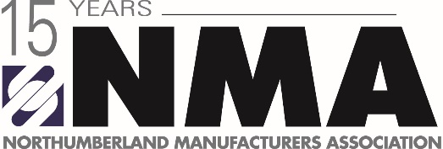

Celebrate Manufacturing Month Newspaper/Community Magazine
Each member is asked to answer some questions below to be included as an introduction to your business. Please send your responses along with a photo to admin@thenma.ca by September 16, 2019.
QUESTIONS:
Please answer the mandatory question:
1. What do you manufacturer/produce?
Please answer 2 questions of the 5 below (250 words or less) to be included in your profile:
1. Describe your most exciting accomplishment this year.

2. What absolutely excites you right now about your company?

3. If you and your team (company) were stuck on a deserted island, and you could only bring 3 things, what would they be?

4. Name a (non-monetary) way employee’s at your company received rewards/recognition?

5. As CEO/Owner, as a child what did you want to be when you grew up?

Thank you for your time and we look forward to sharing your responses.

