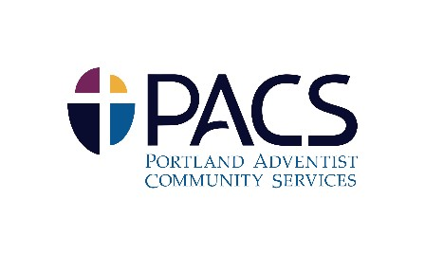

Title: Goods Processor, Receiver
Department: Home Store
Location: Back door & warehouse
Reports to: Thrift Store Manager and Assistant Manager

JOB SUMMARY:
This position should receive and process donated items; keep goods processing area organized, neat and clean; prepare donations for pricing by sorting into carts; empty garbage cans; perform duties as assigned by the manager.
The employee position is governed by the staff hiring polices of Oregon Conference of Seventh-day Adventist and as a faith-based organization limits employees to those with membership in the Seventh-Day Adventists Church allowed by law.

HOURLY RATE & STATUS: $13.50-14.25 / hour; part-time Tuesday, Wednesday & Thursday, 8:30 a.m.-5:30 p.m. (non-exempt)

OPEN UNTIL FILLED: Applications will be considered immediately and the position is open until filled.

DUTIES AND RESPONISBILITIES:
- Dealing with customers, co-workers, volunteers and donors on a continual basis.
- Exhibiting warmth and friendliness at all times to people and represent the mission of PACS
- Must be on time for your shift unless you’ve communicated with your manager

KNOWLEDGE, SKILLS, & ABILITIES
On the job training
Skills in:
- Self-motivation
- Flexible to respond to varying work from day to day, deal with emergencies, identify problems quickly and take immediate action

- Handle donated items with care
- Ability to concentrate on job while other things are going on around one

PHYSICAL REQUIREMENTS
- Speak English fluently and clearly; other language abilities helpful
- Appear personable and engaging while communicating with various constituents
- Job requires ability to be on one’s feet for a long period of time, bending, lifting, carrying, pushing and loading anything from boxes to large furniture alone or with the help from others

WORKING ENVIRONRMENT
- Generally fast paced environment outside and inside

HOW TO APPLY:
To be considered for this position, submit a cover letter describing your interest in this position and a complete resume to laura.pascoe@pacsonline.org

Portland Adventist Community Services (PACS) is an equal opportunity employer and does not discriminate against qualifies applicants or employees on account of race, color, sex, (including pregnancy, childbirth, and pregnancy related conditions), age national origin, marital status, physical or mental disability, or other protected categories under Oregon laws, regulations or local ordinances. PACS hires Seventh-day Adventist Church members in good standing based on religious preferences permitted by the Unites States Constitution and controlling law.

