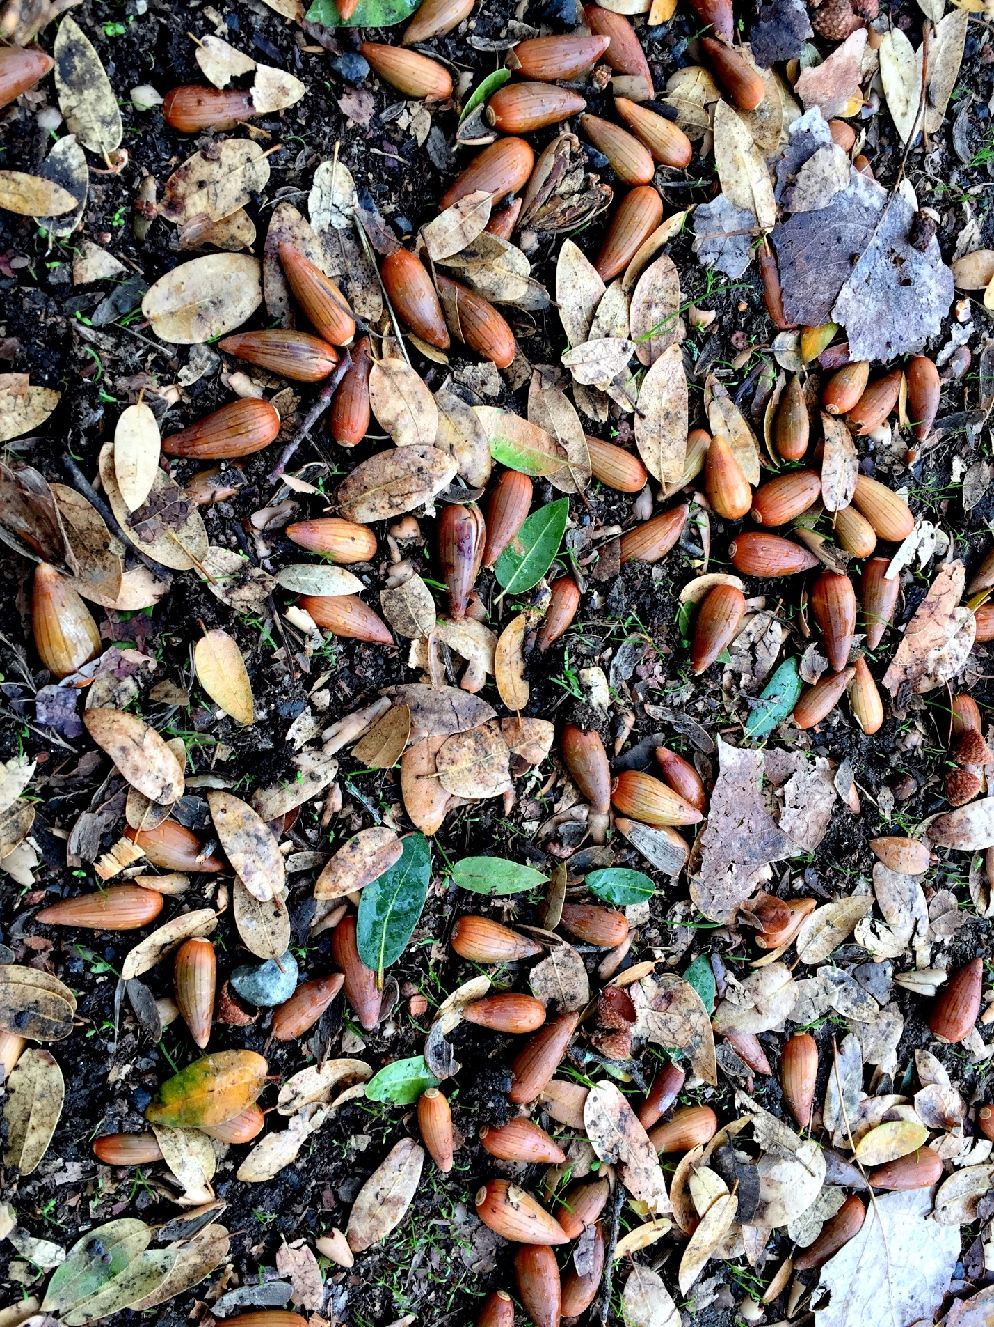
Interior Live Oak acorns. River Ridge Ranch
Environmental Education Enhanced: Acorns, Classes, Ecosystems (ACE)
Goal: To combine indoor and outdoor education using a sustainable model.
Current Status: Various Fish in the Classroom programs have spread throughout the United States since the 1970’s from their origin in Canada. Tens of thousands of students participate annually. In Tulare County, we offer a version called Trout in the Classroom (TIC).
The current Superintendent of Schools for Tulare County, Tim Hire, has expressed both admiration for the TIC program and has also been interested in extending the program to all fourth graders in the county. He has also expressed interest in a proposed new program: Oaks in the Classrooms.
The Trout in the Classroom (TIC) program by California Department of Fish and Wildlife (CDFW) is delivered in portions of Tulare County by a partnership between the Kaweah Fly Fishers (KFF), Sequoia Riverlands Trust (SRT), River Ridge Ranch (RRR), River Ridge Institute (RRI) and Tulare County Office of Education (TCOE).
The program relies upon CDFW to provide sterile hybrid trout eggs for classroom rearing by elementary school students, grades 4-7. It also depends upon KFF to pick up and deliver eggs to classrooms, provide teacher training in chiller and trout husbandry, and provide volunteers to staff one of five teaching modules on release days. SRT provides two staff and two AmeriCorps members along with high school students from the EARTH Academy. These EARTH Technicians are currently recruited from five school districts in Tulare County and are trained to guide the younger students through the education stations for TIC release field trips at RRR. River Ridge Ranch donates its facility and labor and RRI provides funding and staff.
The TIC curriculum on River Ridge has changed over the last 15 years to include Watershed Structure and Function, Soil Ecology, Water Conservation, Enviroscape (a modular water pollution/water quality game) and a Nature Hike. The changes were designed to increase the scientific rigor and environmental awareness of children and comply with No Child Left Behind and Core Curriculum standards emphasizing STEM or STEAM (Science, Technology, Engineering, Art, Math).
Problem/Reason for curricular change:
Over the last decade, KFF’s members have aged and the organization is struggling to provide the outdoor education component. While CDFW continues to provide eggs, they no longer attempt to provide day-of-release personnel and egg delivery dates vary from year-to-year, thus creating a scheduling challenge. The cost in parts and repair and maintenance required for the chillers that maintain trout eggs at constant temperature in the classroom is significant. Teachers are required to spend an entire day in training and devote considerable effort to in-classroom maintenance of equipment and husbandry for fish, including over weekends and breaks.
We deem the program unsustainable in its current form.
New Program
We propose an alternative that is ecologically relevant, scientifically sound, and easier to administer. Our program engages students in making a permanent contribution to the environment, understanding and interacting with soil, vegetation and the carbon cycle, and will make a life-long change in the way students view every tree they see. This alternative program will assist students in making a positive contribution to predicted changes in climate by improving carbon sequestration, soil retention, water infiltration, water retention and seasonal water availability.
The new program needs to
- reduce the burden on classroom teachers,
- still engage students in the classroom,
- be of moderate cost,
- culminate in an outdoor field experience and
- have a positive environmental benefit.

Our proposal is to substitute acorns for trout eggs and oak tree seedlings for juvenile trout.
The new program is based upon the iconic nature of oaks in the world, the United States and California, the importance of oaks ecologically and economically and the presence of numerous species of oaks locally. This program reduces equipment and maintenance costs, incorporates scientific method and inquiry, extends the outdoor education component, creates an experiment that has lasting educational opportunities, and has the crucial benefit of providing a positive environmental engagement and benefit to our shared environment.
In Brief: Acorns, Classrooms and Ecosystems (ACE)
Acorns are collected during the Fall of each year from properties (e.g., River Ridge Ranch, Blue Oak Ranch, Kaweah Oaks Preserve, Circle J Norris Ranch, Bartlett Park) where field trips may eventually occur. (Because acorns and oaks do not require rivers and streams, properties with water courses are no longer a requirement as they were for trout release.)
~ At current participation levels that would require about 1,000 acorns per year. Acorns are separated by species during collection.
~ Acorns are distributed to classroom teachers, along with pots and planting media and instructions.
~ Students begin an in-classroom experience learning about oaks, Native Americans’ history and relation to our local environment and their management of oaks.
~ In the classroom, students observe and analyze germination and growth. (Classroom maintenance is reduced to watering and rotating pots with respect to sunlight.)
The field trip component consists of two options:
- a visit to collect acorns in the Fall of each year and/or

- a hike and planting module during which students:
~ visit oak habitats for three species of oaks,
~observe, touch and measure oaks,
~learn about Native American relationship to these lands and oaks,
~learn oak natural history and the importance of oaks as part of the complex ecosystem of plants, animals and humans in the Central Valley and Sierra foothills,
~plant their oak seedlings in designated locations and plots.
Advantages: ACE is far less resource-intensive than Trout in the Classroom and ACE makes a far greater positive environmental contribution by planting a long-lived, keystone species of native tree as compared with a sterile hybrid hatchery-reared non-contributing batch of trout fingerlings.
Children’s awareness of oaks in their neighborhoods and trees in general will be greatly enhanced.
Classroom electricity demand is zero.
Planting pots can be sterilized and re-used dozens of times.
Planting media can be renewed or composted.
Maintenance of equipment is restricted to recycling pots for the following year.
Field maintenance is zero as acorns are subjected to natural environmental selective conditions: rainfall, temperature, herbivory, disease, etc. Purchase and continuing repair of classroom tank chillers goes to zero. Transportation for retrieving eggs from distant hatcheries is replaced with collecting acorns on field sites.
ACE is making a positive contribution to oak restoration as many sites have undergone deliberate deforestation under past management and oaks are declining under current conditions and predicted to decline further.
ACE is making a positive contribution to addressing climate change by improving carbon sequestration, soil retention, water infiltration, water retention and seasonal water availability.
ACE is making a positive contribution to habitat for wildlife by restoring a keystone species that provides food, roosting and nesting sites for invertebrates and vertebrates and creates conditions for harvestable edible foodstuffs.

Future Expansion:
To do this using trout is impossible for many reasons. To do this using acorns and oaks is both feasible economically and ecologically. In the worst acorn years, finding adequate sample sizes is virtually guaranteed on thousands of acres under the ownership and/or management of TCOE and NGO’s.
The startup and continuing effort with potted plants as opposed to trout is significantly lower.
The demand for maintenance on weekends and over holidays is significantly reduced or eliminated.
With TCOE’s leadership, extending an outdoor program to every 4th-grader becomes possible and a natural lead-in to the 5th-grade day at SCICON and the 6th-grade week at SCICON.
This program has the advantage and capacity to scale to other counties and states and could become a nationwide model.

