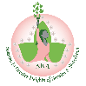Gamma Sigma Omega Chapter
Alpha Kappa Alpha Sorority, Inc.
Chapter Officer/Committee Reporting Form

Officer: Deborah Clarke Committee/Position: Public Relations/Ivy Leaf Reporter

Executive Meeting: X__ General Meeting: X __ Date: February 1, 2023

Announcement: ____ Report: __X__ Recommendation: _______

____________________________________________________________

Flyers
2023 AKA Founders’ Day
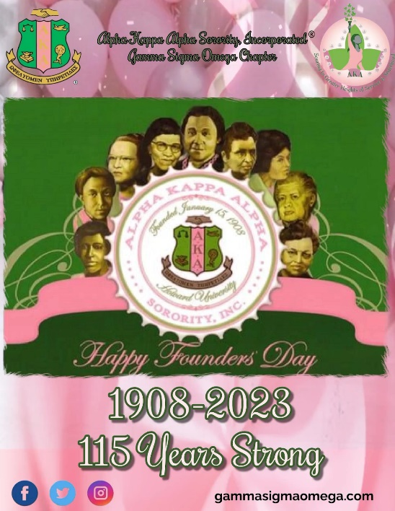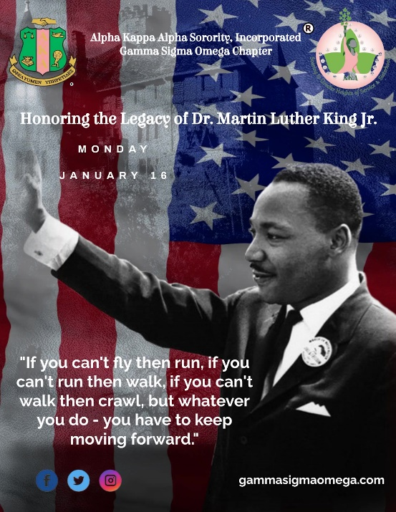
2023 Dr. Martin Luther King Day

Articles
GSO Holds Passing of the Gavel Ceremony
https://www.savannahtribune.com/articles/gso-holds-passing-of-the-gavel-ceremony/
GSO Pays Tribute to the Memory and Legacy of Dr. King
https://www.savannahtribune.com/articles/gamma-sigma-omega-pays-tribute-to-the-memory-and-legacy-of-dr-king/
Nicole S. Fields Leads Alpha Kappa Alpha Locally
https://www.savannahtribune.com/articles/nicole-s-fields-leads-alpha-kappa-alpha-locally/
Ivy Beyond The Wall-Carmelita Suzanne Maynard
https://docs.google.com/document/d/1I7s92VOK98c4igLA1SgDKlpUDoWPmuVfgdmKvE0izqQ/edit?usp=sharing

Meetings and Events Attended by Members
Dr. M. L. King Day Parade
Greenbriar & Emmaus House Community Service Event
Executive Board Meeting
Chapter Meeting
MARTHA Board Meeting
MARTHA General Body Meeting
Technology & Public Relations Committee Combined Meeting

Committee Members
Soror Deborah Clarke
Soror Dawnique Steel
Soror Jackie Tomlin
Soror Denise Cooper
Soror Tessa Livingston
Soror Sandra Clarke
Soror Diann Scott
Soror Andria David
Soror Sherone Hubbard

Alpha Kappa Alpha Sorority, Incorporated®
Gamma Sigma Omega Chapter
Chapter Officer/Committee Reporting Form
Officer: Soror Grace Albright, Soror Silviller Watson, and Soror Wanda Hobson Committee/Position: Pan-Hellenic Council Delegates
Executive Meeting: x General Meeting: Date: January 23, 2023
Announcement: _________ Report: ___x______ Recommendation: _______
“Soaring to Greater Heights of Service and Sisterhood”
General Council Information:
- Starting next month, the council will resume meeting in person for our monthly meetings. We will be meeting on the campus of Savannah State University in the King Frazier Building on the Second Floor
- We are looking to do more NPHC organized events such as bringing back the Greek Picnic this June (details shall be forthcoming) and other community service based projects that each of our perspective organizations can participate in
- The council desires to develop a stronger community presence as a group
- The following flyer was shared in the GroupMe that Soror Wanda is in and is open to all NPHC members
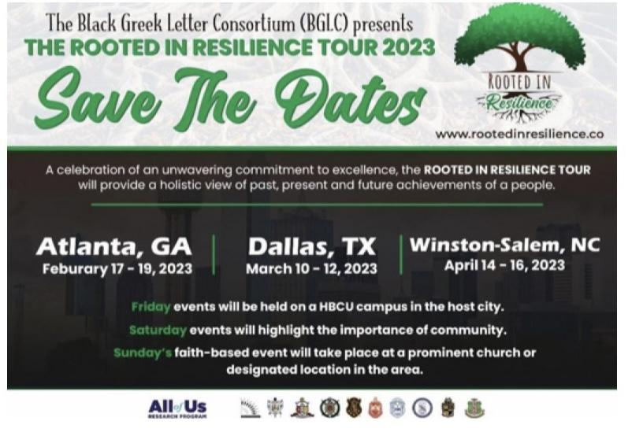

Alpha Phi Alpha Fraternity, Inc.:
- January 2023 Events and Programs:
  - The Brothers of Alpha Phi Alpha participated in the MLK Parade with a float and volunteered with the coordination of parade logistics. Following the parade, they partnered with the undergraduate members to do a street cleanup at W. 34th street and MLK.
- February 2023 Events and Programs:
  - Annual MegaGenesis Program on February 25th on the Savannah campus of Georgia Tech
  - Preparing to host Project Alpha in collaboration with the March of Dimes (the event is not set to take place until April, but the preparations for it have begun)
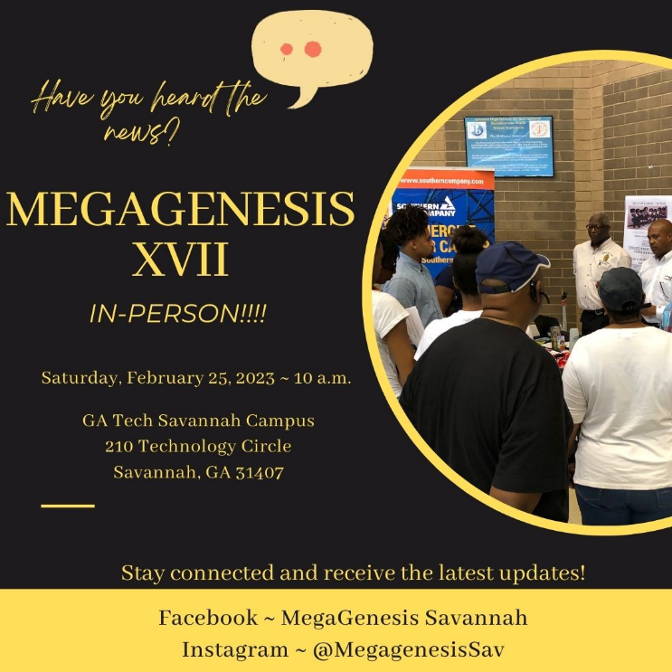

Alpha Kappa Alpha Sorority, Inc.:
- January 2023 Events and Programs:
  - MLK Parade and Service Project with Greenbriar and Emmaus House
  - 115th Alpha Kappa Alpha Sorority, Inc. Founders’ Day
- Upcoming February 2023 Events and Programs:
  - AKA Day at the Capital February 19th- 20th
  - 115th Founders’ Day Observance February 26th at 4PM

Kappa Alpha Psi Fraternity, Inc.:
- January 2023 Events and Programs:
  - The brothers of Kappa Alpha Psi extended their sincere thanks to those who attended their Krimson and Kream Party on January 6, 2023
- February 2023 Events and Programs:
  - Currently the brothers of Kappa Alpha Psi are undergoing Spring intake for their chapters.

Omega Psi Phi Fraternity, Inc.:
- January 2023 Events and Programs:
  - Nothing discussed.
- February 2023 Events and Programs:
  - The Brothers of Omega Psi Phi have their undergraduate summit coming up, no date was provided.

Delta Sigma Theta Sorority, Inc.:
- January 2023 Events and Programs: During the month of January the members of Delta Sigma Theta Sorority, Inc. participated in and/or held the following events:
  - SIDC 8th Savannah Traffic Jam Walk
  - Georgia Cluster January 27th- 28th
- February 2023 Events and Programs: In the month of February the members of Delta Sigma Theta Sorority, Inc. will participate in and/or hold the following events:
  - February 5th Healthy Heart Tour
  - MIP for Graduate and Undergraduate Chapters
  - Virtual All White Party February 2nd at 7:30 p.m.

Phi Beta Sigma Fraternity, Inc.:
- Absent, but we hope to receive information regarding events and programs soon.

Zeta Phi Beta Sorority, Inc.:
- January 2023 Events and Programs: During the month of January the members of Zeta Phi Beta Sorority, Inc. participated in and/or held the following events:
  - Feed the hungry
  - Painting of a Home
  - Sigma Gala on January 8th
  - Zeta Mail Network on January 28th
- February 2023 Events and Programs: In the month of February the members of Zeta Phi Beta, Inc. will participate in and/or hold the following events:
  - None reported

Sigma Gamma Rho Sorority, Inc. (Savannah):
- January 2023 Events and Programs: During the month of January the members Sigma Gamma Rho Sorority, Inc. participated in and/or held the following events:
  - SIDC 8th Savannah Traffic Jam Walk
  - Repack the Backpack January 31st
- February 2023 Events and Programs: In the month of February the members of Sigma Gamma Rho Sorority, Inc. will participate in and/or hold the following events:
  - MIP for Graduate and Undergraduate chapters

Sigma Gamma Rho Sorority, Inc. (Statesboro):
- Absent, but we hope to receive information regarding events and programs soon.

Iota Phi Theta Fraternity, Inc.:
- Present, but no report was provided

Gamma Sigma Omega Chapter
Alpha Kappa Alpha Sorority, Inc.
Chapter Officer/Committee Reporting Form

Officer: Kimberly Rhodes Committee/Position: Technology Committee
Executive Meeting: X__ General Meeting: X _ Date: January 2023__
Announcement: _________ Report: __X____ Recommendation: _______
“Exemplifying Excellence Through Sustainable Service”
The committee worked on the following projects during the month of October:
Website Updates | https://www.gammasigmaomega.com/  - Continue to update the calendar with meetings and links.  - Continuing to update the website to allow for more up-to-date pictures and events.
Trainings | - No trainings held.  - Future Training sessions to be Scheduled for March – Let’s master Canva
Technology Assistance | - Continue to host zoom meetings.  - Assisted various committees with presentations.  - Assisted with making fillable forms for various committees.  - Submitted Connections video for AKA Day at the Capital.
New Process for taking attendance at Chapter Meeting. Each Soror will be provided her own QR code. The QR code must be brought to Chapter meeting to be scanned.

Technology
Soror Kimberly Rhodes – Chairman

Soror Ivanette Richardson – Co-Chairman
Members: Soror Dawnique Cassandra Thompson, Soror Taqwaa Saleem, Soror Emily Crawford Sanders, Soror Erika Washington
Alpha Kappa Alpha Sorority, Incorporated®
Gamma Sigma Omega Chapter
Chapter Officer/Committee Reporting Form
Officer: Kim Dubois Committee/Position: AKA Connection and Social Action
Executive Meeting: X General Meeting: X Date: January 28, 2023
Announcement: _________ Report: _____X____ Recommendation: _______
“Soaring to Greater Heights of Service and Sisterhood”
The 2023 AKA Connection and Social Action Committee did not meet in January; however, the committee anticipates robust attendance for the 30th Anniversary of Georgia AKA Day at the Capitol, February 19-20, 2023. The Captain and Co-Captain, Kim Dubois and Jaundalyn Barker with attend in person. The group will decide upon the date and time for upcoming standing meetings.
The AKA Day at the Capitol Planning Committee will ask each chapter to draft a letter or develop a social media campaign to encourage TBD lawmakers to address childhood hunger, pass the Crown Act, and promote suicide prevention in Georgia.
The 2023 committee currently consists of: Kim Dubois and Jaundalyn Barker—Captain and Co-Captain respectively, Lynda Deloach, Janice Munn, Janice Bryant, Alvernia Jackson, Hope Johnson, Tiffany Lumpkin, Pam Denson, LaWanda Ramson, Michelle M. Gwyn, Stephanie Anderson, Jackie Gilbert-Grant, Sharon Stallings, S. Renee Grant, and Denise Cooper.

Alpha Kappa Alpha Sorority, Incorporated®
Gamma Sigma Omega Chapter
Chapter Officer/Committee Reporting Form

Officer: _LaShanda Reid Wilson_ Committee/Position: __EAF______
Executive Meeting: X General Meeting: X Date: ____2/2/2023______
Announcement: ____X_____ Report: ____Z_____ Recommendation: _______
“Soaring to Greater Heights of Service and Sisterhood”

I just want to report that 51 Sorors donated to EAF so that our Chapter could reach $600 need to achieve the Platinum Level of recognition at Regional Conference. Thank You very much.

The link below has information on how to apply for EAF Scholarships and deadline dates:
https://akaeaf.org/uploads/files/Scholarship-Corner-Quick.pdf

Alpha Kappa Alpha Sorority, Incorporated®
Gamma Sigma Omega Chapter
Chapter Officer/Committee Reporting Form

Officer: _Soror Patricia J. Clark, Chairman_ Committee/Position: Strategic Planning Committee
Executive Meeting: X General Meeting: X Date: _02/02/2023; 02/11/2023_
Announcement: _________ Report: __X_______ Recommendation: _______
“Soaring to Greater Heights of Service and Sisterhood”
The first task of the Strategic Planning Committee will be to summarize the results of the chapter survey that was done in 2021. This information will provide the top five (5) Guiding Principals that are of significant interest to members of Gamma Sigma Omega Chapter. These 5 Principals will be used to design and draft a current Strategic Plan for the Chapter.
The committee needs members from diverse professions and experiences.
If you would like to become a member of the Strategic Planning Committee, please contact Soror Patricia Clark at 912 665 0305.

Sisterly,
Soror Patricia Clark, Chairman
Soror Charlene Jones
Soror Sylvia Perry (Consultant /Member)
Soror Sharon Stallings (Consultant/Member)
Soror Sonya Renee Grant (Consultant/Member)

Alpha Kappa Alpha Sorority, Incorporated®
Gamma Sigma Omega Chapter
Chapter Officer/Committee Reporting Form

Officer: Soror Tara Scott-Brown Committee/Position: Graduate Advisor___________
Executive Meeting: X General Meeting: X Date: _1/28/2023______
Announcement: _________ Report: ____X_____ Recommendation: _______
“Soaring to Greater Heights of Service and Sisterhood”
ACTIVITIES AT A GLANCE

01/15/2023 – Founders’ Day Celebration
01/16/2023 – M. L. King, Jr. Day of Service
01/21/2023 – SSU Greek Night
01/26/2023 – GU Programs meeting
01/26/2023 – Alumni meeting with Dr. Ballard-Washington
01/30/2023 – Joint Founders’ Day Program with Sigma tau Chapter
01/30/2023 – Cluster VI Meeting

PROGRAM INITIATIVES

EMPOWER OUR FAMILIES: None.

BUILD OUR ECONOMIC WEALTH: None.
ENHANCE OUR ENVIRONMENT: None.

ADVOCATE FOR SOCIAL JUSTICE: None.

UPLIFT OUR LOCAL COMMUNITY: See Community Impact
COMMUNITY IMPACT DAY:
01/16/2023 – MLK King Day of Service: Gamma Upsilon and the Mr. 1908 Court joined the Martin Luther King Day Observance Committee to volunteer on the Parade Line Up Committee. Setup started at 7 a.m. and we were in charge of helping to line-up over 275 entries.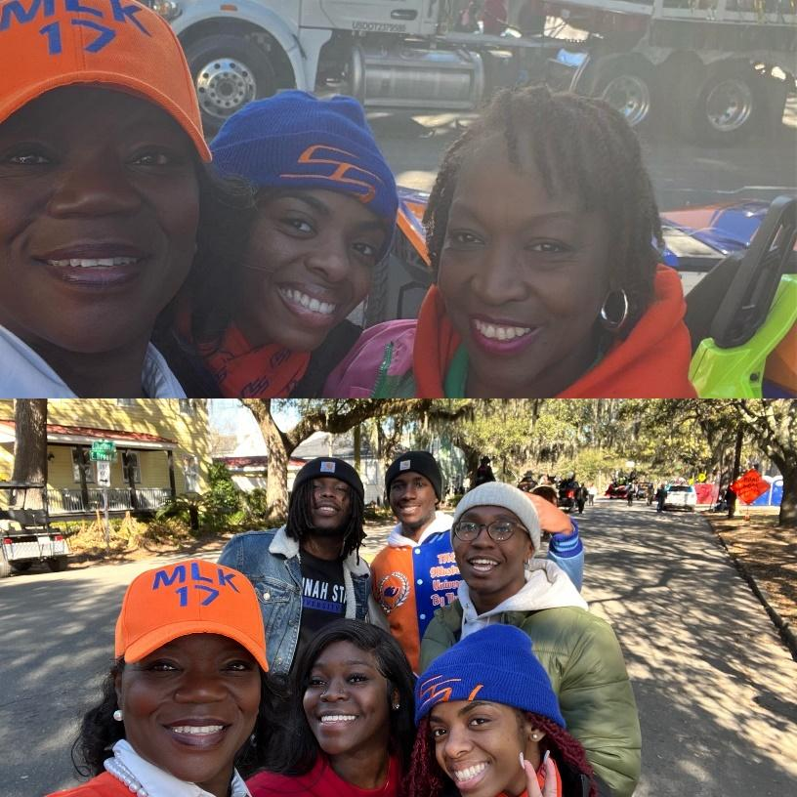
CONNECTIONS: NONE.

STRENGTHEN OUR SISTERHOOD:

01/15/2023 – FOUNDERS’ DAY CELEBRATION – Gamma Upsilon, the Mr. 1908 Kings, and members of GSO celebrated Founders’ Day by inviting their living Charter Member, Pearl Soror Jessie Collier Deloach to dinner at Ardsley Station. It was a wonderful celebration!!!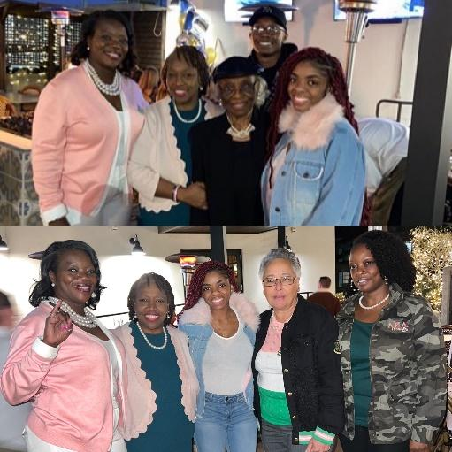

01/21/2023 – Greek Night for SSU Basketball – It was a night of sisterly bonding in the Tiger Arena, as GSO Sorors came out to Support Gamma Upsilon on Greek Night. Thank you Sorors for showing up and showing out!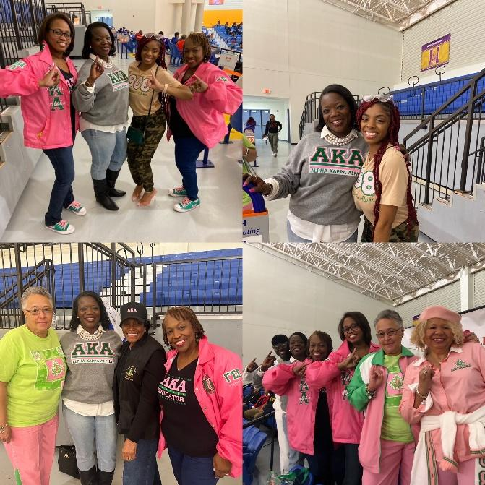
CONFERENCES: None.

MEMBERSHIP MATTERS: None.

OTHER CHAPTER EVENTS

NONE.

Upcoming Events

February 1, 2023 – Chapter Informational Table during lunch in King Frazier
February 1, 2023 – Know The Signs Program on Human Trafficking
February 6, 2023 – Joint Program with Delta Sigma Theta –“Red and Pink Table Talk”
February 6-10, 2023 – Canned Food & Supplies Drive
February 11, 2023 - Joint Chapter Meeting – African Attire
February 16, 2023 – Frank Callen Boys Club Black History Program
February 17-19, 2023 – Membership Experience Training
February 23, 2023 – Pretty Boot Camp
February 26, 2023 – GSO Founders’ Day Program
February 27,2023 – Are You Smarter Than An AKA?
February 28, 2023 – Guys and Gurls Charm School

Submitted by
Soror Tara Scott-Brown, Graduate Advisor, Gamma Upsilon
Soror Kisha Aites, Assistant Grad Advisor
Soror Cora Bragg-Thompson, On-Campus Advisor

Officer: Nicole Williams Committee/Position: Program Chair/Anti Basileus Executive Meeting: X General Meeting: X Date: January 31, 2023 Announcement: _________ Report: X Recommendation: _______
“Soaring to Greater Heights of Service and Sisterhood”
Thank you to the Sorors who graciously accepted the Chair and Co-Chair positions for our Program Initiatives. You are all truly appreciated. We are off to a great start.
For Dr. Martin Luther King, Jr. Observance Day, under the Empower Our Families Initiative, Sorors and Precious Gems participated in the Annual Parade. We also made donations to Greenbriar Children's Center and the Emmaus House.
Empower Our Families also encourages Sorors to wear RED on Friday, February 3 and post to social media using the hashtags, #pinkgoesred and #gammasigmaomega Thank you Soror Wanda Hobson and Soror April Scott for your leadership in these efforts.
We are also starting the recruitment process for our Youth Leadership Institute. Please contact Soror Wanda Hopkins with recommendations for youth ages 11 to 13.
For the Enhance Our Environment Initiative, Soror Kimberly Nixon has started the collaboration to work with the PARC on Pennsylvania Avenue to work on their Community Garden. Kudos to Soror Kim for making this connection.
Please look out for information from our Program Initiative Chairs for the upcoming meeting dates and times. Our Chairs and Co-Chairs are as follows:
Empower Our Families – Chair, Soror Wanda Hobson & Co-Chair, Soror April Scott with Soror Wanda Hopkins leading our Youth Leadership Institute.
Build Our Economic Wealth – Chair, Soror Michelle Mincey-Gwyn & Co-Chair, Soror Ernita Greene-Brown
Enhance Our Environment – Chair, Soror Kimberly Nixon
Advocate for Social Justice – Chair, Soror LaShawna Alderman
Uplift Our Local Community – Chair, Soror Bettina Tate & Co-Chair, Soror Sharon Stallings

Uplift Our Local Community
Bettina Polite Tate, Chair and Sharon Stallings, Co-Chair met via conference call on January 14, 2023, for committee pre-planning to discuss strategies regarding future committee meetings. The chairs discussed overview of Uplifting Our Community (UOC) initiatives, data gathering process and strategies to connect with UOC committee members and the community.
A google form was created and sent to UOC committee members to collect data regarding meeting days/times and availability for activity/service project participation. Currently, there are 27 Sorors signed up for this committee.
GSO members were invited to attend the stage play Broken Wings II: Devine Intervention presented by the 100 Black Men of Savannah, Inc. on February 3-4, 2023, at 7:00 p.m. at the Savannah Cultural Arts Center. Flyer and ticket links were sent to GSO members via the weekly chapter announcements.

Gamma Sigma Omega Chapter
Alpha Kappa Alpha Sorority, Inc.
Chapter Officer/Committee Reporting Form

Officer: _________Committee/Position: _Founders’ Day Committee
Executive Meeting: General Meeting: X Date: February 11, 2023
Announcement: _________ Report: __X_______ Recommendation: _______

“Soaring to Greater Heights of Service and Sisterhood”
2023 open Founders Day will be observed, Sunday, February 26, 2023
Venue: Jonesville Baptist Church of the Pentecostal Assembly – 5201 Montgomery Street
Time: 4:00PM
Speaker: Soror Thuane Fielding, Co-Chair of South Atlantic Region Leadership Development Institute
Attire: Pink and Green
Theme: ” Capturing a Vision Fair” – Building Relationships Through Community Service & Sisterhood
Overview: During our Founders’ Day observance program, we will honor the Founders of our sorority, recognize our chapter’s new Silver and Golden Sorors, recognize soror recipients for our chapter’s annual awards (ie. Soror of the Year), and our Community Award.
A reception will be hosted immediately following the program in the social (overflow) area of the church.
A pink and green brooch for Founders’ Day observance, purchase your brooch for a small fee of $20.

Founders’ Day Committee
Soror Alvernia Jackson
Soror Kimberly Rhodes
Soror Taqwaa Saleem

Gamma Sigma Omega Chapter
Alpha Kappa Alpha Sorority, Inc.
Chapter Officer/Committee Reporting Form
Officer: Annette Mitchell/Sheila Hutcherson_ Committee/Position: Greenbriar Liaisons_
Executive Meeting: General Meeting: Date: February 2, 2023
Announcement: ____X_____ Report: _____X____ Recommendation: _______

Thank you for supporting Greenbriar Children’s Center. We do not have contribution totals for the Gift Wrap Center yet, but we will report those figures as soon as they become available.

Fundraising is a MUST for the 2023-2024 year. Greenbriar was able to sustain itself during the past three years because of the National government supplements. These supplements have ended, and we are off and running to bring funding for Greenbriar. Your Greenbriar Liaisons are working on a fundraising project for our GSO sisters.

Announcements-Good News

Greenbriar Center’s Infant Center Grand Opening!!!
Save the Date: April 5, 2023, @ 4:00 p.m.
Opened to the public.

DECAL
We are thrilled to announce that Greenbriar has been awarded a second Community Transformation Grant by the Department of Early Care and Learning (DECAL), which will run from January 1 of this year through June 2024.
Forsyth Farmers Market
Greenbriar will partner with The Forsyth Farmers Market and other community organizations to introduce fresh, locally grown fruits and vegetables to the plates of young children in other early learning centers across Savannah.
Two Generation Grant
Greenbriar received the TwoGen Grant- This grant is for those parents who are also students. The grant provides support services to these parents.

FREE Training on ACES for Community Members
Adverse Childhood Experiences, also known as ACES, are stressful and traumatic events that can impact a child’s mental AND physical health well into adulthood if not adequately mitigated. Learn how YOU, your family, your local church group, or fellow employees can learn simple ways to help mitigate the impact of childhood trauma. This training can be done at YOUR location or by ZOOM. Continuing education credits are available for social workers, emergency personnel, and childcare staff through Bright from The Start/DECAL.

Early Learning is Critical

The two early learning centers at Windy's Preschool and W.W. Law Learning Center provide quality-rated, AFFORDABLE early education to our youngest learners. We know that early education sets the stage for all that comes afterward. There are opening at both centers. For additional information, please email our Director of Early Childhood Education and Care, Jennifer McMichael, by clicking the link: jmcmichael@greenbriarchildrenscenter.org

