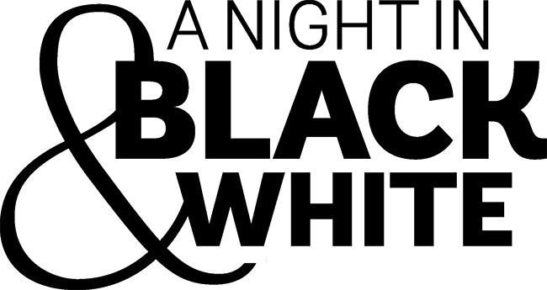

January 2017

Dear Friend of Eleanor Roosevelt High School,

We invite you to be a Corporate Sponsor of Eleanor Roosevelt High School’s 13th Annual Fundraising Benefit. This year’s auction event will be held on Friday evening, May 12 from 6:00 to 10:00, at the Mount Vernon Hotel, Museum and Garden, 421 East 61st Street, NYC.

Eleanor Roosevelt High School is a local public high school and has been subject to annual budget cuts for many years now. This deeply affects the high quality programs the school has to offer. The ElRo Parent Teacher Association, a 501(c)(3) not-for-profit-corporation, uses every effort to raise essential funds needed to supplement the ever-shrinking budget allowance from the New York City Department of Education to enrich and provide many academic, science, music & arts and sports programs that benefits all of the students within our community. Every dollar raised through this event is used to pay for programs that support ElRo’s reputation for excellence.

This year’s sponsorship levels are listed on the reverse of this page. Please contact us directly with your interest or if you have any questions. We can be reached by email at: erhsauction17@gmail.com.

On behalf of Eleanor Roosevelt High School and the Parent Teacher Association Auction Committee, we look forward to partnering with you on this special event.

Thank you very much for your consideration.

Sincerely,

ERHS Auction Committee

<see reverse>

SPONSORSHIP OPPORTUNIES

$2,500 Black & White Sponsor
- Black & White Sponsor Listing in program
- Verbal & Visual acknowledgement of sponsorship during program
- Corporate banner displayed at event
- 2 full page Ads in the event catalog
- Two admissions to the event

$1,500 Live Auction Sponsor
- Live Auction Sponsor Listing in program
- Verbal & Visual acknowledgement of sponsorship during Live Auction
- Corporate banner displayed at event
- Full page ad in the event catalog
- Two admissions to the event

$950 Signature Sponsor
- Signature Sponsor Listing in program
- Full page ad in the event catalog
- Two admissions to the event

$500 Corporate Sponsor
- Corporate Sponsor Listing in program
- 1/2 page ad in the event catalog
- Two admissions to the event.

All sponsorship packages include distribution of promotional materials.

<see reverse>

