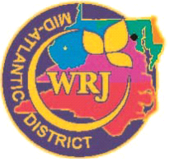WRJ MID-ATLANTIC DISTRICT
Speaker Bureau Request Form

Today’s Date:
Name of Sisterhood: Click here to enter text
City , State Click here to enter text.
Sisterhood President: Click here to enter text.
Phone (xxx-xxx-xxxx): Click here to enter text.
Email: Click here to enter text.
Name of person making request, if not the President: Click here to enter text.
Phone: Click here to enter text.
Email: Click here to enter text.
Desired date of visit: Click here to enter text.
Time needed: Click here to enter text.
Location: Click here to enter text.
Anticipated number of attendees: Click here to enter text.
Type of event? Choose an item.
Is there a particular speaker you are requesting? Click here to enter text.
When did your Sisterhood last have a District Speaker? Click here to enter text.
For what event? Click here to enter text.
When did your Sisterhood last have a WRJ Speaker? Click here to enter text.
For what event? Click here to enter text.

Open Document, Complete the form by tying over the “click here to enter text”, Save to your computer as word document (not a word template), and then email to:
sjacobs1109@gmail.com, Sarah Jacobs

For our records only
The speaker will be:

Contacted on:

