St. Michael and All Angels Episcopal Church
The Episcopal Diocese of Atlanta
Sixth Sunday after the Epiphany
February 12, 2023



OUR PURPOSE AT ST. MICHAEL AND ALL ANGELS

TO CARE FOR OUR CHURCH FAMILY WITH MUTUAL LOVE AND SUPPORT

TO PARTICIPATE, LEARN AND SERVE IN OUR NEIGHBORING COMMUNITIES

TO ENRICH AND SHARE OUR GROWING SPIRITUALITY, RICH DIVERSITY, WELCOMING FELLOWSHIP, JOYFUL WORSHIP AND LOVING CARE

TO INVITE NEIGHBORS INTO OUR CHURCH FAMILY IN OUR COMMITMENT TO SEEK AND SERVE CHRIST IN ALL PERSONS

6780 James B Rivers Drive
Stone Mountain, Georgia 30083
Telephone: 770-469-8551
Email: admin@stmichaelstonemountain.org
Website: www.stmichaelstonemountain.org
Office Hours: Monday-Thursday 9:00 A.M. to 2:00 pm
Father WINSTON’S PHONE Number: 404-386-8833; Call or Text
Holy Eucharist Rite II at 10:30 AM
February 12, 2023
The Ringing of the Bell

All are invited to a time of silence for quiet contemplation and centering

Prelude

Opening Prayer
The Word of God

The Opening Hymn “God of Grace” Hymn 594

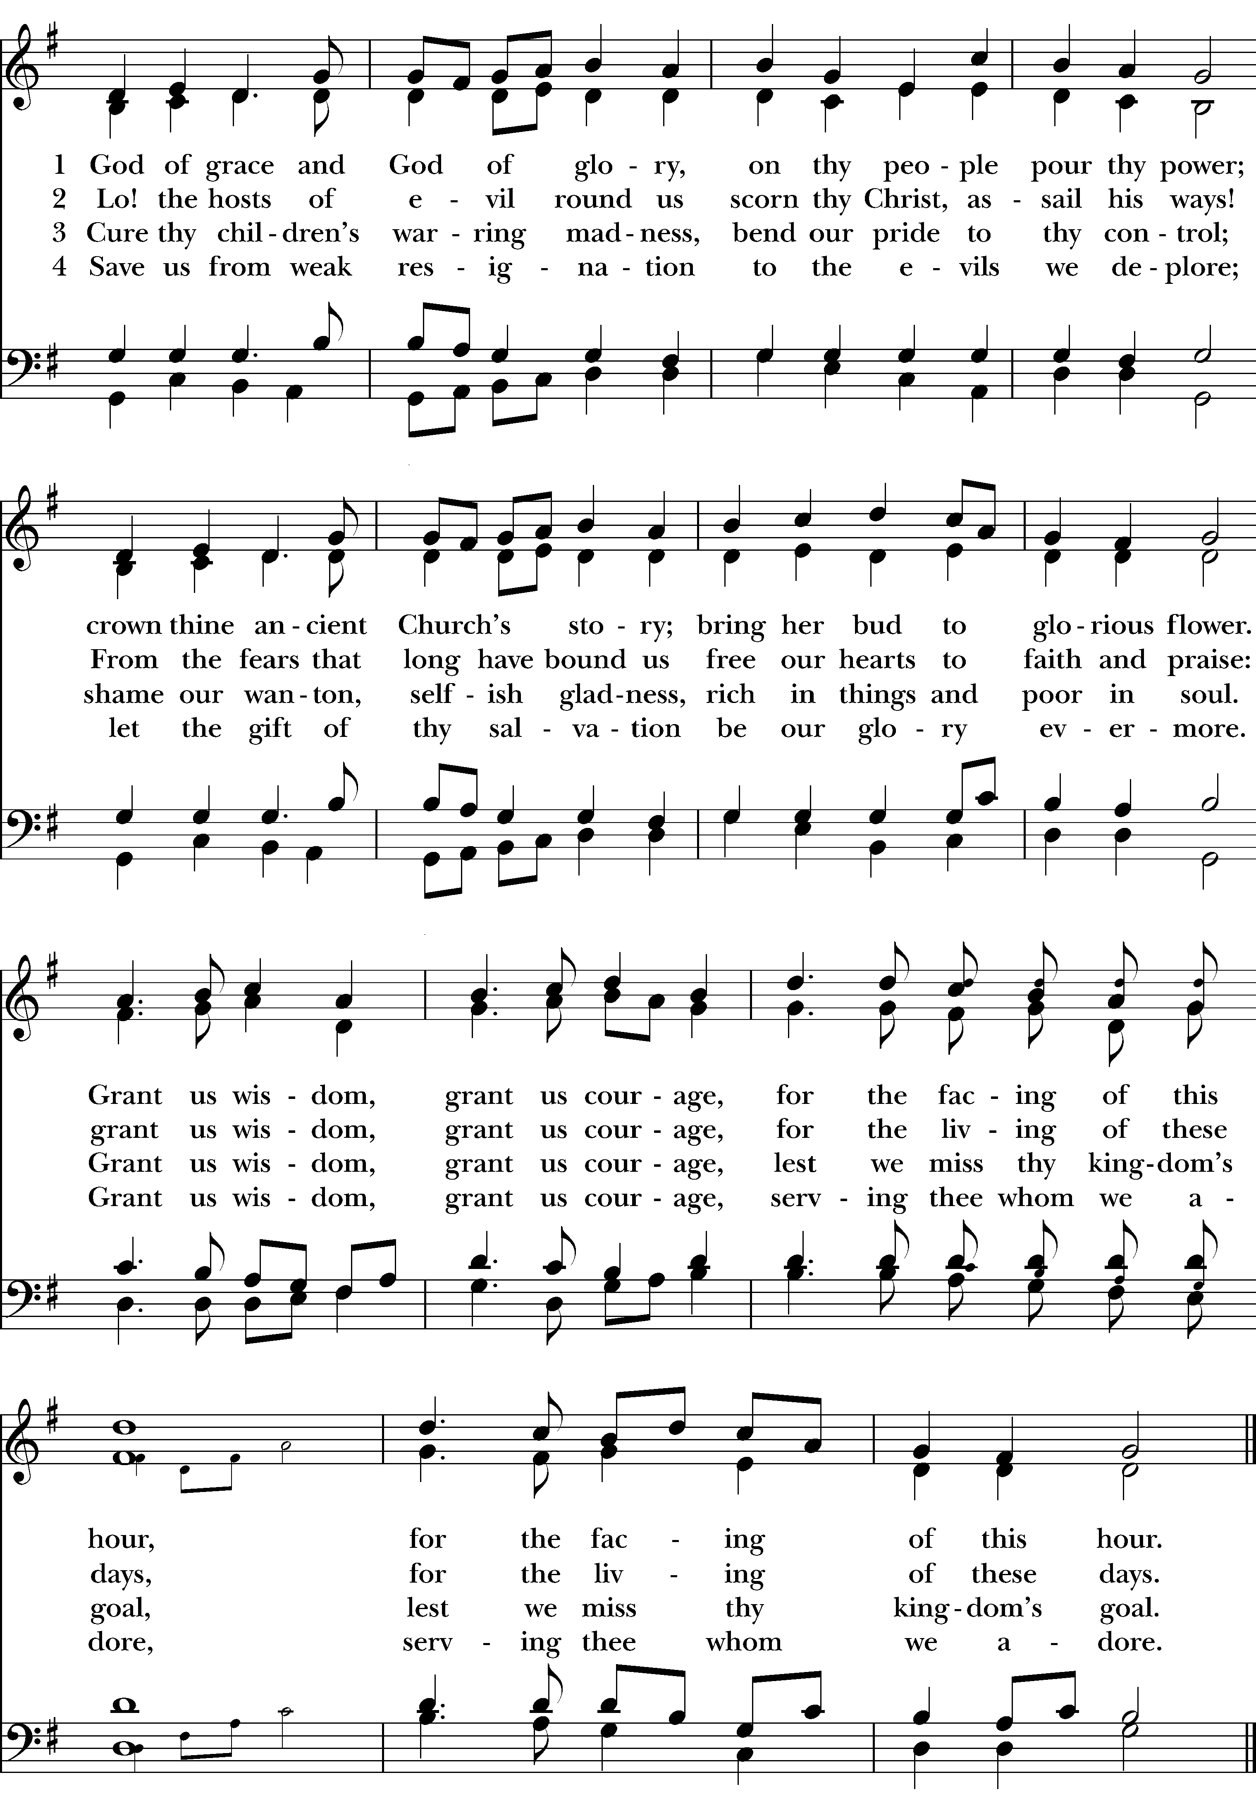

The Opening Acclamation
All stand, as able

Celebrant Blessed be God: Father, Son, and Holy Spirit.
People And Blessed be His Kingdom, now and for ever. Amen.

The Collect for Purity BCP 355
Almighty God, to you all hearts are open, all desires known, and from you no secrets are hid: Cleanse the thoughts of our hearts by the inspiration of your Holy Spirit, that we may perfectly love you and worthily magnify your holy Name; through Christ our Lord. Amen.

The Gloria Hymnal S280

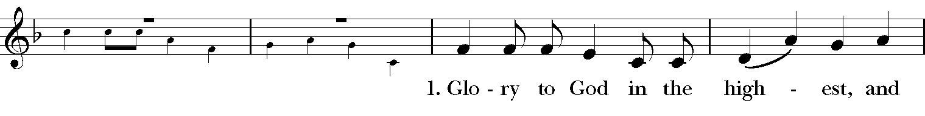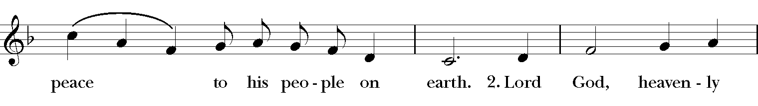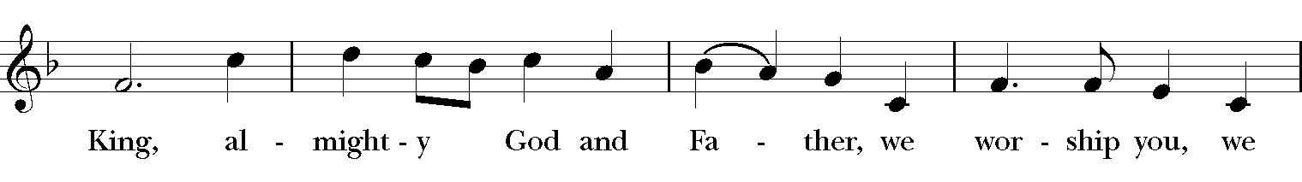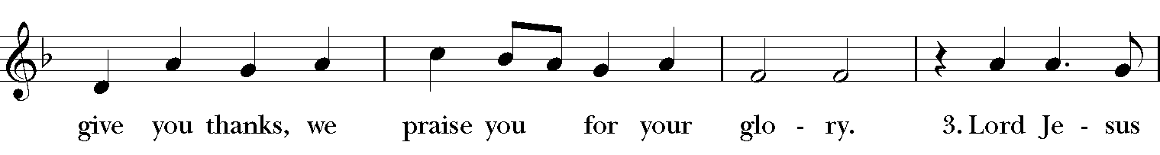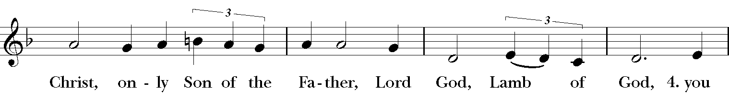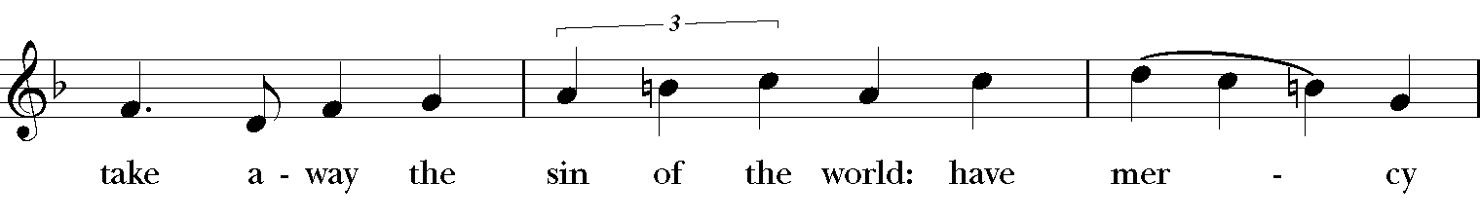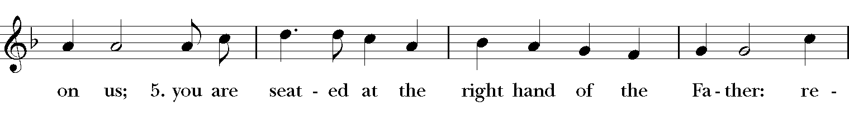
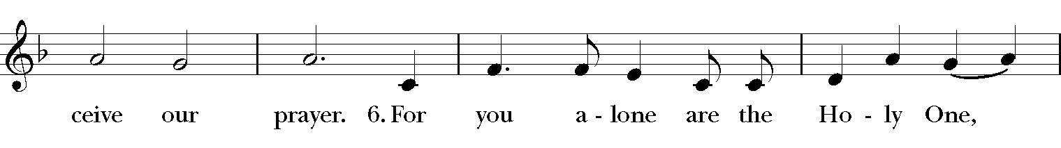
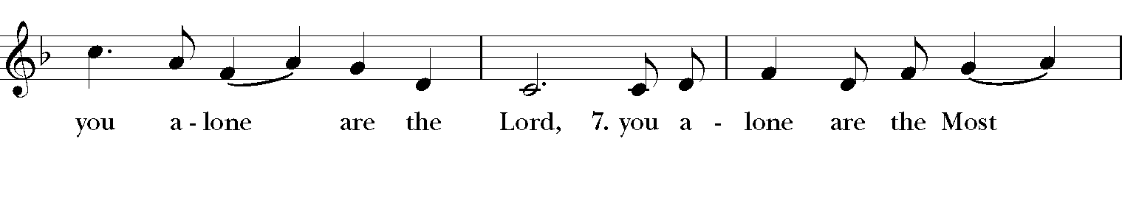
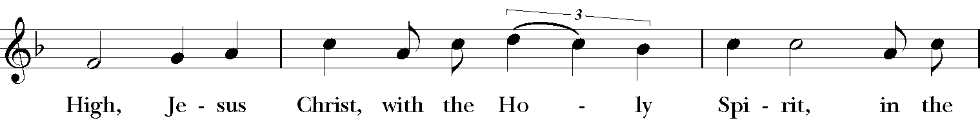
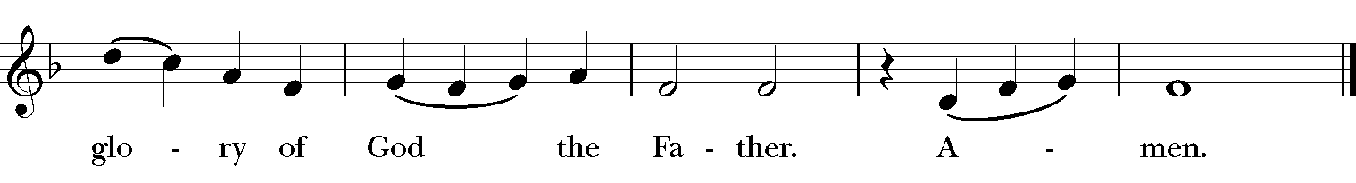

The Collect of the Day

Celebrant The Lord be with you.
People And also, with you.

Celebrant Let us pray.

O God, the strength of all who put their trust in you: Mercifully accept our prayers; and because in our weakness we can do nothing good without you, give us the help of your grace, that in keeping your commandments we may please you both in will and deed; through Jesus Christ our Lord, who lives and reigns with you and the Holy Spirit, one God, for ever and ever. Amen.

Please be seated

The First Lesson Deuteronomy 30:15-20

Moses said, “See, I have set before you today life and prosperity, death and adversity. If you obey the commandments of the Lord your God that I am commanding you today, by loving the Lord your God, walking in his ways, and observing his commandments, decrees, and ordinances, then you shall live and become numerous, and the Lord your God will bless you in the land that you are entering to possess. But if your heart turns away and you do not hear, but are led astray to bow down to other gods and serve them, I declare to you today that you shall perish; you shall not live long in the land that you are crossing the Jordan to enter and possess. I call heaven and earth to witness against you today that I have set before you life and death, blessings and curses. Choose life so that you and your descendants may live, loving the Lord your God, obeying him, and holding fast to him; for that means life to you and length of days, so that you may live in the land that the Lord swore to give to your ancestors, to Abraham, to Isaac, and to Jacob.”

Reader The word of the Lord.
People Thanks be to God.

Psalm: 119:1-8
- Happy are they whose way is blameless, *
who walk in the law of the Lord!
- Happy are they who observe his decrees *
and seek him with all their hearts!
- Who never do any wrong, *
but always walk in his ways.
- You laid down your commandments, *
that we should fully keep them.
- Oh, that my ways were made so direct *
that I might keep your statutes!
- Then I should not be put to shame, *
when I regard all your commandments.

- I will thank you with an unfeigned heart, *
when I have learned your righteous judgments.
- I will keep your statutes; *
do not utterly forsake me.

The Second Lesson 1 Corinthians 3:1-9

Brothers and sisters, I could not speak to you as spiritual people, but rather as people of the flesh, as infants in Christ. I fed you with milk, not solid food, for you were not ready for solid food. Even now you are still not ready, for you are still of the flesh. For as long as there is jealousy and quarreling among you, are you not of the flesh, and behaving according to human inclinations? For when one says, “I belong to Paul,” and another, “I belong to Apollos,” are you not merely human?
What then is Apollos? What is Paul? Servants through whom you came to believe, as the Lord assigned to each. I planted, Apollos watered, but God gave the growth. So neither the one who plants nor the one who waters is anything, but only God who gives the growth. The one who plants and the one who waters have a common purpose, and each will receive wages according to the labor of each. For we are God’s servants, working together; you are God’s field, God’s building.

Reader The word of the Lord.
People Thanks be to God.

Sequence Hymn “Blessed Jesus at Thy Word” Hymn 440
All stand, as able Verses 1-2 before the Gospel, Verse 3 after the Gospel

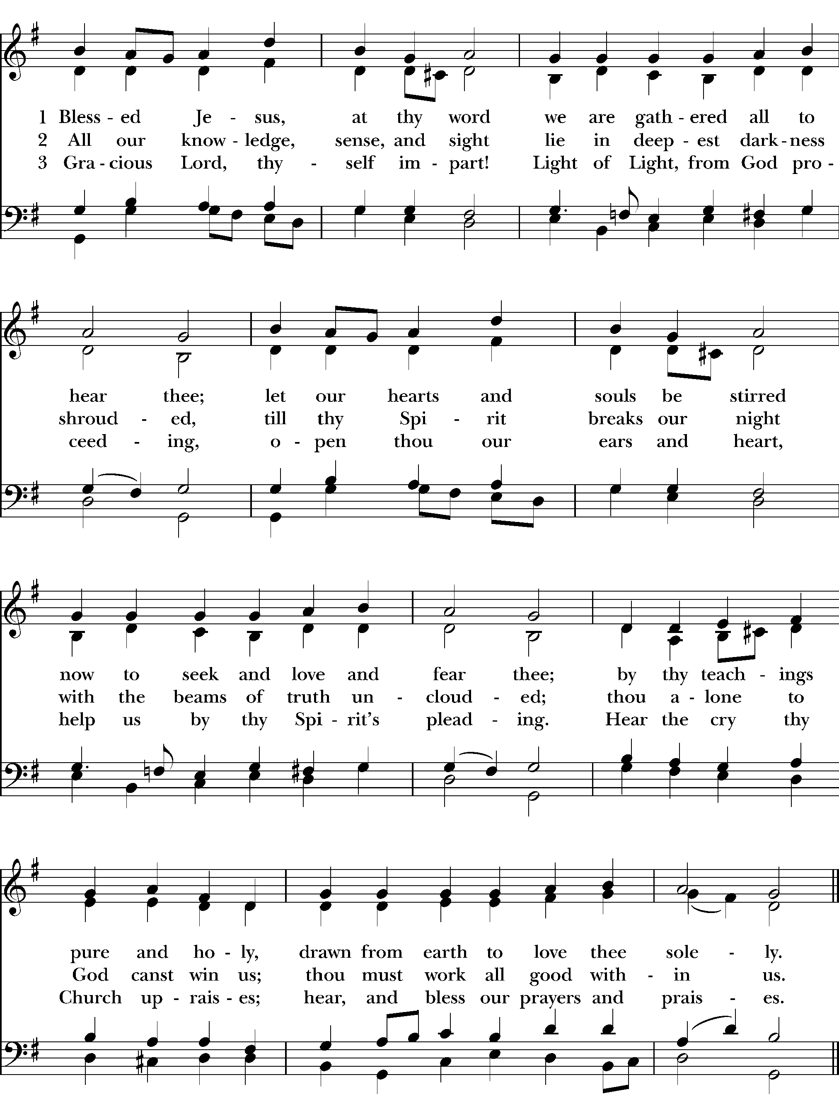

The Gospel Matthew 5:21-37

All stand as able

Gospeler The Holy Gospel of our Lord Jesus Christ according to Matthew.
People Glory be to you, Lord Christ.

Jesus said, “You have heard that it was said to those of ancient times, ‘You shall not murder’; and ‘whoever murders shall be liable to judgment.’ But I say to you that if you are angry with a brother or sister, you will be liable to judgment; and if you insult a brother or sister, you will be liable to the council; and if you say, ‘You fool,’ you will be liable to the hell of fire. So when you are offering your gift at the altar, if you remember that your brother or sister has something against you, leave your gift there before the altar and go; first be reconciled to your brother or sister, and then come and offer your gift. Come to terms quickly with your accuser while you are on the way to court with him, or your accuser may hand you over to the judge, and the judge to the guard, and you will be thrown into prison. Truly I tell you, you will never get out until you have paid the last penny.

“You have heard that it was said, ‘You shall not commit adultery.’ But I say to you that everyone who looks at a woman with lust has already committed adultery with her in his heart. If your right eye causes you to sin, tear it out and throw it away; it is better for you to lose one of your members than for your whole body to be thrown into hell. And if your right hand causes you to sin, cut it off and throw it away; it is better for you to lose one of your members than for your whole body to go into hell.

“It was also said, ‘Whoever divorces his wife, let him give her a certificate of divorce.’ But I say to you that anyone who divorces his wife, except on the ground of unchastity, causes her to commit adultery; and whoever marries a divorced woman commits adultery.

“Again, you have heard that it was said to those of ancient times, ‘You shall not swear falsely, but carry out the vows you have made to the Lord.’ But I say to you, Do not swear at all, either by heaven, for it is the throne of God, or by the earth, for it is his footstool, or by Jerusalem, for it is the city of the great King. And do not swear by your head, for you cannot make one hair white or black. Let your word be ‘Yes, Yes’ or ‘No, No’; anything more than this comes from the evil one.”

Gospeler The Gospel of the Lord.
People Praise to you, Lord Christ.

Please be seated

The Sermon Father Winston Arthur

The Nicene Creed
All stand, as able

We believe in one God,
the Father, the Almighty,
maker of heaven and earth,
of all that is, seen and unseen.
We believe in one Lord, Jesus Christ,
the only Son of God,
eternally begotten of the Father,
God from God, Light from Light,
true God from true God,
begotten, not made,
of one Being with the Father.
Through him all things were made.
For us and for our salvation
he came down from heaven:
by the power of the Holy Spirit
he became incarnate from the Virgin Mary,
and was made man.
For our sake he was crucified under Pontius Pilate;
he suffered death and was buried
On the third day he rose again
in accordance with the Scriptures;
he ascended into heaven
and is seated at the right hand of the Father.
He will come again in glory to judge the living and the dead,
and his kingdom will have no end.
We believe in the Holy Spirit, the Lord,
the giver of life,
who proceeds from the Father and the Son.
With the Father and the Son he is worshiped
and glorified.
He has spoken through the Prophets.
We believe in one holy catholic and apostolic Church.
We acknowledge one baptism for the forgiveness of sins.
We look for the resurrection of the dead,
and the life of the world to come. Amen.

The Prayers of the People

Reader Happy are they who walk in the law of the Lord! So let come before the Lord, saying, “Righteous God, direct our ways.”

Lord our God, bless your Church. May those who plant and those we water recognize their common purpose. Give abundant growth where your Church labors faithfully.

Silence
Righteous God,

People Direct our ways.

Reader Lord our God, bless the people of this and every nation. Draw nations and leaders to choose those ways that promote life and not death.

Silence
Righteous God,

People Direct our ways.

Reader Lord our God, bless this planet – your very footstool. Give us wisdom and will to allow the earth to prosper as you have intended – naturally bringing forth growth and prosperity.
Invite the congregation to add their thanksgivings, followed by silence.

Righteous God,

People Direct our ways.

Reader Lord our God, bless our city. Give us those things we need to live together as neighbors. Remove from our hearts anger, discord, and lust.

Silence
Righteous God,

People Direct our ways.

Reader Lord our God, bless the sick and the struggling. May they find life in relationship with you. Make them happy as they seek you with all their hearts.

(Let us engage in a moment of quiet contemplation as we silently pray for the following names)
Jaye, Seth, Corey, Raymond, River P., Jamal, Gideon M., Richelle B., The Bynoe Family, Kelsey T., Rohan D., Shauna, Rachel, Sonia A., Carlos A., Paulette C., Joyce E., Thelma M., Karia, Gossett, Jataun, Angela, Clemson, Errol, Barbara P., Edwards, Marcia, Althea, Fronie, Velita, Jackie, Pauline, Kerri, Kaneez, Shahid, Olando, Rick, Trevon, Venita, Basmattie, Floyd, Christine, Dorothy, George, Annie, Ruth, Reece, Ladan, Morris, Deng, Marlene, Deneen, Faye, Ann, Joanne, Bill, Linda, Shaista, Suleman, Naveed, Ardonous, Edna, Royan, Cherrie, Joyce R., Bob, Howard, Jennifer, Yannick, Fatima, Barbara, Beverly, The Episcopal Church in the Philippines, the people of South Sudan, the people of Ukraine, for those suffering from Covid-19 and for all those who in this transitory life, are in trouble, sorrow, need, sickness, or any other adversity, and for the special needs and concerns of this congregation.

Invite the congregation to add their petitions, followed by silence

Righteous God,

People Direct our ways.

Reader Lord our God, bless the dying and the dead. May they find peace and comfort at the foot of your heavenly throne.

Silence
Righteous God,

People Direct our ways.

Grant these our prayers, O Father, for Jesus Christ’s sake our only Mediator and Advocate. Amen

The Confession of Sin BCP 360
Celebrant Let us confess our sins against God and our neighbor.

Celebrant and People

Most merciful God, we confess that we have sinned against you in thought, word, and deed, by what we have done, and by what we have left undone. We have not loved you with our whole heart; we have not loved our neighbors as ourselves. We are truly sorry and we humbly repent. For the sake of your Son Jesus Christ, have mercy on us and forgive us; that we may delight in your will, and walk in your ways, to the glory of your Name. Amen.

The Absolution
Almighty God have mercy on you, forgive you all your sins through our Lord Jesus Christ, strengthen you in all goodness, and by the power of the Holy Spirit keep you in eternal life. Amen.
The Peace
Celebrant The peace of the Lord be always with you.
People And also with you.

Offertory “Come Unto Me and Wait”

THE GREAT THANKSGIVING

The Doxology Tune: "Old 100th"
Celebrant and People
Praise God, from Whom all blessings flow;
Praise Him, all creatures here below;
Praise Him above, ye heav’nly host;
Praise Father, Son, and Holy Ghost. Amen.

The Great Thanksgiving: Eucharistic Prayer A BCP 361
All stand, as able
Celebrant The Lord be with you.
People And also with you.
Celebrant Lift up your hearts.
People We lift them to the Lord.
Celebrant Let us give thanks to the Lord our God.
People It is right to give our thanks and praise.

Then, facing the Holy Table, the Celebrant proceeds
Celebrant
It is right, and a good and joyful thing, always and everywhere to give thanks to you, Father
Almighty, Creator of heaven and earth
Therefore we praise you, joining our voices with Angels and Archangels and with all the company of heaven, who for ever sing this hymn to proclaim the glory of your Name:
The Sanctus: Holy, Holy, Holy from Lift Every Voice and Sing 255

Holy, holy, holy, holy, Holy Lord God of hosts.
Heaven and earth are filled with your glo-ry. Hosanna in the high-est.
Blessed is He who comes in the name
Of the Lord, of the Lord.
Ho-sanna in the high-est, Ho-sanna in the high-est.
The Celebrant continues
Holy and gracious Father: In your infinite love you made us for yourself, and, when we had fallen into sin and become subject to evil and death, you, in your mercy, sent Jesus Christ, your only and eternal Son, to share our human nature, to live and die as one of us, to reconcile us to you, the God and Father of all.
He stretched out his arms upon the cross, and offered himself, in obedience to your will, a perfect sacrifice for the whole world.
At the following words concerning the bread, the Celebrant is to hold it, or lay a hand upon it, and at the words concerning the cup, to hold or place a hand upon the cup and any other vessel containing wine to be consecrated.
On the night he was handed over to suffering and death, our Lord Jesus Christ took bread; and when he had given thanks to you, he broke it, and gave it to his disciples, and said, "Take, eat: This is my Body, which is given for you. Do this for the remembrance of me."
After supper he took the cup of wine; and when he had given thanks, he gave it to them, and said, "Drink this, all of you: This is my Blood of the new Covenant, which is shed for you and for many for the forgiveness of sins. Whenever you drink it, do this for the remembrance of me."
Therefore we proclaim the mystery of faith:
Celebrant and People Christ has died. Christ has risen. Christ will come again.
The Celebrant continues

We celebrate the memorial of our redemption, O Father, in this sacrifice of praise and thanksgiving. Recalling his death, resurrection, and ascension, we offer you these gifts.
Sanctify them by your Holy Spirit to be for your people the Body and Blood of your Son, the holy food and drink of new and unending life in him. Sanctify us also that we may faithfully receive this holy Sacrament, and serve you in unity, constancy, and peace; and at the last day bring us with all your saints into the joy of your eternal kingdom.
All this we ask through your Son Jesus Christ: By him, and with him, and in him, in the unity of the Holy Spirit all honor and glory is yours, Almighty Father, now and for ever. Amen.

And now, as our Savior Christ has taught us, we are bold to say,

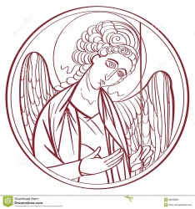
The Lord’s Prayer
Our Father, who art in heaven,
hallowed be thy Name,
thy kingdom come,
thy will be done, on earth as it is in heaven.
Give us this day our daily bread.
And forgive us our trespassess,

As we forgive those
who trespass against us
And lead us not into temptation,
but deliever us from evil.
For thine is the kingdom, and the power,
and the glory for ever and ever. Amen

The Breaking of the Bread
Celebrant Alleluia. Christ our Passover is sacrificed for us.
People Therefore let us keep the feast. Alleluia.

The Fraction Anthem Celebrant and People

Lamb of God (sung by all) Tune: Beach Spring Setting: Carla Strott

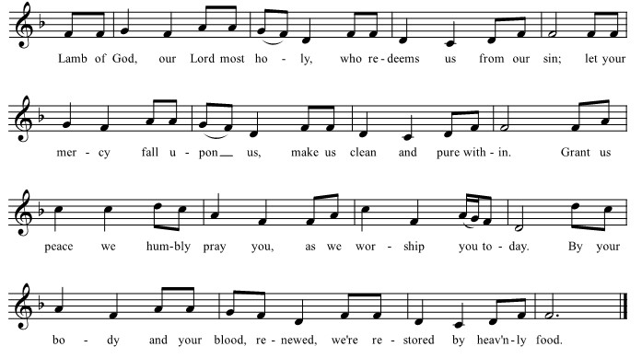

The Invitation
The gifts of God for the people of God. Take them in remembrance that Christ died for you, and feed on him in your hearts by faith, with thanksgiving.

The Communion of the People
All God’s people are welcome to share in the banquet of the Holy Eucharist, in one kind. If you prefer to receive a blessing instead of Communion, cross your hands across your chest.

The Communion Hymn “My God, Thy Table Now is Spread” Hymn 593

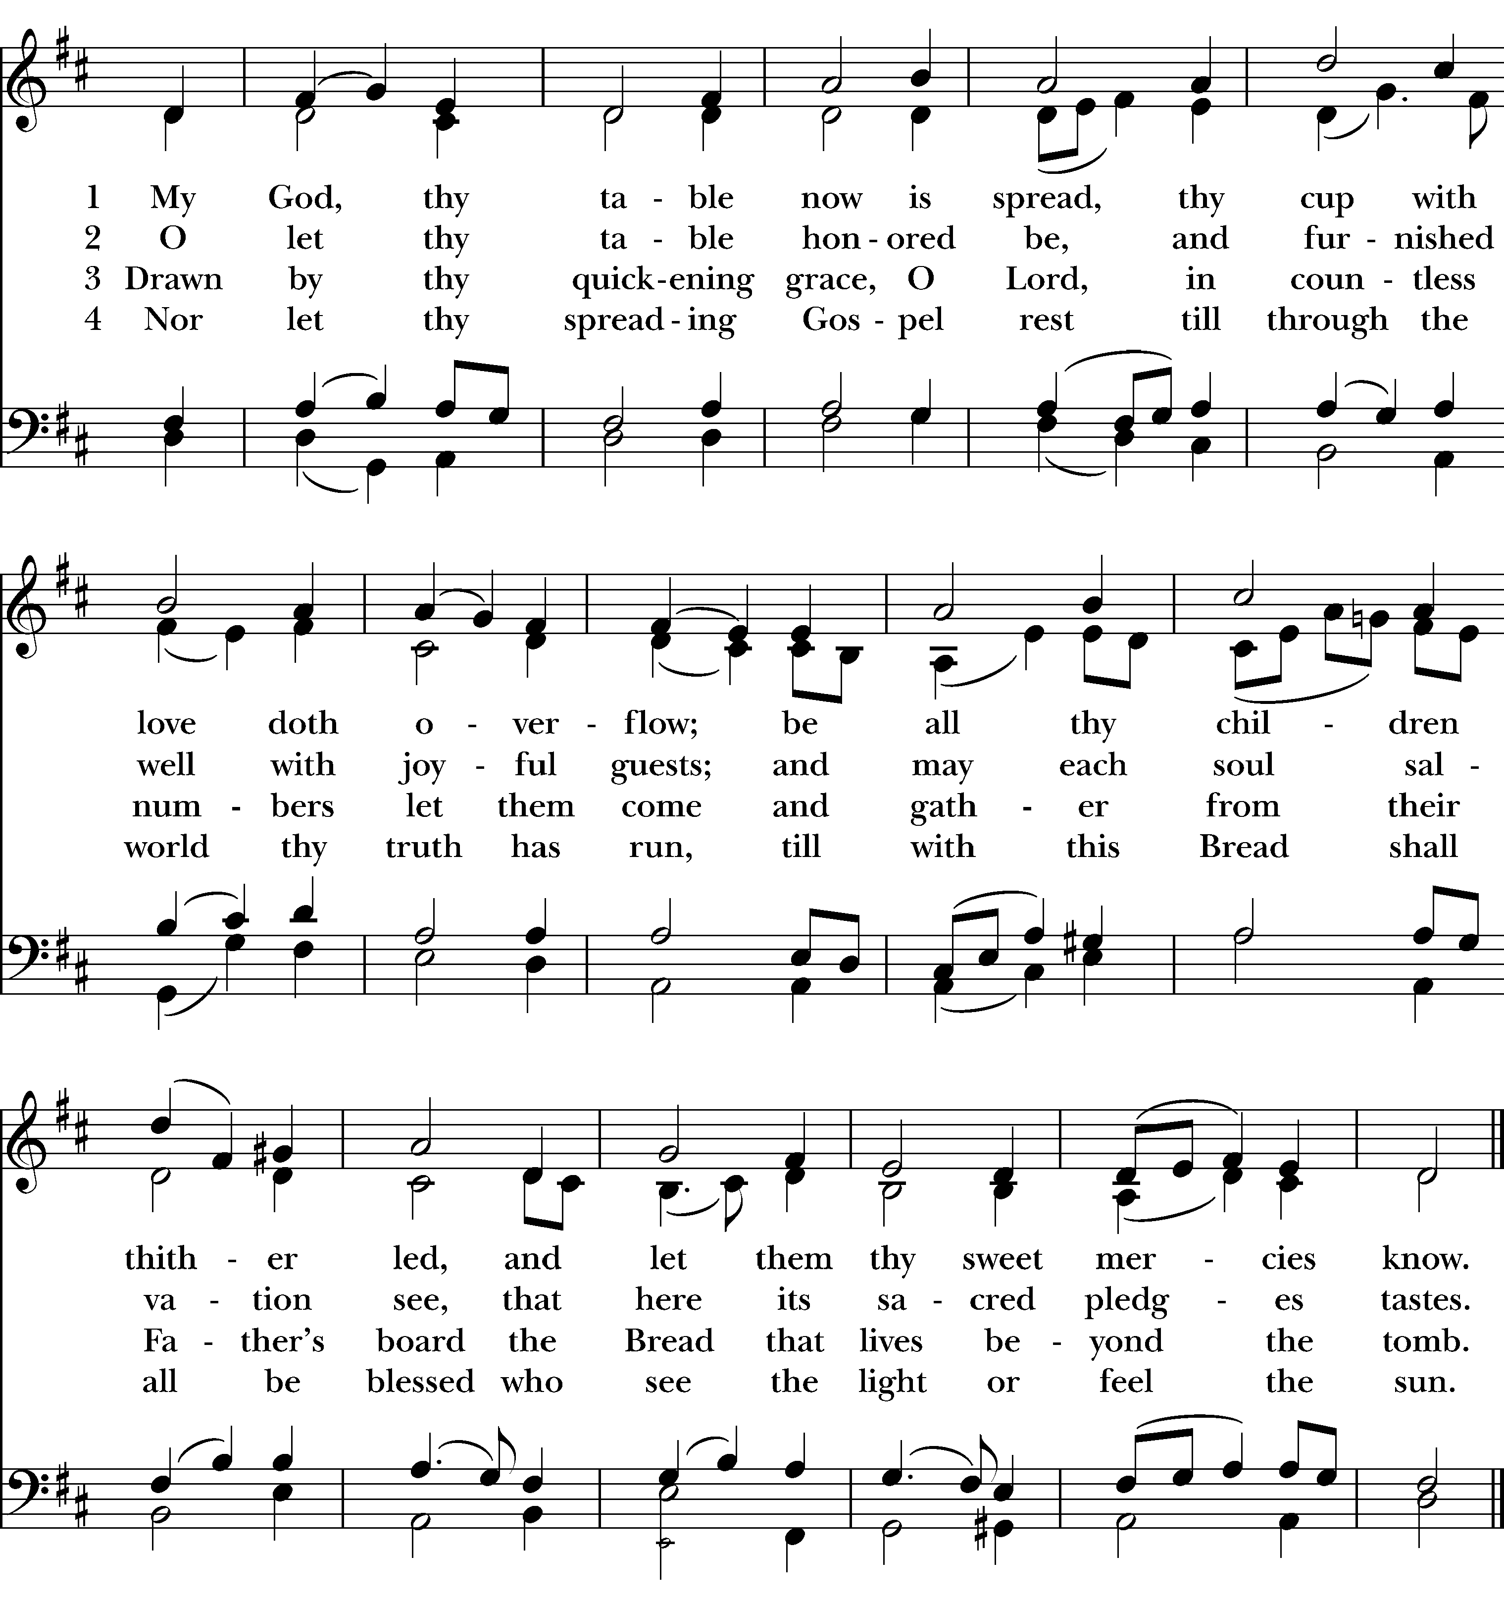

“I come with joy to meet my Lord” LEVAS 157
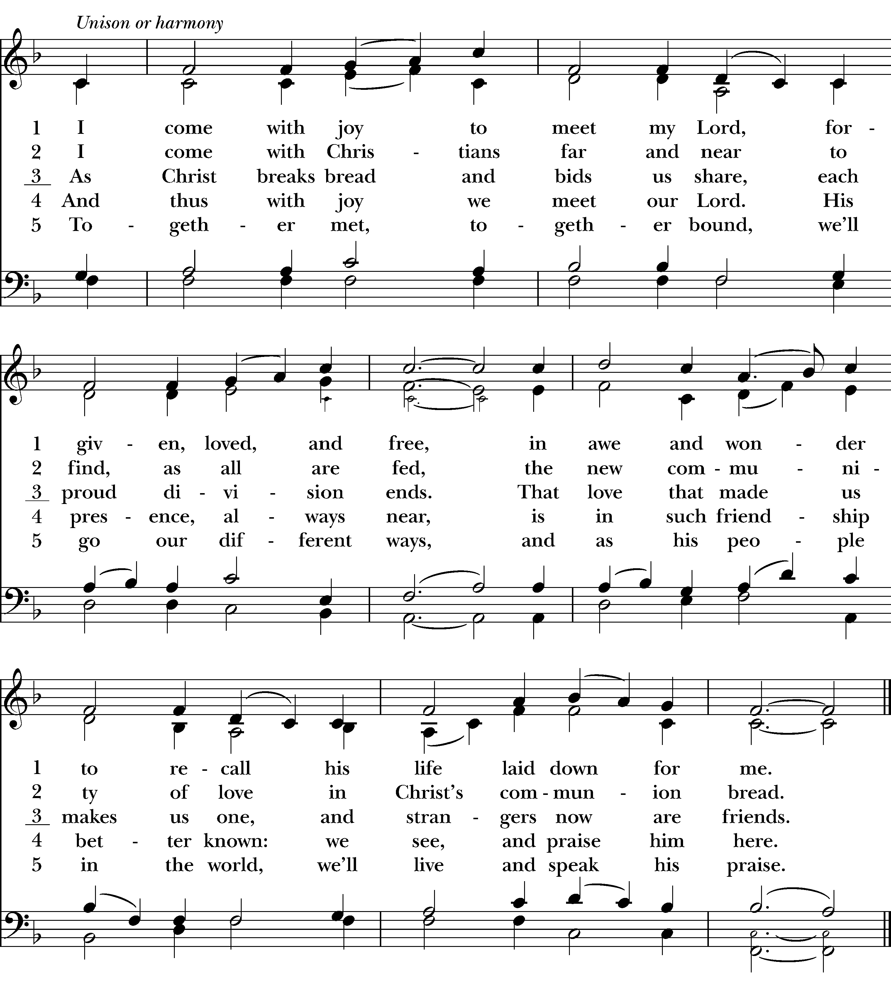

“Lead me, Guide Me” LEVAS 194
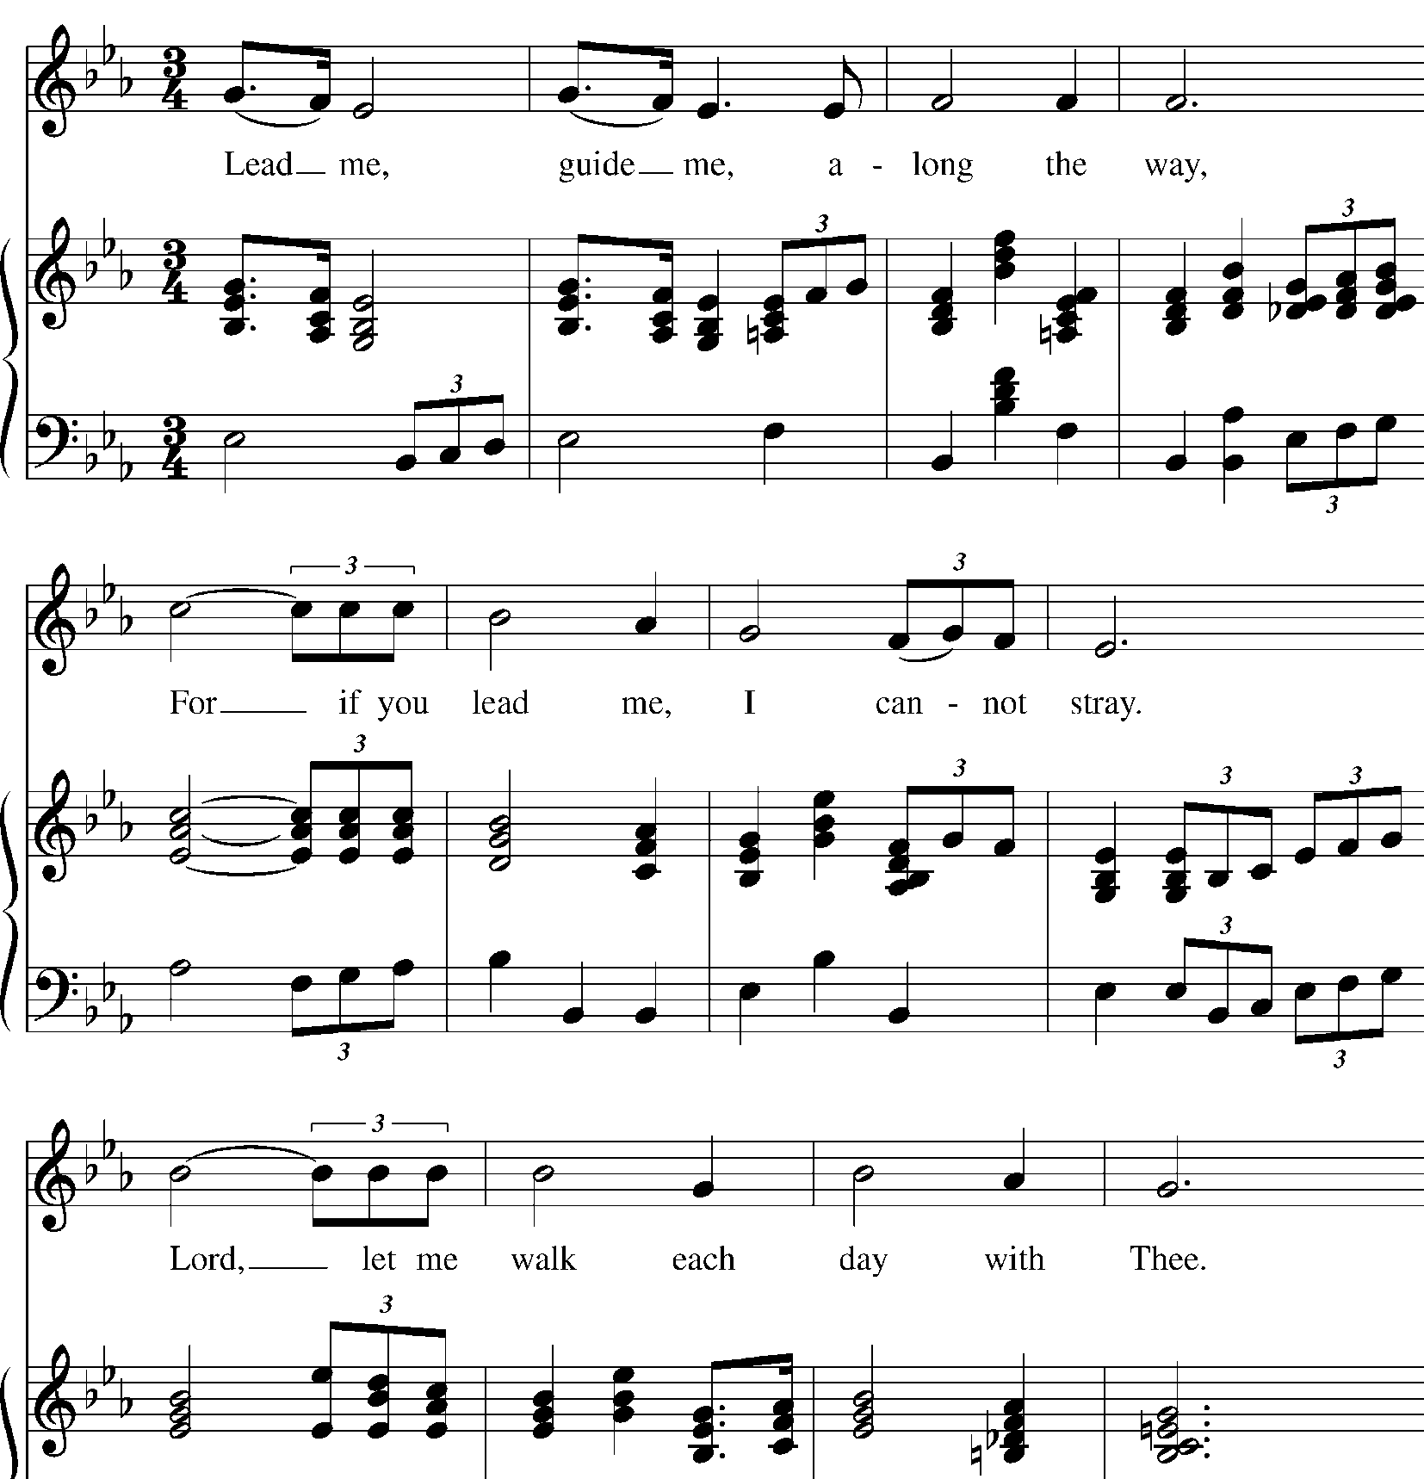

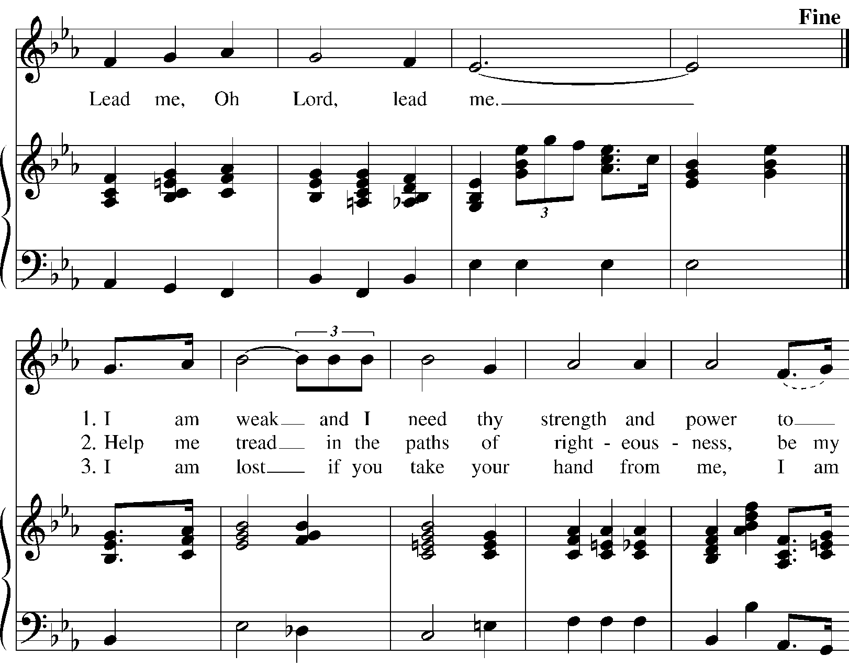

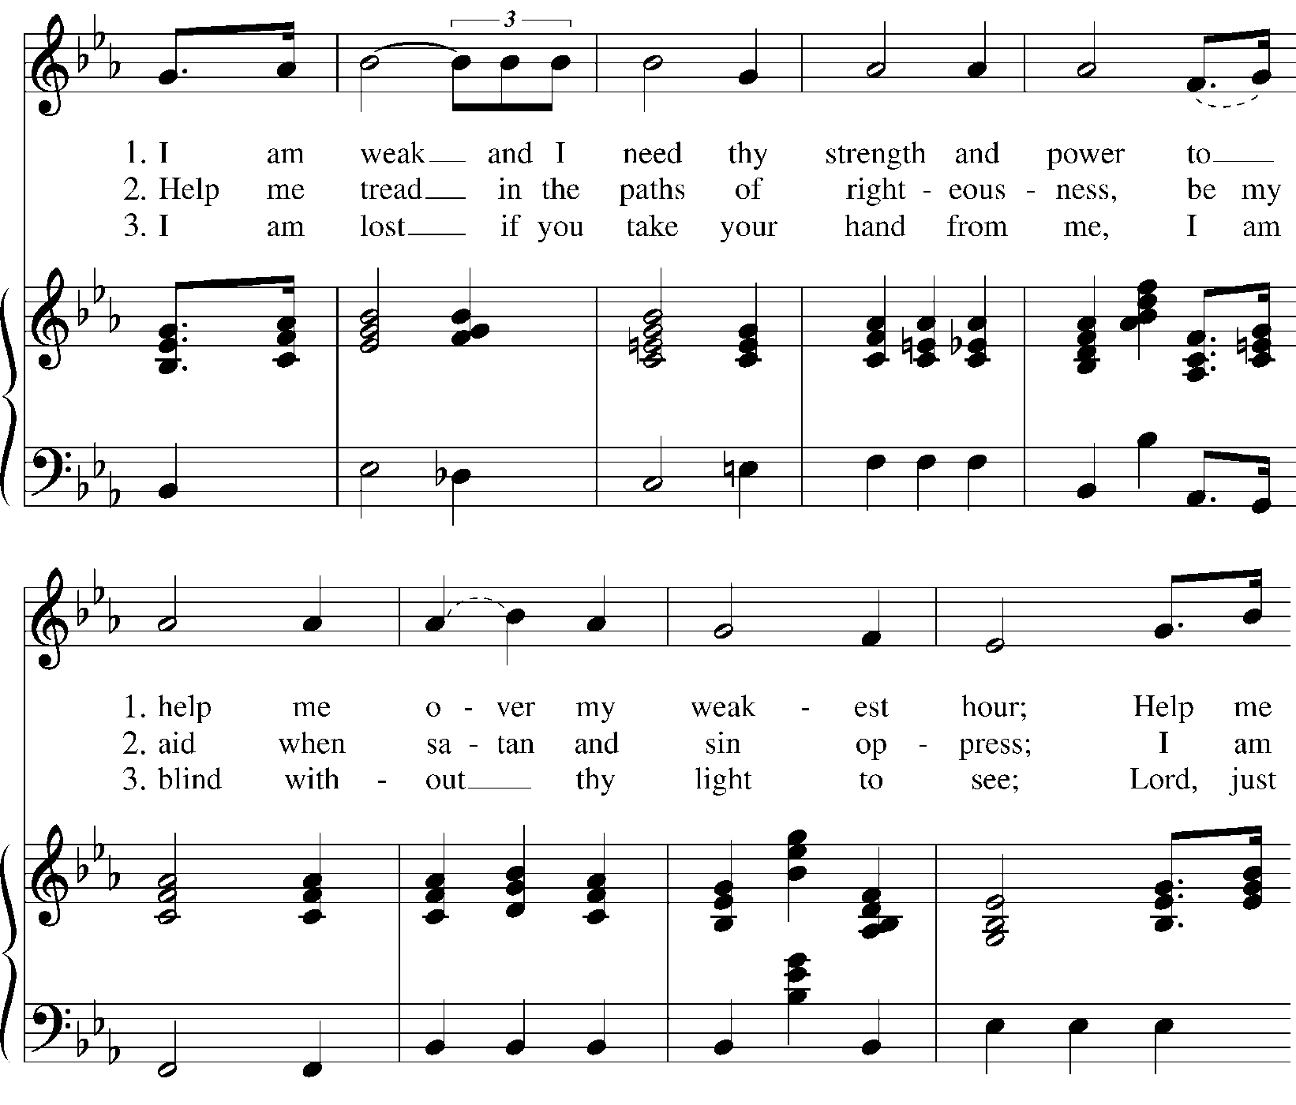

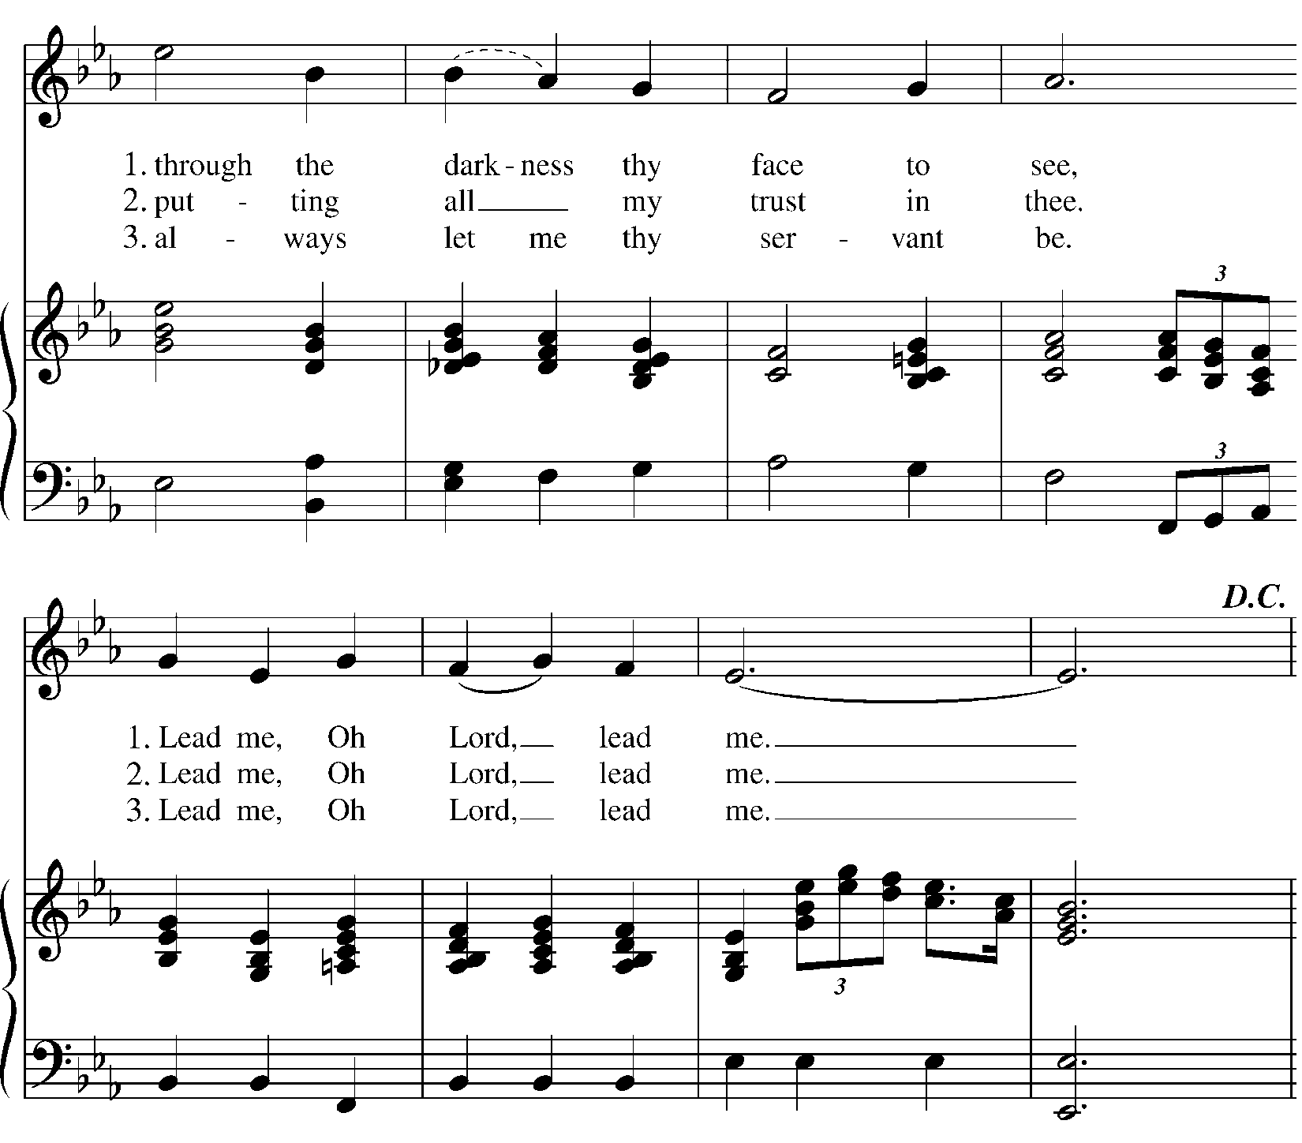
The Post Communion Prayer

Eternal God, heavenly Father, you have graciously accepted us as living members of your Son our Savior Jesus Christ, and you have fed us with spiritual food in the sacrament of his Body and Blood. Send us now into the world in peace, and grant us strength and courage to love and serve you with gladness and singleness of heart; through Christ our Lord. Amen.

The Blessing

Finally, beloved, whatever is true, whatever is honorable, whatever is just, whatever is pure, whatever is pleasing, whatever is commendable, if there is any excellence and if there is anything worthy of praise, think about these things; and the blessing of God Almighty, the Father, the Son, and the Holy Ghost, be amongst you, and remain with you always. Amen.

At the Procession into the World

The Closing Hymn “Lead us Heavenly Father” Hymn 559
Sung to the tune of hymn 595- Mannham

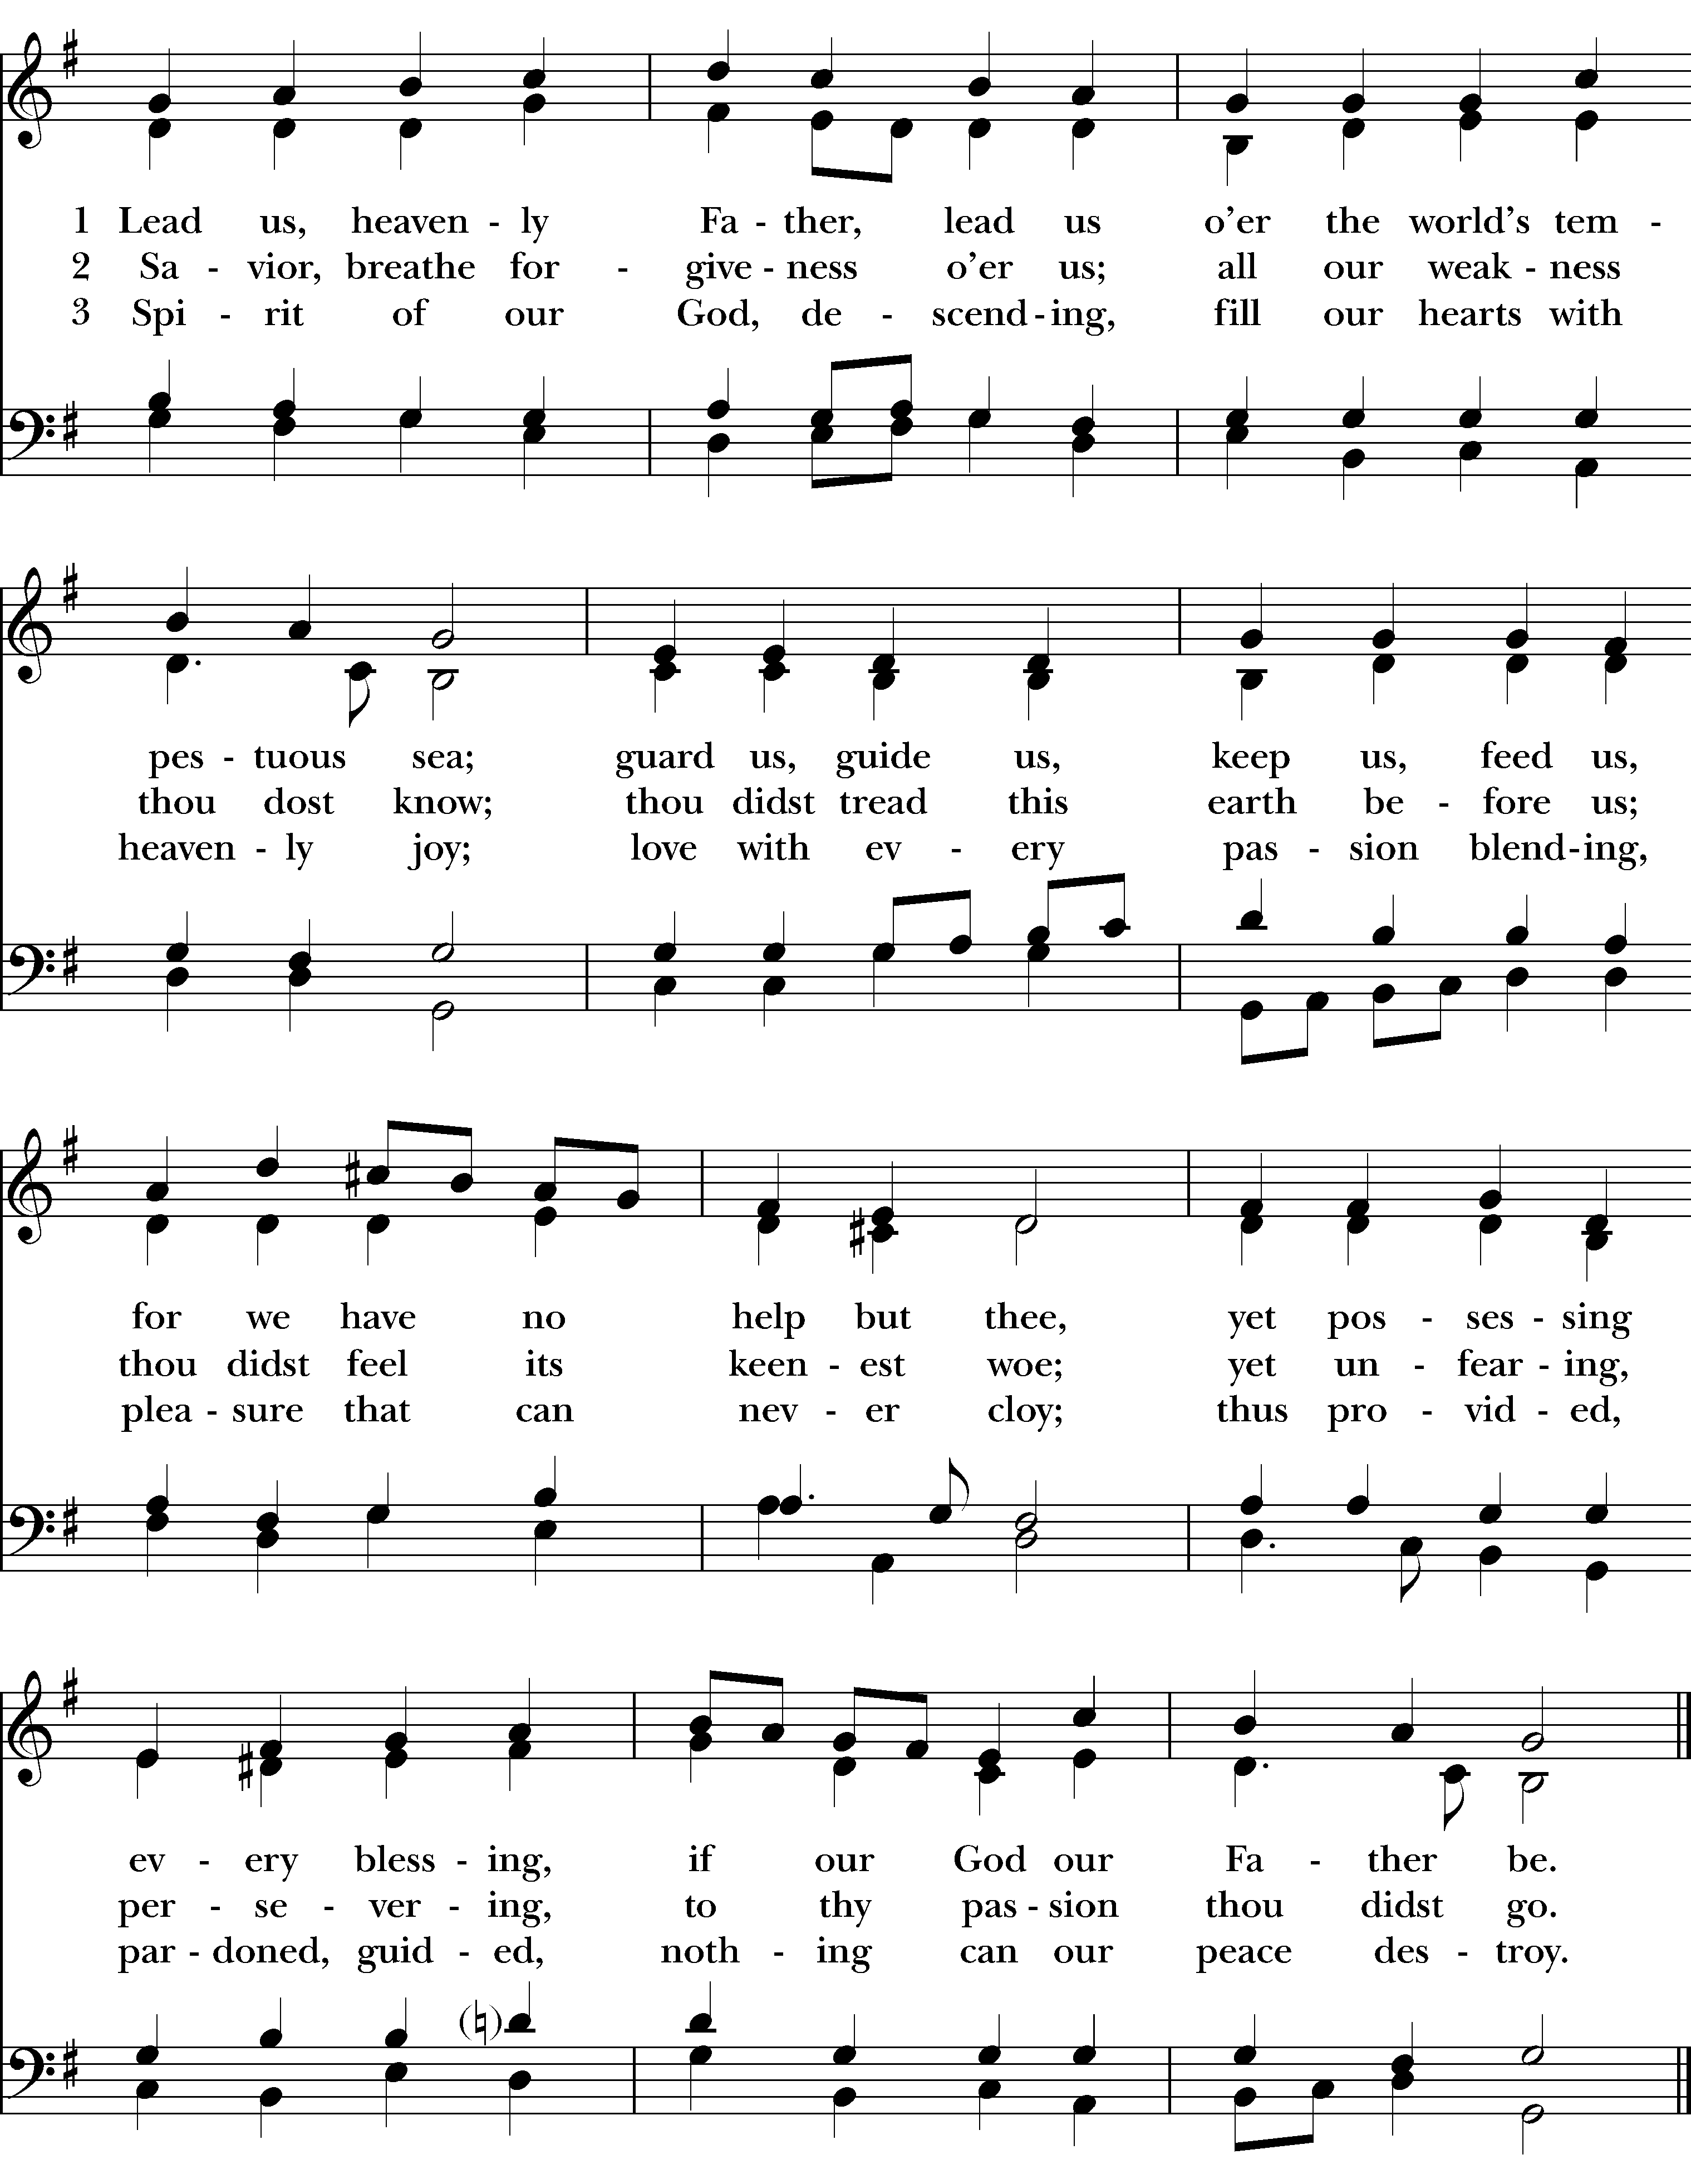

The Dismissal
Celebrant Let us go forth into the world rejoicing in the power of the Spirit. Alleluia, Alleluia.
People Thanks be to God. Alleluia, Alleluia!

Postlude

Copyright Permissions
Permission to print and stream music in this service obtained from ONE LICENSE # A-715408.
All rights reserved.

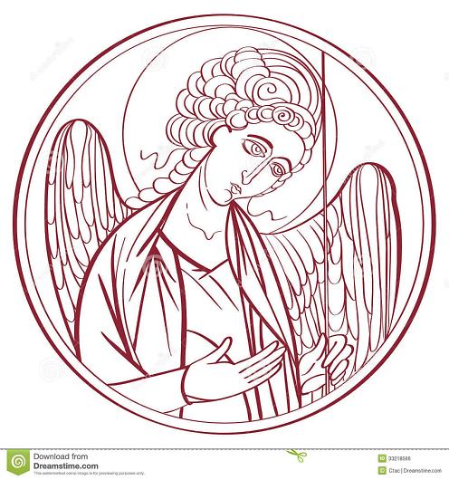

The Mission of the Church is the Mission of Christ
(The Five Marks of Mission)
Tell • To proclaim the Good News of the Kingdom.
Teach • To teach, baptize and nurture new believers.
Tend • To respond to human need by loving service.
Transform • To seek to transform unjust structures of society,
to challenge violence of every kind and to pursue peace and
reconciliation.
Treasure • To strive to safeguard the integrity of creation and
sustain and renew the life of the earth.

Rector – Father R. Winston Arthur
Deacon – Rev Florence Mitchell
Choir Director – Dawn-Marie James
Organist -Dr Richard Beckford
Finance Clerk – Charlene Smith
Postulate- Caroline Carter
Seminarian- Cheyne Collier
Custodian – John Lam
Parish Administrators – Heather Cutting and Sydney Tye

