St. Michael and All Angels Episcopal Church
The Episcopal Diocese of Atlanta
Thirteenth Sunday After Pentecost
September 04, 2022



OUR PURPOSE AT ST. MICHAEL AND ALL ANGELS

TO CARE FOR OUR CHURCH FAMILY WITH MUTUAL LOVE AND SUPPORT

TO PARTICIPATE, LEARN AND SERVE IN OUR NEIGHBORING COMMUNITIES

TO ENRICH AND SHARE OUR GROWING SPIRITUALITY, RICH DIVERSITY, WELCOMING FELLOWSHIP, JOYFUL WORSHIP AND LOVING CARE

TO INVITE NEIGHBORS INTO OUR CHURCH FAMILY IN OUR COMMITMENT TO SEEK AND SERVE CHRIST IN ALL PERSONS

6780 James B Rivers Drive
Stone Mountain, Georgia 30083
Telephone: 770-469-8551
Email: admin@stmichaelstonemountain.org
Website: www.stmichaelstonemountain.org
Office Hours: Monday-Thursday 9:00 A.M. to 2:00 P.M.
Father Winston’s Phone Number: 404-386-8833; call or text.

Holy Eucharist Rite II at 10:30 am
September 04, 2022

The Ringing of the Bell

All are invited to a time of silence for quiet contemplation and centering

Prelude Choir introduction to the hymn “Search, O My God”

Opening Prayer
The Word of God

The Opening Hymn “Not here, for high and holy things” Hymnal 9

- Not here for high and holy things
we render thanks to thee,
but for the common things of earth,
the purple pageantry
of dawning and of dying days,
the splendor of the sea,

- Awake, awake to love and work!
The lark is in the sky,
the fields are wet with diamond dew,
the worlds awake to cry
their blessings on the Lord of life,
as he goes meekly by.

- Come, let thy voice be one with theirs,
shout with their shout of praise;
see how the giant sun soars up,
great lord of years and days!
So let the love of Jesus come
and set thy soul ablaze,

- to give and give, and give again,
what God hath given thee;
to spend thyself nor count the cost;
to serve right gloriously
the God who gave all worlds that are,
and all that are to be.

Geoffrey Anketel Studdert-Kennedy (1883-1929)
These words are in the public domain.

Opening Acclamation

All stand, as able
Celebrant Blessed be God, Father, Son and Holy Spirit
People And Blessed be His Kingdom, now and forever. Amen

The Collect for Purity BCP 355
Almighty God, to you all hearts are open, all desires known, and from you no secrets are hid: Cleanse the thoughts of our hearts by the inspiration of your Holy Spirit; that we may perfectly love you, and worthily magnify your holy Name; through Christ our Lord. Amen.

The Gloria Hymnal S-280
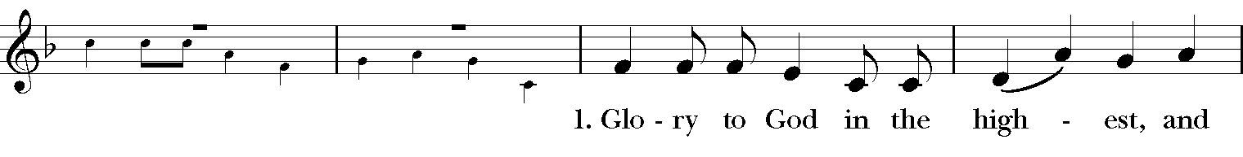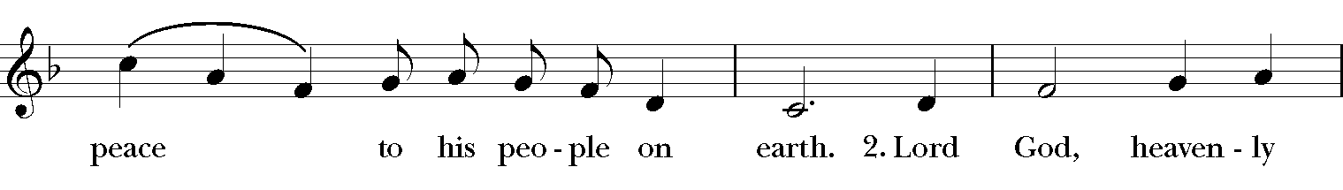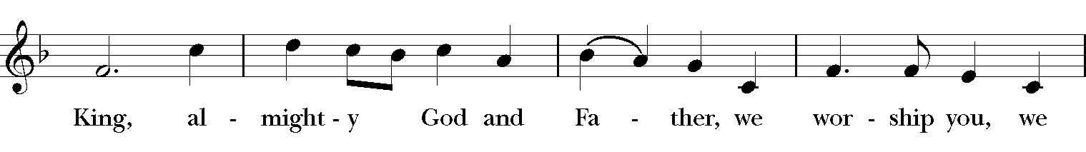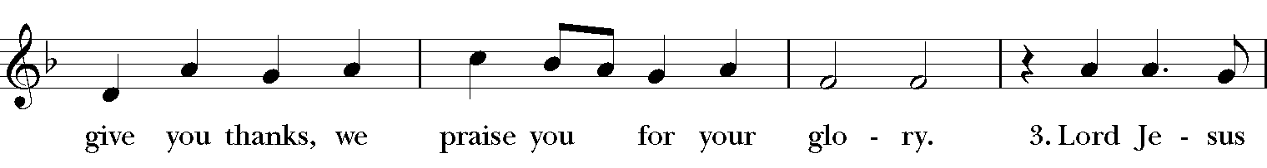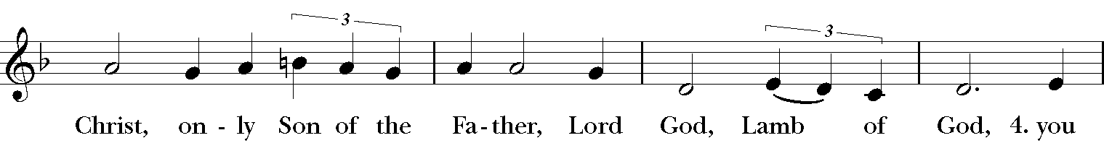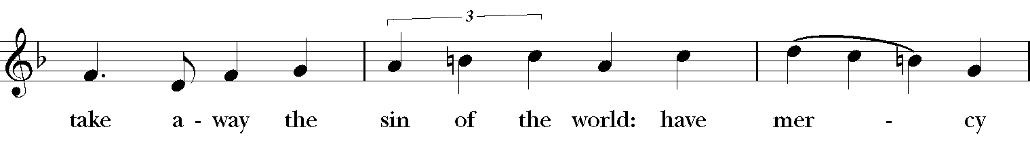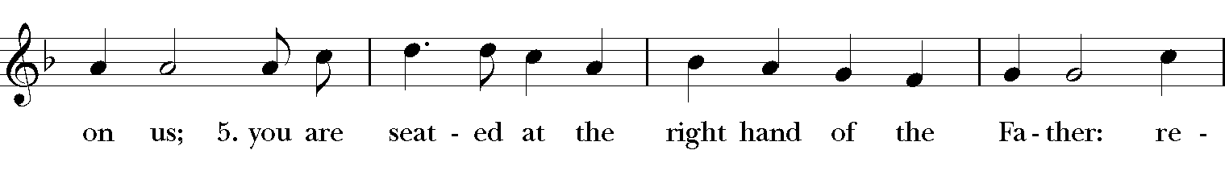
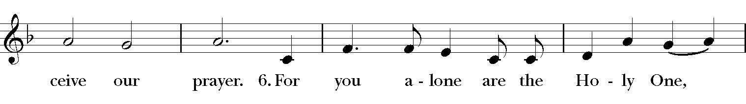
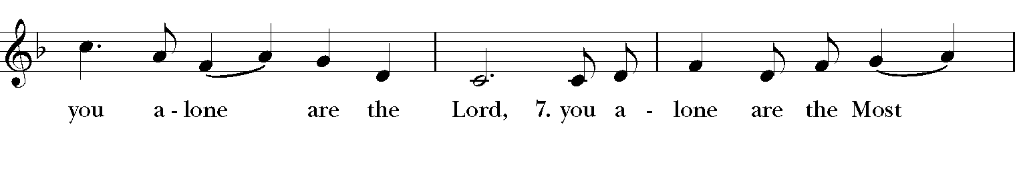
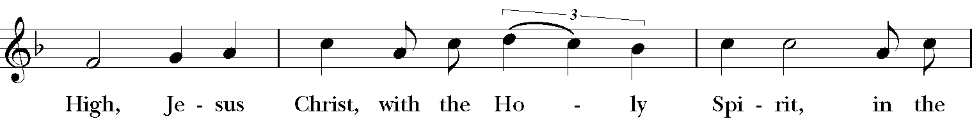
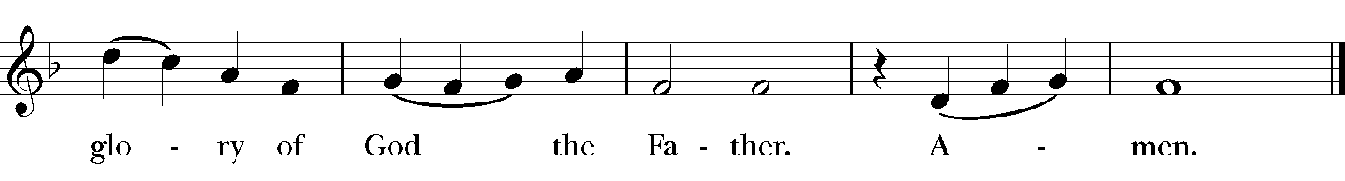

The Collect of the Day

Celebrant: The Lord be with you.
People: And also, with you.

Celebrant: Let us pray.
Grant us, O Lord, to trust in you with all our hearts; for, as you always resist the proud who confide in their own strength, so you never forsake those who make their boast of your mercy; through Jesus Christ our Lord, who lives and reigns with you and the Holy Spirit, one God, now and for ever. Amen.
The First Lesson Deuteronomy 30:15-2
Moses said to all Israel the words which the Lord commanded him, "See, I have set before you today life and prosperity, death and adversity. If you obey the commandments of the Lord your God that I am commanding you today, by loving the Lord your God, walking in his ways, and observing his commandments, decrees, and ordinances, then you shall live and become numerous, and the Lord your God will bless you in the land that you are entering to possess. But if your heart turns away and you do not hear, but are led astray to bow down to other gods and serve them, I declare to you today that you shall perish; you shall not live long in the land that you are crossing the Jordan to enter and possess. I call heaven and earth to witness against you today that I have set before you life and death, blessings and curses. Choose life so that you and your descendants may live, loving the Lord your God, obeying him, and holding fast to him; for that means life to you and length of days, so that you may live in the land that the Lord swore to give to your ancestors, to Abraham, to Isaac, and to Jacob."
Reader: The Word of the Lord.
People: Thanks be to God.

Psalm 139
Lord, you have searched me out and known me; *
you know my sitting down and my rising up;
you discern my thoughts from afar.
You trace my journeys and my resting-places *
and are acquainted with all my ways.
Indeed, there is not a word on my lips, *
but you, O Lord, know it altogether.
You press upon me behind and before *
and lay your hand upon me.
Such knowledge is too wonderful for me; *
it is so high that I cannot attain to it.
For you yourself created my inmost parts; *
you knit me together in my mother's womb.
I will thank you because I am marvelously made; *
your works are wonderful, and I know it well.
My body was not hidden from you, *
while I was being made in secret
and woven in the depths of the earth.
Your eyes beheld my limbs, yet unfinished in the womb;
all of them were written in your book; *
they were fashioned day by day,
when as yet there was none of them.
How deep I find your thoughts, O God! *
how great is the sum of them!
If I were to count them, they would be more in number than the sand; *
to count them all, my life span would need to be like yours.

The Second Lesson Philemon 1-21
Paul, a prisoner of Christ Jesus, and Timothy our brother,
To Philemon our dear friend and co-worker, to Apphia our sister, to Archippus our fellow soldier, and to the church in your house:
Grace to you and peace from God our Father and the Lord Jesus Christ.
When I remember you in my prayers, I always thank my God because I hear of your love for all the saints and your faith toward the Lord Jesus. I pray that the sharing of your faith may become effective when you perceive all the good that we may do for Christ.
I have indeed received much joy and encouragement from your love, because the hearts of the saints have been refreshed through you, my brother.
For this reason, though I am bold enough in Christ to command you to do your duty, yet I would rather appeal to you on the basis of love-- and I, Paul, do this as an old man, and now also as a prisoner of Christ Jesus. I am appealing to you for my child, Onesimus, whose father I have become during my imprisonment. Formerly he was useless to you, but now he is indeed useful both to you and to me. I am sending him, that is, my own heart, back to you. I wanted to keep him with me, so that he might be of service to me in your place during my imprisonment for the gospel; but I preferred to do nothing without your consent, in order that your good deed might be voluntary and not something forced. Perhaps this is the reason he was separated from you for a while, so that you might have him back forever, no longer as a slave but more than a slave, a beloved brother-- especially to me but how much more to you, both in the flesh and in the Lord.
So if you consider me your partner, welcome him as you would welcome me. If he has wronged you in any way, or owes you anything, charge that to my account. I, Paul, am writing this with my own hand: I will repay it. I say nothing about your owing me even your own self. Yes, brother, let me have this benefit from you in the Lord! Refresh my heart in Christ. Confident of your obedience, I am writing to you, knowing that you will do even more than I say.
Reader: The Word of the Lord.
People: Thanks be to God.

The Sequence Hymn “Praise to the living God”” Hymnal 423

V. 1-2 to be sung before Gospel reading, V. 3- 4 to be sung after Gospel reading

- Immortal, invisible, God only wise,
in light inaccessible hid from our eyes,
most blessed, most glorious, the Ancient of Days,
almighty, victorious, thy great Name we praise.

- Unresting, unhasting, and silent as light,
nor wanting, nor wasting, thou rulest in might;
thy justice like mountains high soaring above
thy clouds, which are fountains of goodness
and love.
- To all life thou givest, to both great and
small; in all life thou livest, the true life of all;
we blossom and flourish, like leaves on the tree,
then wither and perish; but nought changeth thee.

- Thou reignest in glory, thou rulest in light,
Thine angels adore thee, all veiling their sight;
All laud we would render: O help us to see
‘tis only the splendor of light hideth thee.

Walter Chalmers Smith (1824-1908), alt.

The Gospel Luke 14:25-33
Gospeler: The Holy Gospel of our Savior Jesus Christ according to Luke.
People: Glory to you, Lord Christ.

Now large crowds were traveling with Jesus; and he turned and said to them, "Whoever comes to me and does not hate father and mother, wife and children, brothers and sisters, yes, and even life itself, cannot be my disciple. Whoever does not carry the cross and follow me cannot be my disciple. For which of you, intending to build a tower, does not first sit down and estimate the cost, to see whether he has enough to complete it? Otherwise, when he has laid a foundation and is not able to finish, all who see it will begin to ridicule him, saying, `This fellow began to build and was not able to finish.' Or what king, going out to wage war against another king, will not sit down first and consider whether he is able with ten thousand to oppose the one who comes against him with twenty thousand? If he cannot, then, while the other is still far away, he sends a delegation and asks for the terms of peace. So therefore, none of you can become my disciple if you do not give up all your possessions."

Gospeler The Gospel of the Lord.

People Praise to you, Lord Christ.

Please be seated.
The Sermon The Rev. Winston Arthur

The Gathering Hymn “Shall we Gather at the River” LEVAS. 141

- Shall we gather at the river,
Where bright angel feet have trod;
With its crystal tide forever
Flowing by the throne of God?

Refrain

Yes, we’ll gather at the river,
The beautiful, the beautiful river;
Gather with the saints at the river
That flows by the throne of God.

- On the margin of the river,
Washing up its silver spray,
We will walk and walk and worship ever,
All the happy golden day. Refrain

- Ere we reach the shining river,
Lay we ev’ry burden down;
Grace our spirits will deliver,
And provide a robe and crown. Refrain

- Soon we’ll reach the shining river,
Soon our pilgrimage will cease,
Soon our happy hearts will quiver
With the melody of peace. Refrain

Robert Lowry (1826-1899)

Presentation and Examination of the Candidate
The Celebrant says
The Candidate for Holy Baptism will now be presented.
Parents and Godparents
I present Charlotte to receive the Sacrament of Baptism
When all have been presented the Celebrant asks the parents and godparents
Will you be responsible for seeing that the child you present is brought up in the Christian faith and life?
Parents and Godparents
I will, with God’s help.
Celebrant
Will you by your prayers and witness help this child to grow into the full stature of Christ?
Parents and Godparents
I will, with God’s help.
Question | Do you renounce Satan and all the spiritual forces of wickedness that rebel against God?
Answer | I renounce them.
Question | Do you renounce the evil powers of this world which corrupt and destroy the creatures of God?
Answer | I renounce them.
Question | Do you renounce all sinful desires that draw you from the love of God?
Answer | I renounce them.
Question | Do you turn to Jesus Christ and accept him as your Savior?
Answer | I do.
Question | Do you put your whole trust in his grace and love?
Answer | I do.
Question | Do you promise to follow and obey him as your Lord?
Answer | I do I do
All Stand

After all have been presented, the Celebrant addresses the congregation, saying
Will you who witness these vows do all in your power to support Charlotte in her life in Christ?
People We will.

The Celebrant then says these or similar words
Let us join with those who are committing themselves to Christ and renew our own baptismal covenant.

The Baptismal Covenant
Celebrant | Do you believe in God the Father?
People | I believe in God, the Father almighty,  creator of heaven and earth.
Celebrant | Do you believe in Jesus Christ, the Son of God?
People | I believe in Jesus Christ, his only Son, our Lord,  He was conceived by the power of the Holy Spirit  and born of the Virgin Mary.  He suffered under Pontius Pilate,  was crucified, died, and was buried.  He descended to the dead.  On the third day he rose again.  He ascended into heaven,  and is seated at the right hand of the Father.  He will come again to judge the living and the dead.
Celebrant | Do you believe in God the Holy Spirit?
People | I believe in the Holy Spirit,  the holy catholic Church,  the communion of saints,  the forgiveness of sins,  the resurrection of the body,  and the life everlasting.
Celebrant | Will you continue in the apostles' teaching and fellowship, in the breaking of the bread, and in the prayers?
People | I will, with God's help.
Celebrant | Will you persevere in resisting evil, and, whenever you fall into sin, repent and return to the Lord?
People | I will, with God's help.
Celebrant | Will you proclaim by word and example the Good News of God in Christ?
People | I will, with God's help.
Celebrant | Will you seek and serve Christ in all persons, loving your neighbor as yourself?
People | I will, with God's help.
Celebrant | Will you strive for justice and peace among all people, and respect the dignity of every human being?
People | I will, with God's help.

Prayers for the Candidates
The Celebrant then says to the congregation
Let us now pray for Charlotte who is to receive the Sacrament of new birth.
A Person appointed leads the following petitions
Reader | Deliver her, O Lord, from the way of sin and death.
People | Lord, hear our prayer.
Reader | Open her heart to your grace and truth.
People | Lord, hear our prayer.
Reader | Fill her with your holy and life-giving Spirit.

People | Lord, hear our prayer.
Reader | Keep her in the faith and communion of your holy Church.
People | Lord, hear our prayer.
Reader | Teach her to love others in the power of the Spirit.
People | Lord, hear our prayer.
Reader | Send her into the world in witness to your love.
People | Lord, hear our prayer.
Reader | Bring her to the fullness of your peace and glory.
People | Lord, hear our prayer.

Reader We are surrounded by people who are in pain, physically and spiritually. We pray that they are upheld by our prayers and come to know healing in their lives. Those for whom we pray today [the congregation reads out loud the following names]
Shauna, Rachel, Sonia A., Carlos A., Paulette C., Joyce E., Thelma M., Karia, Gossett, Jataun, Angela, Clemson, Errol, Barbara P., Edwards, Marcia, Althea, Fronie, Velita, Jackie, Pauline, Kerri, Kaneez, Shahid, Olando, Rick, Trevon, Venita, Basmattie, Floyd, Christine, Dorothy, George, Annie, Ruth, Reece, Ladan, Morris, Deng, Marlene, Deneen, Faye, Ann, Joanne, Bill, Linda, Shaista, Suleman, Naveed, Ardonous, Edna, Royan, Cherrie, Yvonne, Joyce R., Bob, Howard, Jennifer, Yannick, Fatima, Barbara, Beverly, Heather Y., the people of South Sudan, those suffering from Covid-19
and for this assembly, as we serve the sisters and brothers among us and as we work outside church doors, forget us not, O holy One [Here other intercession may be offered].
O God of abundant mercy
People Lord, hear our prayer.
The Celebrant says
Grant, O Lord, that all who are baptized into the death of Jesus Christ your Son may live in the power of his resurrection and look for him to come again in glory; who lives and reigns now and forever. Amen.

Thanksgiving over the Water
The Celebrant blesses the water, first saying
Celebrant | The Lord be with you.
People | And also, with you.
Celebrant | Let us give thanks to the Lord our God.
People | It is right to give him thanks and praise.
Celebrant
We thank you, Almighty God, for the gift of water. Over it the Holy Spirit moved in the beginning of creation. Through it you led the children of Israel out of their bondage in Egypt into the land of promise. In it your Son Jesus received the baptism of John and was anointed by the Holy Spirit as the Messiah, the Christ, to lead us, through his death and resurrection, from the bondage of sin into everlasting life.
We thank you, Father, for the water of Baptism. In it we are buried with Christ in his death. By it we share in his resurrection. Through it we are reborn by the Holy Spirit. Therefore, in joyful obedience to your Son, we bring into his fellowship those who come to him in faith, baptizing them in the Name of the Father, and of the Son, and of the Holy Spirit.
At the following words, the Celebrant touches the water
Now sanctify this water, we pray you, by the power of your Holy Spirit, that those who here are cleansed from sin and born again may continue for ever in the risen life of Jesus Christ our Savior.
To him, to you, and to the Holy Spirit, be all honor and glory, now and for ever. Amen
The Baptism
The candidate is presented by name to the Celebrant, or to an assisting priest or deacon, who then immerses, or pours water upon, the candidate, saying
Charlotte, I baptize you in the Name of the Father, and of the Son, and of the Holy Spirit. Amen.
When this action has been completed for the candidate, the Priest, at a place in full sight of the congregation, prays over her, saying
Let us pray.
Heavenly Father, we thank you that by water and the Holy Spirit you have bestowed upon these your servants the forgiveness of sin and have raised them to the new life of grace. Sustain her O Lord, in your Holy Spirit. Give her an inquiring and discerning heart, the courage to will and to persevere, a spirit to know and to love you, and the gift of joy and wonder in all your works. Amen.
Then the Priest places a hand on the person's head, marking on the forehead the sign of the cross [using Chrism if desired] and saying to each one
Charlotte, you are sealed by the Holy Spirit in Baptism and marked as Christ's own for ever. Amen.
When she has been baptized, the Celebrant says
Let us welcome the newly baptized.

Celebrant and People
We receive you into the household of God. Confess the faith of Christ crucified, proclaim his resurrection, and share with us in his eternal priesthood.

The Peace
Celebrant The peace of the Lord be always with you.
People And also with you.

The Offertory “ God be in my head” Brad Phillips
(Choir)

THE GREAT THANKSGIVING
The Doxology Tune: "Old 100th"
Celebrant and People
Praise God, from Whom all blessings flow;
Praise Him, all creatures here below;
Praise Him above, ye heav’nly host;
Praise Father, Son, and Holy Ghost. Amen

The Great Thanksgiving: Eucharistic Prayer A BCP 355

All stand, as able
Celebrant The Lord be with you.
People And also with you.
Celebrant Lift up your hearts.
People We lift them to the Lord.
Celebrant Let us give thanks to the Lord our God.
People It is right to give our thanks and praise.
Then, facing the Holy Table, the Celebrant proceeds
It is right, and a good and joyful thing, always and everywhere to give thanks to you, Father Almighty, Creator of heaven and earth.
Therefore, we praise you, joining our voices with Angels and Archangels and with
all the company of heaven, who forever sing this hymn to proclaim the glory of your Name:

The Sanctus: Holy, Holy, Holy from Lift Every Voice and Sing 255

Holy, holy, holy, holy, Holy Lord God of hosts.
Heaven and earth are filled with your glo-ry. Hosanna in the high-est.
Blessed is He who comes in the name
Of the Lord, of the Lord.
Ho-sannna in the high-est, Ho-sanna in the high-est.

The Celebrant continues
Holy and gracious Father: In your infinite love you made us for yourself, and, when we had fallen into sin and become subject to evil and death, you, in your mercy, sent Jesus Christ, your only and eternal Son, to share our human nature, to live and die as one of us, to reconcile us to you, the God and Father of all.
He stretched out his arms upon the cross, and offered himself, in obedience to your will, a perfect sacrifice for the whole world.
At the following words concerning the bread, the Celebrant is to hold it, or lay a hand upon it, and at the words concerning the cup, to hold or place a hand upon the cup and any other vessel containing wine to be consecrated.
On the night he was handed over to suffering and death, our Lord Jesus Christ took bread; and when he had given thanks to you, he broke it, and gave it to his disciples, and said, "Take, eat: This is my Body, which is given for you. Do this for the remembrance of me."
After supper he took the cup of wine; and when he had given thanks, he gave it to them, and said, "Drink this, all of you: This is my Blood of the new Covenant, which is shed for you and for many for the forgiveness of sins. Whenever you drink it, do this for the remembrance of me."
Therefore we proclaim the mystery of faith:
Celebrant and People Christ has died. Christ has risen. Christ will come again.
The Celebrant continues
We celebrate the memorial of our redemption, O Father, in this sacrifice of praise and thanksgiving. Recalling his death, resurrection, and ascension, we offer you these gifts.
Sanctify them by your Holy Spirit to be for your people the Body and Blood of your Son, the holy food and drink of new and unending life in him. Sanctify us also that we may faithfully receive this holy Sacrament, and serve you in unity, constancy, and peace; and at the last day bring us with all your saints into the joy of your eternal kingdom.
All this we ask through your Son Jesus Christ: By him, and with him, and in him, in the unity of the Holy Spirit all honor and glory is yours, Almighty Father, now and forever. Amen.
And now, as our Savior Christ has taught us, we are bold to say,

Celebrant and People
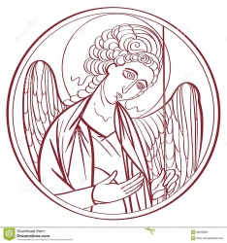
The Lord’s Prayer

Our Father, who art in heaven,
hallowed be thy Name,
thy kingdom come,
thy will be done, on earth as it is in heaven.
Give us this day our daily bread.
And forgive us our trespasses,
As we forgive those
who trespass against us
And lead us not into temptation,
but deliver us from evil.
For thine is the kingdom, and the power, and the glory for ever and ever. Amen.

The Breaking of the Bread
Celebrant Alleluia. Christ our Passover is sacrificed for us
People Therefore let us keep the feast. Alleluia.

The Fraction Anthem Celebrant and People
O Lamb of God, that takest away the sins of the world, have mercy upon us.
O Lamb of God, that takest away the sins of the world, have mercy upon us.
O Lamb of God, that takest away the sins of the world, grant us thy peace.

The Invitation
The gifts of God for the people of God. Take them in remembrance that Christ died for you, and feed on him in your hearts by faith, with thanksgiving.

The Communion of the People

All God’s people are welcome to share in the banquet of the Holy Eucharist, in one kind. If you prefer to receive a blessing instead of Communion, cross your hands across your chest.

The Communion Hymns

“Baptized in Water” Hymnal 294
(Tune: Bunessan/Morning has broken)

- Baptized in water,
sealed by the Spirit,
cleansed by the blood of Christ our King:
heirs of salvation,
trusting his promise,
faithfully now God’s praise we sing.

- Baptized in water,
Sealed in the Spirit
Dead in the tomb with Christ our King;
One with his rising,
Freed and forgiven,
Thankfully now God’s praise we sing

- Baptized in water,
sealed by the Spirit,
marked with the sign of Christ our King:
born of one Father,
we are his children,
joyfully now God’s praise we sing.

Michael Saward (b. 1932), alt.

“Come, gracious Spirit, heavenly Dove” Hymnal 512

- Come, gracious Spirit, heavenly Dove,
with light and comfort from above;
be thou our guardian, thou our guide;
o’er every thought and step preside.

- The light of truth to us display,
and make us know and choose thy way;
plant holy fear in every heart,
that we from thee may ne’er depart.
- Lead us to Christ, the living Way,
nor let us from his precepts stray;
lead us to holiness, the road
that we must take to dwell with God.

- Lead us to heaven, that we may share
fullness of joy for ever there;
lead us to God, our final rest,
to be with him for ever blest.

Simon Browne (1680-1732), alt.
This selection is in the public domain.

“I am the Bread of Life” Hymnal 335

- I am the bread of life;
they who come to me shall not hunger;
they who believe in me shall not thirst.
No one can come to me
unless the Father draw them.

Refrain
And I will raise them up,
And I will raise them up,
and I will raise them up on the
last day.

- The Bread that I will give
is my Flesh for the life of the world,
and they who eat of this bread,
they shall live for ever. Refrain

- Unless you eat
of the Flesh of the Son of Man
and drink of his Blood,
you shall not have life within you. Refrain

- I am the resurrection,
I am the life.
They who believe in me,
even if they die,
they shall live for ever. Refrain

- Yes, Lord, we believe
that you are the Christ,
the Son of God
who has come into the world. Refrain

Suzanne Toolan (b. 1927), adapt. of John 6

The Post Communion Prayer
Eternal God, heavenly Father, you have graciously accepted us as living members of your Son our Savior Jesus Christ, and you have fed us with spiritual food in the Sacrament of his Body and Blood. Send us now into the world in peace and grant us strength and courage to love and serve you with gladness and singleness of heart, through Christ our Lord. Amen.

The Blessing
Finally, beloved, whatever is true, whatever is honorable, whatever is just, whatever is pure, whatever is pleasing, whatever is commendable, if there is any excellence and if there is anything worthy of praise, think about these things; and the blessing of God Almighty, the Father, the Son, and the Holy Spirit, be amongst you, and remain with you always. Amen.

The Parish Announcement

At the Procession into the World

The Closing Hymn “Search, O my God” See bulletin Insert

The Dismissal
Celebrant: Let us go forth into the world rejoicing in the power of the Spirit
People: Thanks be to God.

Postlude “ Earth & All Stars” David Johnson

Flowers on the Altar

Donated by Connie Adibe in celebration of her loving husband, Toni Adibe’s, 70th birthday on September 4, 2022.

Donated by Connie Adibe and Toni Adibe in celebration of their 36th Wedding Anniversary on August 30, 2022.

Donated by Fr. Winston Arthur in celebration of his loving wife, Laura Arthur’s birthday on September 5, 2022

Copyright Permissions
Permission to print and stream music in this service obtained from ONE LICENSE # A-715408.
All rights reserved.

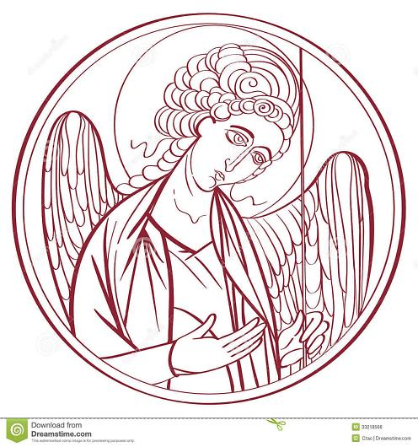

The Mission of the Church is the Mission of Christ
(The Five Marks of Mission)
Tell • To proclaim the Good News of the Kingdom.
Teach • To teach, baptize and nurture new believers.
Tend • To respond to human need by loving service.
Transform • To seek to transform unjust structures of society,
to challenge violence of every kind and to pursue peace and
reconciliation.
Treasure • To strive to safeguard the integrity of creation and
sustain and renew the life of the earth.

Rector – Father R. Winston Arthur
Choir Director – Dawn-Marie James
Organist – Bradley Phillips
Finance Clerk – Charlene Smith
Custodian – John Lam

