St. Michael and All Angels Episcopal Church
The Episcopal Diocese of Atlanta
Eleventh Sunday After Pentecost
August 21, 2022



OUR PURPOSE AT ST. MICHAEL AND ALL ANGELS

TO CARE FOR OUR CHURCH FAMILY WITH MUTUAL LOVE AND SUPPORT

TO PARTICIPATE, LEARN AND SERVE IN OUR NEIGHBORING COMMUNITIES

TO ENRICH AND SHARE OUR GROWING SPIRITUALITY, RICH DIVERSITY, WELCOMING FELLOWSHIP, JOYFUL WORSHIP AND LOVING CARE

TO INVITE NEIGHBORS INTO OUR CHURCH FAMILY IN OUR COMMITMENT TO SEEK AND SERVE CHRIST IN ALL PERSONS

6780 James B Rivers Drive
Stone Mountain, Georgia 30083
Telephone: 770-469-8551
Email: admin@stmichaelstonemountain.org
Website: www.stmichaelstonemountain.org
Office Hours: Monday-Thursday 9:00 A.M. to 2:00 P.M.
Father Winston’s Phone Number: 404-386-8833; call or text.

Holy Eucharist Rite II at 10:30 am
August 21, 2022

The Ringing of the Bell

All are invited to a time of silence for quiet contemplation and centering

Prelude ”Give praise and glory unto God” Peter Sohren

Opening Prayer
The Word of God

The Opening Hymn “I come with joy to meet my Lord” Hymnal 304

I come with joy to meet my Lord,
forgiven, loved, and free,
in awe and wonder to recall
his life laid down for me.

I come with Christians far and near
to find, as all are fed,
the new community of love
in Christ’s communion bread.

As Christ breaks bread and bids us share,
each proud division ends.
That love that made us makes us one,
and strangers now are friends.

And thus with joy we meet our Lord.
His presence, always near,
is in such friendship better known:
we see, and praise him here.

Together met, together bound,
we’ll go our different ways,
and as his people in the world,
we’ll live and speak his praise.
Brian A. Wren (b. 1936), alt.

Opening Acclamation

All stand, as able
Celebrant Blessed be God, Father, Son and Holy Spirit
People And Blessed be His Kingdom, now and forever. Amen

The Collect for Purity BCP 355
Almighty God, to you all hearts are open, all desires known, and from you no secrets are hid: Cleanse the thoughts of our hearts by the inspiration of your Holy Spirit; that we may perfectly love you, and worthily magnify your holy Name; through Christ our Lord. Amen.

The Gloria Hymnal S-280

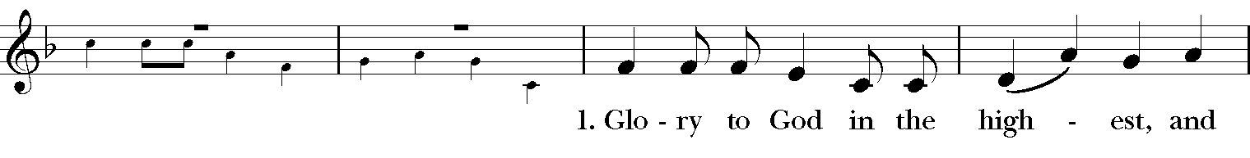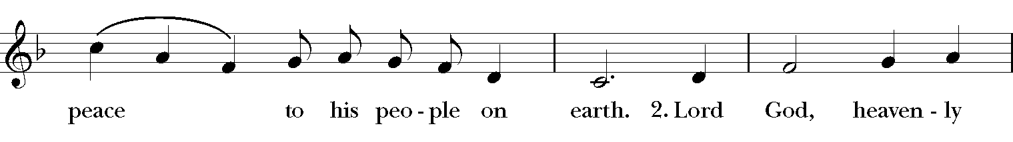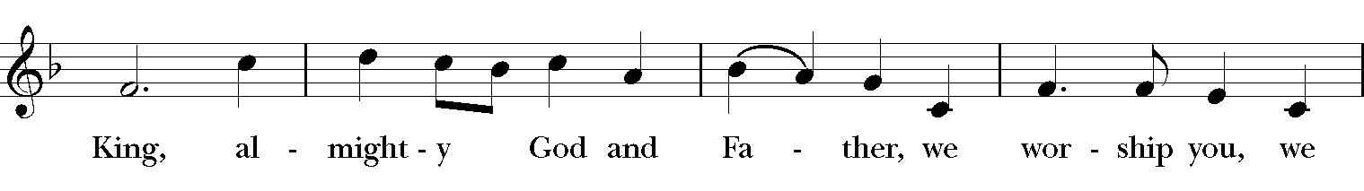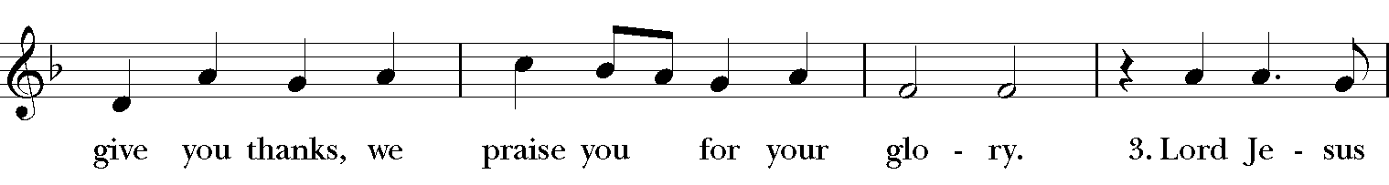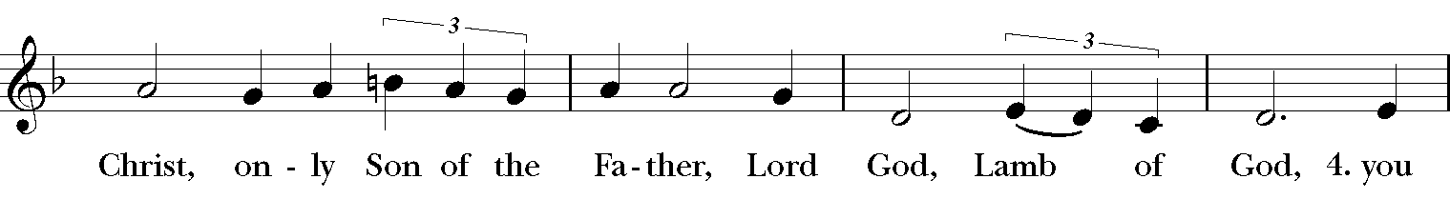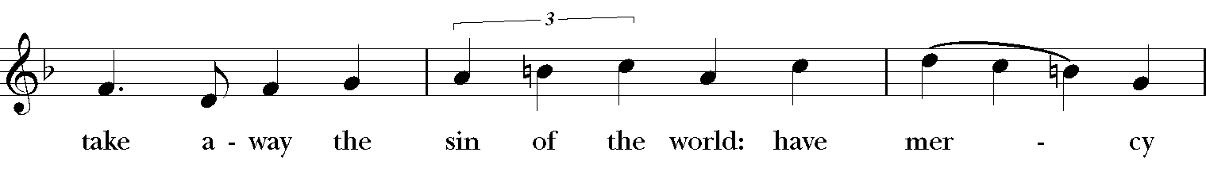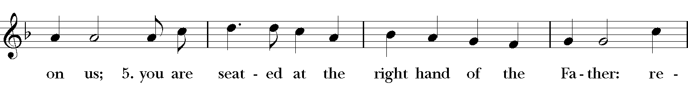
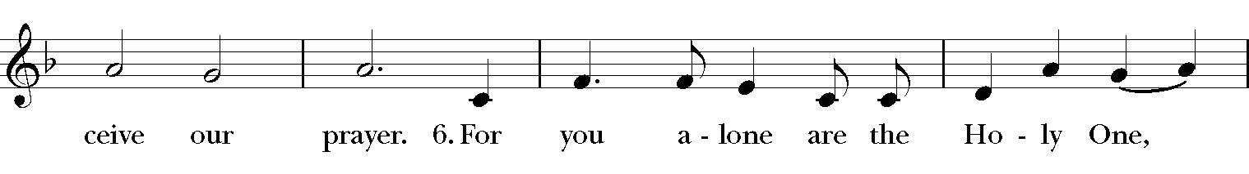
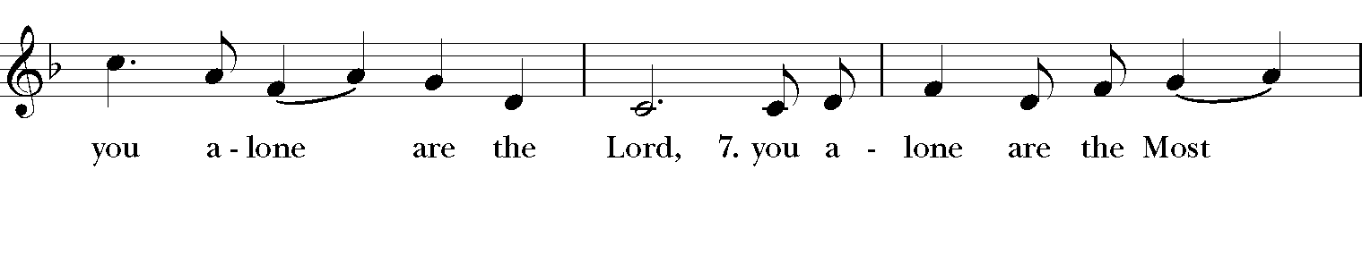
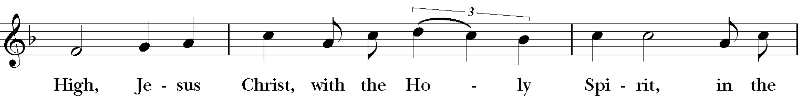
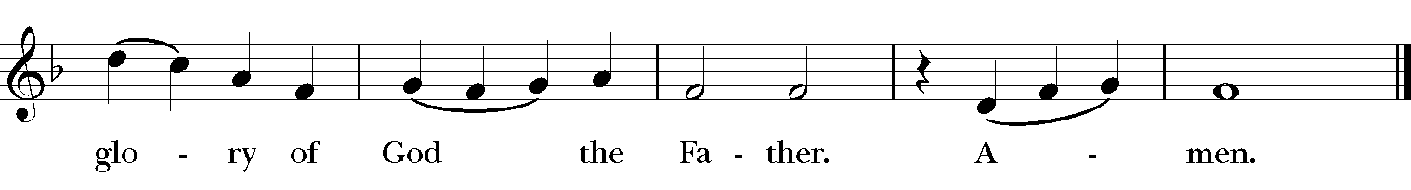

The Collect of the Day

Celebrant: The Lord be with you.
People: And also, with you.

Celebrant: Let us pray.
Grant, O merciful God, that your Church, being gathered together in unity by your Holy Spirit, may show forth your power among all peoples, to the glory of your Name; through Jesus Christ our Lord, who lives and reigns with you and the Holy Spirit, one God, for ever and ever. Amen.
The First Lesson Isaiah 58:9b-14

If you remove the yoke from among you,
the pointing of the finger, the speaking of evil,
if you offer your food to the hungry
and satisfy the needs of the afflicted,
then your light shall rise in the darkness
and your gloom be like the noonday.
The Lord will guide you continually,
and satisfy your needs in parched places,
and make your bones strong;
and you shall be like a watered garden,
like a spring of water,
whose waters never fail.
Your ancient ruins shall be rebuilt;
you shall raise up the foundations of many generations;
you shall be called the repairer of the breach,
the restorer of streets to live in.
If you refrain from trampling the sabbath,
from pursuing your own interests on my holy day;
if you call the sabbath a delight
and the holy day of the Lord honorable;
if you honor it, not going your own ways,
serving your own interests, or pursuing your own affairs;
then you shall take delight in the Lord,
and I will make you ride upon the heights of the earth;
I will feed you with the heritage of your ancestor Jacob,
for the mouth of the Lord has spoken.
Reader: The Word of the Lord.
People: Thanks be to God.

Psalm 103
Bless the Lord, O my soul, *
and all that is within me, bless his holy Name.
Bless the Lord, O my soul, *
and forget not all his benefits.
He forgives all your sins *
and heals all your infirmities;
He redeems your life from the grave *
and crowns you with mercy and loving-kindness;
He satisfies you with good things, *
and your youth is renewed like an eagle's.
The Lord executes righteousness *
and judgment for all who are oppressed.
He made his ways known to Moses *
and his works to the children of Israel.
The Lord is full of compassion and mercy, *
slow to anger and of great kindness.

The Second Lesson Hebrews 12:18-29
You have not come to something that can be touched, a blazing fire, and darkness, and gloom, and a tempest, and the sound of a trumpet, and a voice whose words made the hearers beg that not another word be spoken to them. (For they could not endure the order that was given, "If even an animal touches the mountain, it shall be stoned to death." Indeed, so terrifying was the sight that Moses said, "I tremble with fear.") But you have come to Mount Zion and to the city of the living God, the heavenly Jerusalem, and to innumerable angels in festal gathering, and to the assembly of the firstborn who are enrolled in heaven, and to God the judge of all, and to the spirits of the righteous made perfect, and to Jesus, the mediator of a new covenant, and to the sprinkled blood that speaks a better word than the blood of Abel.
See that you do not refuse the one who is speaking; for if they did not escape when they refused the one who warned them on earth, how much less will we escape if we reject the one who warns from heaven! At that time his voice shook the earth; but now he has promised, "Yet once more I will shake not only the earth but also the heaven." This phrase, "Yet once more," indicates the removal of what is shaken-- that is, created things-- so that what cannot be shaken may remain. Therefore, since we are receiving a kingdom that cannot be shaken, let us give thanks, by which we offer to God an acceptable worship with reverence and awe; for indeed our God is a consuming fire.
Reader: The Word of the Lord.
People: Thanks be to God.

The Sequence Hymn “Glorious things of thee are spoken” Hymnal 522

V. 1-2 to be sung before Gospel reading, V. 3-4 to be sung after Gospel reading

Glorious things of thee are spoken,
Zion, city of our God;
he whose word cannot be broken
formed thee for his own abode;
on the Rock of Ages founded,
what can shake thy sure repose?
With salvation’s walls surrounded,
thou may’st smile at all thy foes.

See! the streams of living waters,
springing from eternal love,
well supply thy sons and daughters
and all fear of want remove.
Who can faint, when such a river
ever will their thirst assuage?
Grace which, like the Lord, the giver
never fails from age to age.

Round each habitation hovering,
see the cloud and fire appear
for a glory and a covering,
showing that the Lord is near.
Thus deriving from their banner,
light by night, and shade by day,
safe they feed upon the manna
which he gives them when they pray.

Blest inhabitants of Zion,
washed in the Redeemer’s blood!
Jesus, whom their souls rely on,
makes them kings and priests to God.
‘Tis his love his people raise
over self to reign as kings:
and as priests, his solemn praises
each for a thank-offering brings.

John Newton (1725-1807), alt.
These words are in the public domain.

The Gospel Luke 13:10-17
Gospeler: The Holy Gospel of our Savior Jesus Christ according to Luke.

People: Glory to you, Lord Christ.

Now Jesus was teaching in one of the synagogues on the sabbath. And just then there appeared a woman with a spirit that had crippled her for eighteen years. She was bent over and was quite unable to stand up straight. When Jesus saw her, he called her over and said, "Woman, you are set free from your ailment." When he laid his hands on her, immediately she stood up straight and began praising God. But the leader of the synagogue, indignant because Jesus had cured on the sabbath, kept saying to the crowd, "There are six days on which work ought to be done; come on those days and be cured, and not on the sabbath day." But the Lord answered him and said, "You hypocrites! Does not each of you on the sabbath untie his ox or his donkey from the manger, and lead it away to give it water? And ought not this woman, a daughter of Abraham whom Satan bound for eighteen long years, be set free from this bondage on the sabbath day?" When he said this, all his opponents were put to shame; and the entire crowd was rejoicing at all the wonderful things that he was doing.

Gospeler The Gospel of the Lord.

People Praise to you, Lord Christ.

Please be seated.
The Sermon The Rev. Winston Arthur

The Nicene Creed
All stand, as able

We believe in one God,
the Father, the Almighty,
maker of heaven and earth,
of all that is, seen and unseen.
We believe in one Lord, Jesus Christ,
the only Son of God,
eternally begotten of the Father,
God from God, Light from Light,
true God from true God,
begotten, not made,
of one Being with the Father.
Through him all things were made.
For us and for our salvation
he came down from heaven:
by the power of the Holy Spirit
he became incarnate from the Virgin Mary,
and was made man.
For our sake he was crucified under Pontius Pilate;
he suffered death and was buried.
On the third day he rose again
in accordance with the Scriptures;
he ascended into heaven
and is seated at the right hand of the Father.
He will come again in glory to judge the living and the dead,
and his kingdom will have no end.
We believe in the Holy Spirit, the Lord, the giver of life,
who proceeds from the Father and the Son.
With the Father and the Son he is worshiped and glorified.
He has spoken through the Prophets.
We believe in one holy catholic and apostolic Church.
We acknowledge one baptism for the forgiveness of sins.
We look for the resurrection of the dead,
and the life of the world to come. Amen.

The Prayers of the People

Reader Sisters and brothers, the Lord is full of compassion and mercy. Let us then pray to the Lord, saying, “You, O God, are our hope; incline your ear to us.”
O Lord, may your Church take delight in you above all else. Fill our hearts with joy and gladness as we worship in your presence. May we faithfully keep the feast.
Invite the congregation to add their thanksgiving
Silence
You, O God, are our hope;
People Incline your ear to us.
Reader Give to the leaders of nations, O Lord, compassion for the hungry; satisfy the needs of the afflicted. May we, satisfied with good things, show mercy to the poor and oppressed.
Silence
You, O God, are our hope;
People Incline your ear to us.
Reader God, you are a consuming fire. Your light rises in the darkness and our gloom becomes like the noonday. Continue to make yourself known to us in your creation-in the stars of the night and the new light of the morning.
Silence
You, O God, are our hope;
People Incline your ear to us.
Reader: You call us, O God, into a great community of believers; to join with angels and saints, with those you have made righteous, and with your Son Jesus, the mediator of the new covenant. We pray for our fellow Christians around the world, especially those facing persecutions. Protect and strengthen. Have mercy, Lord.
Silence
You, O God, are our hope;
People: Incline your ear to us.
Reader: We pray for the healing of those who are spiritually and physically broken. May all who are troubled by the power of evil find freedom in the hands of your Son.
Invite the congregation to add their petitions
Silence
You, O God, are our hope;
People: Incline your ear to us.
Reader: Comfort and heal all those who suffer any affliction; give them strength and courage in their troubles and remind them of the hope of glory they find in Christ. We pray for,
Joyce E., Thelma M., Karia, Laura, Gossett, Jataun, Angela, Clemson, Errol, Barbara P., Edwards, Marcia, Althea, Fronie, Velita, Jackie, Pauline, Kerri, Kaneez, Shahid, Olando, Rick, Trevon, Venita, Basmattie, Floyd, Christine, Dorothy, George, Annie, Ruth, Reece, Ladan, Morris, Deng, Marlene, Deneen, Faye, Ann, Joanne, Bill, Linda, Shaista, Suleman, Naveed, Ardonous, Edna, Royan, Cherrie, Yvonne, Joyce R., Bob, Howard, Jennifer, Yannick, Fatima, Barbara, Beverly, Heather Y., the people of South Sudan, those suffering from Covid-19
Invite the congregation to add their petitions
Silence
You, O God, are our hope;
People: Incline your ear to us.
Reader: O God, you redeem life from the grave through the resurrection of Christ. We pray for those who have died in hope; may they eternally be satisfied with good things.
Silence
You, O God, are our hope;
People: Incline your ear to us.

Reader: And we also bless thy holy Name for all thy servants departed this life in thy faith and fear, especially the Souls of All Saints, beseeching thee to grant them continual growth in thy love and service; and to grant us grace so to follow the good examples of all thy saints, that with them we may be partakers of thy heavenly kingdom and for this assembly, as we serve the sisters and brothers among us and as we work outside church doors, we pray [Here other intercession may be offered].
Silence
You, O God, are our hope;
People Incline your ear to us.
Silence
The Celebrant adds a concluding Collect.

The Confession of Sin BCP 360

Celebrant Let us confess our sins against God and our neighbor.
Celebrant and People
Most merciful God, we confess that we have sinned against you in thought, word, and deed, by what we have done, and by what we have left undone. We have not loved you with our whole heart; we have not loved our neighbors as ourselves. We are truly sorry and we humbly repent. For the sake of your Son Jesus Christ, have mercy on us and forgive us; that we may delight in your will, and walk in your ways, to the glory of your Name. Amen.
The Absolution
Almighty God have mercy on you, forgive you all your sins through our Lord Jesus Christ, strengthen you in all goodness, and by the power of the Holy Spirit keep you in eternal life. Amen.
The Peace
Celebrant The peace of the Lord be always with you.
People And also with you.

The Offertory “ City Called Heaven” arr. Hall Johnson
Soloist, Dawn-Marie James

THE GREAT THANKSGIVING
The Doxology Tune: "Old 100th"
Celebrant and People
Praise God, from Whom all blessings flow;
Praise Him, all creatures here below;
Praise Him above, ye heav’nly host;
Praise Father, Son, and Holy Ghost. Amen

The Great Thanksgiving: Eucharistic Prayer A BCP 355

All stand, as able
Celebrant The Lord be with you.
People And also with you.
Celebrant Lift up your hearts.
People We lift them to the Lord.
Celebrant Let us give thanks to the Lord our God.
People It is right to give our thanks and praise.
Then, facing the Holy Table, the Celebrant proceeds
It is right, and a good and joyful thing, always and everywhere to give thanks to you, Father Almighty, Creator of heaven and earth.
Therefore, we praise you, joining our voices with Angels and Archangels and with all the company of heaven, who forever sing this hymn to proclaim the glory of your Name:

The Sanctus: Holy, Holy, Holy from Lift Every Voice and Sing 255

Holy, holy, holy, holy, Holy Lord God of hosts.
Heaven and earth are filled with your glo-ry. Hosanna in the high-est.
Blessed is He who comes in the name
Of the Lord, of the Lord.
Ho-sannna in the high-est, Ho-sanna in the high-est.
The Celebrant continues
Holy and gracious Father: In your infinite love you made us for yourself, and, when we had fallen into sin and become subject to evil and death, you, in your mercy, sent Jesus Christ, your only and eternal Son, to share our human nature, to live and die as one of us, to reconcile us to you, the God and Father of all.
He stretched out his arms upon the cross, and offered himself, in obedience to your will, a perfect sacrifice for the whole world.
At the following words concerning the bread, the Celebrant is to hold it, or lay a hand upon it, and at the words concerning the cup, to hold or place a hand upon the cup and any other vessel containing wine to be consecrated.
On the night he was handed over to suffering and death, our Lord Jesus Christ took bread; and when he had given thanks to you, he broke it, and gave it to his disciples, and said, "Take, eat: This is my Body, which is given for you. Do this for the remembrance of me."
After supper he took the cup of wine; and when he had given thanks, he gave it to them, and said, "Drink this, all of you: This is my Blood of the new Covenant, which is shed for you and for many for the forgiveness of sins. Whenever you drink it, do this for the remembrance of me."
Therefore we proclaim the mystery of faith:
Celebrant and People Christ has died. Christ has risen. Christ will come again.
The Celebrant continues
We celebrate the memorial of our redemption, O Father, in this sacrifice of praise and thanksgiving. Recalling his death, resurrection, and ascension, we offer you these gifts.
Sanctify them by your Holy Spirit to be for your people the Body and Blood of your Son, the holy food and drink of new and unending life in him. Sanctify us also that we may faithfully receive this holy Sacrament, and serve you in unity, constancy, and peace; and at the last day bring us with all your saints into the joy of your eternal kingdom.
All this we ask through your Son Jesus Christ: By him, and with him, and in him, in the unity of the Holy Spirit all honor and glory is yours, Almighty Father, now and forever. Amen.
And now, as our Savior Christ has taught us, we are bold to say,

Celebrant and People
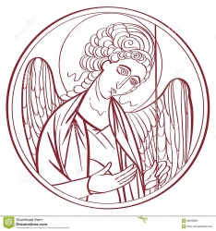
The Lord’s Prayer

Our Father, who art in heaven,
hallowed be thy Name,
thy kingdom come,
thy will be done, on earth as it is in heaven.
Give us this day our daily bread.
And forgive us our trespasses,
As we forgive those
who trespass against us
And lead us not into temptation,
but deliver us from evil.
For thine is the kingdom, and the power, and the glory for ever and ever. Amen.
The Breaking of the Bread
Celebrant Alleluia. Christ our Passover is sacrificed for us
People Therefore let us keep the feast. Alleluia.

The Fraction Anthem Celebrant and People
O Lamb of God, that takest away the sins of the world, have mercy upon us.
O Lamb of God, that takest away the sins of the world, have mercy upon us.
O Lamb of God, that takest away the sins of the world, grant us thy peace.

The Invitation
The gifts of God for the people of God. Take them in remembrance that Christ died for you, and feed on him in your hearts by faith, with thanksgiving.

The Communion of the People
All God’s people are welcome to share in the banquet of the Holy Eucharist, in one kind. If you prefer to receive a blessing instead of Communion, cross your hands across your chest.

The Communion Hymns

“God will take care of you” LEVAS 183

Be not dismayed whate’er betide,
God will take care of you;
Beneath His wings of love abide,
God will take care of you.

Refrain
God will take care of you,
Through ev’ry day,
O’er all the way;
He will take care of you,
God will take care of you.

Through days of toil when heart doth fail,
God will take care of you;
When dangers fierce your path assail,
God will take care of you. Refrain

All you may need He will provide,
God will take care of you;
Nothing you ask will be denied,
God will take care of you. Refrain

No matter what may be the test,
God will take care of you;
Lean, weary one, upon His breast,
God will take care of you. Refrain

Civilla D. Martin (1869-1948)
This selection is in the public domain.

“O Bless the Lord, My soul” Hymnal 411
O bless the Lord, my soul!
His grace to thee proclaim!
And all that is within me join
to bless his holy Name!

O bless the Lord, my soul!
His mercies bear in mind!
Forget not all his benefits!
The Lord to thee is kind.

He will not always chide;
he will with patience wait;
his wrath is ever slow to rise
and ready to abate.

He pardons all thy sins,
prolongs thy feeble breath;
he healeth thine infirmities
and ransoms thee from death.

He clothes thee with his love,
upholds thee with his truth;
and like the eagle he renews
the vigor of thy youth.

Then bless his holy Name,
whose grace hath made thee whole,
whose loving-kindness crowns thy days:
O bless the Lord, my soul!

James Montgomery (1771-1854); para. of Psalm 103
This selection is in the public domain.

“Heal me hands of Jesus” WLP 773
Heal me, hands of Jesus,
and search out all my pain:
restore my hope, remove my fear
and bring me peace again.

Cleanse me, blood of Jesus,
take bitterness away;
let me forgive as one forgiven
and bring me peace today.

Know me, mind of Jesus,
and show me all my sin;
dispel the memories of guilt,
and bring me peace within.

Fill me, joy of Jesus:
anxiety shall cease
and heaven’s serenity be mine,
or Jesus brings me peace!

Michael Perry
The Post Communion Prayer
Eternal God, heavenly Father, you have graciously accepted us as living members of your Son our Savior Jesus Christ, and you have fed us with spiritual food in the Sacrament of his Body and Blood. Send us now into the world in peace and grant us strength and courage to love and serve you with gladness and singleness of heart, through Christ our Lord. Amen.

The Blessing
Finally, beloved, whatever is true, whatever is honorable, whatever is just, whatever is pure, whatever is pleasing, whatever is commendable, if there is any excellence and if there is anything worthy of praise, think about these things; and the blessing of God Almighty, the Father, the Son, and the Holy Spirit, be amongst you, and remain with you always. Amen.

The Parish Announcements

At the Procession into the World

The Closing Hymn “O for a thousand tongues to sing” Hymnal 493

O for a thousand tongues to sing
my dear Redeemer’s praise,
the glories of my God and King,
the triumphs of his grace!

My gracious Master and my God,
assist me to proclaim
and spread through all the earth
abroad the honors of thy Name.

Jesus! the Name that charms our fears
and bids our sorrows cease;
‘tis music in the sinner’s ears,
‘tis life and health and peace.

He speaks; and, listening to his voice,
new life the dead receive,
the mournful broken hearts rejoice,
the humble poor believe.

Hear him, ye deaf; ye voiceless ones,
your loosened tongues employ;
ye blind, behold, your Savior comes;
and leap, ye lame, for joy!

Glory to God and praise and love
be now and ever given
by saints below and saints above,
the Church in earth and heaven.
The Dismissal
Celebrant: Let us go forth into the world rejoicing in the power of the Spirit
People: Thanks be to God.

Postlude “ Du Lebensbrot Herr Jesu Christ” adapt. Johann Freylinghausen

“This week’s flowers were donated by Sydney Rabsatt in memory of his beloved wife, Louella Smith Rabsatt on the anniversary of her ascension to be with her Lord”

Copyright Permissions
Permission to print and stream music in this service obtained from ONE LICENSE # A-715408.
All rights reserved.



The Mission of the Church is the Mission of Christ
(The Five Marks of Mission)
Tell • To proclaim the Good News of the Kingdom.
Teach • To teach, baptize and nurture new believers.
Tend • To respond to human need by loving service.
Transform • To seek to transform unjust structures of society,
to challenge violence of every kind and to pursue peace and
reconciliation.
Treasure • To strive to safeguard the integrity of creation and
sustain and renew the life of the earth.

Rector – Father R. Winston Arthur
Choir Director – Dawn-Marie James
Organist – Bradley Phillips
Finance Clerk – Charlene Smith
Custodian – John Lam

