St. Michael and All Angels Episcopal Church
The Episcopal Diocese of Atlanta
Twelfth Sunday After Pentecost
August 28, 2022



OUR PURPOSE AT ST. MICHAEL AND ALL ANGELS

TO CARE FOR OUR CHURCH FAMILY WITH MUTUAL LOVE AND SUPPORT

TO PARTICIPATE, LEARN AND SERVE IN OUR NEIGHBORING COMMUNITIES

TO ENRICH AND SHARE OUR GROWING SPIRITUALITY, RICH DIVERSITY, WELCOMING FELLOWSHIP, JOYFUL WORSHIP AND LOVING CARE

TO INVITE NEIGHBORS INTO OUR CHURCH FAMILY IN OUR COMMITMENT TO SEEK AND SERVE CHRIST IN ALL PERSONS

6780 James B Rivers Drive
Stone Mountain, Georgia 30083
Telephone: 770-469-8551
Email: admin@stmichaelstonemountain.org
Website: www.stmichaelstonemountain.org
Office Hours: Monday-Thursday 9:00 A.M. to 2:00 P.M.
Father Winston’s Phone Number: 404-386-8833; call or text.

Holy Eucharist Rite II at 10:30 am
August 28, 2022

The Ringing of the Bell

All are invited to a time of silence for quiet contemplation and centering

Prelude ”Morning has broken” arr. Charles Callahan

Opening Prayer
The Word of God

The Opening Hymm “Immortal, invisible, God only wise” Hymnal 423

Immortal, invisible, God only wise,
in light inaccessible hid from our eyes,
most blessed, most glorious, the Ancient of Days,
almighty, victorious, thy great Name we praise.

Unresting, unhasting, and silent as light,
nor wanting, nor wasting, thou rulest in might;
thy justice like mountains high soaring above
thy clouds, which are fountains of goodness and love.

To all life thou givest, to both great and small;
in all life thou livest, the true life of all;
we blossom and flourish, like leaves on the tree,
then wither and perish; but nought changeth thee.

Thou reignest in glory, thou rulest in light,
Thine angels adore thee, all veiling their sight;
All laud we would render: O help us to see
‘tis only the splendor of light hideth thee.

Walter Chalmers Smith (1824-1908), alt.
This selection is in the public domain.

Opening Acclamation

All stand, as able
Celebrant Blessed be God, Father, Son and Holy Spirit
People And Blessed be His Kingdom, now and forever. Amen

The Collect for Purity BCP 355
Almighty God, to you all hearts are open, all desires known, and from you no secrets are hid: Cleanse the thoughts of our hearts by the inspiration of your Holy Spirit; that we may perfectly love you, and worthily magnify your holy Name; through Christ our Lord. Amen.

The Gloria Hymnal S-280

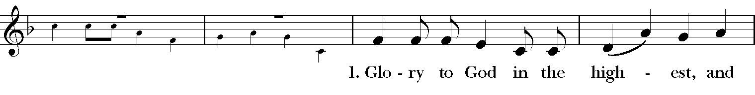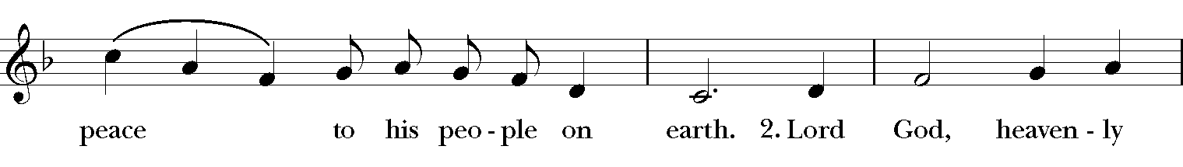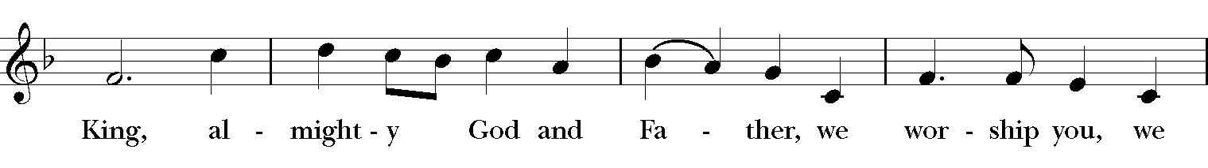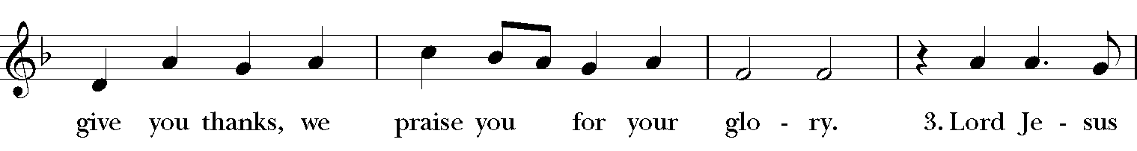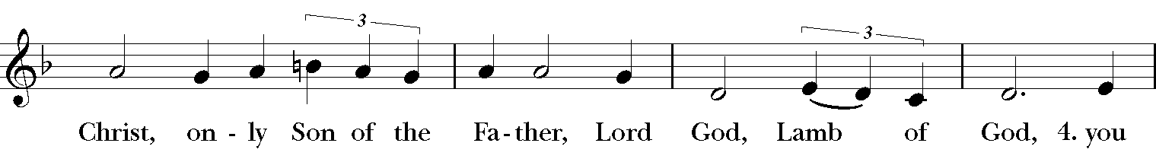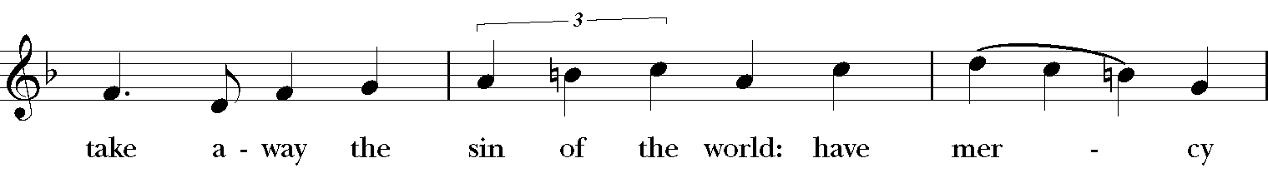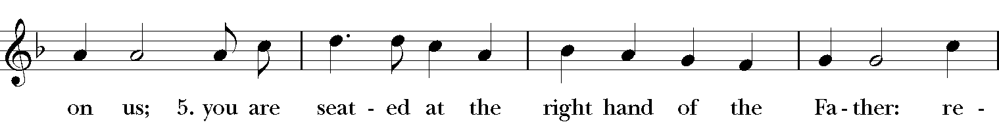
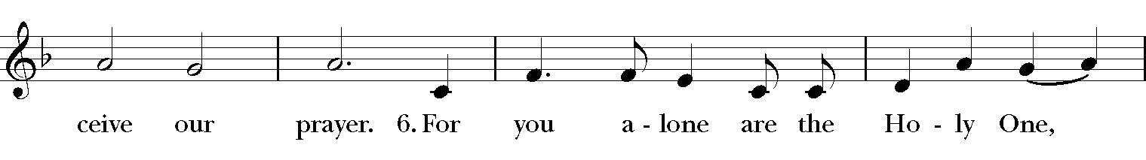
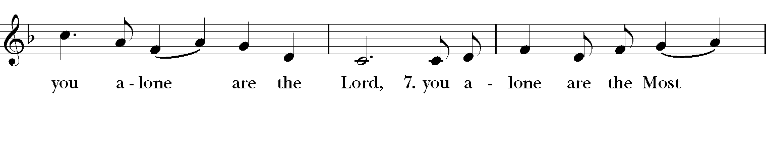
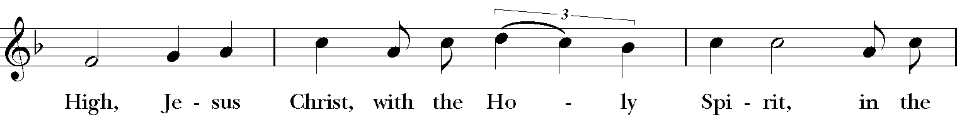
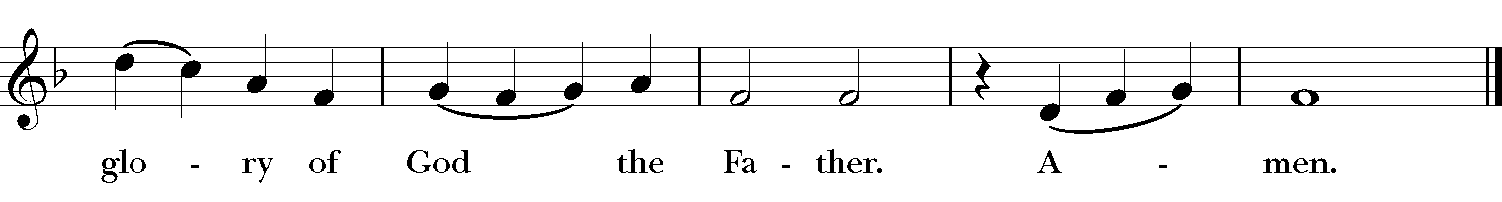

The Collect of the Day

Celebrant: The Lord be with you.
People: And also, with you.

Celebrant: Let us pray.
Lord of all power and might, the author and giver of all good things: Graft in our hearts the love of your Name; increase in us true religion; nourish us with all goodness; and bring forth in us the fruit of good works; through Jesus Christ our Lord, who lives and reigns with you and the Holy Spirit, one God for ever and ever. Amen.
The First Lesson Sirach 10:12-18

The beginning of human pride is to forsake the Lord;
the heart has withdrawn from its Maker.
For the beginning of pride is sin,
and the one who clings to it pours out abominations.
Therefore, the Lord brings upon them unheard-of calamities,
and destroys them completely.
The Lord overthrows the thrones of rulers,
and enthrones the lowly in their place.
The Lord plucks up the roots of the nations,
and plants the humble in their place.
The Lord lays waste the lands of the nations,
and destroys them to the foundations of the earth.
He removes some of them and destroys them,
and erases the memory of them from the earth.
Pride was not created for human beings,
or violent anger for those born of women.
Reader: The Word of the Lord.
People: Thanks be to God.

Psalm 112

Hallelujah!
Happy are they who fear the Lord *
and have great delight in his commandments!
Their descendants will be mighty in the land; *
the generation of the upright will be blessed.
Wealth and riches will be in their house, *
and their righteousness will last for ever.
Light shines in the darkness for the upright; *
the righteous are merciful and full of compassion.
It is good for them to be generous in lending *
and to manage their affairs with justice.
For they will never be shaken; *
the righteous will be kept in everlasting remembrance.
They will not be afraid of any evil rumors; *
their heart is right;
they put their trust in the Lord.
Their heart is established and will not shrink, *
until they see their desire upon their enemies.
They have given freely to the poor, *
and their righteousness stands fast for ever;
they will hold up their head with honor.
The wicked will see it and be angry;
they will gnash their teeth and pine away; *
the desires of the wicked will perish.

The Second Lesson Hebrews 13:1-8, 15-16
Let mutual love continue. Do not neglect to show hospitality to strangers, for by doing that some have entertained angels without knowing it. Remember those who are in prison, as though you were in prison with them; those who are being tortured, as though you yourselves were being tortured. Let marriage be held in honor by all, and let the marriage bed be kept undefiled; for God will judge fornicators and adulterers. Keep your lives free from the love of money, and be content with what you have; for he has said, "I will never leave you or forsake you." So we can say with confidence,
"The Lord is my helper;
I will not be afraid.
What can anyone do to me?"
Remember your leaders, those who spoke the word of God to you; consider the outcome of their way of life, and imitate their faith. Jesus Christ is the same yesterday and today and forever.
Through him, then, let us continually offer a sacrifice of praise to God, that is, the fruit of lips that confess his name. Do not neglect to do good and to share what you have, for such sacrifices are pleasing to God.
Reader: The Word of the Lord.
People: Thanks be to God.

The Sequence Hymn “I the Lord, of sea & sky” WLP 812

V. 1-2 to be sung before Gospel reading, V. 3- to be sung after Gospel reading
I, the Lord of sea and sky,
I have heard my people cry.
All who dwell in deepest sin
My hand will save.
I who made the stars of night,
I will make their darkness bright.
Who will bear my light to them?
Whom shall I send?

Refrain
Here I am, Lord. Is it I, Lord?
I have heard you calling in the night.
I will go, Lord, if you lead me,
I will hold your people in my heart.

I, the Lord of snow and rain,
I have borne my people’s pain.
I have wept for love of them,
They turn away.
I will break their hearts of stone,
Give them hearts for love alone.
I will speak my word to them.
Whom shall I send? Refrain

I, the Lord of wind and flame,
I will tend the poor and lame.
I will set a feast for them,
My hand will save.
Finest bread I will provide
Till their hearts be satisfied.
I will give my life to them.
Whom shall I send? Refrain
Daniel L. Schutte

The Gospel Luke 14:1, 7-14
Gospeler: The Holy Gospel of our Savior Jesus Christ according to Luke.

People: Glory to you, Lord Christ.

On one occasion when Jesus was going to the house of a leader of the Pharisees to eat a meal on the sabbath, they were watching him closely.
When he noticed how the guests chose the places of honor, he told them a parable. "When you are invited by someone to a wedding banquet, do not sit down at the place of honor, in case someone more distinguished than you has been invited by your host; and the host who invited both of you may come and say to you, `Give this person your place,' and then in disgrace you would start to take the lowest place. But when you are invited, go and sit down at the lowest place, so that when your host comes, he may say to you, `Friend, move up higher'; then you will be honored in the presence of all who sit at the table with you. For all who exalt themselves will be humbled, and those who humble themselves will be exalted."
He said also to the one who had invited him, "When you give a luncheon or a dinner, do not invite your friends or your brothers or your relatives or rich neighbors, in case they may invite you in return, and you would be repaid. But when you give a banquet, invite the poor, the crippled, the lame, and the blind. And you will be blessed, because they cannot repay you, for you will be repaid at the resurrection of the righteous."

Gospeler The Gospel of the Lord.

People Praise to you, Lord Christ.

Please be seated.
The Sermon The Rev. Winston Arthur

The Nicene Creed
All stand, as able

We believe in one God,
the Father, the Almighty,
maker of heaven and earth,
of all that is, seen and unseen.
We believe in one Lord, Jesus Christ,
the only Son of God,
eternally begotten of the Father,
God from God, Light from Light,
true God from true God,
begotten, not made,
of one Being with the Father.
Through him all things were made.
For us and for our salvation
he came down from heaven:
by the power of the Holy Spirit
he became incarnate from the Virgin Mary,
and was made man.
For our sake he was crucified under Pontius Pilate;
he suffered death and was buried.
On the third day he rose again
in accordance with the Scriptures;
he ascended into heaven
and is seated at the right hand of the Father.
He will come again in glory to judge the living and the dead,
and his kingdom will have no end.
We believe in the Holy Spirit, the Lord, the giver of life,
who proceeds from the Father and the Son.
With the Father and the Son he is worshiped and glorified.
He has spoken through the Prophets.
We believe in one holy catholic and apostolic Church.
We acknowledge one baptism for the forgiveness of sins.
We look for the resurrection of the dead,
and the life of the world to come. Amen.

The Prayers of the People

Reader Brothers and sisters, God will never leave us or forsake us. Let us humbly appeal to our faithful God, saying, “We offer to you, O God, a sacrifice of praise; we offer the fruit of our lips.”
We pray for our leaders, those who speak your word to us, especially our bishop and our priest. May your whole Church listen for your voice and obey your words.
Invite the congregation to add their thanksgiving
Silence
We offer to you, O God, a sacrifice of praise;
People We offer the fruit of our lips.
Reader O God, you exalt the humble the exalted. We pray that the leaders of the nations will serve their people in humility and manage their affairs with justice. May the poor and lowly be treated with respect and shown mercy.
Silence
We offer to you, O God, a sacrifice of praise;
People We offer the fruit of our lips.
Reader You have created a beautiful planet, full of wondrous creatures and magnificent works. Open our eyes to see your hand at work in the world about us.
Silence
We offer to you, O God, a sacrifice of praise;
People We offer the fruit of our lips.
Reader: We pray for all laborers: for those who work, that they might be fulfilled; for those in need of work, that they might find meaningful employment; for those who are struggling to make ends meet, that they might receive a fair wage for their labors. In labor and in rest, be glorified by all we do.
Silence
We offer to you, O God, a sacrifice of praise;
People: We offer the fruit of our lips.
Reader: We pray for strength to do your will. May we boldly and compassionately welcome the poor, the crippled, the lame, and the blind. May all of us know you as God our helper. We pray for,
Richard, Peter, Sonia A., Carlos A., Paulette C., Joyce E., Thelma M., Karia, Gossett, Jataun, Angela, Clemson, Errol, Barbara P., Edwards, Marcia, Althea, Fronie, Velita, Jackie, Pauline, Kerri, Kaneez, Shahid, Olando, Rick, Trevon, Venita, Basmattie, Floyd, Christine, Dorothy, George, Annie, Ruth, Reece, Ladan, Morris, Deng, Marlene, Deneen, Faye, Ann, Joanne, Bill, Linda, Shaista, Suleman, Naveed, Ardonous, Edna, Royan, Cherrie, Yvonne, Joyce R., Bob, Howard, Jennifer, Yannick, Fatima, Barbara, Beverly, Heather Y., the people of South Sudan, those suffering from Covid-19
Invite the congregation to add their petitions
Silence
We offer to you, O God, a sacrifice of praise;
People: We offer the fruit of our lips.
Reader: O God you invite those who have died to feast at your heavenly banquet. We take great hope in the promise that not even death will cause you to leave us or forsake us.
Silence
We offer to you, O God, a sacrifice of praise;
People: We offer the fruit of our lips.
Reader: And we also bless thy holy Name for all thy servants departed this life in thy faith and fear, especially the Souls of All Saints, beseeching thee to grant them continual growth in thy love and service; and to grant us grace so to follow the good examples of all thy saints, that with them we may be partakers of thy heavenly kingdom and for this assembly, as we serve the sisters and brothers among us and as we work outside church doors, we pray [Here other intercession may be offered].
Silence
We offer to you, O God, a sacrifice of praise
People We offer the fruit of our lips.
Silence
The Celebrant adds a concluding Collect.

The Confession of Sin BCP 360

Celebrant Let us confess our sins against God and our neighbor.
Celebrant and People
Most merciful God, we confess that we have sinned against you in thought, word, and deed, by what we have done, and by what we have left undone. We have not loved you with our whole heart; we have not loved our neighbors as ourselves. We are truly sorry and we humbly repent. For the sake of your Son Jesus Christ, have mercy on us and forgive us; that we may delight in your will, and walk in your ways, to the glory of your Name. Amen.
The Absolution
Almighty God have mercy on you, forgive you all your sins through our Lord Jesus Christ, strengthen you in all goodness, and by the power of the Holy Spirit keep you in eternal life. Amen.
The Peace
Celebrant The peace of the Lord be always with you.
People And also with you.

The Offertory “ This little light of mine” LEVAS 221
(Youth Choir)

This little light of mine, I’m gonna let it shine,
Let it shine, let it shine, let it shine.

Ev’ry where I go, I’m gonna let it shine,
Let it shine, let it shine, let it shine.

Jesus gave it to me, I’m gonna let it shine,
Let it shine, let it shine, let it shine.

Traditional
These words are in the public domain.

THE GREAT THANKSGIVING
The Doxology Tune: "Old 100th"
Celebrant and People
Praise God, from Whom all blessings flow;
Praise Him, all creatures here below;
Praise Him above, ye heav’nly host;
Praise Father, Son, and Holy Ghost. Amen

The Great Thanksgiving: Eucharistic Prayer A BCP 355

All stand, as able
Celebrant The Lord be with you.
People And also with you.
Celebrant Lift up your hearts.
People We lift them to the Lord.
Celebrant Let us give thanks to the Lord our God.
People It is right to give our thanks and praise.
Then, facing the Holy Table, the Celebrant proceeds
It is right, and a good and joyful thing, always and everywhere to give thanks to you, Father Almighty, Creator of heaven and earth.
Therefore, we praise you, joining our voices with Angels and Archangels and with all the company of heaven, who forever sing this hymn to proclaim the glory of your Name:

The Sanctus: Holy, Holy, Holy from Lift Every Voice and Sing 255

Holy, holy, holy, holy, Holy Lord God of hosts.
Heaven and earth are filled with your glo-ry. Hosanna in the high-est.
Blessed is He who comes in the name
Of the Lord, of the Lord.
Ho-sannna in the high-est, Ho-sanna in the high-est.
The Celebrant continues
Holy and gracious Father: In your infinite love you made us for yourself, and, when we had fallen into sin and become subject to evil and death, you, in your mercy, sent Jesus Christ, your only and eternal Son, to share our human nature, to live and die as one of us, to reconcile us to you, the God and Father of all.
He stretched out his arms upon the cross, and offered himself, in obedience to your will, a perfect sacrifice for the whole world.
At the following words concerning the bread, the Celebrant is to hold it, or lay a hand upon it, and at the words concerning the cup, to hold or place a hand upon the cup and any other vessel containing wine to be consecrated.
On the night he was handed over to suffering and death, our Lord Jesus Christ took bread; and when he had given thanks to you, he broke it, and gave it to his disciples, and said, "Take, eat: This is my Body, which is given for you. Do this for the remembrance of me."
After supper he took the cup of wine; and when he had given thanks, he gave it to them, and said, "Drink this, all of you: This is my Blood of the new Covenant, which is shed for you and for many for the forgiveness of sins. Whenever you drink it, do this for the remembrance of me."
Therefore we proclaim the mystery of faith:
Celebrant and People Christ has died. Christ has risen. Christ will come again.
The Celebrant continues
We celebrate the memorial of our redemption, O Father, in this sacrifice of praise and thanksgiving. Recalling his death, resurrection, and ascension, we offer you these gifts.
Sanctify them by your Holy Spirit to be for your people the Body and Blood of your Son, the holy food and drink of new and unending life in him. Sanctify us also that we may faithfully receive this holy Sacrament, and serve you in unity, constancy, and peace; and at the last day bring us with all your saints into the joy of your eternal kingdom.
All this we ask through your Son Jesus Christ: By him, and with him, and in him, in the unity of the Holy Spirit all honor and glory is yours, Almighty Father, now and forever. Amen.
And now, as our Savior Christ has taught us, we are bold to say,
Celebrant and People
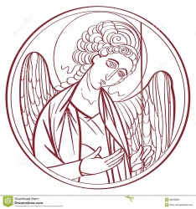
The Lord’s Prayer

Our Father, who art in heaven,
hallowed be thy Name,
thy kingdom come,
thy will be done, on earth as it is in heaven.
Give us this day our daily bread.
And forgive us our trespasses,
As we forgive those
who trespass against us
And lead us not into temptation,
but deliver us from evil.
For thine is the kingdom, and the power, and the glory for ever and ever. Amen.
The Breaking of the Bread
Celebrant Alleluia. Christ our Passover is sacrificed for us
People Therefore let us keep the feast. Alleluia.

The Fraction Anthem Celebrant and People
O Lamb of God, that takest away the sins of the world, have mercy upon us.
O Lamb of God, that takest away the sins of the world, have mercy upon us.
O Lamb of God, that takest away the sins of the world, grant us thy peace.

The Invitation
The gifts of God for the people of God. Take them in remembrance that Christ died for you, and feed on him in your hearts by faith, with thanksgiving.

The Communion of the People
All God’s people are welcome to share in the banquet of the Holy Eucharist, in one kind. If you prefer to receive a blessing instead of Communion, cross your hands across your chest.

The Communion Hymns

“My God, thy table now is spread” Hymnal 321

My God, thy table now is spread,
thy cup with love doth overflow;
be all thy children thither led,
and let them thy sweet mercies know.

O let thy table honored be,
and furnished well with joyful guests;
and may each soul salvation see,
that here its sacred pledges tastes.

Drawn by thy quickening grace, O Lord,
in countless number let them come
and gather from their Father’s board
the Bread that lives beyond the tomb.

Nor let thy spreading Gospel rest
till through the world thy truth has run,
till with this Bread shall all be blessed
who see the light or feel the sun.

Sts. 1-3, Philip Doddridge (1702-1751), alt.; st. 4, Isaac Watts (1674-1748), alt.
This selection is in the public domain.

“Thou, who at thy first Eucharist didst pray” Hymnal 315

Thou, who at thy first Eucharist didst pray
that all thy Church might be for ever one,
grant us at every Eucharist to say
with longing heart and soul, ‘Thy will be done.’
O may we all one bread, one body be,
through this blest sacrament of unity.

For all thy Church, O Lord, we intercede;
make thou our sad divisions soon to cease;
draw us the nearer each to each, we plead,
by drawing all to thee, O Prince of Peace;
thus may we all one bread, one body be,
through this blest sacrament of unity.

So, Lord, at length when sacraments shall cease,
may we be one with all thy Church above,
one with thy saints in one unbroken peace,
one with thy saints in one unbounded love;
more blesséd still, in peace and love to be
one with the Trinity in Unity.

William Harry Turton (1856-1938)

Piano Solo Willoughby Cane

“Let us talent and tongues employ” (Sung by all)

Let us talents and tongues employ,
reaching out with a shout of joy:
bread is broken, the wine is poured,
Christ is spoken and seen and heard:

Jesus lives again, earth can breathe again,
pass the word around: loaves abound.

Christ is able to make us one,
at his table he sets the tone,
teaching people to live to bless,
love in word and in deed express:

Jesus calls us in, sends us out
bearing fruit in a world of doubt,
gives us love to tell, bread to share:
God Emmanuel everywhere:
Fred Kaan

The Post Communion Prayer
Eternal God, heavenly Father, you have graciously accepted us as living members of your Son our Savior Jesus Christ, and you have fed us with spiritual food in the Sacrament of his Body and Blood. Send us now into the world in peace and grant us strength and courage to love and serve you with gladness and singleness of heart, through Christ our Lord. Amen.

The Blessing
Finally, beloved, whatever is true, whatever is honorable, whatever is just, whatever is pure, whatever is pleasing, whatever is commendable, if there is any excellence and if there is anything worthy of praise, think about these things; and the blessing of God Almighty, the Father, the Son, and the Holy Spirit, be amongst you, and remain with you always. Amen.

The Parish Announcement

At the Procession into the World

The Closing Hymn “Lord dismiss us with thy blessing” Hymnal 344

Lord, dismiss us with thy blessing;
fill our hearts with joy and peace;
let us each, thy love possessing,
triumph in redeeming grace:
O refresh us, O refresh us
traveling through this wilderness.

Thanks we give and adoration
for thy Gospel’s joyful sound:
may the fruits of thy salvation
in our hearts and lives abound:
ever faithful, ever faithful
to thy truth may we be found;

so that when thy love shall call us,
Savior, from the world away,
fear of death shall not appall us,
glad thy summons to obey.
May we ever, may we ever
reign with thee in endless day.

Att. to John Fawcett (1739/40-1817)
This selection is in the public domain.

The Dismissal
Celebrant: Let us go forth into the world rejoicing in the power of the Spirit
People: Thanks be to God.

Postlude “ Search, O my God” (on Ps. 139) Bradley Phillips

Copyright Permissions
Permission to print and stream music in this service obtained from ONE LICENSE # A-715408.
All rights reserved.



The Mission of the Church is the Mission of Christ
(The Five Marks of Mission)
Tell • To proclaim the Good News of the Kingdom.
Teach • To teach, baptize and nurture new believers.
Tend • To respond to human need by loving service.
Transform • To seek to transform unjust structures of society,
to challenge violence of every kind and to pursue peace and
reconciliation.
Treasure • To strive to safeguard the integrity of creation and
sustain and renew the life of the earth.

Rector – Father R. Winston Arthur
Choir Director – Dawn-Marie James
Organist – Bradley Phillips
Finance Clerk – Charlene Smith
Custodian – John Lam

