St. Michael and All Angels Episcopal Church
The Episcopal Diocese of Atlanta
Tenth Sunday After Pentecost
August 14, 2022



OUR PURPOSE AT ST. MICHAEL AND ALL ANGELS

TO CARE FOR OUR CHURCH FAMILY WITH MUTUAL LOVE AND SUPPORT

TO PARTICIPATE, LEARN AND SERVE IN OUR NEIGHBORING COMMUNITIES

TO ENRICH AND SHARE OUR GROWING SPIRITUALITY, RICH DIVERSITY, WELCOMING FELLOWSHIP, JOYFUL WORSHIP AND LOVING CARE

TO INVITE NEIGHBORS INTO OUR CHURCH FAMILY IN OUR COMMITMENT TO SEEK AND SERVE CHRIST IN ALL PERSONS

6780 James B Rivers Drive
Stone Mountain, Georgia 30083
Telephone: 770-469-8551
Email: admin@stmichaelstonemountain.org
Website: www.stmichaelstonemountain.org
Office Hours: Monday-Thursday 9:00 A.M. to 2:00 P.M.
Father Winston’s Phone Number: 404-386-8833; call or text.

Holy Eucharist Rite II at 10:30 am
August 14, 2022

The Ringing of the Bell

All are invited to a time of silence for quiet contemplation and centering

Prelude ” God’s Time is Best” J. S. Bach

Opening Prayer
The Word of God

The Opening Hymn “Holy God we praise thy Name” Hymnal 366

Holy God, we praise thy Name,
Lord of all, we bow before thee;
all on earth thy scepter claim,
all in heaven above adore thee;
infinite thy vast domain,
everlasting is thy reign.

Hark, the loud celestial hymn
angel choirs above are raising;
cherubim and seraphim,
in unceasing chorus praising,
fill the heavens with sweet accord:
holy, holy, holy Lord!

Lo, the apostolic train
join, thy sacred Name to hallow;
prophets swell the loud refrain,
and the white-robed martyrs follow;
and, from morn till set of sun,
through the Church the song goes on.

Holy Father, holy Son,
Holy Spirit, Three we name thee,
while in essence only One,
undivided God we claim thee;
then, adoring, bend the knee
and confess the mystery.

Part II
Christ, thou art our glorious King,
Son of God enthroned in splendor;
but deliverance to bring
thou all honors didst surrender,
and wast of a virgin born
humbly on that blesséd morn.

Thou didst take the sting from death,
Son of God, as Savior given;
on the cross thy dying breath
opened wide the realm of heaven.
In the glory of that land

Para. the Te Deum, Sts. 1-4, Ignaz Franz (1719-1790), tr. Clarence Walworth (1820-1900). Sts. 5-7, F. Bland Tucker (1895-1984)

Opening Acclamation

All stand, as able

Celebrant Blessed be God, Father, Son and Holy Spirit
People And Blessed be His Kingdom, now and forever. Amen

The Collect for Purity BCP 355
Almighty God, to you all hearts are open, all desires known, and from you no secrets are hid: Cleanse the thoughts of our hearts by the inspiration of your Holy Spirit; that we may perfectly love you, and worthily magnify your holy Name; through Christ our Lord. Amen.

The Gloria Hymnal S-280

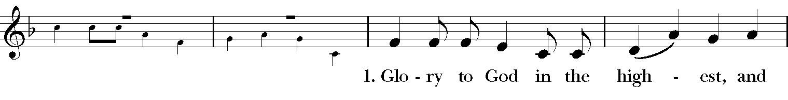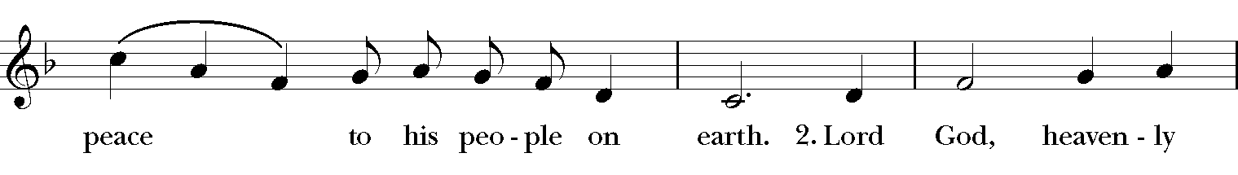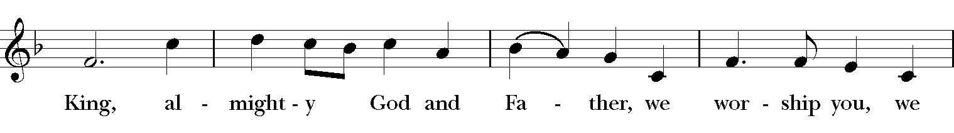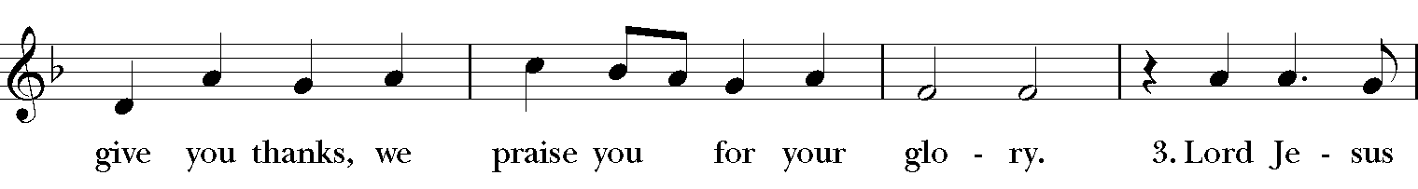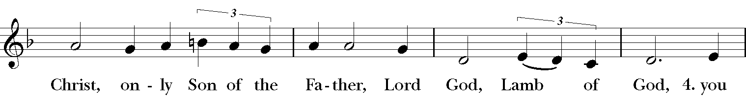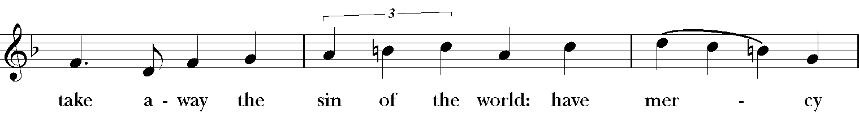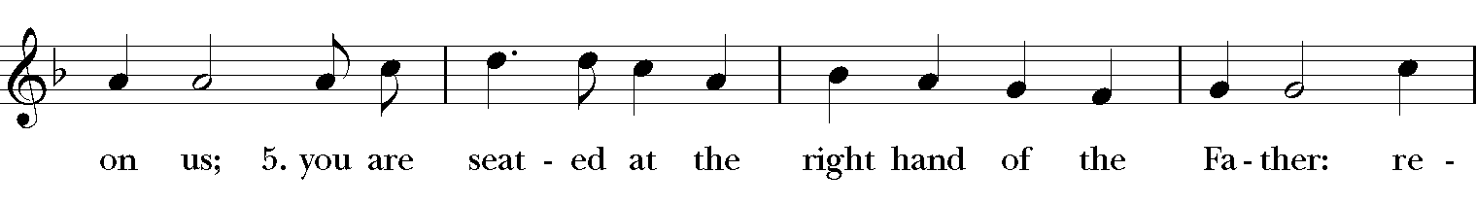
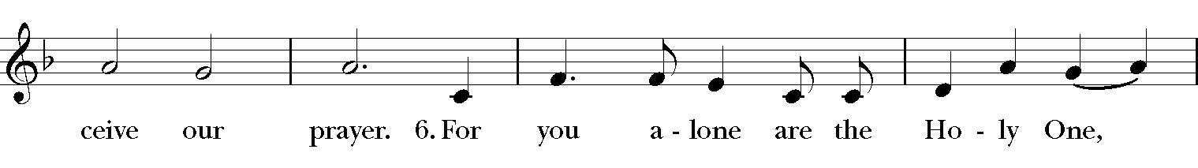
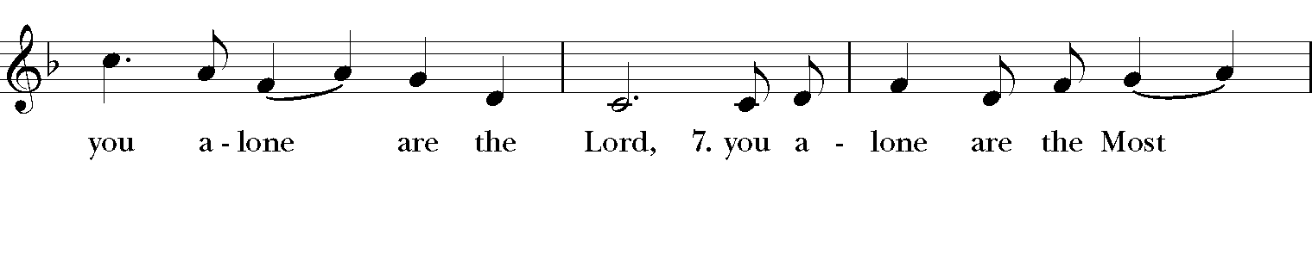
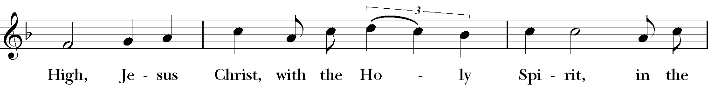
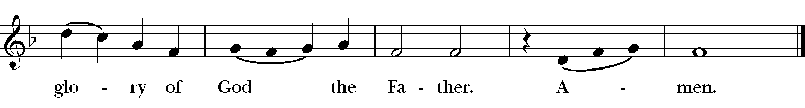

The Collect of the Day

Celebrant: The Lord be with you.
People: And also, with you.

Celebrant: Let us pray.
Almighty God, you have given your only Son to be for us a sacrifice for sin, and also an example of godly life: Give us grace to receive thankfully the fruits of his redeeming work, and to follow daily in the blessed steps of his most holy life; through Jesus Christ your Son our Lord, who lives and reigns with you and the Holy Spirit, one God, now and for ever. Amen.
The First Lesson Jeremiah 23:23-29

Am I a God nearby, says the Lord, and not a God far off? Who can hide in secret places so that I cannot see them? says the Lord. Do I not fill heaven and earth? says the Lord. I have heard what the prophets have said who prophesy lies in my name, saying, "I have dreamed, I have dreamed!" How long? Will the hearts of the prophets ever turn back-- those who prophesy lies, and who prophesy the deceit of their own heart? They plan to make my people forget my name by their dreams that they tell one another, just as their ancestors forgot my name for Baal. Let the prophet who has a dream tell the dream but let the one who has my word speak my word faithfully. What has straw in common with wheat? says the Lord. Is not my word like fire, says the Lord, and like a hammer that breaks a rock in pieces?
Reader: The Word of the Lord.
People: Thanks be to God.

Psalm 82
God takes his stand in the council of heaven; *
"How long will you judge unjustly, *
and show favor to the wicked?
Save the weak and the orphan; *
defend the humble and needy;
Rescue the weak and the poor; *
deliver them from the power of the wicked.
They do not know, neither do they understand;
they go about in darkness; *
all the foundations of the earth are shaken.
Now I say to you, 'You are gods, *
and all of you children of the Most High;
Nevertheless, you shall die like mortals, *
and fall like any prince.'"
Arise, O God, and rule the earth, *
for you shall take all nations for your own.

The Second Lesson Hebrews 11:29-12:2
By faith the people passed through the Red Sea as if it were dry land, but when the Egyptians attempted to do so they were drowned. By faith the walls of Jericho fell after they had been encircled for seven days. By faith Rahab the prostitute did not perish with those who were disobedient, because she had received the spies in peace.
And what more should I say? For time would fail me to tell of Gideon, Barak, Samson, Jephthah, of David and Samuel and the prophets-- who through faith conquered kingdoms, administered justice, obtained promises, shut the mouths of lions, quenched raging fire, escaped the edge of the sword, won strength out of weakness, became mighty in war, put foreign armies to flight. Women received their dead by resurrection. Others were tortured, refusing to accept release, in order to obtain a better resurrection. Others suffered mocking and flogging, and even chains and imprisonment. They were stoned to death, they were sawn in two, they were killed by the sword; they went about in skins of sheep and goats, destitute, persecuted, tormented-- of whom the world was not worthy. They wandered in deserts and mountains, and in caves and holes in the ground.
Yet all these, though they were commended for their faith, did not receive what was promised, since God had provided something better so that they would not, apart from us, be made perfect.
Therefore, since we are surrounded by so great a cloud of witnesses, let us also lay aside every weight and the sin that clings so closely, and let us run with perseverance the race that is set before us, looking to Jesus the pioneer and perfecter of our faith, who for the sake of the joy that was set before him endured the cross, disregarding its shame, and has taken his seat at the right hand of the throne of God.
Reader: The Word of the Lord.
People: Thanks be to God.

The Sequence Hymn “Before thy throne” Hymnal 574

V. 1-2 to be sung before Gospel reading, V. 3-4 to be sung after Gospel reading

Before thy throne, O God, we kneel:
give us a conscience quick to feel,
a ready mind to understand
the meaning of thy chastening hand;
whate’er the pain and shame may be,
bring us, O Father, nearer thee.

Search out our hearts and make us true;
help us to give to all their due.
From love of pleasure, lust of gold,
from sins which make the heart grow cold,
wean us and train us with thy rod;
teach us to know our faults, O God.

For sins of heedless word and deed,
for pride ambitious to succeed,
for crafty trade and subtle snare
to catch the simple unaware,
for lives bereft of purpose high,
forgive, forgive, O Lord, we cry.

Let the fierce fires which burn and try,
our inmost spirits purify:
consume the ill; purge out the shame;
O God, be with us in the flame;
a new-born people may we rise,
more pure, more true, more nobly wise.

William Boyd Carpenter (1841-1918), alt.
This selection is in the public domain.

The Gospel Luke 12:49-56
Gospeler: The Holy Gospel of our Savior Jesus Christ according to Luke.

People: Glory to you, Lord Christ.

Jesus said, "I came to bring fire to the earth, and how I wish it were already kindled! I have a baptism with which to be baptized, and what stress I am under until it is completed! Do you think that I have come to bring peace to the earth? No, I tell you, but rather division! From now on five in one household will be divided, three against two and two against three; they will be divided:
father against son
and son against father,
mother against daughter
and daughter against mother,
mother-in-law against her daughter-in-law
and daughter-in-law against mother-in-law."
He also said to the crowds, "When you see a cloud rising in the west, you immediately say, `It is going to rain'; and so it happens. And when you see the south wind blowing, you say, `There will be scorching heat'; and it happens. You hypocrites! You know how to interpret the appearance of earth and sky, but why do you not know how to interpret the present time?"

Gospeler The Gospel of the Lord.

People Praise to you, Lord Christ.

Please be seated.
The Sermon The Rev. Winston Arthur
The Nicene Creed
All stand, as able

We believe in one God,
the Father, the Almighty,
maker of heaven and earth,
of all that is, seen and unseen.
We believe in one Lord, Jesus Christ,
the only Son of God,
eternally begotten of the Father,
God from God, Light from Light,
true God from true God,
begotten, not made,
of one Being with the Father.
Through him all things were made.
For us and for our salvation
he came down from heaven:
by the power of the Holy Spirit
he became incarnate from the Virgin Mary,
and was made man.
For our sake he was crucified under Pontius Pilate;
he suffered death and was buried.
On the third day he rose again
in accordance with the Scriptures;
he ascended into heaven
and is seated at the right hand of the Father.
He will come again in glory to judge the living and the dead,
and his kingdom will have no end.
We believe in the Holy Spirit, the Lord, the giver of life,
who proceeds from the Father and the Son.
With the Father and the Son he is worshiped and glorified.
He has spoken through the Prophets.
We believe in one holy catholic and apostolic Church.
We acknowledge one baptism for the forgiveness of sins.
We look for the resurrection of the dead,
and the life of the world to come. Amen.

The Prayers of the People

Reader Surrounded by so great a cloud of witnesses, and guided by the perfecter of our faith, let us bring our prayers before God, saying, “Behold your children, and restore us, O God of hosts.”
Inspire in your Church the faithfulness of the saints. Following in their footsteps, may we lay aside every weight and the sin that clings so closely, and run with perseverance the race that is set before us.
Silence
Behold your children,
People And restore us, O God of hosts.
Reader Almighty judge, you rule the earth with your justice and mercy. Save the weak and the orphan; defend the humble and the needy; rescue the weak and the poor; forgive us when we fail to be merciful.
Silence
Behold your children,
People And restore us, O God of hosts.
Reader By your Word, O God, you created the heavens and the earth. By your generosity you continue to cause growth. In your faithfulness you clothe, protect, and sustain your children. We honor you for your creativity and your provision
Invite the congregation to add their thanksgiving
Silence
Behold your children,
People And restore us, O God of hosts.
Reader: Bless all those we have taught us to live faithfully. May our lives also witness to your Son Jesus, the pioneer and perfecter of our faith.
Silence
Behold your children,
People: And restore us, O God of hosts.
Reader: We pray for all who suffer and struggle. May they take comfort in knowing that you are not a God who is far off but you are very near us, even filling heaven and earth. We pray for;
Joyce E., Thelma M., Karia, Laura, Gossett, Jataun, Angela, Clemson, Errol, Barbara P., Edwards, Marcia, Althea, Fronie, Velita, Jackie, Pauline, Kerri, Kaneez, Shahid, Olando, Rick, Trevon, Venita, Basmattie, Floyd, Christine, Dorothy, George, Annie, Ruth, Reece, Ladan, Morris, Deng, Marlene, Deneen, Faye, Ann, Joanne, Bill, Linda, Shaista, Suleman, Naveed, Ardonous, Edna, Royan, Cherrie, Yvonne, Joyce R., Bob, Howard, Jennifer, Yannick, Fatima, Barbara, Beverly, Heather Y., the people of South Sudan, those suffering from Covid-19
Invite the congregation to add their petitions
Silence
Behold your children,
People: And restore us, O God of hosts.
Reader: We pray for all your saints, both famous and obscure, who surround us with their prayers, their encouragement, and their strength. Make us ever mindful of the great company that makes with us our earthly pilgrimage.
Silence
Behold your children,
People: And restore us, O God of hosts.

Reader: And we also bless thy holy Name for all thy servants departed this life in thy faith and fear, especially, the Souls of All Saints, beseeching thee to grant them continual growth in thy love and service; and to grant us grace so to follow the good examples of all thy saints, that with them we may be partakers of thy heavenly kingdom and for this assembly, as we serve the sisters and brothers among us and as we work outside church doors, we pray [Here other intercession may be offered].
Silence
Behold your children,
People And restore us, O God of hosts.

Silence
The Celebrant adds a concluding Collect.

The Confession of Sin BCP 360

Celebrant Let us confess our sins against God and our neighbor.
Celebrant and People
Most merciful God, we confess that we have sinned against you in thought, word, and deed, by what we have done, and by what we have left undone. We have not loved you with our whole heart; we have not loved our neighbors as ourselves. We are truly sorry and we humbly repent. For the sake of your Son Jesus Christ, have mercy on us and forgive us; that we may delight in your will, and walk in your ways, to the glory of your Name. Amen.
The Absolution
Almighty God have mercy on you, forgive you all your sins through our Lord Jesus Christ, strengthen you in all goodness, and by the power of the Holy Spirit keep you in eternal life. Amen.
The Peace
Celebrant The peace of the Lord be always with you.
People And also with you.

The Offertory “ O Holy Spirit breathe on me”
Soloist, Bridget Bristol

THE GREAT THANKSGIVING
The Doxology Tune: "Old 100th"
Celebrant and People
Praise God, from Whom all blessings flow;
Praise Him, all creatures here below;
Praise Him above, ye heav’nly host;
Praise Father, Son, and Holy Ghost. Amen

The Great Thanksgiving: Eucharistic Prayer A BCP 355
All stand, as able
Celebrant The Lord be with you.
People And also with you.
Celebrant Lift up your hearts.
People We lift them to the Lord.
Celebrant Let us give thanks to the Lord our God.
People It is right to give our thanks and praise.
Then, facing the Holy Table, the Celebrant proceeds
It is right, and a good and joyful thing, always and everywhere to give thanks to you, Father Almighty, Creator of heaven and earth.
Therefore, we praise you, joining our voices with Angels and Archangels and with all the company of heaven, who forever sing this hymn to proclaim the glory of your Name:

The Sanctus: Holy, Holy, Holy from Lift Every Voice and Sing 255

Holy, holy, holy, holy, Holy Lord God of hosts.
Heaven and earth are filled with your glo-ry. Hosanna in the high-est.
Blessed is He who comes in the name
Of the Lord, of the Lord.
Ho-sannna in the high-est, Ho-sanna in the high-est.
The Celebrant continues
Holy and gracious Father: In your infinite love you made us for yourself, and, when we had fallen into sin and become subject to evil and death, you, in your mercy, sent Jesus Christ, your only and eternal Son, to share our human nature, to live and die as one of us, to reconcile us to you, the God and Father of all.
He stretched out his arms upon the cross, and offered himself, in obedience to your will, a perfect sacrifice for the whole world.
At the following words concerning the bread, the Celebrant is to hold it, or lay a hand upon it, and at the words concerning the cup, to hold or place a hand upon the cup and any other vessel containing wine to be consecrated.
On the night he was handed over to suffering and death, our Lord Jesus Christ took bread; and when he had given thanks to you, he broke it, and gave it to his disciples, and said, "Take, eat: This is my Body, which is given for you. Do this for the remembrance of me."
After supper he took the cup of wine; and when he had given thanks, he gave it to them, and said, "Drink this, all of you: This is my Blood of the new Covenant, which is shed for you and for many for the forgiveness of sins. Whenever you drink it, do this for the remembrance of me."
Therefore we proclaim the mystery of faith:
Celebrant and People Christ has died. Christ has risen. Christ will come again.
The Celebrant continues
We celebrate the memorial of our redemption, O Father, in this sacrifice of praise and thanksgiving. Recalling his death, resurrection, and ascension, we offer you these gifts.
Sanctify them by your Holy Spirit to be for your people the Body and Blood of your Son, the holy food and drink of new and unending life in him. Sanctify us also that we may faithfully receive this holy Sacrament, and serve you in unity, constancy, and peace; and at the last day bring us with all your saints into the joy of your eternal kingdom.
All this we ask through your Son Jesus Christ: By him, and with him, and in him, in the unity of the Holy Spirit all honor and glory is yours, Almighty Father, now and forever. Amen.
And now, as our Savior Christ has taught us, we are bold to say,
Celebrant and People
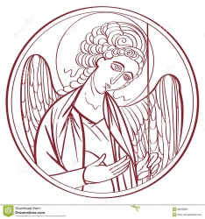
The Lord’s Prayer

Our Father, who art in heaven,
hallowed be thy Name,
thy kingdom come,
thy will be done, on earth as it is in heaven.
Give us this day our daily bread.
And forgive us our trespasses,
As we forgive those
who trespass against us
And lead us not into temptation,
but deliver us from evil.
For thine is the kingdom, and the power, and the glory for ever and ever. Amen.
The Breaking of the Bread
Celebrant Alleluia. Christ our Passover is sacrificed for us
People Therefore let us keep the feast. Alleluia.

The Fraction Anthem Celebrant and People
O Lamb of God, that takest away the sins of the world, have mercy upon us.
O Lamb of God, that takest away the sins of the world, have mercy upon us.
O Lamb of God, that takest away the sins of the world, grant us thy peace.

The Invitation
The gifts of God for the people of God. Take them in remembrance that Christ died for you, and feed on him in your hearts by faith, with thanksgiving.

The Communion of the People
All God’s people are welcome to share in the banquet of the Holy Eucharist, in one kind. If you prefer to receive a blessing instead of Communion, cross your hands across your chest.

The Communion Hymns
“Thou, who at thy first Eucharist” Hymnal 315
Thou, who at thy first Eucharist didst pray
that all thy Church might be for ever one,
grant us at every Eucharist to say
with longing heart and soul, ‘Thy will be done.’
O may we all one bread, one body be,
through this blest sacrament of unity.

For all thy Church, O Lord, we intercede;
make thou our sad divisions soon to cease;
draw us the nearer each to each, we plead,
by drawing all to thee, O Prince of Peace;
thus may we all one bread, one body be,
through this blest sacrament of unity.

So, Lord, at length when sacraments shall cease,
may we be one with all thy Church above,
one with thy saints in one unbroken peace,
one with thy saints in one unbounded love;
more blessed still, in peace and love to be
one with the Trinity in Unity.

William Harry Turton (1856-1938)

“If Thou but trust in God to guide me” Hymnal 635
If thou but trust in God to guide thee,
and hope in him through all thy ways,
he’ll give thee strength whate’er betide thee,
and bear thee through the evil days.
Who trusts in God’s unchanging love
builds on a rock that nought can move.

Sing, pray, and keep his ways unswerving;
so do thine own part faithfully,
and trust his word, though undeserving;
thou yet shalt find it true for thee;
God never yet forsook in need
the soul that trusted him indeed.

Georg Neumark (1621-1681); tr. Catherine Winkworth (1829-1878), alt.
This selection is in the public domain.

The Post Communion Prayer
Eternal God, heavenly Father, you have graciously accepted us as living members of your Son our Savior Jesus Christ, and you have fed us with spiritual food in the Sacrament of his Body and Blood. Send us now into the world in peace and grant us strength and courage to love and serve you with gladness and singleness of heart, through Christ our Lord. Amen.

The Blessing
Finally, beloved, whatever is true, whatever is honorable, whatever is just, whatever is pure, whatever is pleasing, whatever is commendable, if there is any excellence and if there is anything worthy of praise, think about these things; and the blessing of God Almighty, the Father, the Son, and the Holy Spirit, be amongst you, and remain with you always. Amen.

The Parish Announcements

At the Procession into the World

The Closing Hymn “Judge eternal, throned in splendor” Hymnal 596

Judge eternal, throned in splendor,
Lord of lords and King of kings,
with thy living fire of judgment
purge this land of bitter things;
solace all its wide dominion
with the healing of thy wings.

Still the weary folk are pining
for the hour that brings release,
and the city’s crowded clangor
cries aloud for sin to cease;
and the homesteads and the woodlands
plead in silence for their peace.

Crown, O God, thine own endeavor;
cleave our darkness with thy sword;
feed all those who do not know thee
with the richness of thy word;
cleanse the body of this nation
through the glory of the Lord.

Henry Scott Holland (1847-1918), alt.
This selection is in the public domain.

The Dismissal
Celebrant: Let us go forth into the world rejoicing in the power of the Spirit
People: Thanks be to God.

Postlude “ Prelude & Fugue in G” J. S. Bach

Copyright Permissions
Permission to print and stream music in this service obtained from ONE LICENSE # A-715408.
All rights reserved.

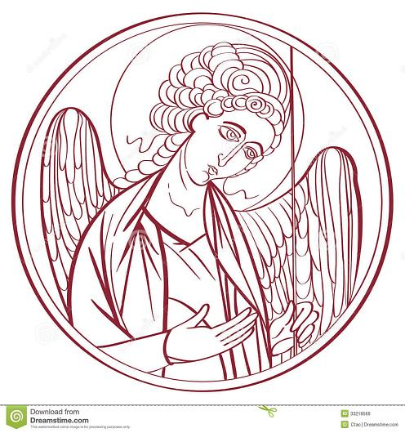

The Mission of the Church is the Mission of Christ
(The Five Marks of Mission)
Tell • To proclaim the Good News of the Kingdom.
Teach • To teach, baptize and nurture new believers.
Tend • To respond to human need by loving service.
Transform • To seek to transform unjust structures of society,
to challenge violence of every kind and to pursue peace and
reconciliation.
Treasure • To strive to safeguard the integrity of creation and
sustain and renew the life of the earth.

Rector – Father R. Winston Arthur
Choir Director – Dawn-Marie James
Organist – Bradley Phillips
Finance Clerk – Charlene Smith
Custodian – John Lam

