St. Michael and All Angels Episcopal Church
The Episcopal Diocese of Atlanta
The Sunday of the Passion: Palm Sunday
April 13, 2025



OUR PURPOSE AT ST. MICHAEL AND ALL ANGELS

TO CARE FOR OUR CHURCH FAMILY WITH MUTUAL LOVE AND SUPPORT

TO PARTICIPATE, LEARN AND SERVE IN OUR NEIGHBORING COMMUNITIES

TO ENRICH AND SHARE OUR GROWING SPIRITUALITY, RICH DIVERSITY, WELCOMING FELLOWSHIP, JOYFUL WORSHIP AND LOVING CARE

TO INVITE NEIGHBORS INTO OUR CHURCH FAMILY IN OUR COMMITMENT TO SEEK AND SERVE CHRIST IN ALL PERSONS

6780 James B Rivers Drive
Stone Mountain, Georgia 30083
Telephone: 770-469-8551
Email: admin@stmichaelstonemountain.org
Website: www.stmichaelstonemountain.org
Office Hours: Monday-Thursday 9:00 A.M. to 3:00 P.M.
Canon John Thompson-Quartey office hours-Monday to Wednesday, by appointment
Canon John Thompson-Quartey telephone 404-889-2131
The Liturgy of the Palms and Holy Eucharist Rite II at 10:30 AM
April 13, 2025
The Ringing of the bell
Please refer to the Hymnal in the pews for the musical selections
The Liturgy of the Palms
The Opening Acclamation
Celebrant Blessed is the King who comes in the name of the Lord.
People Peace in heaven and glory in the highest.
Celebrant Let us pray.
Assist us mercifully with your help, O Lord God of our salvation, that we may enter with joy upon the contemplation of those mighty acts, whereby you have given us life and immortality; through Jesus Christ our Lord. Amen.

Luke 19:28-40
After telling a parable to the crowd at Jericho, Jesus went on ahead, going up to Jerusalem. When he had come near Bethphage and Bethany, at the place called the Mount of Olives, he sent two of the disciples, saying, "Go into the village ahead of you, and as you enter it you will find tied there a colt that has never been ridden. Untie it and bring it here. If anyone asks you, 'Why are you untying it?' just say this, 'The Lord needs it.'" So those who were sent departed and found it as he had told them. As they were untying the colt, its owners asked them, "Why are you untying the colt?" They said, "The Lord needs it." Then they brought it to Jesus; and after throwing their cloaks on the colt, they set Jesus on it. As he rode along, people kept spreading their cloaks on the road. As he was now approaching the path down from the Mount of Olives, the whole multitude of the disciples began to praise God joyfully with a loud voice for all the deeds of power that they had seen, saying,
"Blessed is the king
who comes in the name of the Lord!
Peace in heaven,
and glory in the highest heaven!"
Some of the Pharisees in the crowd said to him, "Teacher, order your disciples to stop." He answered, "I tell you, if these were silent, the stones would shout out."
The Celebrant then says the following blessing
Celebrant The Lord be with you.
People And also with you.
Celebrant Let us give thanks to the Lord our God.
People It is right to give God thanks and praise

Celebrant
It is right to praise you, Almighty God, for the acts of love by which you have redeemed us through your Son Jesus Christ our Lord. On this day he entered the holy city of Jerusalem in triumph, and was proclaimed as King of kings by those who spread their garments and branches of palm along his way. Let these branches be for us signs of his victory, and grant that we who bear them in his name may ever hail him as our King, and follow him in the way that leads to eternal life; who lives and reigns in glory with you and the Holy Spirit, now and for ever. Amen.

Celebrant Blessed is he who comes in the name of the Lord.
People Hosanna in the highest.
Celebrant Let us go forth in peace.
People In the name of Christ. Amen.

The palms are distributed, and the people process to the church door from the car park, singing:

Procession “When the saints go marching in”

1.
Oh, when the saints (oh, when the saints)
Go marching in, (go marching in)
Oh, when the saints go marching in,
Oh, yes, I want to be in that number
(in that number)
When the saints go marching in.

2.
Up where the streets (up where the streets)
Are paved with gold, (are paved with gold)
Up where the streets are paved with gold,
Oh, yes, I want to be in that number
(in that number)
Where the streets are paved with gold.
3.
We’ll dwell in peace (we’ll dwell in peace)
Forever more, (forever more)
We’ll dwell in peace forever more.
Oh, yes, I want to be in that number (in that number)
Dwell in peace forever more.

At the door to the church, the Celebrant prays
Almighty God, whose most dear Son went not up to joy but first he suffered pain, and entered not into glory before he was crucified: Mercifully grant that we, walking in the way of the cross, may find it none other than the way of life and peace; through Jesus Christ our Lord. Amen

The Opening Hymn “All Glory, Laud and Honor” Hymnal 154

All glory, laud, and honor
to thee, Redeemer, King!
to whom the lips of children
made sweet hosannas ring.

Thou art the King of Israel,
thou David’s royal Son,
who in the Lord’s Name comest,
the King and Blesséd One.

The company of angels
is praising thee on high;
and we with all creation
in chorus make reply.

The people of the Hebrews
with palms before thee went;
our praise and prayers and anthems
before thee we present.

To thee before thy passion
they sang their hymns of praise;
to thee, now high exalted,
our melody we raise.

Thou didst accept their praises;
accept the prayers we bring,
who in all good delightest,
thou good and gracious King.

The Collect of the Day
Celebrant The Lord be with you.
People And also with you.
Celebrant Let us pray
Almighty and everliving God, in your tender love for the human race you sent your Son our Savior Jesus Christ to take upon him our nature, and to suffer death upon the cross, giving us the example of his great humility: Mercifully grant that we may walk in the way of his suffering, and also share in his resurrection; through Jesus Christ our Lord, who lives and reigns with you and the Holy Spirit, one God, for ever and ever. Amen.

The First Lesson is taken from the book of Isaiah

The Lord God has given me the tongue of a teacher,
that I may know how to sustain the weary with a word.

Morning by morning he wakens--wakens my ear to listen as those who are taught.
The Lord God has opened my ear, and I was not rebellious, I did not turn backward.
I gave my back to those who struck me, and my cheeks to those who pulled out the beard;
I did not hide my face from insult and spitting.

The Lord God helps me; therefore I have not been disgraced;
therefore I have set my face like flint, and I know that I shall not be put to shame;
he who vindicates me is near. Who will contend with me? Let us stand up together.
Who are my adversaries? Let them confront me. It is the Lord God who helps me;
who will declare me guilty?

Reader The Word of the Lord.
People Thanks be to God.

Psalm 31:9-16

9 Have mercy on me, O Lord, for I am in trouble; *
my eye is consumed with sorrow,
and also my throat and my belly.
10 For my life is wasted with grief,
and my years with sighing; *
my strength fails me because of affliction,
and my bones are consumed.
11 I have become a reproach to all my enemies and even to my neighbors,
a dismay to those of my acquaintance; *
when they see me in the street they avoid me.
12 I am forgotten like a dead man, out of mind; *
I am as useless as a broken pot.
13 For I have heard the whispering of the crowd;
fear is all around; *
they put their heads together against me;
they plot to take my life.
14 But as for me, I have trusted in you, O Lord. *
I have said, "You are my God.
15 My times are in your hand; *
rescue me from the hand of my enemies,
and from those who persecute me.
16 Make your face to shine upon your servant, *
and in your loving-kindness save me."

The Second Lesson is taken from Paul’s letter to the Philippians
Let the same mind be in you that was in Christ Jesus, who, though he was in the form of God, did not regard equality with God as something to be exploited, but emptied himself,
taking the form of a slave, being born in human likeness.
And being found in human form, he humbled himself and became obedient to the point of death--even death on a cross.
Therefore God also highly exalted him and gave him the name that is above every name,
so that at the name of Jesus every knee should bend, in heaven and on earth and
under the earth, and every tongue should confess that Jesus Christ is Lord,
to the glory of God the Father.

Reader The Word of the Lord.
People Thanks be to God.
The Sequence Hymn “To mock your reign” Hymnal 170

The Gospel Luke 22:14-23:56
The Passion According to Luke
The congregation remains seated.
NARRATOR: When the hour for the Passover meal came, Jesus took his place at the table, and the apostles with him. He said to them,
JESUS: "I have eagerly desired to eat this Passover with you before I suffer; for I tell you, I will not eat it until it is fulfilled in the kingdom of God."
NARRATOR: Then he took a cup, and after giving thanks he said,
JESUS: "Take this and divide it among yourselves; for I tell you that from now on I will not drink of the fruit of the vine until the kingdom of God comes."
NARRATOR: Then he took a loaf of bread, and when he had given thanks, he broke it and gave it to them, saying,
JESUS: "This is my body, which is given for you. Do this in remembrance of me."
NARRATOR: And he did the same with the cup after supper, saying,
JESUS: "This cup that is poured out for you is the new covenant in my blood. But see, the one who betrays me is with me, and his hand is on the table. For the Son of Man is going as it has been determined, but woe to that one by whom he is betrayed!"
NARRATOR: Then they began to ask one another, which one of them it could be who would do this.
A dispute also arose among them as to which one of them was to be regarded as the greatest. But he said to them,

JESUS: "The kings of the Gentiles lord it over them; and those in authority over them are called benefactors. But not so with you; rather the greatest among you must become like the youngest, and the leader like one who serves. For who is greater, the one who is at the table or the one who serves? Is it not the one at the table? But I am among you as one who serves.
"You are those who have stood by me in my trials; and I confer on you, just as my Father has conferred on me, a kingdom, so that you may eat and drink at my table in my kingdom, and you will sit on thrones judging the twelve tribes of Israel.
"Simon, Simon, listen! Satan has demanded to sift all of you like wheat, but I have prayed for you that your own faith may not fail; and you, when once you have turned back, strengthen your brothers."
NARRATOR: And he said to him,
PETER: "Lord, I am ready to go with you to prison and to death!"
NARRATOR: Jesus said,
JESUS: "I tell you, Peter, the cock will not crow this day, until you have denied three times that you know me."
NARRATOR: He said to them,
JESUS: "When I sent you out without a purse, bag, or sandals, did you lack anything?"
NARRATOR: They said,
DISCIPLES: "No, not a thing."
NARRATOR: He said to them,
JESUS: "But now, the one who has a purse must take it, and likewise a bag. And the one who has no sword must sell his cloak and buy one. For I tell you, this scripture must be fulfilled in me, `And he was counted among the lawless'; and indeed what is written about me is being fulfilled."
NARRATOR: They said,
DISCIPLES: "Lord, look, here are two swords."
NARRATOR: He replied,
JESUS: "It is enough."
NARRATOR: He came out and went, as was his custom, to the Mount of Olives; and the disciples followed him. When he reached the place, he said to them,
JESUS: "Pray that you may not come into the time of trial."
NARRATOR: Then he withdrew from them about a stone's throw, knelt down, and prayed,
JESUS: "Father, if you are willing, remove this cup from me; yet, not my will but yours be done."
NARRATOR: Then an angel from heaven appeared to him and gave him strength. In his anguish he prayed more earnestly, and his sweat became like great drops of blood falling down on the ground. When he got up from prayer, he came to the disciples and found them sleeping because of grief, and he said to them,
JESUS: "Why are you sleeping? Get up and pray that you may not come into the time of trial."
NARRATOR: While he was still speaking, suddenly a crowd came, and the one called Judas, one of the twelve, was leading them. He approached Jesus to kiss him; but Jesus said to him,
JESUS: "Judas, is it with a kiss that you are betraying the Son of Man?"
NARRATOR: When those who were around him saw what was coming, they asked,
DISCIPLES: "Lord, should we strike with the sword?"
NARRATOR: Then one of them struck the slave of the high priest and cut off his right ear. But Jesus said,
JESUS: "No more of this!"
NARRATOR: And he touched his ear and healed him. Then Jesus said to the chief priests, the officers of the temple police, and the elders who had come for him,
JESUS: "Have you come out with swords and clubs as if I were a bandit? When I was with you day after day in the temple, you did not lay hands on me. But this is your hour, and the power of darkness!"
NARRATOR: Then they seized him and led him away, bringing him into the high priest's house. But Peter was following at a distance. When they had kindled a fire in the middle of the courtyard and sat down together, Peter sat among them. Then a servant-girl, seeing him in the firelight, stared at him and said,
SERVANT 1: "This man also was with him."
NARRATOR: But he denied it, saying,
PETER: "Woman, I do not know him."
NARRATOR: A little later someone else, on seeing him, said,
ACCUSER 1: "You also are one of them."
NARRATOR: But Peter said,
PETER: "Man, I am not!"
NARRATOR: Then about an hour later still another kept insisting,
ACCUSER 2: "Surely this man also was with him; for he is a Galilean."
NARRATOR: But Peter said,
PETER: "Man, I do not know what you are talking about!"
NARRATOR: At that moment, while he was still speaking, the cock crowed. The Lord turned and looked at Peter. Then Peter remembered the word of the Lord, how he had said to him, "Before the cock crows today, you will deny me three times." And he went out and wept bitterly.
Now the men who were holding Jesus began to mock him and beat him; they also blindfolded him and kept asking him,
SOLDIERS: "Prophesy! Who is it that struck you?"
NARRATOR: They kept heaping many other insults on him.
When day came, the assembly of the elders of the people, both chief priests and scribes, gathered together, and they brought him to their council. They said,
ASSEMBLY: "If you are the Messiah, tell us."
NARRATOR: He replied,
JESUS: "If I tell you, you will not believe; and if I question you, you will not answer. But from now on the Son of Man will be seated at the right hand of the power of God."
NARRATOR: All of them asked,
ASSEMBLY: "Are you, then, the Son of God?"
NARRATOR: He said to them,
JESUS: "You say that I am."
NARRATOR: Then they said,
ASSEMBLY: "What further testimony do we need? We have heard it ourselves from his own lips!"
NARRATOR: Then the assembly rose as a body and brought Jesus before Pilate. They began to accuse him, saying,
ASSEMBLY: "We found this man perverting our nation, forbidding us to pay taxes to the emperor, and saying that he himself is the Messiah, a king."
NARRATOR: Then Pilate asked him,
PILATE: "Are you the king of the Jews?"
NARRATOR: He answered,
JESUS: "You say so."
NARRATOR: Then Pilate said to the chief priests and the crowds,
PILATE: "I find no basis for an accusation against this man."
NARRATOR: But they were insistent and said,
ASSEMBLY: "He stirs up the people by teaching throughout all Judea, from Galilee where he began even to this place."
NARRATOR: When Pilate heard this, he asked whether the man was a Galilean. And when he learned that he was under Herod's jurisdiction, he sent him off to Herod, who was himself in Jerusalem at that time. When Herod saw Jesus, he was very glad, for he had been wanting to see him for a long time, because he had heard about him and was hoping to see him perform some sign. He questioned him at some length, but Jesus gave him no answer. The chief priests and the scribes stood by, vehemently accusing him. Even Herod with his soldiers treated him with contempt and mocked him; then he put an elegant robe on him, and sent him back to Pilate. That same day Herod and Pilate became friends with each other; before this they had been enemies.
Pilate then called together the chief priests, the leaders, and the people, and said to them,
PILATE: "You brought me this man as one who was perverting the people; and here I have examined him in your presence and have not found this man guilty of any of your charges against him. Neither has Herod, for he sent him back to us. Indeed, he has done nothing to deserve death. I will therefore have him flogged and release him."
NARRATOR: Then they all shouted out together,
ASSEMBLY: "Away with this fellow! Release Barabbas for us!"
NARRATOR: (This was a man who had been put in prison for an insurrection that had taken place in the city, and for murder.) Pilate, wanting to release Jesus, addressed them again; but they kept shouting,
ASSEMBLY: "Crucify, crucify him!"
NARRATOR: A third time he said to them,
PILATE: "Why, what evil has he done? I have found in him no ground for the sentence of death; I will therefore have him flogged and then release him."
NARRATOR: But they kept urgently demanding with loud shouts that he should be crucified; and their voices prevailed. So Pilate gave his verdict that their demand should be granted. He released the man they asked for, the one who had been put in prison for insurrection and murder, and he handed Jesus over as they wished.
As they led him away, they seized a man, Simon of Cyrene, who was coming from the country, and they laid the cross on him, and made him carry it behind Jesus. A great number of the people followed him, and among them were women who were beating their breasts and wailing for him. But Jesus turned to them and said,
JESUS: "Daughters of Jerusalem, do not weep for me, but weep for yourselves and for your children. For the days are surely coming when they will say, 'Blessed are the barren, and the wombs that never bore, and the breasts that never nursed.' Then they will begin to say to the mountains, 'Fall on us'; and to the hills, 'Cover us.' For if they do this when the wood is green, what will happen when it is dry?"

(At the mention of the place called the Skull, all should stand, as able.)
NARRATOR: Two others also, who were criminals, were led away to be put to death with him. When they came to the place that is called The Skull, they crucified Jesus there with the criminals, one on his right and one on his left. Then Jesus said,
JESUS: "Father, forgive them; for they do not know what they are doing."
NARRATOR: And they cast lots to divide his clothing. And the people stood by, watching; but the leaders scoffed at him, saying,
ASSEMBLY: "He saved others; let him save himself if he is the Messiah of God, his chosen one!"
NARRATOR: The soldiers also mocked him, coming up and offering him sour wine, and saying,
SOLDIERS: "If you are the King of the Jews, save yourself!"
NARRATOR: There was also an inscription over him, "This is the King of the Jews."
One of the criminals who were hanged there kept deriding him and saying,
CRIMINAL 1: "Are you not the Messiah? Save yourself and us!"
NARRATOR: But the other rebuked him, saying,
CRIMINAL 2: "Do you not fear God, since you are under the same sentence of condemnation? And we indeed have been condemned justly, for we are getting what we deserve for our deeds, but this man has done nothing wrong."
NARRATOR: Then he said,
CRIMINAL 2: "Jesus, remember me when you come into your kingdom."
NARRATOR: He replied,
JESUS: "Truly I tell you, today you will be with me in Paradise."
NARRATOR: It was now about noon, and darkness came over the whole land until three in the afternoon, while the sun's light failed; and the curtain of the temple was torn in two. Then Jesus, crying with a loud voice, said,
JESUS: "Father, into your hands I commend my spirit."
NARRATOR: Having said this, he breathed his last. When the centurion saw what had taken place, he praised God and said,
CENTURION: "Certainly this man was innocent."
NARRATOR: And when all the crowds who had gathered there for this spectacle saw what had taken place, they returned home, beating their breasts. But all his acquaintances, including the women who had followed him from Galilee, stood at a distance, watching these things.
Now there was a good and righteous man named Joseph, who, though a member of the council, had not agreed to their plan and action. He came from the Jewish town of Arimathea, and he was waiting expectantly for the kingdom of God. This man went to Pilate and asked for the body of Jesus. Then he took it down, wrapped it in a linen cloth, and laid it in a rock-hewn tomb where no one had ever been laid. It was the day of Preparation, and the sabbath was beginning. The women who had come with him from Galilee followed, and they saw the tomb and how his body was laid. Then they returned, and prepared spices and ointments.
On the sabbath they rested according to the commandment.

The Bible text is from the New Revised Standard Version Bible, copyright 1989 by the Division of Christian Education of the National Council of the Churches of Christ in the USA, and used by permission.
The Homily The Rev. Canon John Thompson-Quartey
The Prayers of the People

As we journey this week with Christ and celebrate the paschal mystery of his death and resurrection, let us earnestly pray to God for those following the way of the cross and for all people everywhere, according to their needs; saying: Lord, have mercy.

Reader For the whole church throughout the world, its’ bishops, clergy, and all the baptized, let us pray to the Lord;
People Lord, have mercy.

Reader For peace among nations and forbearance among all people, let us pray to the Lord;
People Lord, have mercy.

Reader For this assembly as we walk the road towards the cross, let us pray to the Lord;
People Lord, have mercy.

Reader For the weary and the sick and for those who are consumed with sorrow, especially those named here:

(Let us engage in a moment of quiet contemplation as we silently pray for the following people)
Lisa, Kenroy, Ariel, Brad, Jim, Sandra, Marlene, Cynthia, Lili, Audrey, Lovell, Andre, Dorita, Aaron, Angela, Caleb and Everil, Leo T Sr., Arthur, Dawn J., Yannick, Errol, Ann, Janis, Carline, Leslyn, Allison, Godfrey, Olga, Rachel, Jaye, Corey, Pauline, Dorothy, George, Ladan, Morris, Faye, Beverly, the peoples of South Sudan, Congo, Ukraine, Palestine, for the innocent souls who have been affected by the ongoing conflicts.
And for all those who, in this transitory life, are in trouble, sorrow, need, sickness,
or any other adversity, and for the special needs and concerns of this congregation, let us pray to the Lord;
People Lord, have mercy.

Reader We give thanks for all the departed who had the mind of Christ and were humble servants of God. For ourselves, that we may be obedient even unto death, let us pray to the Lord;
People Lord, have mercy.

Reader Into your hands, O God, we commend ourselves and all for whom we pray, through your son Jesus Christ our Lord. Amen.
The Peace
Celebrant The peace of the Lord be always with you.
People And also with you.

The Offertory “Ain’t no rock gonna” by J. Paul Williams and Lloyd Larson

THE HOLY COMMUNION
The Doxology [sung] Tune: "Old 100th"
Celebrant and People
Praise God, from Whom all blessings flow;
Praise Him, all creatures here below;
Praise Him above, ye heav’nly host;
Praise Father, Son, and Holy Ghost. Amen.

THE GREAT THANKSGIVING
Eucharistic Prayer A
Celebrant | The Lord be with you.
People | And also with you.
Celebrant | Lift up your hearts.
People | We lift them to the Lord.
Celebrant | Let us give thanks to the Lord our God.
People | It is right to give him thanks and praise.
Then, facing the Holy Table, the Celebrant proceeds
It is right, and a good and joyful thing, always and every-
where to give thanks to you, Father Almighty, Creator of
heaven and earth.
Through Jesus Christ our Lord. For our sins he was lifted high
upon the cross, that he might draw the whole world to
himself; and, by his suffering and death, he became the
source of eternal salvation for all who put their trust in him.
Therefore we praise you, joining our voices with Angels and
Archangels and with all the company of heaven, who for ever
sing this hymn to proclaim the glory of your Name:
The Sanctus: Holy, Holy, Holy S130
Celebrant and People
Holy, holy, holy Lord, God of power and might,
heaven and earth are full of your glory.
Hosanna in the highest.
Blessed is he who comes in the name of the Lord.
Hosanna in the highest.
The Celebrant continues

Holy and gracious Father: In your infinite love you made us
for yourself, and, when we had fallen into sin and become
subject to evil and death, you, in your mercy, sent Jesus
Christ, your only and eternal Son, to share our human
nature, to live and die as one of us, to reconcile us to you, the
God and Father of all.
He stretched out his arms upon the cross, and offered himself,
in obedience to your will, a perfect sacrifice for the whole
world.

On the night he was handed over to suffering and death, our
Lord Jesus Christ took bread; and when he had given thanks
to you, he broke it, and gave it to his disciples, and said, "Take,
eat: This is my Body, which is given for you. Do this for the
remembrance of me."

After supper he took the cup of wine; and when he had given
thanks, he gave it to them, and said, "Drink this, all of you:
This is my Blood of the new Covenant, which is shed for you
and for many for the forgiveness of sins. Whenever you drink
it, do this for the remembrance of me."
Therefore we proclaim the mystery of faith:

Celebrant and People
Christ has died.
Christ is risen.
Christ will come again.

The Celebrant continues
We celebrate the memorial of our redemption, O Father, in
this sacrifice of praise and thanksgiving. Recalling his death,
resurrection, and ascension, we offer you these gifts.
Sanctify them by your Holy Spirit to be for your people the
Body and Blood of your Son, the holy food and drink of new
and unending life in him. Sanctify us also that we may faithfully
receive this holy Sacrament, and serve you in unity, constancy,
and peace; and at the last day bring us with all your saints
into the joy of your eternal kingdom.
All this we ask through your Son Jesus Christ: By him, and
with him, and in him, in the unity of the Holy Spirit all honor
and glory is yours, Almighty Father, now and for ever. AMEN.

And now, as our Savior Christ has taught us, we are bold to say,
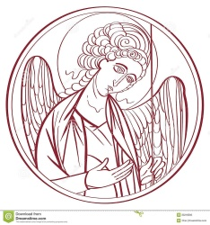
The Lord’s Prayer
Celebrant and People

Our Father, who art in heaven,
hallowed be thy Name,
thy kingdom come,
thy will be done,
on earth as it is in heaven.
Give us this day our daily bread.
And forgive us our trespasses,
as we forgive those
who trespass against us.
And lead us not into temptation,
but deliver us from evil.
For thine is the kingdom,
and the power, and the glory,
for ever and ever. Amen.

The Breaking of the Bread
Celebrant Christ our Passover is sacrificed for us;
People Therefore let us keep the feast.

The Fraction Anthem Celebrant and People S-164

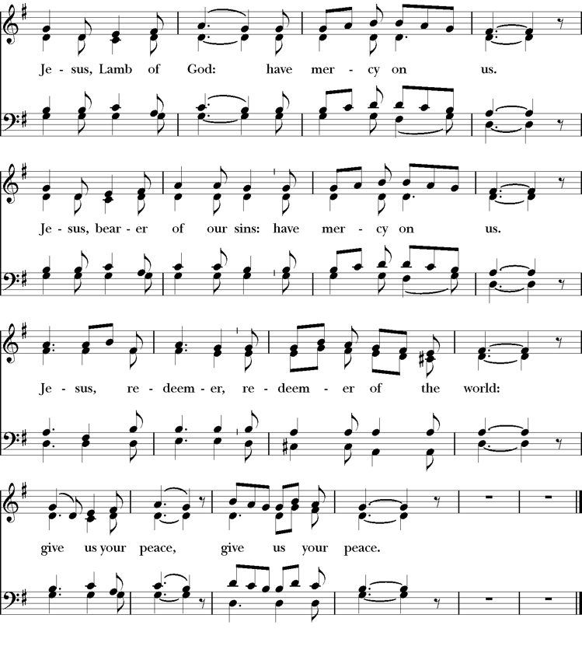

The Invitation
The gifts of God for the people of God. Take them in remembrance that Christ died for you, and feed on him in your hearts by faith, with thanksgiving.

The Communion of the People
All God’s people are welcome to share in the banquet of the Holy Eucharist, in one kind. If you prefer to receive a blessing instead of Communion, cross your hands across your chest.

The First Communion Hymn “My song is love unknown” Hymnal 458

The Second Communion Hymn “Lead me to Calvary” LEVAS 31

King of my life I crown thee now,
Thine shall the glory be;
Lest I forget thy thorn-crowned brow,
Lead me to Calvary.
Refrain
Lest I forget Gethsemane,
Lest I forget thine agony,
Lest I forget thy love for me,
Lead me to Calvary.

Show me the tomb where thou wast laid,
Tenderly mourned and wept;
Angels in robes of light arrayed

Guarded thee whilst Thou slept. Refrain

Let me, like Mary, through the gloom,
Come with a gift to thee;
Show to me now the empty tomb,
Lead me to Calvary. Refrain

May I be willing, Lord, to bear
Daily my cross for thee;
Even thy cup of grief to share
Thou hast borne all for me. Refrain

The Post Communion Prayer
Eternal God, heavenly Father, you have graciously accepted us as living members of your Son our Savior Jesus Christ, and you have fed us with spiritual food in the Sacrament of his Body and Blood. Send us now into the world in peace, and grant us strength and courage to love and serve you with gladness and singleness of heart; through Christ our Lord. Amen.

The Blessing
Almighty God, we pray you graciously to behold this your family, for whom our Lord Jesus Christ was willing to be betrayed, and given into the hands of sinners, and to suffer death upon the cross; who lives and reigns for ever and ever. And the blessing of God Almighty, the Father, the Son, and the Holy Spirit, be upon you and remain with you for ever. Ame

The Parish Announcements

A warm welcome to anyone worshipping with us for the first time.
SMAA Community Outreach Easter Egg Hunt Saturday April 19th, noon-4pm.
Easter Sunday Potluck in Hensler Hall immediately following 10:00 AM service.
Advanced Planning Empowerment Seminar presented by Roosevelt Harden
Saturday April 26th 10AM-NOON

Mandatory Teller Training Sunday, May 4th immediately following 10:30 AM service.
Please refer to the weekly E-Blast for more details.
AT THE PROCESSION INTO THE WORLD
The Closing Hymn “When I survey the wondrous cross” Hymnal 474
The Dismissal
Celebrant: Let us bless the Lord.
People: Thanks be to God.

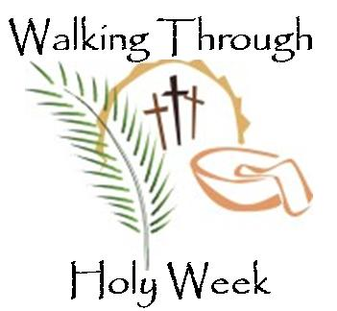

Maundy Thursday, April 17
Agape Supper and Foot Washing
at 6 pm
Followed by Stripping of the Altar

Good Friday, April 18
Stations of the Cross at 12 pm
Outdoor Service, in carpark by Hensler Hall
The Veneration of the Cross at 7:00 p.m.

Easter Sunday, April 20
Sunrise Easter Vigil at 6:00 a.m.
Easter Service at 10:00 a.m.

Copyright Permissions
Permission to print and stream music in this service obtained from ONE LICENSE # A-715408.
All rights reserved.
S 96 - Copyright © 1985 GIA Publications, Inc.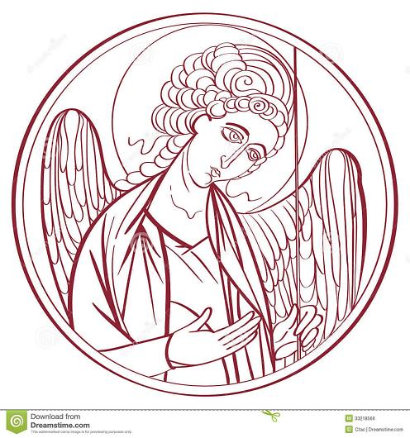
The Mission of the Church is the Mission of Christ
(The Five Marks of Mission)
Tell • To proclaim the Good News of the Kingdom.
Teach • To teach, baptize and nurture new believers.
Tend • To respond to human need by loving service.
Transform • To seek to transform unjust structures of society,
to challenge violence of every kind and to pursue peace and
reconciliation.
Treasure • To strive to safeguard the integrity of creation and
sustain and renew the life of the earth.

Celebrant & Interim Rector– The Rev. Canon John Thompson-Quartey

Assisting Clergy – Rev. John Manyuon Aroch (South Sudan Community)

Seminarian – Cheyne Collier

Choir Director – Dawn-Marie James

Supply Organist – Bennett Craft

Finance Clerk – Charlene Smith

Custodian – John Lam

Parish Administrator - Heather Cutting

