St. Michael and All Angels Episcopal Church
The Episcopal Diocese of Atlanta
Eighth Sunday After Pentecost
July 31, 2022



OUR PURPOSE AT ST. MICHAEL AND ALL ANGELS

TO CARE FOR OUR CHURCH FAMILY WITH MUTUAL LOVE AND SUPPORT

TO PARTICIPATE, LEARN AND SERVE IN OUR NEIGHBORING COMMUNITIES

TO ENRICH AND SHARE OUR GROWING SPIRITUALITY, RICH DIVERSITY, WELCOMING FELLOWSHIP, JOYFUL WORSHIP AND LOVING CARE

TO INVITE NEIGHBORS INTO OUR CHURCH FAMILY IN OUR COMMITMENT TO SEEK AND SERVE CHRIST IN ALL PERSONS

6780 James B Rivers Drive
Stone Mountain, Georgia 30083
Telephone: 770-469-8551
Email: admin@stmichaelstonemountain.org
Website: www.stmichaelstonemountain.org
Office Hours: Monday-Thursday 9:00 A.M. to 2:00 P.M.
Father Winston’s Phone Number: 404-386-8833; call or text.

Holy Eucharist Rite II at 10:30 am
July 31, 2022

The Ringing of the Bell

All are invited to a time of silence for quiet contemplation and centering

Prelude ” Gather Us In” Marty Haugen
Opening Prayer
The Word of God

The Opening Hymn “Sing Praise to God who reigns above” Hymnal 408

Sing praise to God who reigns above,
the God of all creation,
the God of power, the God of love,
the God of our salvation;
with healing balm my soul he fills,
and every faithless murmur stills:
to God all praise and glory.

What God’s almighty power hath made,
his gracious mercy keepeth;
by morning glow or evening shade
his watchful eye ne’er sleepeth.
Within the kingdom of his might,
lo! All is just and all is right:
to God all praise and glory.

Let all who name Christ’s holy Name
give God all praise and glory;
let all who know his power proclaim
aloud the wondrous story!
Cast each false idol from its throne,
The Lord is God and he alone;
To God all praise and glory.

Johann Jakob Schütz (1640-1690); tr. Frances Elizabeth Cox (1812-1897), alt.
This selection is in the public domain.

Opening Acclamation

All stand, as able
Celebrant Blessed be God, Father, Son and Holy Spirit
People And Blessed be His Kingdom, now and forever. Amen

The Collect for Purity BCP 355
Almighty God, to you all hearts are open, all desires known, and from you no secrets are hid: Cleanse the thoughts of our hearts by the inspiration of your Holy Spirit; that we may perfectly love you, and worthily magnify your holy Name; through Christ our Lord. Amen.

The Gloria Hymnal S-280

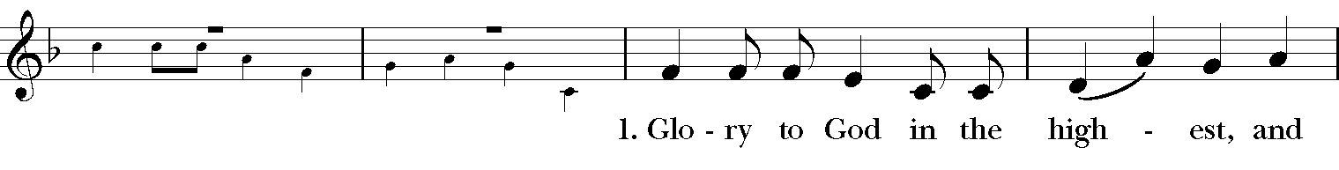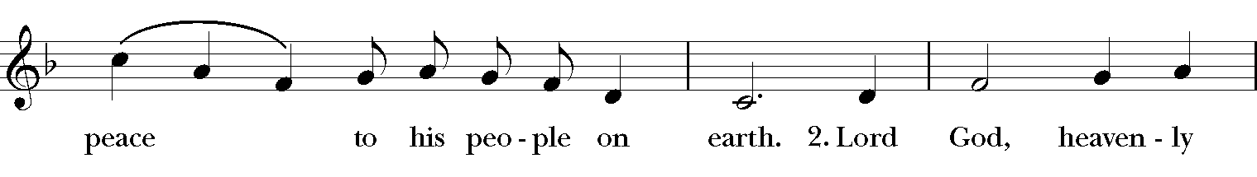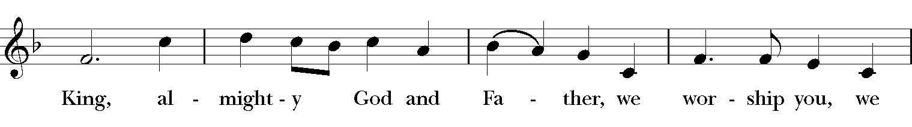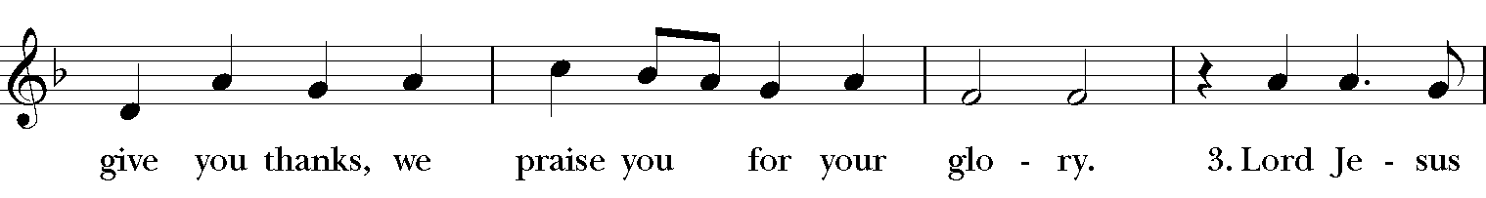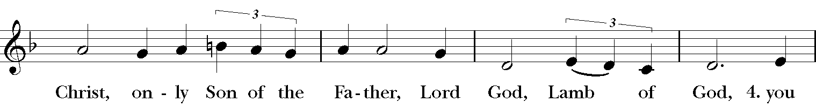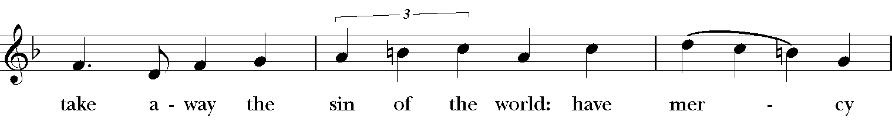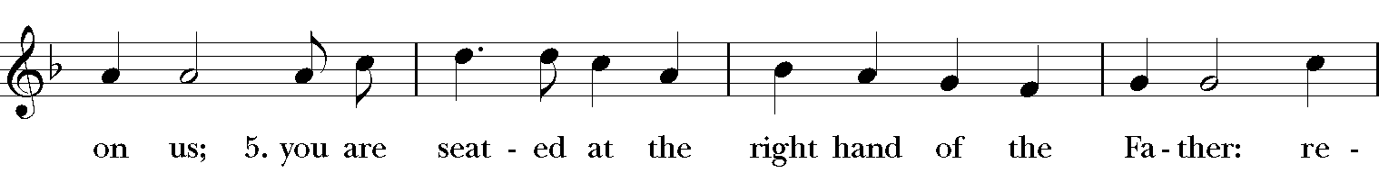
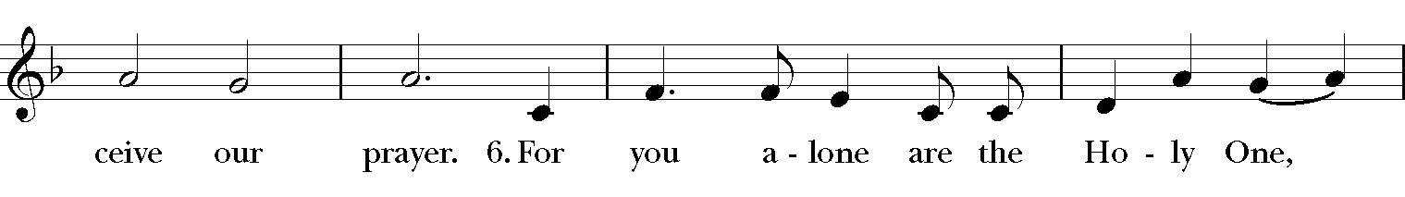
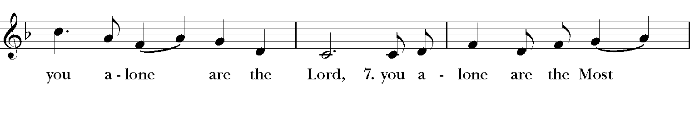
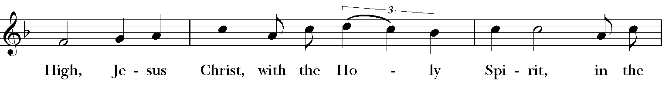
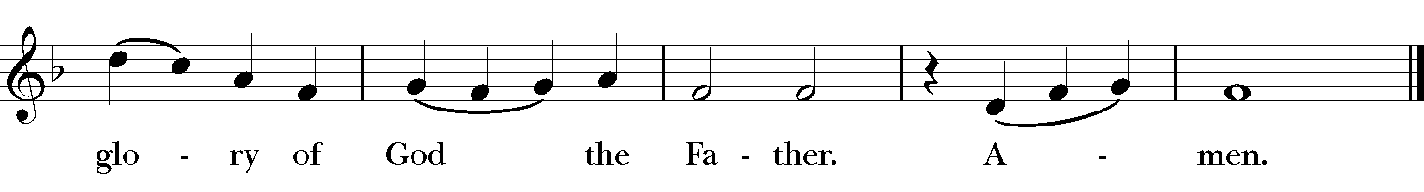

The Collect of the Day

Celebrant: The Lord be with you.
People: And also, with you.

Celebrant: Let us pray.
Let your continual mercy, O Lord, cleanse and defend your Church; and, because it cannot continue in safety without your help, protect and govern it always by your goodness; through Jesus Christ our Lord, who lives and reigns with you and the Holy Spirit, one God, for ever and ever. Amen.

The First Lesson Ecclesiastes 1-2, 12-14, 2: 18-23

Vanity of vanities, says the Teacher, vanity of vanities! All is vanity.
I, the Teacher, when king over Israel in Jerusalem, applied my mind to seek and to search out by wisdom all that is done under heaven; it is an unhappy business that God has given to human beings to be busy with. I saw all the deeds that are done under the sun; and see, all is vanity and a chasing after wind.
I hated all my toil in which I had toiled under the sun, seeing that I must leave it to those who come after me -- and who knows whether they will be wise or foolish? Yet they will be master of all for which I toiled and used my wisdom under the sun. This also is vanity. So I turned and gave my heart up to despair concerning all the toil of my labors under the sun, because sometimes one who has toiled with wisdom and knowledge and skill must leave all to be enjoyed by another who did not toil for it. This also is vanity and a great evil. What do mortals get from all the toil and strain with which they toil under the sun? For all their days are full of pain, and their work is a vexation; even at night their minds do not rest. This also is vanity.
Reader: The Word of the Lord.
People: Thanks be to God.

Psalm 49: 1-11
Hear this, all you peoples;
hearken, all you who dwell in the world, *
you of high degree and low, rich and poor together.
My mouth shall speak of wisdom, *
and my heart shall meditate on understanding.
I will incline my ear to a proverb *
and set forth my riddle upon the harp.
Why should I be afraid in evil days, *
when the wickedness of those at my heels surrounds me,
The wickedness of those who put their trust in their goods, *
and boast of their great riches?
We can never ransom ourselves, *
or deliver to God the price of our life;
For the ransom of our life is so great, *
In order to live for ever and ever, *
and never see the grave.
For we see that the wise die also;
like the dull and stupid they perish *
and leave their wealth to those who come after them.
Their graves shall be their homes for ever,
their dwelling places from generation to generation, *
though they call the lands after their own names.
Even though honored, they cannot live for ever; *
they are like the beasts that perish.

The Second Lesson Colossians 3: 1-11
If you have been raised with Christ, seek the things that are above, where Christ is, seated at the right hand of God. Set your minds on things that are above, not on things that are on earth, for you have died, and your life is hidden with Christ in God. When Christ who is your life is revealed, then you also will be revealed with him in glory.
Put to death, therefore, whatever in you is earthly: fornication, impurity, passion, evil desire, and greed (which is idolatry). On account of these the wrath of God is coming on those who are disobedient. These are the ways you also once followed, when you were living that life. But now you must get rid of all such things-- anger, wrath, malice, slander, and abusive language from your mouth. Do not lie to one another, seeing that you have stripped off the old self with its practices and have clothed yourselves with the new self, which is being renewed in knowledge according to the image of its creator. In that renewal there is no longer Greek and Jew, circumcised and uncircumcised, barbarian, Scythian, slave and free; but Christ is all and in all!
Reader: The Word of the Lord.
People: Thanks be to God.

The Sequence Hymn “How wondrous and great thy works” Hymnal 533

V. 1 to be sung before Gospel reading, V. 2 to be sung after Gospel reading

How wondrous and great thy works, God of praise!
How just, King of saints, and true are thy ways!
O who shall not fear thee, and honor thy Name?
Thou only art holy, thou only supreme.

To nations of earth thy light shall be shown;
their worship and vows shall come to thy throne:
thy truth and thy judgments shall spread all abroad,
till earth’s every people confess thee their God.

Henry Ustick Onderdonk (1759-1858), alt.; para. The Song of the Redeemed
This selection is in the public domain.

The Gospel Luke 12: 13-21
Gospeler: The Holy Gospel of our Savior Jesus Christ according to Luke.

People: Glory to you, Lord Christ.

Someone in the crowd said to Jesus, "Teacher, tell my brother to divide the family inheritance with me." But he said to him, "Friend, who set me to be a judge or arbitrator over you?" And he said to them, "Take care! Be on your guard against all kinds of greed; for one's life does not consist in the abundance of possessions." Then he told them a parable: "The land of a rich man produced abundantly. And he thought to himself, `What should I do, for I have no place to store my crops?' Then he said, `I will do this: I will pull down my barns and build larger ones, and there I will store all my grain and my goods. And I will say to my soul, `Soul, you have ample goods laid up for many years; relax, eat, drink, be merry.' But God said to him, `You fool! This very night your life is being demanded of you. And the things you have prepared, whose will they be?' So it is with those who store up treasures for themselves but are not rich toward God."

Gospeler The Gospel of the Lord.

People Praise to you, Lord Christ.

Please be seated.
The Sermon Canon John Bolton
The Nicene Creed
All stand, as able

We believe in one God,
the Father, the Almighty,
maker of heaven and earth,
of all that is, seen and unseen.
We believe in one Lord, Jesus Christ,
the only Son of God,
eternally begotten of the Father,
God from God, Light from Light,
true God from true God,
begotten, not made,
of one Being with the Father.
Through him all things were made.
For us and for our salvation
he came down from heaven:
by the power of the Holy Spirit
he became incarnate from the Virgin Mary,
and was made man.
For our sake he was crucified under Pontius Pilate;
he suffered death and was buried.
On the third day he rose again
in accordance with the Scriptures;
he ascended into heaven
and is seated at the right hand of the Father.
He will come again in glory to judge the living and the dead,
and his kingdom will have no end.
We believe in the Holy Spirit, the Lord, the giver of life,
who proceeds from the Father and the Son.
With the Father and the Son he is worshiped and glorified.
He has spoken through the Prophets.
We believe in one holy catholic and apostolic Church.
We acknowledge one baptism for the forgiveness of sins.
We look for the resurrection of the dead,
and the life of the world to come. Amen.

The Prayers of the People

Reader Sisters and brothers, children of God, let us come before the Most High with humility, saying, “Great and holy God, incline your ear to us.”

Set our minds on things divine, O God, that your Church may guard yourself against the love of earthly things and instead be rich toward you.
Silence
Great and holy God,
People Incline your ear to us.
Reader May all who dwell in the world, those of both high degree and low, incline their hearts to wisdom and meditate on understanding.
Silence
Great and holy God,
People Incline your ear to us.
Reader Give us grace to be wise and generous stewards, O God. Open our eyes to see your abundance and our reliance
Invite the congregation to add their thanksgiving
Silence
Great and holy God,
People Incline your ear to us.
Reader: Bless all those to whom we are connected. May we value our relationships more than our possessions. May we realize that in Christ all human distinctions cease to mater. We pray for justice and peace.
Silence
Great and holy God,
People: Incline your ear to us.
Reader: Comfort and heal all those who are in pain or sorrow or any kind of trouble. May we, who have known sorrow, pain and trouble, show them mercy and compassion and remind them of the hope we have in Christ. We pray for;
Jasmine, Joyce E., Thelma M., Karia, Gossett, Jataun, Angela, Clemson, Errol, Barbara P., Edwards, Marcia, Althea, Fronie, Velita, Jackie, Pauline, Kerri, Kaneez, Shahid, Olando, Rick, Trevon, Venita, Basmattie, Floyd, Christine, Dorothy, George, Annie, Ruth, Reece, Ladan, Morris, Deng, Marlene, Deneen, Faye, Ann, Joanne, Bill, Linda, Shaista, Suleman, Naveed, Ardonous, Edna, Royan, Cherrie, Yvonne, Victor T., Joyce R., Bob, Howard, Jennifer, Yannick, Fatima, Barbara, Beverly, Heather Y., the people of South Sudan, those suffering from Covid-19
Invite the congregation to add their petitions
Silence
Great and holy God,
People: Incline your ear to us.
Reader: We acknowledge our mortality before you. Everlasting God, and we rejoice in the hope of being raised with your Christ. We remember before you the lives of our forebears; may they find, in you, rest from their labors.
Silence
Great and holy God,
People: Incline your ear to us.

Reader: And we also bless thy holy Name for all thy servants departed this life in thy faith and fear, especially, (The Souls of Othine Garner ,Norma La Haye and Elton Cusp) beseeching thee to grant them continual growth in thy love and service; and to grant us grace so to follow the good examples of all thy saints, that with them we may be partakers of thy heavenly kingdom and for this assembly, as we serve the sisters and brothers among us and as we work outside church doors, we pray [Here other intercession may be offered].
Silence
Great and holy God,
People Incline your ear to us.
Silence
The Celebrant adds a concluding Collect.

The Confession of Sin BCP 360

Celebrant Let us confess our sins against God and our neighbor.
Celebrant and People
Most merciful God, we confess that we have sinned against you in thought, word, and deed, by what we have done, and by what we have left undone. We have not loved you with our whole heart; we have not loved our neighbors as ourselves. We are truly sorry and we humbly repent. For the sake of your Son Jesus Christ, have mercy on us and forgive us; that we may delight in your will, and walk in your ways, to the glory of your Name. Amen.
The Absolution
Almighty God have mercy on you, forgive you all your sins through our Lord Jesus Christ, strengthen you in all goodness, and by the power of the Holy Spirit keep you in eternal life. Amen.
The Peace
Celebrant The peace of the Lord be always with you.
People And also with you.

The Offertory “ Give me joy in my heart” Youth

THE GREAT THANKSGIVING
The Doxology Tune: "Old 100th"
Celebrant and People
Praise God, from Whom all blessings flow;
Praise Him, all creatures here below;
Praise Him above, ye heav’nly host;
Praise Father, Son, and Holy Ghost. Amen

The Great Thanksgiving: Eucharistic Prayer A BCP 355
All stand, as able
Celebrant The Lord be with you.
People And also with you.
Celebrant Lift up your hearts.
People We lift them to the Lord.
Celebrant Let us give thanks to the Lord our God.
People It is right to give our thanks and praise.
Then, facing the Holy Table, the Celebrant proceeds
It is right, and a good and joyful thing, always and everywhere to give thanks to you, Father Almighty, Creator of heaven and earth.
Therefore, we praise you, joining our voices with Angels and Archangels and with all the company of heaven, who forever sing this hymn to proclaim the glory of your Name:

The Sanctus: Holy, Holy, Holy from Lift Every Voice and Sing 255

Holy, holy, holy, holy, Holy Lord God of hosts.
Heaven and earth are filled with your glo-ry. Hosanna in the high-est.
Blessed is He who comes in the name
Of the Lord, of the Lord.
Ho-sannna in the high-est, Ho-sanna in the high-est.
The Celebrant continues
Holy and gracious Father: In your infinite love you made us for yourself, and, when we had fallen into sin and become subject to evil and death, you, in your mercy, sent Jesus Christ, your only and eternal Son, to share our human nature, to live and die as one of us, to reconcile us to you, theGod and Father of all.
He stretched out his arms upon the cross, and offered himself, in obedience to your will, a perfect sacrifice for the whole world.
At the following words concerning the bread, the Celebrant is to hold it, or lay a hand upon it, and at the words concerning the cup, to hold or place a hand upon the cup and any other vessel containing wine to be consecrated.
On the night he was handed over to suffering and death, our Lord Jesus Christ took bread; and when he had given thanks to you, he broke it, and gave it to his disciples, and said, "Take, eat: This is my Body, which is given for you. Do this for the remembrance of me."
After supper he took the cup of wine; and when he had given thanks, he gave it to them, and said, "Drink this, all of you: This is my Blood of the new Covenant, which is shed for you and for many for the forgiveness of sins. Whenever you drink it, do this for the remembrance of me."
Therefore we proclaim the mystery of faith:
Celebrant and People Christ has died. Christ has risen. Christ will come again.
The Celebrant continues
We celebrate the memorial of our redemption, O Father, in this sacrifice of praise and thanksgiving. Recalling his death, resurrection, and ascension, we offer you these gifts.
Sanctify them by your Holy Spirit to be for your people the Body and Blood of your Son, the holy food and drink of new and unending life in him. Sanctify us also that we may faithfully receive this holy Sacrament, and serve you in unity, constancy, and peace; and at the last day bring us with all your saints into the joy of your eternal kingdom.
All this we ask through your Son Jesus Christ: By him, and with him, and in him, in the unity of the Holy Spirit all honor and glory is yours, Almighty Father, now and forever. Amen.
And now, as our Savior Christ has taught us, we are bold to say,
Celebrant and People
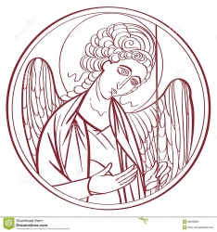
The Lord’s Prayer

Our Father, who art in heaven,
hallowed be thy Name,
thy kingdom come,
thy will be done, on earth as it is in heaven.
Give us this day our daily bread.
And forgive us our trespasses,
As we forgive those
who trespass against us
And lead us not into temptation,
but deliver us from evil.
For thine is the kingdom, and the power, and the glory for ever and ever. Amen.
The Breaking of the Bread
Celebrant Alleluia. Christ our Passover is sacrificed for us
People Therefore let us keep the feast. Alleluia.

The Fraction Anthem Celebrant and People
O Lamb of God, that takest away the sins of the world, have mercy upon us.
O Lamb of God, that takest away the sins of the world, have mercy upon us.
O Lamb of God, that takest away the sins of the world, grant us thy peace.

The Invitation
The gifts of God for the people of God. Take them in remembrance that Christ died for you, and feed on him in your hearts by faith, with thanksgiving.

The Communion of the People
All God’s people are welcome to share in the banquet of the Holy Eucharist, in one kind. If you prefer to receive a blessing instead of Communion, cross your hands across your chest.

The Communion Hymns

Piano solo “My Tribute” Willoughby Caine

“Let us talents and tongues employ” Sung by all
Let us talents and tongues employ,
reaching out with a shout of joy:
bread is broken, the wine is poured,
Christ is spoken and seen and heard.
Refrain
Jesus lives again, earth can breathe again,
pass the word around: loaves abound.

Christ is able to make us one,
at his table he sets the tone,
teaching people to live to bless,
love in word and in deed express. Refrain

Jesus calls us in, sends us out
bearing fruit in a world of doubt,
gives us love to tell, bread to share:
God Emmanuel everywhere! Refrain
Sources | Text: Fred Kaan  Music: Jamaican folk song; adapt. Doreen Potter (1925-1980)
“One Bread, One Body” LEVAS 151
Refrain
One bread, one body, one Lord of all,
one cup of blessing which we bless.
And we, though many, throughout the earth,
We are one body in this one Lord.

Gentile or Jew, servant or free,
woman or man, no more.
Refrain

Many the gifts, many the works,
one in the Lord of all.
Refrain

Grain for the fields, scattered and grown,
gathered to one for all.
Refrain

Corinthians 10:16, 17; 12:4; Galatians 3:28; The Didache 9
These words are in the public domain.

The Post Communion Prayer
Eternal God, heavenly Father, you have graciously accepted us as living members of your Son our Savior Jesus Christ, and you have fed us with spiritual food in the Sacrament of his Body and Blood. Send us now into the world in peace and grant us strength and courage to love and serve you with gladness and singleness of heart, through Christ our Lord. Amen.

The Blessing
Finally, beloved, whatever is true, whatever is honorable, whatever is just, whatever is pure, whatever is pleasing, whatever is commendable, if there is any excellence and if there is anything worthy of praise, think about these things; and the blessing of God Almighty, the Father, the Son, and the Holy Spirit, be amongst you, and remain with you always. Amen.

The Parish Announcements

At the Procession into the World

The Closing Hymn “Lead Us Heavenly Father, Lead Us” Hymnal 559

Lead us, heavenly Father, lead us
o’er the world’s tempestuous sea;
guard us, guide us, keep us, feed us,
for we have no help but thee,
yet possessing every blessing,
if our God our Father be.

Savior, breathe forgiveness o’er us;
all our weakness thou dost know;
thou didst tread this earth before us;
thou didst feel its keenest woe;
yet unfearing, persevering,
to thy passion thou didst go.

Spirit of our God, descending,
fill our hearts with heavenly joy;
love with every passion blending,
pleasure that can never cloy;
thus provided, pardoned, guided,
nothing can our peace destroy.

James Edmeston (1791-1867), alt.
This selection is in the public domain.

The Dismissal
Celebrant: Let us go forth into the world rejoicing in the power of the Spirit
People: Thanks be to God.

Postlude “Surely it is God who saves me” Ray W. Urwin

Copyright Permissions
Permission to print and stream music in this service obtained from ONE LICENSE # A-715408.
All rights reserved.

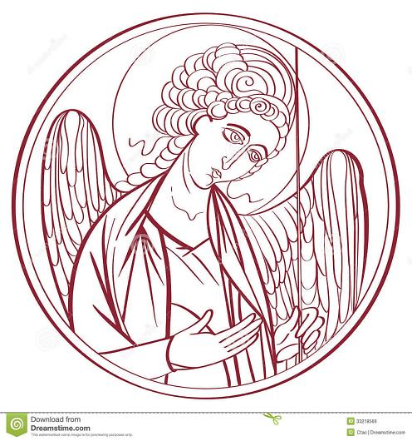

The Mission of the Church is the Mission of Christ
(The Five Marks of Mission)
Tell • To proclaim the Good News of the Kingdom.
Teach • To teach, baptize and nurture new believers.
Tend • To respond to human need by loving service.
Transform • To seek to transform unjust structures of society,
to challenge violence of every kind and to pursue peace and
reconciliation.
Treasure • To strive to safeguard the integrity of creation and
sustain and renew the life of the earth.

Rector – Father R. Winston Arthur
Choir Director – Dawn-Marie James
Organist – Bradley Phillips
Finance Clerk – Charlene Smith
Custodian – John Lam

