St. Michael and All Angels Episcopal Church
The Episcopal Diocese of Atlanta
Second Sunday Of Advent
December 10,2023



OUR PURPOSE AT ST. MICHAEL AND ALL ANGELS

TO CARE FOR OUR CHURCH FAMILY WITH MUTUAL LOVE AND SUPPORT

TO PARTICIPATE, LEARN AND SERVE IN OUR NEIGHBORING COMMUNITIES

TO ENRICH AND SHARE OUR GROWING SPIRITUALITY, RICH DIVERSITY, WELCOMING FELLOWSHIP, JOYFUL WORSHIP AND LOVING CARE

TO INVITE NEIGHBORS INTO OUR CHURCH FAMILY IN OUR COMMITMENT TO SEEK AND SERVE CHRIST IN ALL PERSONS

6780 James B Rivers Drive
Stone Mountain, Georgia 30083
Telephone: 770-469-8551
Email: admin@stmichaelstonemountain.org
Website: www.stmichaelstonemountain.org
Office Hours: Monday - Wednesday and Friday9:00 A.M. to 2 P.M.
Father Winston’s Office Hours: Monday and Wednesday 1:00-3:00 P.M., Thursday 9:00 A.M. - Noon
Father Winston’s Phone Number: 404-386-8833; call or text.

Holy Eucharist Rite I at 8:00 am
December 10, 2023
THE WORD OF GOD
Please refer to the Book of Common Prayer in the pews for the order of service.
The Opening Prayer
All stand, as able
The Lighting of the Advent Wreath

The Opening Acclamation
Celebrant Blessed be God: Father, Son, and Holy Spirit.
People And blessed be his kingdom, now and forever. Amen.
The Collect for Purity and the Kyrie BCP 323 & 324
The Collect of the Day
Merciful God, who sent thy messengers the prophets to preach repentance and prepare the way for our salvation: Give us grace to heed their warnings and forsake our sins, that we may greet with joy the coming of Jesus Christ our Redeemer; who liveth and reigneth with thee and the Holy Spirit, one God, now and for ever. Amen.
Scriptures [Refer to Pages 4-6]
The Sermon Seminarian Cheyne Collier
The Nicene Creed BCP 326
All stand, as able
The Prayers of the People BCP 328
The Confession of Sin BCP 330
The Absolution BCP 332
The Peace BCP 332
THE HOLY COMMUNION
The Offertory
The Doxology Page 8
Eucharistic Prayer I BCP 333
All stand, as able
The Prayer of Humble Access BCP 337 The Post Communion Prayer BCP 339
The Advent Blessing Page 10
The Parish Announcements Page 11
The Dismissal
Celebrant Let us go forth into the world, rejoicing in the power of the Spirit.
People Thanks be to God.

Holy Eucharist Rite II at 10:30 am
December 10, 2023
The Ringing of the Bell
Prelude
Please refer to the BCP and the Hymnals in the pews for the order of service and the musical selections
THE WORD OF GOD

The Opening Prayer
The Opening Hymn “On Jordan’s bank” Hymnal 76
All stand, as able

The Lighting of the Advent Wreath The Orisa and Okpokiri Family

Leader: Merciful God, who sent your messengers the prophets to preach repentance,
People: And prepare the way for our salvation.
Leader: Give us grace to heed their warnings and forsake our sins, that we may greet with
joy the coming of Jesus Christ our Redeemer: who lives and reigns with you and
the Holy Spirit, one God, now and for ever. Amen.

Two candles are lit this week. Pause for a moment of silence.
Leader: Let us pray.

People: God, because You are Love, Your passionate desire to share our lives is with us.

Help us, we pray to acknowledge and turn away from anything that keeps us

from welcoming Your presence. As we prepare for the coming again of Jesus,

who was passionately committed to Your vision of justice, stir in us a desire to be

like Him. Send Your Spirit to help us truly desire to create with You a world of

peace. Amen.

The Opening Acclamation
Celebrant Blessed be God: Father, Son, and Holy Spirit.
People And blessed be his kingdom, now and forever. Amen.

The Collect for Purity BCP 355

Kyrie (sung in unison) S96
Lord, have mercy, Lord, have mercy.
Christ, have mercy, Christ, have mercy.
Lord, have mercy, Lord, have mercy.

The Collect of the Day
Celebrant The Lord be with you.
People And also with you.
Celebrant Let us pray.

Merciful God, who sent your messengers the prophets to preach repentance and prepare the way for our salvation: Give us grace to heed their warnings and forsake our sins, that we may greet with joy the coming of Jesus Christ our Redeemer; who lives and reigns with you and the Holy Spirit, one God, now and for ever. Amen.
Please be seated.
The First Lesson Isaiah 40:1-11
Comfort, O comfort my people, says your God. Speak tenderly to Jerusalem,
and cry to her that she has served her term, that her penalty is paid, that she has received from the Lord's hand double for all her sins.

A voice cries out: “In the wilderness prepare the way of the Lord, make straight in the desert a highway for our God. Every valley shall be lifted up, and every mountain and hill be made low; the uneven ground shall become level, and the rough places a plain. Then the glory of the Lord shall be revealed, and all people shall see it together, for the mouth of the Lord has spoken.”

A voice says, “Cry out!”
And I said, “What shall I cry?”

All people are grass, their constancy is like the flower of the field.
The grass withers, the flower fades, when the breath of the Lord blows upon it;
surely the people are grass. The grass withers, the flower fades;
but the word of our God will stand for ever. Get you up to a high mountain,
O Zion, herald of good tidings; lift up your voice with strength,
O Jerusalem, herald of good tidings, lift it up, do not fear; say to the cities of Judah,
“Here is your God!” See, the Lord God comes with might,
and his arm rules for him; his reward is with him, and his recompense before him.
He will feed his flock like a shepherd; he will gather the lambs in his arms,
and carry them in his bosom, and gently lead the mother sheep.
Reader The Word of the Lord.
People Thanks be to God.

Psalm 85:1-2, 8-13

1. You have been gracious to your land, O Lord, *
you have restored the good fortune of Jacob.

2. You have forgiven the iniquity of your people *
and blotted out all their sins.

8. I will listen to what the Lord God is saying, *
for he is speaking peace to his faithful people
and to those who turn their hearts to him.

9. Truly, his salvation is very near to those who fear him, *
that his glory may dwell in our land.

10. Mercy and truth have met together; *
righteousness and peace have kissed each other.

11. Truth shall spring up from the earth, *
and righteousness shall look down from heaven.

12. The Lord will indeed grant prosperity, *
and our land will yield its increase.

13. Righteousness shall go before him, *
and peace shall be a pathway for his feet.

The Second Lesson 2 Peter 3:8-15a

Do not ignore this one fact, beloved, that with the Lord one day is like a thousand years, and a thousand years are like one day. The Lord is not slow about his promise, as some think of slowness, but is patient with you, not wanting any to perish, but all to come to repentance. But the day of the Lord will come like a thief, and then the heavens will pass away with a loud noise, and the elements will be dissolved with fire, and the earth and everything that is done on it will be disclosed.
Since all these things are to be dissolved in this way, what sort of persons ought you to be in leading lives of holiness and godliness, waiting for and hastening the coming of the day of God, because of which the heavens will be set ablaze and dissolved, and the elements will melt with fire? But, in accordance with his promise, we wait for new heavens and a new earth, where righteousness is at home.

Therefore, beloved, while you are waiting for these things, strive to be found by him at peace, without spot or blemish; and regard the patience of our Lord as salvation.

Reader The Word of the Lord.
People Thanks be to God.

The Sequence Hymn “O come, O come Emmanuel” Hymnal 615
Verses 1&6 sung before the gospel; Verses 7&8 sung after the Gospel

The Gospel Mark 1:1-8

Gospeler The Holy Gospel of our Savior Jesus Christ according to Mark
People Glory to you, Lord Christ.
The beginning of the good news of Jesus Christ, the Son of God. As it is written in the prophet Isaiah,
“See, I am sending my messenger ahead of you, who will prepare your way; the voice of one crying out in the wilderness: ‘Prepare the way of the Lord, make his paths straight,’”
John the baptizer appeared in the wilderness, proclaiming a baptism of repentance for the forgiveness of sins. And people from the whole Judean countryside and all the people of Jerusalem were going out to him, and were baptized by him in the river Jordan, confessing their sins. Now John was clothed with camel’s hair, with a leather belt around his waist, and he ate locusts and wild honey. He proclaimed, “The one who is more powerful than I is coming after me; I am not worthy to stoop down and untie the thong of his sandals. I have baptized you with water; but he will baptize you with the Holy Spirit.”
Gospeler The Gospel of the Lord.
People Praise to you, Lord Christ.

The Sermon Seminarian Cheyne Collier

The Nicene Creed BCP358
All stand, as able
The Prayers of the People
Reader Let us lift up our voices to God in strength, saying, “Be patient with us and prepare us, Lord.”
Together as your Church, we long to see your face. Speak to us, Lord, as we walk through the wilderness listening for the sound of your voice. Give our leaders patience, wisdom, and a heart for your will: for Michael, our presiding bishop; Robert, our bishop; and Winston, our priest.
In your mercy,
People Be patient with us and prepare us, Lord.
Reader We pray for all who govern, especially Joseph, our president, and for the Congress and courts of this land. Guide the leaders of the nations as they work for the welfare of their people and the good of all.
In your mercy,
People Be patient with us and prepare us, Lord.
Reader Awaken us to the suffering of people near us and those far from us. Call forth in us a spirit of generosity and kindness. Equip us to respond to their needs. Arouse in us a sense of urgency to demonstrate your Good News in our lives and voice it, that all may hear. Make us messengers of your love.
In your mercy,
People Be patient with us and prepare us, Lord.
Reader We ask you to comfort those who have lost hope, who struggle with anxiety about the future, who live in fear. Bring healing to those for whom we now silently pray, especially:
(Let us engage in a moment of quiet contemplation as we silently pray for the following names)
The Bovell, Smith, Hodge and McGhee Families, Arthur, Abigail, Dawn J., Daisy, Erinn, Yannick, Aaron, Errol, , Ann, Gerri, Janis, Seth and Family, Carline, Leslyn, Nellie, Terri, Cleveland, Allison, Godfrey, Marlene, Olga, Rachel, Jaye, Corey, Pauline, Dorothy, George, Ladan, Morris, Faye, Cherrie, Beverly, the people of South Sudan, the people of Ukraine, the end of the conflict in the Middle East, for the innocent souls who have been affected and for all those who in this transitory life, are in trouble, sorrow, need, sickness, or any other adversity, and for the special needs and concerns of this congregation
Invite the congregation to add their petitions and thanksgivings, followed by silence
In your mercy,
People Be patient with us and prepare us, Lord.
Reader We pray for those who have died, that their memories be blessings in our lives.
In your mercy,
People Be patient with us and prepare us, Lord.
Reader Grant these our prayers, O Father, for Jesus Christ's sake, our only Mediator and Advocate. Amen.
The Confession of Sin BCP 360
The Absolution BCP 360
The Peace BCP 360
Celebrant The peace of the Lord be always with you
People And also with you

The Offertory Anthem “Will we know Him when He comes” by Don Besig

THE GREAT THANKSGIVING
The Doxology

Celebrant and People
Praise God, from Whom all blessings flow;
Praise Him, all creatures here below;
Praise Him above, ye heav’nly host;
Praise Father, Son, and Holy Ghost. Amen
The Great Thanksgiving: Eucharistic Prayer B BCP 367
The Sanctus: Holy, Holy, Holy LEVAS 255 Holy, holy, holy, holy, Holy Lord God of hosts.
Heaven and earth are filled with your glo-ry. Hosanna in the high-est.
Blessed is He who comes in the name,
Of the Lord, of the Lord.
Hosanna in the highest, hosanna in the highest.
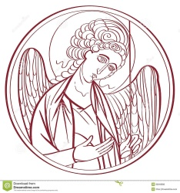
The Lord’s Prayer

The Fraction Anthem Hymnal S-172

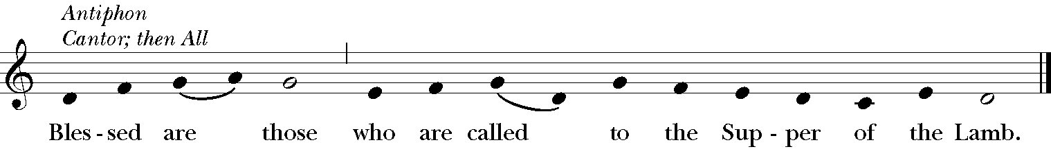
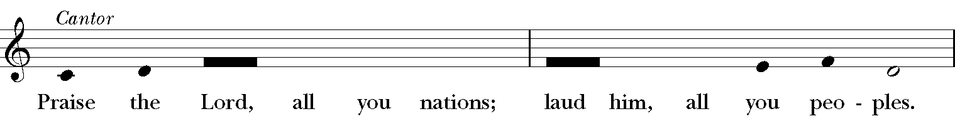
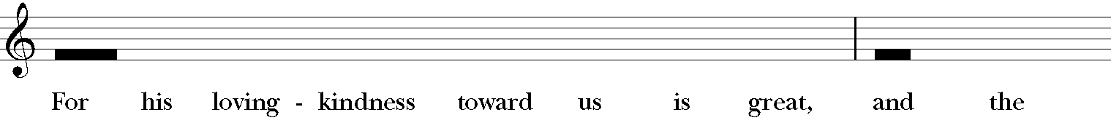
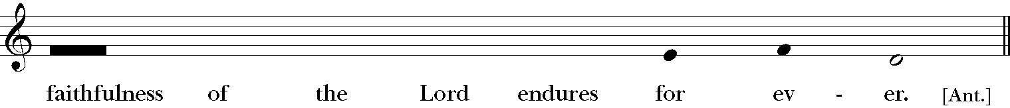

The Communion of the People
All God’s people are welcome to share in the banquet of the Holy Eucharist. As you come forward for Communion, please stand or kneel. If you prefer to receive a blessing instead of Communion, cross your hands across your chest.
The First Communion Hymn “Take my gifts” Choir
The Second Communion Hymn “Comfort, comfort ye my people” Hymnal 67
The Third Communion Hymn “Have thine own way” LEVAS 145

Have thine own way, Lord!
Have thine own way!
Thou art the potter,
I am the clay!
Mold me and make me
After thy will,
While I am waiting,
Yielded and still.

Have thine own way, Lord!
Have thine own way!
Search me and try me,
Master, today!
Purer than snow, Lord,
Wash me just now,
As in thy presence
Humbly I bow.

Have thine own way, Lord!
Have thine own way!
Wounded and weary,
Help me, I pray!
Power all power
Surely is thine!
Touch me and heal me,
Savior divine!

Have thine own way, Lord!
Have thine own way!
Hold o’er my being
Absolute sway!
Fill with thy Spirit
‘Til all shall see
Christ only, always,
Living in me!

The Post Communion Prayer BCP 365
Celebrant and People
All stand as able

Eternal God, heavenly Father, you have graciously accepted us as living members of your Son our Savior Jesus Christ, and you have fed us with spiritual food in the Sacrament of his Body and Blood. Send us now into the world in peace, and grant us strength and courage to love and serve you with gladness and singleness of heart; through Christ our Lord. Amen.

Advent Blessing
May Almighty God, by whose providence our Savior Christ came among us in great humility, sanctify you with the light of his blessing and set you free from all sin.

May he whose second Coming in power and great glory we await, make you steadfast in faith, joyful in hope, and constant in love.

May you, who rejoice in the first Advent of our Redeemer, at his second Advent be rewarded with unending life.

And the blessing of God Almighty, the Father, the Son, and the Holy Spirit, be upon you and remain with you for ever. Amen.

The Parish Announcements

Reminder: Please submit your pledge cards if you have not already done so.

Thank you, Fr. Harold Lockett, for worshipping with us today.

Upcoming Events:

Advent Bible Study led by the women of ECW
continues Sunday December 9th.

MoM and ECW – Winter Wonderland Holiday Party
Saturday, December 16th.

ECW Holiday Outing Sunday, December 17th.

Senior Luncheon- “White elephant gift exchange” Tuesday, December 19th.

“Dignity” – Seven Strategies for creating Authentic Community by Dr Beth Sarah Wright
A book study beginning January 7th 2024.

Fr. Frank Baltz – “Invite, Welcome, Connect” January 13th 2024.

A warm welcome to anyone visiting with us for the first time.

Please refer to weekly E-Blast for details.

At the Procession into the World

The Closing Hymn “Prepare the way” Hymnal 65

The Dismissal
Celebrant Let us bless the Lord.
People Thanks be to God.

Postlude

__________________________________________________________________________________ Copyright Permission
Permission to print and stream music in this service obtained from ONE LICENSE # A-715408.
All rights reserved.

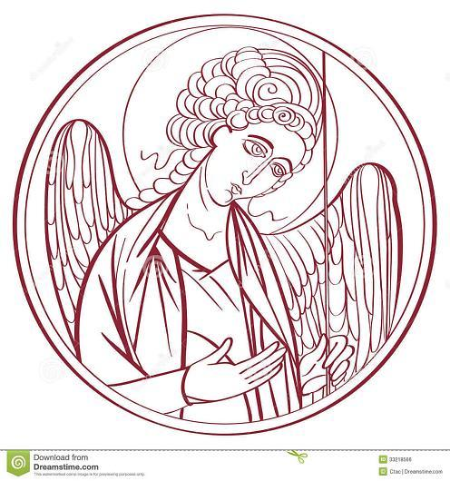

The Mission of the Church is the Mission of Christ
(The Five Marks of Mission)
Tell • To proclaim the Good News of the Kingdom.
Teach • To teach, baptize and nurture new believers.
Tend • To respond to human need by loving service.
Transform • To seek to transform unjust structures of society,
to challenge violence of every kind and to pursue peace and
reconciliation.
Treasure • To strive to safeguard the integrity of creation and
sustain and renew the life of the earth.

Rector – Rev. R. Winston Arthur
Assisting Clergy – Rev. John Manyuon Aroch (South Sudan Community)
Deacon – Rev. Florence Mitchell
Seminarian – Cheyne Collier
Choir Director – Dawn-Marie James
Supply Organist – Dr. Richard Beckford
Finance Clerk – Charlene Smith
Custodian – John Lam
Parish Administrator - Heather Cutting

