St. Michael and All Angels Episcopal Church
The Episcopal Diocese of Atlanta
The Fifteenth Sunday after Pentecost
September 13, 2020



OUR PURPOSE AT ST. MICHAEL AND ALL ANGELS

TO CARE FOR OUR CHURCH FAMILY WITH MUTUAL LOVE AND SUPPORT

TO PARTICIPATE, LEARN AND SERVE IN OUR NEIGHBORING COMMUNITIES

TO ENRICH AND SHARE OUR GROWING SPIRITUALITY, RICH DIVERSITY, WELCOMING FELLOWSHIP, JOYFUL WORSHIP AND LOVING CARE

TO INVITE NEIGHBORS INTO OUR CHURCH FAMILY IN OUR COMMITMENT TO SEEK AND SERVE CHRIST IN ALL PERSONS

6780 James B Rivers Drive
Stone Mountain, Georgia 30083
Telephone: 770-469-8551
Email: admin@stmichaelstonemountain.org
Website: www.stmichaelstonemountain.org
Office Hours: Monday-Thursday 9:00 A.M. to 1:00 P.M.
Father Winston’s Phone Number: 404-386-8833; call or text.

Holy Eucharist, Rite I at 9:30 am
September 13, 2020

The Opening Voluntary Two Spirituals Charles Callahan
“Go Down Moses” and “I Want To Be Ready”
THE WORD OF GOD
The Processional Hymn “Lord, Make Us Servants of Your Peace” Hymnal 593
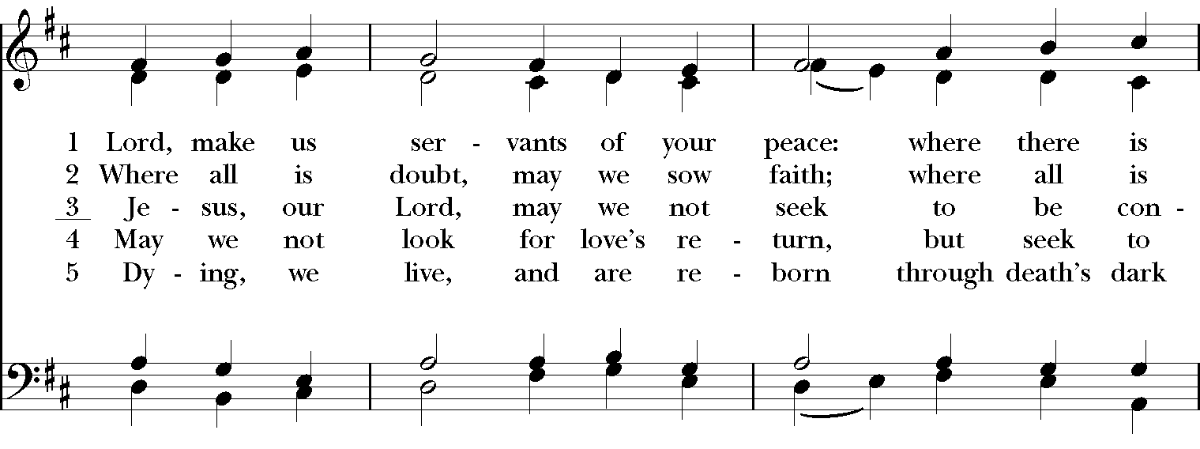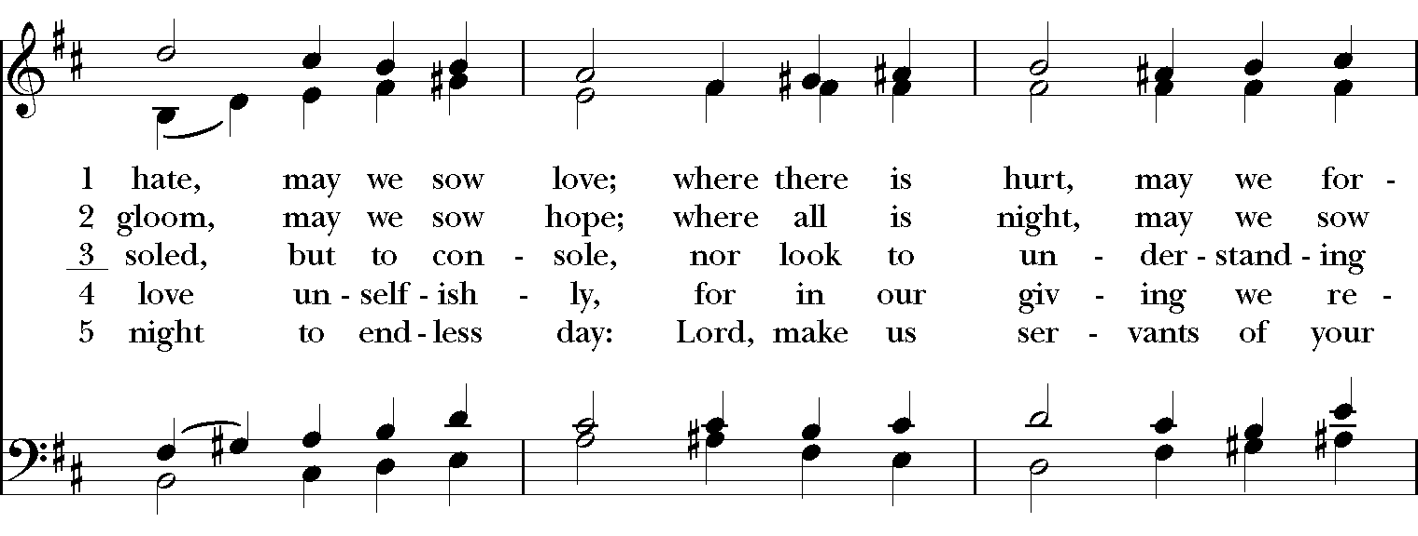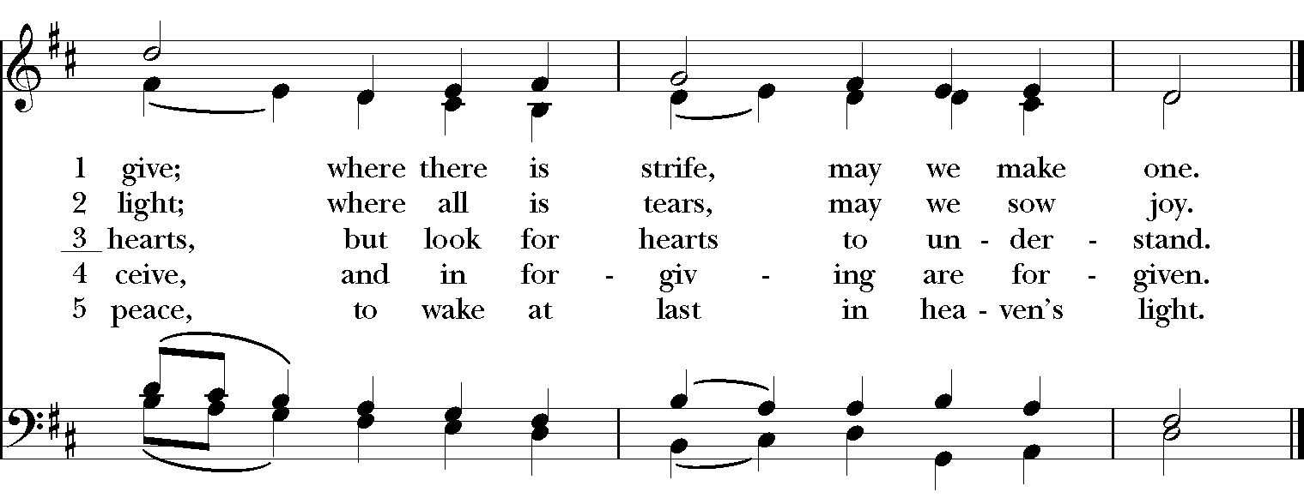
The Opening Acclamation
Celebrant: Blessed be God: Father, Son, and Holy Spirit.
People: And blessed be his kingdom, now and forever. Amen.

The Collect for Purity BCP 323
Almighty God, unto whom all hearts are open, all desires known, and from whom no secrets are hid: Cleanse the
thoughts of our hearts by the inspiration of thy Holy Spirit, that we may perfectly love thee, and worthily magnify thy holy Name; through Christ our Lord. Amen.

Gloria in Excelsis Hymnal S-280

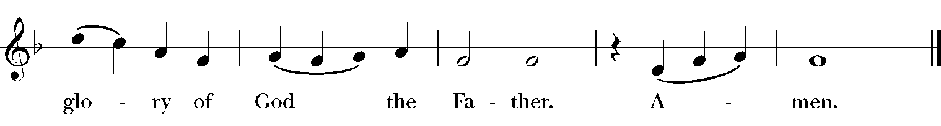
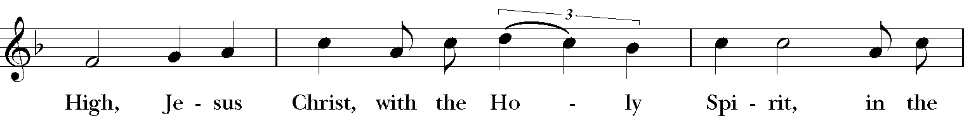
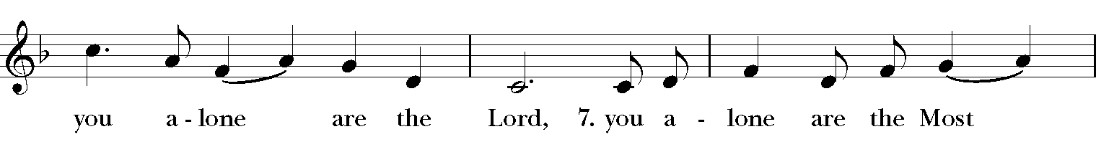
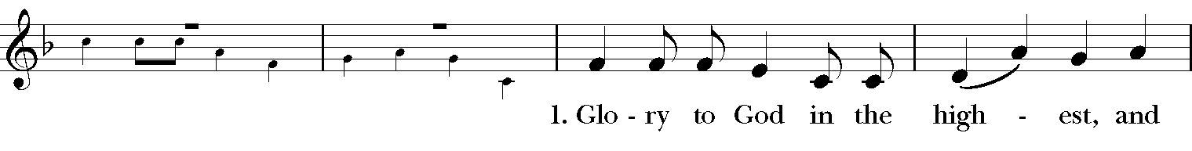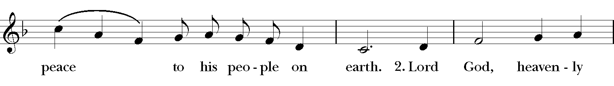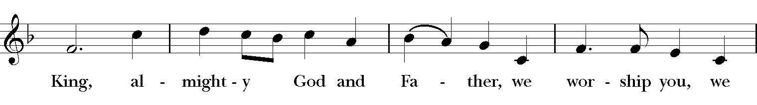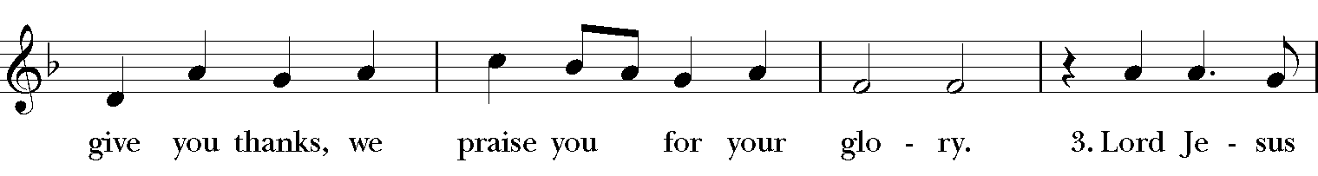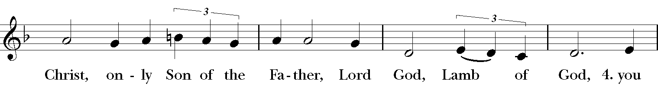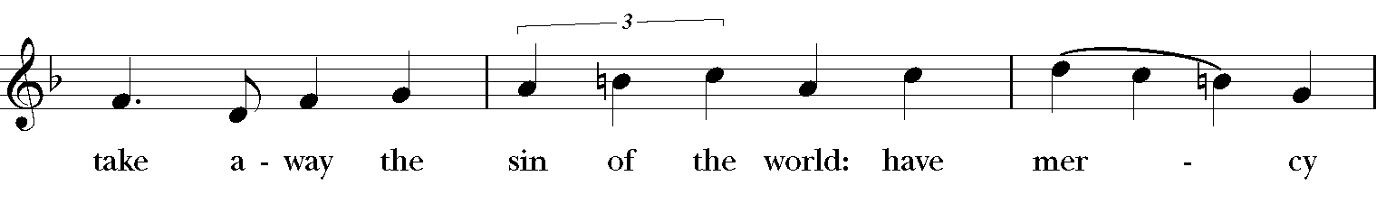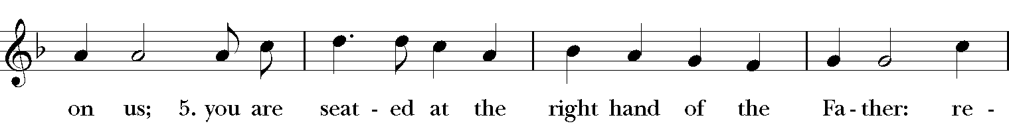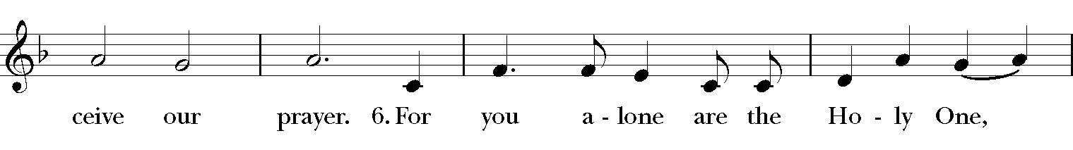

The Collect of the Day
Celebrant: The Lord be with you.
People: And with thy spirit.
Celebrant: Let us pray.
O God, forasmuch as without thee we are not able to please thee, mercifully grant that thy Holy Spirit may in all things direct and rule our hearts; through Jesus Christ our Lord, who with thee and the same Spirit liveth and reigneth, one God, now and for ever. Amen.

The First Lesson Genesis 50:15-21 Realizing that their father was dead, Joseph’s brothers said, “What if Joseph still bears a grudge against us and pays us back in full for all the wrong that we did to him?” So they approached Joseph, saying, “Your father gave this instruction before he died, ‘Say to Joseph: I beg you, forgive the crime of your brothers and the wrong they did in harming you.’ Now therefore please forgive the crime of the servants of the God of your father.” Joseph wept when they spoke to him. Then his brothers also wept, fell down before him, and said, “We are here as your slaves.” But Joseph said to them, “Do not be afraid! Am I in the place of God? Even though you intended to do harm to me, God intended it for good, in order to preserve a numerous people, as he is doing today. So have no fear; I myself will provide for you and your little ones.” In this way he reassured them, speaking kindly to them.

Reader: The Word of the Lord.
People: Thanks be to God.

Psalm 103: 1-13
1 Give judgment for me, O Lord,
for I have lived with integrity; *
I have trusted in the Lord and have not faltered.
2 Test me, O Lord, and try me; *
examine my heart and my mind.
3 For your love is before my eyes; *
I have walked faithfully with you.
4 I have not sat with the worthless, *
nor do I consort with the deceitful.
5 I have hated the company of evildoers; *
I will not sit down with the wicked.
6 I will wash my hands in innocence, O Lord, *
that I may go in procession round your altar,
7 Singing aloud a song of thanksgiving *
and recounting all your wonderful deeds.
8 Lord, I love the house in which you dwell *
and the place where your glory abides.
People: Glory to the Father, and to the Son, and to the Holy Spirit: as it was in the beginning, is now, and will be forever. Amen.

The Second Lesson Romans 14:1-12
Let love be genuine; hate what is evil, hold fast to what is good; love one another with mutual affection; outdo one another in showing honor. Do not lag in zeal, be ardent in spirit, serve the Lord. Rejoice in hope, be patient in suffering, persevere in prayer. Contribute to the needs of the saints; extend hospitality to strangers.
Bless those who persecute you; bless and do not curse them. Rejoice with those who rejoice, weep with those who weep. Live in harmony with one another; do not be haughty, but associate with the lowly; do not claim to be wiser than you are. Do not repay anyone evil for evil, but take thought for what is noble in the sight of all. If it is possible, so far as it depends on you, live peaceably with all. Beloved, never avenge yourselves, but leave room for the wrath of God; for it is written, “Vengeance is mine, I will repay, says the Lord.” No, “if your enemies are hungry, feed them; if they are thirsty, give them something to drink; for by doing this you will heap burning coals on their heads.” Do not be overcome by evil, but overcome evil with good.
Reader: The Word of the Lord.
People: Thanks be to God.

The Gospel Matthew 18:21-35
Gospeler: The Holy Gospel of our Savior Jesus Christ according to Matthew.
People: Glory to you, Lord Christ.
Peter came and said to Jesus, “Lord, if another member of the church sins against me, how often should I forgive? As many as seven times?” Jesus said to him, “Not seven times, but, I tell you, seventy-seven times.
“For this reason the kingdom of heaven may be compared to a king who wished to settle accounts with his slaves. When he began the reckoning, one who owed him ten thousand talents was brought to him; and, as he could not pay, his lord ordered him to be sold, together with his wife and children and all his possessions, and payment to be made. So the slave fell on his knees before him, saying, ‘Have patience with me, and I will pay you everything.’ And out of pity for him, the lord of that slave released him and forgave him the debt. But that same slave, as he went out, came upon one of his fellow slaves who owed him a hundred denarii; and seizing him by the throat, he said, ‘Pay what you owe.’ Then his fellow slave fell down and pleaded with him, ‘Have patience with me, and I will pay you.’ But he refused; then he went and threw him into prison until he would pay the debt. When his fellow slaves saw what had happened, they were greatly distressed, and they went and reported to their lord all that had taken place. Then his lord summoned him and said to him, ‘You wicked slave! I forgave you all that debt because you pleaded with me. Should you not have had mercy on your fellow slave, as I had mercy on you?’ And in anger his lord handed him over to be tortured until he would pay his entire debt. So my heavenly Father will also do to every one of you, if you do not forgive your brother or sister from your heart.”
Gospeler: The Gospel of the Lord.
People: Praise to you, Lord Christ.

The Sermon The Rev. Winston Arthur
The Nicene Creed BCP 326
We believe in one God,
the Father, the Almighty,
maker of heaven and earth,
of all that is, seen and unseen.
We believe in one Lord, Jesus Christ,
the only Son of God,
eternally begotten of the Father,
God from God, Light from Light,
true God from true God,
begotten, not made,
of one Being with the Father.
Through him all things were made.
For us and for our salvation
he came down from heaven:
by the power of the Holy Spirit
he became incarnate from the Virgin Mary,
and was made man.
For our sake he was crucified under Pontius Pilate;
he suffered death and was buried.
On the third day he rose again
in accordance with the Scriptures;
he ascended into heaven
and is seated at the right hand of the Father.
He will come again in glory to judge the living and the dead,
and his kingdom will have no end.
We believe in the Holy Spirit, the Lord, the giver of life,
who proceeds from the Father and the Son.
With the Father and the Son he is worshiped and glorified.
He has spoken through the Prophets.
We believe in one holy catholic and apostolic Church.
We acknowledge one baptism for the forgiveness of sins.
We look for the resurrection of the dead,
and the life of the world to come. Amen.

The Prayers of the People BCP 329
Let us pray for the whole state of Christ's Church and the world. Almighty and ever living God, who in thy holy Word hast taught us to make prayers, and supplications, and to give thanks for all men: Receive these our prayers which we offer unto thy divine Majesty, beseeching thee to inspire continually the Universal Church with the spirit of truth, unity, and concord; and grant that all those who do confess thy holy Name may agree in the truth of thy holy Word, and live in unity and godly love.
Give grace, O heavenly Father, to all bishops and other ministers [especially for Michael, our presiding bishop, and for Rob and Don, our bishops; our rector, Winston; our vestry and parish leaders], that they may, both by their life and doctrine, set forth thy true and lively Word, and rightly and duly administer thy holy Sacraments.
And to all thy people give thy heavenly grace, and especially to this congregation here present; that, with meek heart and due reverence, they may hear and receive thy holy Word, truly serving thee in holiness and righteousness all the days of their life. We beseech thee also so to rule the hearts of those who bear the authority of government in this and every land [especially Donald our President, Brian our Governor, Patricia, the mayor of Stone Mountain], that they may be led to wise decisions and right actions for the welfare and peace of the world.
Open, O Lord, the eyes of all people to behold thy gracious hand in all thy works, that, rejoicing in thy whole creation, they may honor thee with their substance, and be faithful stewards of thy bounty.
And we most humbly beseech thee, of thy goodness, O Lord, to comfort and succor particularly following names:
Dwaine, Rick and Sue, Jack F., the people of South Sudan, Trevon, Venita, Basmattie, Floyd and Christine, Misha and Phyllis, Dorothy, George, Annie, Ruth, Doreen, Reece, Ladan, Amanda, Morris, Deng, Marlene, Deneen, Brad, Jonathan, Ann, Carol, Peg, Joanne, Bill, Steve and Susan, Chris, April, Linda, Don, Shaista, Suleman, Naveed, Madison, Ardonous and Edna, Royan, Cherrie, Yvonne, Victor, Ricky, Joyce and Vincent, Bob, Howard, Maureen, Jennifer, Yannick, Dennis, Fatima, Barbara, Beverley, Heather Y.
and for all those who in this transitory life, are in trouble, sorrow, need, sickness, or any other adversity, and for the special needs and concerns of this congregation…(the congregation is invited to add their petitions at this time)
And we also bless thy holy Name for all thy servants departed this life in thy faith and fear, beseeching thee to grant them continual growth in thy love and service; and to grant us grace so to follow the good examples of all thy saints, that with them we may be partakers of thy heavenly kingdom.
Grant these our prayers, O Father, for Jesus Christ's sake, our only Mediator and Advocate. Amen.
Silence
The Celebrant adds a concluding Collect.

Collect for Remembering September 11, 2001
God the compassionate one, whose loving care extends to all the world, we remember this day your children of many nations and many faiths whose lives were cut short the fierce flames of anger and hatred. Console those who continue to suffer and grieve, and give them comfort and hope as they look to the future. Out of what we have endured, give us the grace to examine our relationships with those who perceive us as the enemy, and show our leaders the way to use our power to serve the good of all for the healing of the nations. This we ask through Jesus Christ our Lord who, in reconciling love, was lifted up from the earth that he might draw all things to himself. Amen.
The Confession of Sin BCP 330
Celebrant: Let us humbly confess our sins unto Almighty God.
Celebrant and People:
Almighty God,
Father of our Lord Jesus Christ,
maker of all things, judge of all men:
We acknowledge and bewail our manifold sins
and wickedness,
which we from time to time most grievously have committed,
by thought, word, and deed, against thy divine Majesty,
provoking most justly thy wrath and indignation against us.
We do earnestly repent,
and are heartily sorry for these our misdoings;
the remembrance of them is grievous unto us,
the burden of them is intolerable.
Have mercy upon us,
have mercy upon us, most merciful Father;
for thy Son our Lord Jesus Christ's sake,
forgive us all that is past;
and grant that we may ever hereafter
serve and please thee in newness of life,
to the honor and glory of thy Name;
through Jesus Christ our Lord. Amen.
The Absolution
Celebrant: Almighty God, our heavenly Father, who of his great mercy hath promised forgiveness of sins to all those who with hearty repentance and true faith turn unto him, have mercy upon you, pardon and deliver you from all your sins, confirm and strengthen you in all goodness, and bring you to everlasting life; through Jesus Christ our Lord. Amen.
The Peace
Celebrant: | The peace of the Lord be always with you.
People: And with thy spirit.

The Parish Announcements

At the Procession into the World

The Closing Hymn “Joyful, Joyful, We Adore Thee” Hymnal 376

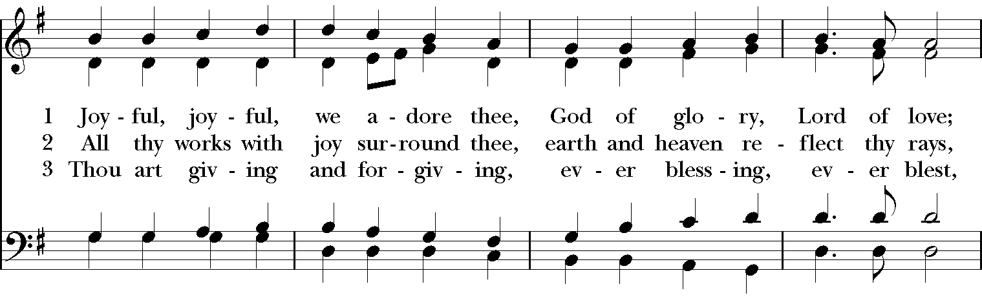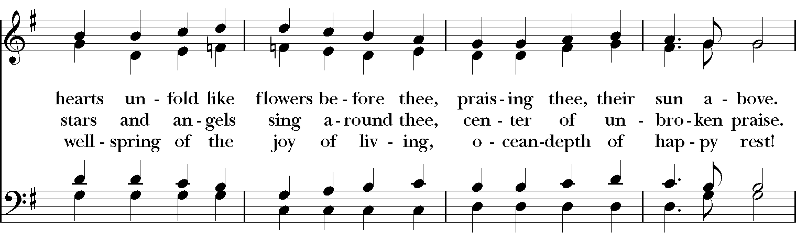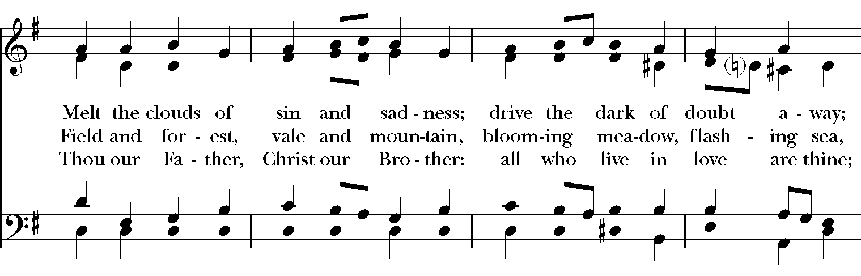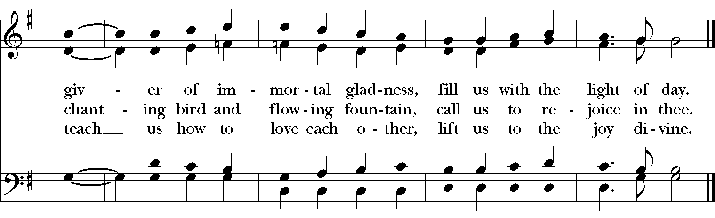

The Dismissal
Celebrant: Let us go forth into the world, rejoicing in the power of the Spirit. Alleluia, Alleluia!
People: Thanks be to God. Alleluia, alleluia!

The Closing Voluntary “Rise Up O Men of God” 1982 Hymnal, Seth Bingham

