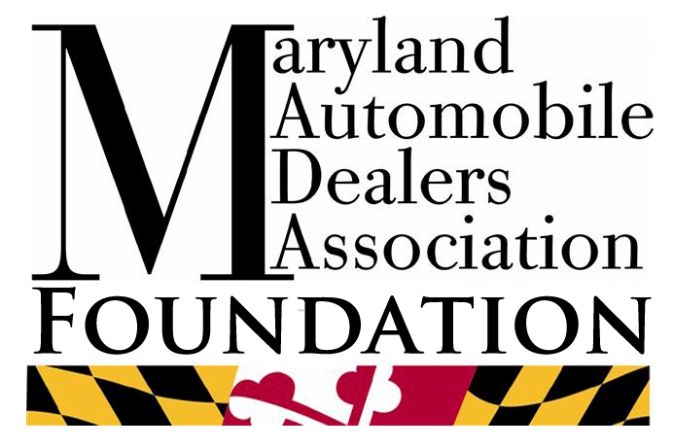

Scholarship Application Packet
for the
2017-2018 Academic Year

The Maryland Automobile Dealers Association Foundation awards educational scholarships to people with the desire of developing skills necessary to work in the Maryland Automobile dealership industry. Applicants should demonstrate their interest in pursuing a career in the industry through their acceptance to an automotive training program, technical institute program or general college credit course program designed to serve the industry.
The Maryland Automobile Dealers Association Foundation scholarships are available to individuals who are currently enrolled in, or seeking enrollment in the programs described above.
Recipients enrolled in degree programs at community colleges, four year universities, or non-degree certificate post-secondary training programs for the 2017-2018 calendar year will receive awards of up to $2,500 per year for each of the first two years.
Applicants will have the support and recommendation of their direct sponsor. Should the direct sponsor not be a current dealer member in good standing of the Maryland Automobile Dealers Association, a dealer member co-sponsor will be required.
Applicants must satisfy the criteria listed on the enclosed forms and provide all requested information. Applications must be postmarked by March 31, 2017, and mailed to the Maryland Automobile Dealers Association Foundation (MADAF), 7 State Circle, Suite 301, Annapolis, Maryland 21401.
If you have any questions or need additional information, please contact Ethel Biensach at 410-269-1710 or ebiensach@mdauto.org.

Maryland Automobile Dealers Association Foundation
Scholarship Application Form
The scholarship is available for tuition, fees, books, tools and other eligible educational expenses. The Foundation does not pay scholarships to individuals, but instead authorizes the grant to be paid directly to the institution to be credited to the individual student’s account.
The MADAF Scholarship Committee will award scholarships based on the following criteria:
1) The recipient must be sponsored or co-sponsored by a Maryland Automobile Dealers Association dealer member in good standing.
2) The recipient must currently have a career, or pledge to seek a career where the Maryland Automobile Dealer industry will be the direct beneficiary of the skills learned.
3) Academic achievement of a cumulative GPA of 2.5 or higher on a scale of 4.0 or a student in good standing.
4) Involvement in extracurricular activities such as: sports, organizations, clubs or community service.
The scholarship is automatically renewed for the second year if the recipient continues to be enrolled as a student in good standing.
Required Attachments
1) Completed Applicant Background Sheet and Questions
2) Completed Essay Questions
3) Completed Survey from non-related instructor, mentor or manager
4) A non-related letter of recommendation discussing the applicant’s qualities that would allow them to succeed in an automotive career.
5) Official High School or College Transcript with raised school seal
6) Sponsor Forms
7) Dealer Member Co-Sponsor form (not applicable if sponsor is a MADA dealer member in good standing)
This application and required attachments must be completed and postmarked by March 31, 2017. Incomplete applications will not be considered. The applications will be reviewed by a committee and the winners will be notified by mail no later than May 1, 2017.
The application, and all supporting materials, should be completed and submitted to:
MADAF, 7 State Circle, Suite 301, Annapolis Maryland 21401.

Maryland Automobile Dealers Association Foundation
Applicant Background
Name:________________________________________________________________________________
Student ID Number: ____________________________________________________________________
Address: _____________________________________________________________________________
City:______________________________________ State:________ Zip: __________________________
Telephone: (____)___________________________ Email: _____________________________________
Cell Phone: ________________________________ Date of Birth: ________/________/______________
High School: _______________________________ Graduation Date: ____________________________
Instructor Name:____________________________ School Phone:_______________________________
Name of College/School you will attend: ____________________________________________________
Major Field(s):___________________________________Entrance Date:__________________________
Credits per semester: ___________________________________________________________________
Are you currently employed at a Maryland Dealership?________________________________________
If so where?___________________________________________________________________________
Sponsors Name and Business Name________________________________________________________
Sponsors Phone________________________________________________________________________
Co-Sponsors Name (if sponsor is not a dealer member)________________________________________
List awards, recognitions, honors and noteworthy achievements:
____________________________________________________________________________________
____________________________________________________________________________________
____________________________________________________________________________________
List organizations, clubs, community service, sports or other extracurricular activities:
____________________________________________________________________________________
____________________________________________________________________________________
Maryland Automobile Dealers Association Foundation
Essay Questions

Essays – Maximum of 400 words each
- What are your career plans?
- What projects or achievements are you most proud of? If possible, provide an answer related to your experience with the automobile industry.
- What do you find interesting about the automobile industry?
- Who in the automobile industry do you admire? And why?

Maryland Automobile Dealers Association Foundation
Instructor, Mentor, Manager Survey
Circle appropriate response
Applicant Name:_______________________________________________________________________
Please rate the overall work ethic of the applicant (showed up to school or work on time, good attendance, good communication, worked well with others.)
POOR AVERAGE GOOD EXCELLENT
Comments:____________________________________________________________________________
_____________________________________________________________________________________
Please rate the overall automotive knowledge and aptitude of the Applicant:
POOR AVERAGE GOOD EXCELLENT
Comments:____________________________________________________________________________
_____________________________________________________________________________________
Please rate the overall learning attitude of the Applicant:
Lacks Ambition Shows interest Is highly motivated
Comments:____________________________________________________________________________
_____________________________________________________________________________________
If able, would you be willing to hire this applicant?
NO YES
Comments:____________________________________________________________________________
_____________________________________________________________________________________
Would you recommend this applicant receive this scholarship?
NO YES
Comments:______________________________________________________________________________
Mentor/Instructor/Manager/Employer Name:__________________________________________________
Mentor/Instructor/Manager/Employer Phone Number:___________________________________________
Mentor/Instructor/Manager/Employer Signature:________________________________________________
Maryland Automobile Dealers Association Foundation
Sponsor Form
To be completed by applicant:
Name:________________________________________________________________________________
Address: _____________________________________________________________________________
City:______________________________________ State:________ Zip: __________________________
Telephone: (____)___________________________ Email: _____________________________________
Cell Phone: ________________________________ Date of Birth: ________/________/______________
High School: _______________________________ Graduation Date: ____________________________
------------------------------------------------------------------------------------------------------------------------------------------
To be completed by sponsor:
What is you affiliation or association with the applicant?_______________________________________
_____________________________________________________________________________________
Do you have an interest in being the applicants sponsor? ________Yes ________ No
Have you spoken with or interviewed the applicant? ________ Yes ________No
Why do you feel this applicant should or should not be eligible to be awarded a scholarship?
_________________________________________________________________________________________________________________________________________________________________________________________________________________________________________________________________________________________________________________________________________________________________________________________________________________________________________
Sponsor’s Business Name:________________________________________________________________
Sponsor’s Name:_______________________________________________________________________
Address:______________________________________________________________________________
City_____________________________________State_________________Zip_____________________
Phone:____________________________Email:______________________________________________
Signature:_____________________________________________________________________________
Maryland Automobile Dealers Association Foundation
Co-sponsor’s Form
(If Sponsor is a MADA dealer member in good standing, Co-sponsor form is not required)
To be completed by applicant:
Name:________________________________________________________________________________
Address: _____________________________________________________________________________
City:______________________________________ State:________ Zip: __________________________
Telephone: (____)___________________________ Email: _____________________________________
Cell Phone: ________________________________ Date of Birth: ________/________/______________
High School: _______________________________ Graduation Date: ____________________________
------------------------------------------------------------------------------------------------------------------------------------------
To be completed by sponsor:
What is you affiliation or association with the applicant?_______________________________________
_____________________________________________________________________________________
Do you have an interest in being the applicants sponsor? ________Yes ________ No
Have you spoken with or interviewed the applicant? ________ Yes ________No
Why do you feel this applicant should or should not be eligible to be awarded a scholarship?
____________________________________________________________________________________________________________________________________________________________________________________________________________________________________________________________________________________________________________________________________________________
Sponsor’s Business Name:________________________________________________________________
Sponsor’s Name:_______________________________________________________________________
Address:______________________________________________________________________________
City_____________________________________State_________________Zip_____________________
Phone:____________________________Email:______________________________________________
Signature:_____________________________________________________________________________

