How to Register/Log In
to Bartlesville e-Services

Overview
This document will take you through the steps to register or log in to the City of Bartlesville e-Services web portal for citizen self service.

Logging Into e-services:
Follow the steps below to log in to Bartlesville e-Services:
- Navigate to the following URL: https://energovweb.cityofbartlesville.org/EnerGovProd/SelfService
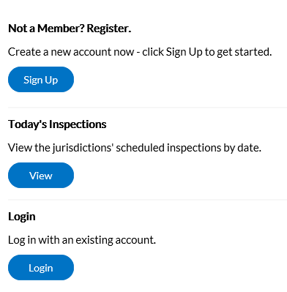
- Click Login button.
- Enter your Email Address and Password in the fields provided. If you do not have an Email Address/Password already registered with the City of Bartlesville, click on SignUp and follow the directions to register for an account.
- Mark the Remember me checkbox to have the system remember your credentials.
- Click Log In. e-Services validates your login and, if it is valid, opens with the functions you are authorized to access.
Becoming a Registered User
Navigate to the following URL:
https://energovweb.cityofbartlesville.org/EnerGovProd/SelfService

- Click the Sign Up option located in the second column on the right under the heading of Not a Member? Register.
- Enter your email address.
- You will be sent a confirmation email. Click Confirm in the email. This will navigate you back to the e-Services registration site.
Email Example
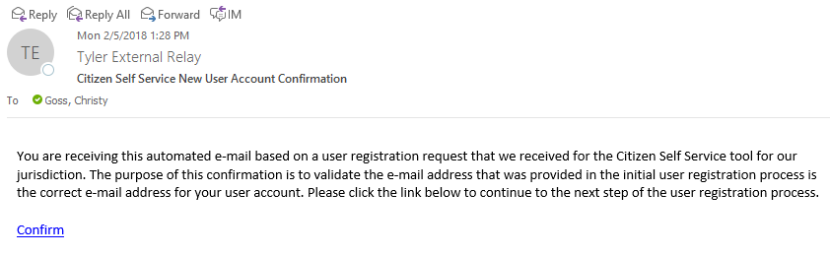

- A confirmation of an existing contact in e-Services will show.

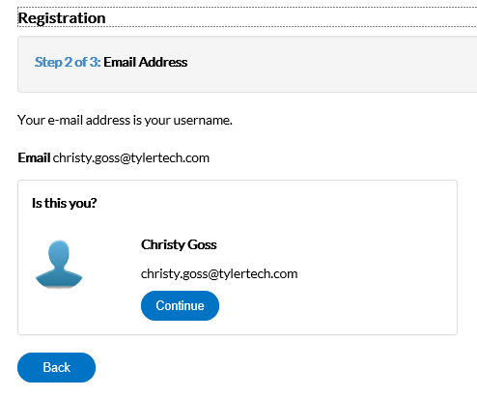
- Click Continue.
- This will prompt a Contact Information screen to appear. Fill in all information for your contact.
- Create a Password.
- Check the “I’m not a robot.” reCaptcha checkbox. Follow instructions for the verification.
- Once verified, click Submit.
- Another screen will appear, click Log In.
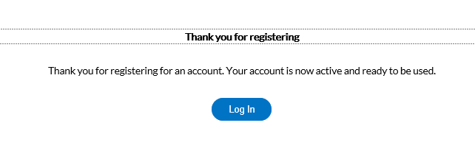
- Log in with the credentials that you provided previously.
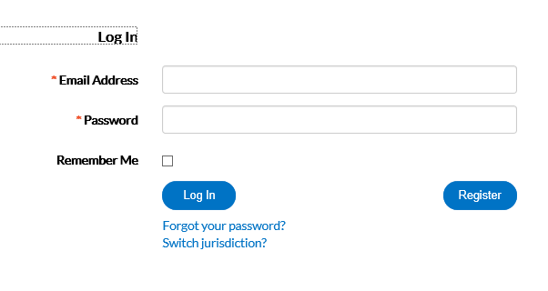
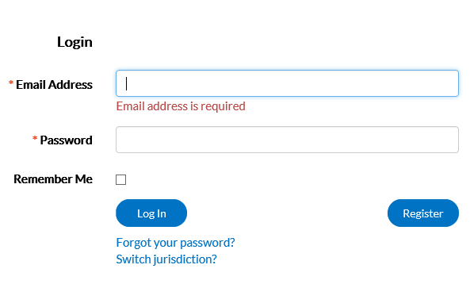
Logging in as a Registered User (when the registration has been forgotten)
- Type in your email address into the email address field.
- Select “Forgot Your Password?”.
- The page will be redirected to a Forgot Password screen.
- Click Submit.

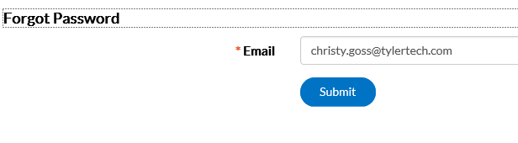

- An email will be sent to the address that was given.
- Open the email and click Reset.
- You will be redirected to an e-Services window where a new password can be entered and confirmed.

