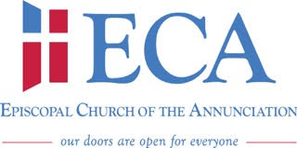

Working Agenda for Reach meeting
January x, 2021

- Opening Prayer
- Spiritual Reflection
- Old Business:
  - Ministry updates

- New Business:
  - 2021 Budget

- Adjourn

