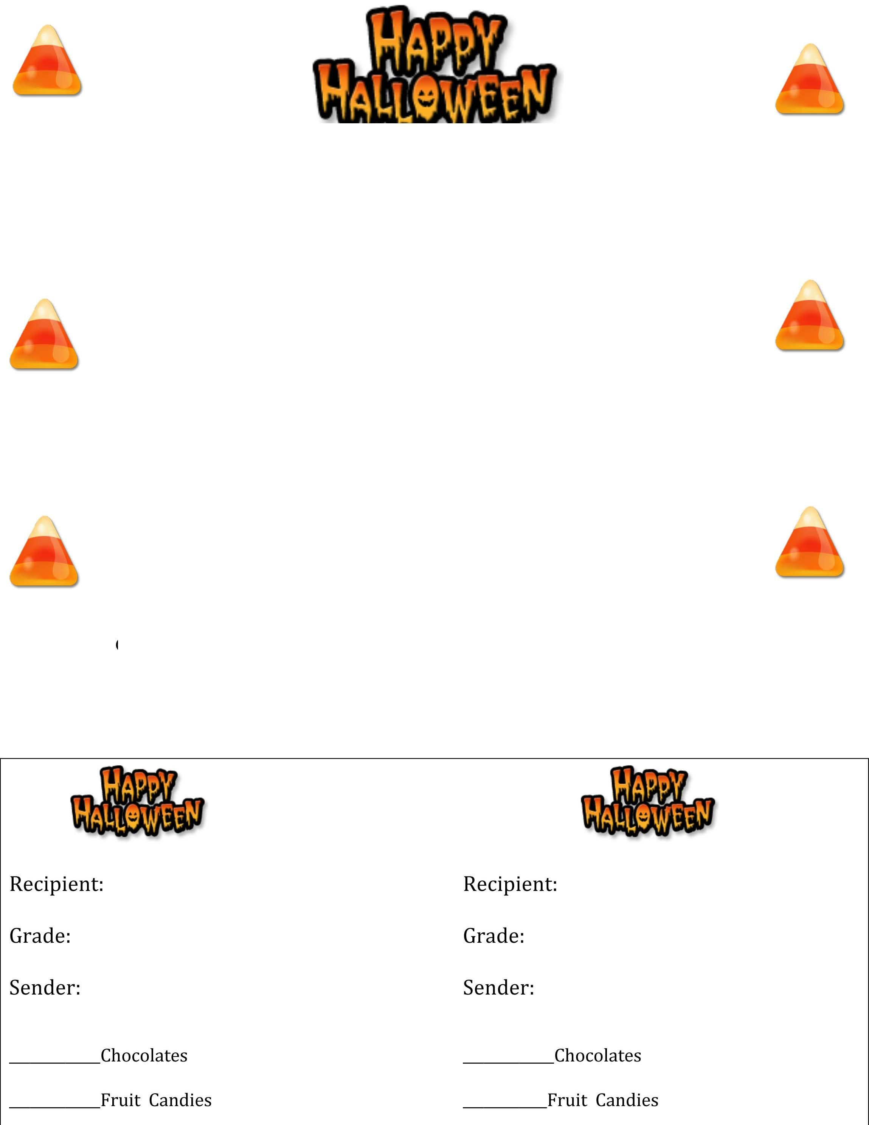

**HALLOWEEN CANDY SALE**

Support the Class of 2019

All-Night Grad Party (ANGP)

# Buy your favorite students, teachers, or staff members a Halloween Treat

**Treats $3.00 each**

# Make checks payable to LHS ANGP 2019

# Chocolate or Fruit Candygrams available

Mail orders no later than October 25th to:

Ann Haley (co-chair)

1129 Bowen Avenue

Great Falls, VA 22066

Questions contact Beth Harkaway at bethkharkaway@gmail.com

Treats will be distributed during 1st block on Tuesday, October 30th