Support the class of 2019
All Night Grad Party Monday June 3, 11:00pm to Tuesday June 4:00am

The ANGP is a fun-filled, non-stop, all night Graduation Party for the Langley High School Class of 2019. This is the last time our seniors will be together as a class as they say farewell to Langley. Every year, over 90% of the graduating seniors attend the ANGP, a highlight of their four years at Langley. Entertainment, food, games, and prizes are included in the ticket price. Please support this event and don’t let your student miss out! The most important reason for sponsoring the ANGP is to provide a safe alcohol and drug free graduation night party!

Please check below and complete the form on the back to let us know how you would like to support ANGP. Thank you!

Business Sponsor
Your company name will be listed as a sponsor on materials during the ANGP and distributed to all Seniors in the event packets. You are ALSO welcome to donate corporate logo items/swag for the event packets!!
__$1,000 __$500 __$250 __Other $_______
Prize Donor
Donate an item, or purchase an item that can be used as a prize or giveaway
Item (s) to donate and value ________________________________________________________________
Purchase ANGP Ticket: $75.00 each ($85.00 after April 1 and $95.00 after May 15)
Student Name (first)______________________(last)_____________________________________________
***You must sign and return the ANGP Parental Authorization Form (attached)*****
Limo Ride and Box Seats for Constitution Hall on June 3rd Graduation!!
Be one of two winners of a Limo Ride and VIP seats by May 15th. $10/ticket or 3 for $25.
Prize includes: 4-hour limo service from Chariots for Hire (gratuity not included) AND VIP Box Seats-up to six people at Constitution Hall (these replace graduation tickets).
Purchase Capitol Steps Ticket: $35.00
Come see DC’s one and only political satire group perform at Langley HS on Sunday February 10, at 7:00pm.
“Congratulations Graduate” Yard Sign: $30.00- Deadline April 30
Student Name: (first)_________________________(last-optional)__________________________________
24” x 18” weather resistant, reusable sign with metal stake. See example on attachment
Underwrite an Expense-Please consider helping to underwrite food, games, prizes, entertainment and more for the ANGP. All amounts are welcome!
Volunteer-We need about 100 volunteers to help with the event and all the fundraisers. Join the fun!!!
Name (s)__________________________________________________________________

Email: _____________________________________________________________________

PLEASE COMPLETE AND RETURN THIS FORM
Contributions of any amount will help to keep our students safe on graduation night.

Support the ANGP | Quantity | Total
Business Sponsor:
$1,000/$500/$250/other
Prize Donor
Capitol Steps Tickets - $35 each
ANGP Tickets- $75 each ($85 after April 1, $95 after May 15)
SIGNED AUTHORIZATION FORM REQUIRED
Limo Ride & Box Seats Raffle
$10/ticket or 3 for $25
Deadline for purchase May 15
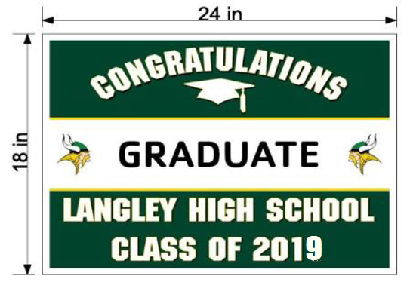
“Congratulations Graduate” Yard Sign
- $30 each
- Student’s name will replace
“Graduate”

Underwrite an Expense: (circle one)
Food/Prizes/Giveaways/Entertainment/Decorations
Make checks payable to:  LHS ANGP | Total:

Your name________________________________________________________________________

Company name (if Applicable)________________________________________________________

Address: ____________________________City:_________________State______Zipcode________

Email:_________________________________________Phone:_____________________________

___Student Authorization form signed and enclosed for ANGP ticket purchase.

___Check here is you prefer to be an anonymous donor.

Please make checks payable to LHS ANGP and return with completed form to:
ANGP c/o Ann Haley, Co-Chair and Treasurer
11129 Bowen Avenue, Great Falls, VA 22066

QUESTIONS? Contact Beth Harkaway at bethkharkaway@gmail.com

The Langley High School ALL-NIGHT GRADUATION PARTY (ANGP) is sponsored by Langley High School Parent Teacher Association, a non-profit organization under section 501(c)(3) of the IRS code: Federal Tax ID 54-1358045
DONATIONS ARE TAX DEDUCTIBLE AS DEFINED BY THE LAW

The Langley High School Class of 2019 Appreciates Your Support!

