
CLASS OF 2023
Transcript Request Deadlines

September 16, 2022 | Early Action October 15th Deadline. Sign up to see counselor ASAP.
October 3, 2022 | Early Action/Early Decision/Rolling admission –sign up to see your counselor  ASAP.
November 18, 2022 | Final Request for transcripts and counselor letters of recommendation.
Mid-February 2023 | Counselors send out mid-year grades to any college a student has submitted a transcript.  *Transcript fee will be posted at this time, payment can be made using MySchoolBucks.
June 2023 | Final transcript submitted to the college the student is matriculating to.

Please note: The above deadlines assist your school counselor in managing college materials and writing letters of recommendations for their students. You must submit your college list, transcript release form, senior information sheet, and parent response forms by the above deadlines. Fees will be collected at a later date.

You do not need to submit your actual applications to colleges by these deadlines. You also do not need to wait for transcripts and letters of rec to be submitted before submitting your application.



Senior Checklist – Items Required to Process College Applications

Item |  |  | Check
1 | List of ALL colleges/universities you are applying to with decisions and application types.(ED, EA, Rolling, Regular, Common app, Coalition) See form in Senior Handbook. | 
2 | Completed answers to the questions on the Senior Information Sheet. These answers will be used to complete counselor recommendation. | 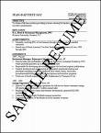
3 | Completed answers to the Parent Response Form. These answers will be used to complete the counselor recommendation. | 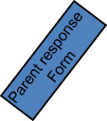
4 | Activities resume | 
5 | Transcript Release Form
6 | Money for sending transcripts: A flat $30 charge will be placed in mid-February and payments should be made through myschoolbucks.com. (Click on records and transcripts icon to pay.)  Unpaid fees become senior obligations. | $30
7 | Colleges you are applying to have been uploaded into Naviance Student. Add under the Colleges I am thinking about tab. | 
Students must submit official test scores from the respective ACT/Collegeboard sites.

Transcript Key
Admission Type

ED – Early Decision: Students make a commitment to a first-choice institution where, if admitted they definitely will enroll. The application deadline and decision deadline occur early. Commitment: BINDING

EA – Early Action: Students apply early and receive a decision well in advance of the institution’s regular response date. Commitment: NON-BINDING

REA - Restrictive Early Action: Students apply to an institution of preference and receive a decision early. They may be restricted from applying ED or EA or REA to other institutions. If offered enrollment, they have until May 1 to confirm. Commitment: NON-BINDING

Regular Decision: Students submit an application by a specified date and receive a decision in a clearly stated period of time. Commitment: NON-BINDING

Rolling Admission: Institutions review applications as they are submitted and render admission decisions throughout the admission cycle. Commitment: NON-BINDING

Priority Admission: Students submit an application by a specified date to be considered for admission, scholarship money, and honors programs, etc. Please choose this option only if the college does indeed have a priority deadline. Commitment: NON-BINDING Delivery Types
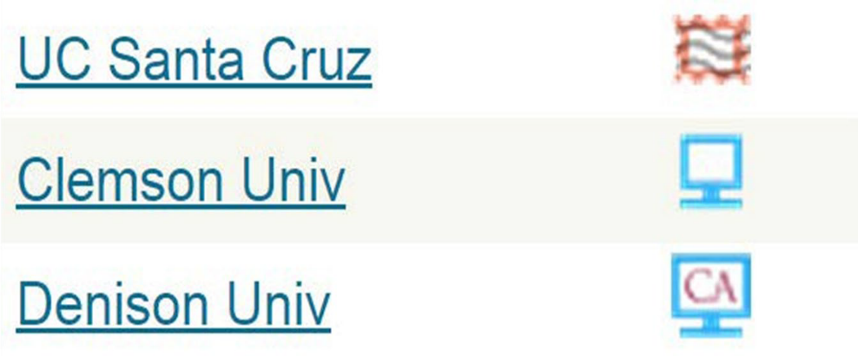
PLEASE DESIGNATE WHICH TYPE EACH COLLEGE REQUIRES SO WE CAN SEND YOUR TRANSCRIPTS/FORMS

Paper
Electronic – eDocs or Coalition App Common App

Note about using the Coalition App: Students will fill out application online, then they will check the box to indicate that they will be sending their transcript separately (not via coalition) as Langley will send via eDocs. Counselor recs will be send via eDocs, teacher recs will be sent through Coalition.

Langley High School Transcript Request Form 2022-23

Student Name: Counselor:
Transcript Request Deadlines
September 16th Early Action-October 15 deadlines. Sign up to see your counselor ASAP

October 3rd November 1, November 15, Rolling, Priority for scholarships. Sign up to see your counselor ASAP

November 18th Final request for transcripts and any additional information for the completion of the college application

Authorizations
I give permission to send my student’s transcript and any additional information necessary for the completion of the college application(s), such as the secondary report form, counselor’s recommendation, and school profile.

Parent Signature: ________________________________________

I waive my right to view the counselor letter of recommendation and understand that it will be submitted directly to the college(s) on my behalf. I understand that it is my responsibility to request test scores from Collegeboard.org or Act.org as well as teacher recommendations. I understand that these documents will not be included in the information sent by the counselor.

Student Signature: ________________________________________

Deadline Date | Admission | Student | Name of College | City, | Fee | For LHS Staff: | For LHS Staff:
 | Type | Application Mode | or Program | State/Country of | ($5 each | Common App | Naviance/eDoc
 | (*See Below) | (Common App, |  | College | after the | Input Date | Date
 |  | Coalition App, |  |  | first three
 |  | eDoc, Mail) |  |  | schools)
October 5, 2018 | EA | Common App | Sample University | Sample, PA | $5
 |  |  |  |  | Free
 |  |  |  |  | Free
 |  |  |  |  | Free
*REG=regular, ROLL=rolling, EA=early action, REA=restrictive early action, ED=early decision, ED2=early decision 2, PRI=priority

Deadline Date | Admission | Student | Name of College | City, | Fee | For LHS Staff: | For LHS Staff:
 | Type | Application Mode | or Program | State/Country of | ($5 each | Common App | Naviance/eDoc
 | (*See Below) | (Common App, |  | College | after the | Input Date | Date
 |  | Coalition App, |  |  | first three
 |  | eDoc, Mail) |  |  | schools)
*REG=regular, ROLL=rolling, EA=early action, REA=restrictive early action, ED=early decision, ED2=early decision 2, PRI=priority

Langley High School Parent Response Form

We are seeking your thoughts and feelings about your child. Please help us by responding to the questions below. If you do not find these specific questions helpful, then write us a letter. Be funny, be serious, be honest, be proud, brag. Your willingness to complete this form or write a separate letter is very helpful in counseling your son or daughter and writing his or her college recommendation.

Student Name: Parent Email:

- Describe a recent incident when your child demonstrated strong character.

- What are three words or phrases you would use to describe your child? Please give an example of each.

- What are your child’s greatest strengths? Are there any special achievements that Langley may not know about?

- Are there any special circumstances that you want the counselor to address in the college recommendation? (i.e. educational background, special family situation, medical history, family trauma, personal achievement, etc.)

- If you were to write your own son or daughter’s recommendation, what would you say in the first paragraph that would prompt the admissions committee to read on? Write the paragraph.

- Is there anything else that you would like to share about your student?

Langley High School Senior Information Sheet
The questions listed below are helpful to your counselor when composing your college letter of recommendation. Please answer these questions and provide as much information as possible. Typed responses please.

Student Name: Student Personal Email:

SAT/ACT Scores: Teacher Recommender(s):

- Identify three words/traits, characteristics, or interests that best describe you to a college admission committee. Questions to ask yourself- Assume that all students applying have met the objective criteria for admission. What do you think distinguishes you from other qualified applicants? Examples and/or anecdotes that further identify and explain these traits, characteristics, and interests are most helpful. Such context can create a meaningful and memorable individual identity in the college application process.

- Is there a person in your life who you have considered to be a mentor? Please tell us about the person’s impact on your life.

- What has been your strongest subject or elective and why? Questions to ask yourself- What subject(s) or academic experience(s) have been the most influential, compelling, intriguing, or challenging, and why? What do you look forward to investigating and exploring and learning about in college.

- What do you choose to learn or explore on your own? Questions to ask yourself- what have you pursued beyond class assignments? What do your choices show about your interests and the way you like to learn? Have there been any events, circumstances or experiences that inspired you to pursue additional learning or had a major impact on your way of thinking (i.e. values, morals, ethics)?

- What are your most significant contributions to LHS or your community? Why did you choose these activities during your high school career? Specifically, what was your personal or academic motivation for participating? What distinguished your participation and involvement in this activity from others? * Please attach an activity resume.

- What are your future career goals? Questions to ask yourself- What have you learned or know about yourself that supports your potential career pathway? What aspects or opportunities are you researching when selecting colleges to apply? What responsibilities or experiences, either in or out of school have helped you define these goals? How do your potential college choice align with your future plans and career goals? What is your intended college major? Why did you choose this? What profession do you see yourself in once you graduate from college?

- What factors, if any (personal, family, social, cultural, academic) contributed to your academic performance positively or negatively while at Langley?

- If you were to write your own recommendation, what would you say in your first paragraph that would prompt the reader to read on? Write the paragraph.

Student Activity Resume
The following is an example of a Student Activity Resume. This could be used when applying for a job, scholarship or anywhere a resume is requested. Use the titles that apply to you or create ones that are more appropriate. Be factual and use only events from ninth through twelfth grade. Get help from your parents as they may remember honors, etc.
Make sure to type it.

First Middle Last Name Street Address
City, State, Zip code Phone number with Area code Email Address

School Activities Grade Level
Club 9, 10
Club 11,12
Athletic Team Fall Semester 9, 10
Athletic Team Spring Semester 11, 12
Honor Society 9, 10, 11, 12
Elected Office 10, 11
School Honors
A/B Honor Roll 9, 10, 11, 12
Most Valuable Player (Team) 11, 12
Varsity or Academic Letter 11, 12 Community Activities
Volunteer with for 3 hours/week | 10
Religious Youth Group | 9
Community Athletic Team Summer | 11, 12
Private Lessons on | 9, 10, 11, 12
Community Honors
Invited participant of on DATE Work Experience
Name of Business, Number of hours/week 11, 12

