Special Lunch Presentation & Conversation
with Dan Prinzing, Executive Director of the Wassmuth Center
Monday, February 21, at noon
Join us on Zoom: https://us02web.zoom.us/j/86140724625
What is my civic responsibility?

The messaging of the Idaho Anne Frank Human Rights Memorial challenges each visitor to examine his/her/their role in the community. Am I a bystander or upstander when I hear or witness injustice? Am I willing to commit to the core principles of diversity, inclusion, ethics, respect, and civility? As a comprehensive human rights education center, the Wassmuth Center for Human Rights is charged with taking the Memorial’s message into businesses, classrooms, and communities – and in the process, to ask the questions that prompt a conversation about our shared humanity. We are reminded, just as it is etched in the Memorial’s stone, the wisdom of Confucius. “What you do not want done to yourself, do not do to others.”
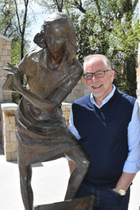
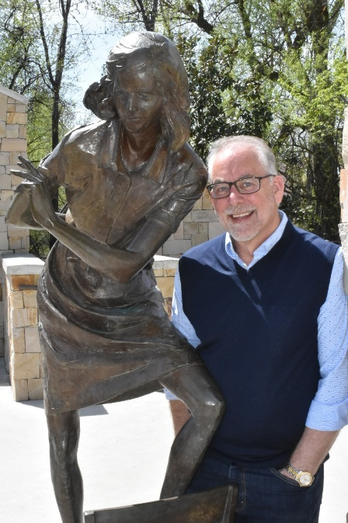
Dr. Dan Prinzing is the executive director of the Wassmuth Center for Human Rights, builder and home of the Idaho Anne Frank Human Rights Memorial. The Center’s mission is “to promote respect for human dignity and diversity through education and to foster individual responsibility to work for peace and justice.” As a career educator, his work has taken him from the classroom to state government to countries around the globe as a teacher, coordinator, and trainer in human rights education. Dr. Prinzing holds a B.A. in History Secondary Education, an MA in Curriculum and Instruction, an MA in History and Government, and a Ph.D. in Educational Leadership.

