Facebook and Instagram Posts

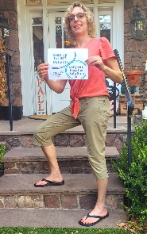
Facebook
I’m stepping up for skin disease patients! [@SenJohnThune] [@SenSchumer] [@SpeakerJohnson] [@RepJeffries] Please support the Safe Step Act to ensure people can get insurance coverage for the treatment their doctor recommends without unnecessary delays. It’s time to put patients first. @CoalitionofSkinDiseases #StepUpForPatients #SafeStepAct #CSD

Instagram
I’m stepping up for skin disease patients! [@SenJohnThune] [@SenSchumer] [@SpeakerJohnson] [@RepJeffries] Please support the Safe Step Act to ensure people can get insurance coverage for the treatment their doctor recommends without unnecessary delays. It’s time to put patients first. @USskincoalition #StepUpForPatients #SafeStepAct #CSD

Tweets

I’m stepping up for skin disease patients! [@SenSchumer] [@SenJohnThune] [@SpeakerJohnson] [@RepJeffries] support the Safe Step Act to ensure people can access needed treatments without delays. It’s time to put patients first. @USskincoalition #StepUpForPatients #SafeStepAct #CSD

