BVA Happenings – October 2
Editor’s note: To use the Table of Contents to quickly jump to the article you are interested in, press CTRL while clicking on the title of the article.
Table of Contents
BVA Happenings – October 2 1
Around BVA 2
Bay Area, Iowa Locations Up Next for In-Person Distribution, Schedule Updated 2
Meta Glasses Shipping Continues, New Requests Will Be Placed on Wait List 3
Save Dates for 2027 National Convention, General Details Revealed 3
Utah Distribution Event Draws Local Media Attention 4
Fall Foliage Contest Deadline Near, Submit by This Monday 4
BVA Welcomes New Veterans National Service Officer 5
Listen to Recent BVA Bulletin by Tuning into “Visions of BVA” Podcast 6
Obtain and Read “Before We Were Yours” to Prepare for October Book Club Meeting 7
NLS Shares Career Position Announcements with BVA Happenings 8
Ambassadog Scoop Series Courtesy of Waymo 9
From Pumpkin Patches to Life-Changing Matches 9
VA Insider 10
Veterans to Benefit from Greater VA Transparency in Choosing Prescribed Medications 10
CSL Offers Caregivers Additional Resources, Support 10
Next Week’s Events 11
VetTech and Educational Series 11

Around BVA

Bay Area, Iowa Locations Up Next for In-Person Distribution, Schedule Updated
Highlighting the in-person distribution events for the Meta Ray-Ban AI glasses are two on the same day this coming week (Wednesday, October 7), one in Menlo Park, California, and the other in Des Moines, Iowa. Glasses will be distributed to blind and low-vision U.S. military veterans at no cost while supplies are available. Both events are being overseen and fully supported financially by Meta on behalf of the Blinded Veterans Association.
- Menlo Park, California; October 7 (4:00-7:00pm), Belle Haven Community Campus, 100 Terminal Avenue, Menlo Park, CA 94025. The registration link is located here.
- Des Moines, Iowa; October 7 (10:00-2:00pm), Iowa Department for the Blind, 524 Fourth Street, Des Moines, IA 50309. The registration link can be found here.
- Honolulu, Hawaii; October 9 (3:00-5:30pm), Elks Lodge Honolulu, 2933 Kalākua Avenue in Honolulu. To RSVP, send an email to Dominique Lawless, dlawless@bva.org, or call her at 202-371-8883, or complete a registration form here. There is a fee for parking, so participants may want to use paratransit or find alternative parking if possible.
- Memphis, Tennessee; October 16 (times to be announced), Courtyard by Marriott Memphis Airport Hotel, 1780 Nonconnah Boulevard in Memphis. This event will occur in conjunction with District 2’s Summit.
If you are a BVA member and are interested in receiving the Meta AI glasses, or if you have applied to receive them via a call or by applying through the BVA website, no action is needed on your part. You will be notified via BVA Happenings and other media once the shipments are fully in place. You will also receive an email, along with a tracking number, once your glasses have been cleared for shipping. It is not necessary to contact the BVA National Board of Directors, BVA National Headquarters, the Veterans Service Program’s National Service Officers, or any VA employee regarding the glasses.

Meta Glasses Shipping Continues, New Requests Will Be Placed on Wait List
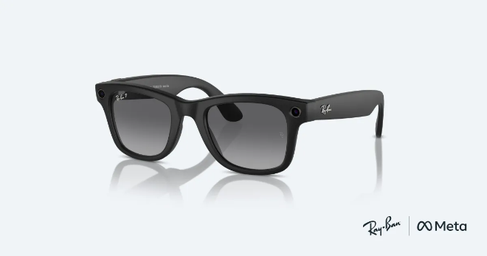
BVA is grateful for the overwhelming interest in the Ray-Ban Meta AI Glasses program and in BVA’s service to blind and low vision veterans. The organization is pleased to welcome so many new members to the community.
Due to the high volume of interest and requests, all new requests for Meta glasses will now be added to a waitlist. In the meantime, those who have applied for the glasses prior to September 20 will receive them shortly if they haven’t already. The patience and understanding of those who have been promised the glasses are deeply appreciated as BVA staff members work through thousands of requests, emails, and phone calls.

Save Dates for 2027 National Convention, General Details Revealed
Photo Caption: CocoCay is a Royal Caribbean private island, offering a mix of record-breaking attractions, family fun, and relaxing beach escapes. It includes Oasis Lagoon, the Caribbean’s largest freshwater pool, Thrill Waterpark, a giant wave pool, and the tallest waterslide in the Caribbean.

Royal Caribbean’s Oasis of the Seas Cruise
Dates, times, and agenda times may vary slightly and are approximate.

- Monday, April 12, 2027 – Leave Fort Lauderdale, Florida (Port Everglades) at 4:00pm; embarkation expected to begin around noon, and guests are required to be checked in and onboard the ship by 2:30pm (90 minutes prior to the scheduled departure time).
- Tuesday, April 13 – Day at Sea/Cruising.
- Wednesday, April 14 – Nassau, Bahamas, 7:30am-5:30pm.
- Thursday, April 15 – Perfect Day at CocoCay, Bahamas-7:30am-5:00pm.
- Friday, April 16 – Return to Fort Lauderdale, Florida (Port Everglades) by 6:00am, guests to disembark the ship between 7:00am and 9:00am (flights home should not depart prior to noon).
For those interested in attending the Convention, please do not register with the cruise line directly. BVA’s dedicated, accessible registration site will be available by the end of next week (October 9). Once the site is available, additional details, required forms, and step-by-step instructions will be shared so that registrants can complete the process securely.

Utah Distribution Event Draws Local Media Attention
Two separate “Wades” were spotlighted in a news feature covering the distribution of Meta Ray-Ban AI glasses this past Tuesday. The Deseret News, one of two Salt Lake City daily newspapers, quoted Navy veteran and BVA member Larry Wade of Bountiful, Utah, extensively for the article and ran photos of him trying on the new glasses and receiving training at the Utah Division of Services for the Blind and Visually Impaired.
Larry was in his late 70s when he lost his sight due to Retinitis Pigmentosa. The loss was especially life-altering and cruel for him as a well-known Utah painter celebrated for his impressionist work of vast landscapes and depictions of early pioneer settlers in the Utah territory. The sight loss made it impossible for him to paint again.
The other Wade interviewed at the distribution event was BVA National President Wade Davis, on hand to represent the Association and greet the arriving blind and low-vision veterans. President Wade also assisted with the training and offered his assessments of the impact of the Meta glasses on his own life.
For additional details about the event, read the Deseret News article in its entirety.
How Meta Is Offering Sight to Utah’s Blind Veterans


Fall Foliage Contest Deadline Near, Submit by This Monday
The fall season is upon us! In honor of the drop in temperatures and changing leaf colors, BVA National Treasurer and Gardening Interest Group Leader Monique Statham is seeking entries for a BVA fall foliage contest! All Association members are eligible to participate by arranging a fall display, either outdoors or as a table centerpiece. The contest is effective immediately, with a deadline of this Monday, October 5, to submit a photo of the display to Monique using the following email address: mstatham@bva.org. A first, second, and third prize will be awarded.
Examples of materials that can be used in the display are fall flowers such as chrysanthemums, branches, acorns, pinecones, pumpkins, gourds, etc. The displays will be judged on color blend and use of fall colors, sensory use of items that have different textures and smells, and overall creativity.

BVA Welcomes New Veterans National Service Officer
Christian Beuttenmuller has joined the BVA Veterans Service Program (VSP) as its newest staff member, effective August 15. He is now part of the team of National Service Director Duayne Driscoll, Deputy National Service Director Marlene Davis-Lilly, and National Service Officers Scott Quinlan and Michael Black.
After graduating from high school, Christian joined the United States Marine Corps, where he proudly served for four years and was honorably discharged. Following his military service, he continued his education and earned a bachelor’s degree in environmental sustainability and a second bachelor’s degree in human resource management. He is currently nearing completion of a master’s degree in human resource management.
Professionally, Christian has previously worked in public contact with the Department of Veterans Affairs, where he assisted veterans with preparing claims, understanding their benefits, and addressing a wide range of questions and needs related to VA. The experience there gave him the opportunity to combine his professional interests with an area of work that has always been personally important to him: helping fellow veterans.
“I chose to become a BVA Veterans Service Officer because the position connects me to many aspects of human resources, particularly benefits administration, my passion for serving the veteran community,” he said.
Christian believes the long process of learning the complexities inherent in VA claims has prepared him for the work he will now do on behalf of blind and low vision veterans.
“As a veteran myself, I understand how complicated and overwhelming the VA system can be,” he acknowledged. “It took me years to learn how to navigate the system on my own, and I find it extremely rewarding to use that knowledge and experience to help other veterans understand the benefits and resources they have earned.”
Outside of work and school, Christian enjoys spending his time fly fishing and building remote-control trucks and boats. He is originally from California but now calls Sarasota, Florida, his home.
“I look forward to bringing my education, VA experience, military background, and commitment to helping veterans into my role as a Veterans Service Officer,” he said.

Listen to Recent BVA Bulletin by Tuning into “Visions of BVA” Podcast
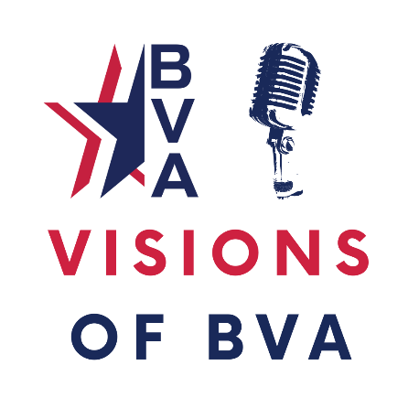
The October episode of Visions of BVA went live on all major platforms as of October 1. Most notably, it is accessible through the Association’s YouTube channel, Apple Podcasts, and Spotify. Featured this month is the audio version of the Summer 2026 BVA Bulletin, the most recently published and distributed issue of the quarterly publication produced by and for blind and low-vision veterans and their families.
Visions of BVA host and producer Steve Baskis has converted the written script of the Bulletin content, complete with descriptions of photos and graphics, into a high-quality, professional audio program that can be heard all at once or section by section.
Inside this issue, BVA National President Wade Davis reflects on his first year as National President and the Association’s continued growth, while Executive Director Lea Rowe discusses the strength of BVA’s collective voice and advocacy on behalf of blind and low-vision veterans. The legislative update examines current legislation affecting veterans, accessibility, VA health care, and issues affecting the blinded veteran community.
Technology and independence are major themes throughout this issue. The Bulletin explores the Meta AI app and accessibility features available with Ray-Ban Meta AI glasses, along with Meta’s nationwide effort to provide the glasses to blind and low-vision veterans and BVA’s role in their training and distribution.
The issue also takes a closer look at VA Blind Rehabilitation Centers and the life-changing skills, confidence, and independence veterans can gain through blind rehabilitation. Additional features cover adaptive sports and recreation, tandem cycling, the National Veterans Golden Age Games, TSA PreCheck eligibility for certain disabled veterans, BVA’s rapidly growing membership, the VISOR Care Review program, the Ambassadog comic book project, scholarships, regional activities, member achievements, veterans’ benefits, and stories from across the BVA community.
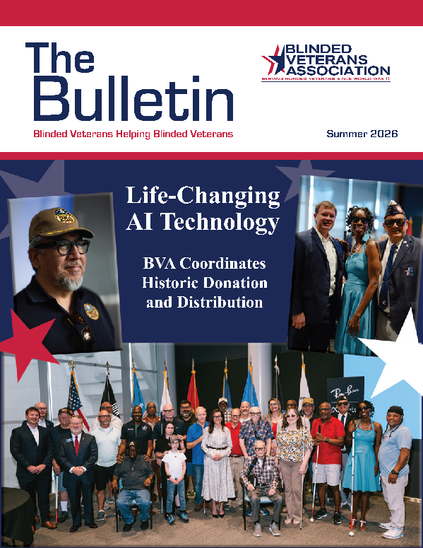
Whether you are a blinded veteran, family member, caregiver, rehabilitation professional, or supporter of the blindness community, the Summer 2026 BVA Bulletin offers news, resources, advocacy updates, technology, and stories highlighting the people and programs of the Blinded Veterans Association.
Visions of BVA is a deep dive into the inspiring stories of the organization and its members, accounts of resilience, and the achievements of blind and low vision veterans. Each episode features interviews, discussions on life-changing technology, and a glimpse into the BVA community.
Listeners and subscribers of Visions of BVA are welcome and encouraged to leave their feedback and share their thoughts with Steve Baskis, sbaskis@bva.org, on any aspect of the podcast.

Obtain and Read “Before We Were Yours” to Prepare for October Book Club Meeting

BVA’s Book Club Interest Group selected Before We Were Yours by Lisa Wingate to read during the last week of September and most of the month of October, which is National Book Month. Celebrate and expand your love of reading this month by participating in the Book Club Interest Group and reading Before We Were Yours.
The Braille and Audio Reading Download Number (BARD) for Before We Were Yours is DB 88202 and total reading time is 14:31 (14 hours, 31 minutes). BARD is a service of the National Library Service for the Blind and Print Disabled (NLS) through which BVA members are eligible to read an almost unlimited library of downloadable books and magazines.
Based on one of America’s most notorious real-life scandals—in which Georgia Tann, director of a Memphis-based adoption organization, kidnapped and sold poor children to wealthy families all over the country—Lisa Wingate’s riveting, wrenching, and ultimately uplifting tale reminds us how, even though the paths we take can lead to many places, the heart never forgets where we belong.
Book Club Interest Group meetings are open to all BVA members. New attendees are always welcome. While prior reading of the assigned book enhances the book club experience for all participants and makes for a livelier discussion, it is not a requirement to attend a meeting. The group will review Before We Were Yours at their next meeting, scheduled for Wednesday, October 28, at 7:00pm Eastern Time via Zoom. The link and other joining information for the meeting will be provided in future messaging

NLS Shares Career Position Announcements with BVA Happenings
The National Library Service for the Blind and Print Disabled (NLS) is currently advertising two vacancy announcements, one for an Overseas Librarian and the other for a Distribution Facilities Specialist.
Job Title: Distribution Facilities Specialist
Open Period: September 30, 2026 - November 2, 2026
Series & Grade: GS-2030-13
Position Information: Permanent Position
“Who May Apply” Open to Public
NLS Org: Materials Management Section (MMS), Business Operations Division, National Library Service for the Blind and Print Disabled Library Collections and Services Group (LCSG), at the Library of Congress (LOC).
Interested applicants can view the electronic version of this NLS vacancy announcement and other Library of Congress vacancies via the following: https://www.usajobs.gov/job/886869400
Job Title: Overseas Librarian
Open Period: September 29, 2026 - October 28, 2026
Series & Grade: GS-1410-12
Position Information: Permanent - Position
“Who May Apply” Open to Public
NLS Org: Information Services Section (INF), Patron and Network Engagement Division, National Library Service for the Blind and Print Disabled Library Collections and Services Group (LCSG), at the Library of Congress (LOC).
Interested applicants can view the electronic version of the NLS vacancy announcements and other Library of Congress vacancies via the following LC https://www.usajobs.gov/job/886691500

Ambassadog Scoop Series Courtesy of Waymo

From Pumpkin Patches to Life-Changing Matches
Photo Caption: Left to right: Butchie, Moose, Yoffi, Hannah, Loki

October brings crisp air, crunchy leaves, pumpkins, and a few spooky surprises. Before we became trusted guides, we were playful puppies romping through pumpkin patches, posing beside gourds, and occasionally forgetting that decorations were not chew toys.
Soon, our little paws stepped into a bigger adventure—and our puppy vests got a serious promotion to guide dog harnesses! With patient training, praise, and plenty of treats, we learned to ignore distractions, navigate busy places, stop at curbs, and guide with confidence. Our puppy curiosity grew into focus and purpose.
Now matched with blind and low-vision veterans, we are proud, life-changing partners. We help our handlers travel safely, move with greater independence, and enjoy the companionship of a four-legged teammate. On duty, we are calm professionals; off duty, we still love tail wags, toys, and belly rubs.
This October, as pumpkins glow and Halloween approaches, we proudly celebrate our journey as Ambassadogs. Behind every polished harness is a pup who began with muddy paws, boundless energy, and a big future. From pumpkin patches to life-changing matches, we have grown into something truly pawsome!

VA Insider

Veterans to Benefit from Greater VA Transparency in Choosing Prescribed Medications
VA earlier this week announced new guidance on informed consent of veterans that will offer them additional information before they make decisions regarding procedures or treatments, including prescriptions for psychotropic medications that include antipsychotics, stimulants, antidepressants, anxiolytics, and opioids.
A host of relevant information is already provided in a full discussion of the risks, side effects, benefits, and alternatives to psychotropic medications and long-term opioid treatment. The additional educational measures regarding the benefits and risks of certain medications will enable veterans to make a more comprehensive assessment of treatment decisions in consultation with their providers and families. Read the September 28 VA press release to learn which informed consent requirements will be added beginning in 2027.
VA Moves to Strengthen Informed Consent Transparency for Veterans

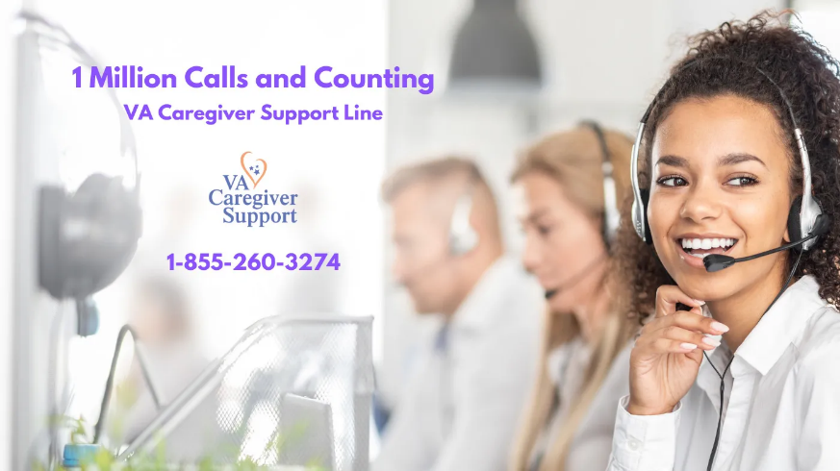
CSL Offers Caregivers Additional Resources, Support
Caregivers with questions or who need support can contact the Caregiver Support Line (CSL). The line offers services such as emotional support and counseling during the call and program referral and information for after the call. CSL can also provide a status for appeals submitted through the Caregiver Support Program’s Appeal process. Call VA’s CSL Monday-Friday 8:00am-8:00pm at 1-855-3274.
Questions that can best be answered at the local level can be directed to local Caregiver Support Teams. Locate contact information about local individual Caregiver Support Program teams at https://www.va.gov/resources/caregiver-support-teams.

Next Week’s Events

VetTech and Educational Series
Date and Time: October 7, 2026 (Wednesday), 3:00pm Eastern Time via Zoom
Meeting ID: 873 9159 8202, Passcode: 1958
The session will be a continuation of VetTech’s three-part wellness series on diabetes education, healthy living, setting goals, and managing blood sugar with no vision or low vision. Diabetes and Health Educator Kim Ladd will be leading this second of three sessions, dedicated to sharing practical tips and tricks for dealing with diabetes with greater confidence, independence, and support using nonvisual and low-vision techniques—all while striving for overall wellness, which is everyone’s ultimate objective! Following Wednesday’s meeting, the final session in the September-November Diabetes Wellness Series will be convened on November 4.

