BVA Happenings – October 23
Editor’s note: To use the Table of Contents to quickly jump to the article you are interested in, press CTRL while clicking on the title of the article.
Table of Contents
BVA Happenings – October 23 1
Around BVA 2
Join Monthly Online Training Session for Meta Ray-Ban AI Glasses this Monday 2
Ahoy! Register Now for 2027 Convention Cruise 3
Carolina Regional Group Celebrates White Cane Day in Two Cities 4
High Marks for First Biannual District 2 Summit 6
Devoted GRG Member and Leader Dennis Darnes Highlighted in Media Segments 8
A Yearly Opportunity to Recognize Deployed Service Members 8
Additional Veterans Day Posters Available via BVA HQ 9
Book Club Interest Group to Huddle This Wednesday 10
Ambassadog Scoop Series Courtesy of Waymo 10
A Bond Forever: Teal’s Tribute to BVA Member Rick Olson 10
VA Insider 11
Regional Sites Now Set for Veterans Day Observances 11
Self-Care Routines Vital to Achieving Whole Health 12
VA Health Care Welcomes 300K-Plus New Veterans 12
Next Week’s Events 13
Ray-Ban AI Meta Glasses Training 13
VetTech and Educational Series 13
Book Club Interest Group 13

Around BVA

Join Monthly Online Training Session for Meta Ray-Ban AI Glasses this Monday
BVA National Program Director Domonique Lawless will direct the monthly online training on the Meta Ray-Ban AI glasses for BVA members and their families on Monday, October 26, at 3:00pm Eastern Time. The session via Zoom will be particularly useful for veterans who have recently received their glasses or those who have specific questions.
“We’ll explore helpful commands you can use with your glasses and share practical tips for basic troubleshooting,” said Domonique. “Bring your curiosity, your questions, and your enthusiasm for discovering more of what your glasses can do. We look forward to seeing you there!”

The Blinded Veterans Association is inviting you to a scheduled Zoom meeting.
Topic: Ray-Ban Meta AI Glasses Training
Time: October 26, 2026, at 3:00pm Eastern Time (US and Canada)
Join Zoom Meeting
Meeting ID: 886 5123 3214
Passcode: 1945
One tap mobile
+13017158592,,88651233214#,,,,*1945# US (Washington, DC)
+13092053325,,88651233214#,,,,*1945# US (Chicago)
By Phone (landline or cellular)
1 301 715 8592 (Washington, DC)
1 312 626 6799 (Chicago)
1 646 558 8656 (New York)
1 720 707 2699 (Denver)
1 253 215 8782 (Tacoma)
1 346 248 7799 (Houston)


Ahoy! Register Now for 2027 Convention Cruise
Registration is open for members and families who would like to attend the 2027 BVA Convention Cruise to the Bahamas aboard Royal Caribbean’s Oasis of the Seas. Visit BVA.org under the Convention tab for cruise details and the registration link or use the registration button below this article.

Important Registration Information
All attendees must register online to submit the required information securely. BVA staff can answer general questions but cannot register attendees. For registration questions and assistance, email bvacruise@landrykling.com during business hours, Monday-Friday, 9:00am-5:00pm Eastern Time. An agent will respond as quickly as possible. Please do not contact Royal Caribbean directly.
Within two weeks of registering, you will receive a confirmation email with your reservation/booking ID and instructions for completing required forms for special needs and guide dogs. A group rate for guests arriving Sunday, April 11, 2027, the night before departure, is being finalized. Details will appear in next week’s BVA Happenings and on the Convention page at BVA.org. Get ready to make waves with BVA in 2027!

Royal Caribbean’s Oasis of the Seas Cruise to the Bahamas: Basic Schedule
- Monday, April 12, 2027 – Leave Fort Lauderdale, Florida (Port Everglades) at 4:00pm; embarkation expected to begin around noon, and guests are required to be checked in and onboard the ship by 2:30pm (90 minutes prior to the scheduled departure time).
- Tuesday, April 13 – Day at Sea/Cruising.
- Wednesday, April 14 – Nassau, Bahamas, 7:30am-5:30pm
- Thursday, April 15 – Perfect Day at CocoCay, Bahamas; 7:30am-5:00pm
- Friday, April 16 – Return to Fort Lauderdale, Florida (Port Everglades), by 6:00am, guests to embark the ship between 7:00 and 9:pm (flights home should not depart prior to noon)
BVA National Convention 2027
Register for the National Convention

Carolina Regional Group Celebrates White Cane Day in Two Cities
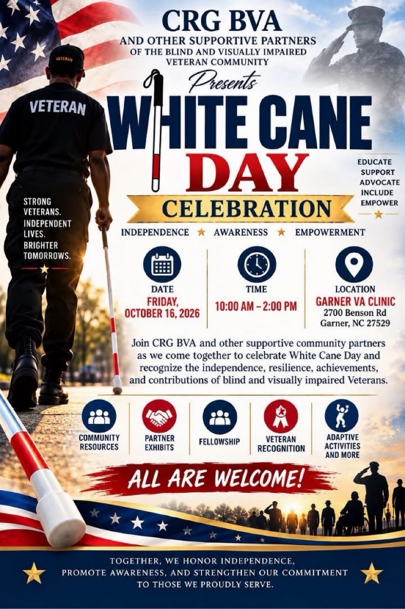
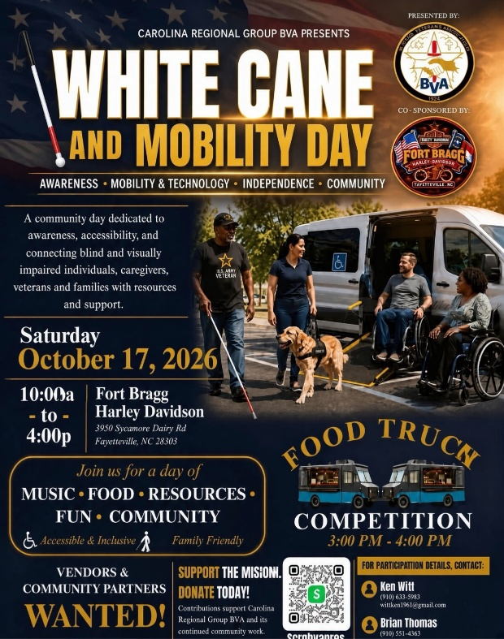
Dr. Jay McLeod, president of the Carolina Regional Group, recounts for BVA Happenings last week’s BVA White Cane Day activities in two separate points within the Tar Heel State.

Photo 1 Caption: BVA National Treasurer Monique Statham welcomed visitors to BVA’s information booth during the Garner Outpatient Clinic White Cane Day Event on October 16.
Photo 2 Caption: Left to right, Arlena Oxendine-McLeod (BVA Auxiliary member since 2018), spouse of Dr. Jay McLeod (Carolina Regional Group), and Jim and Terry Berube, the latter of whom are owners of All Starr Underground and members of Veterans of Foreign Wars Corporal Rodolfo P. Hernandez Post 670 where the regional group holds its monthly meetings. The couple helped bring people to the Fayetteville event and are active community supporters of BVA.
Photo 3 Caption: A strong and brave BVA contingent made it past Mother Nature to safely arrive at White Cane Day activities October 17 at the Fayetteville, North Carolina, VA Medical Center.
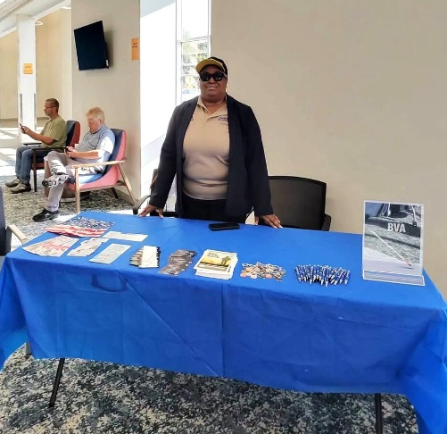
BVA’s Carolina Regional Group marked White Cane Day 2026 October 16-17 across two cities, bringing veterans, families, and community partners together across the central portion of North Carolina.
On October 16 (Friday), the group joined VA Brier Creek Blind Rehabilitation Service officials and community partners at the Garner, North Carolina, VA Outpatient Clinic for a day of recognition, resources, exhibits, and fellowship honoring the independence, resilience, and contributions of blind and low-vision veterans. The regional group expresses special thanks to Monaca Gilmore, whose hard work pulled the event together, and National Treasurer Monique Statham, who represented the National Board of Directors in person.
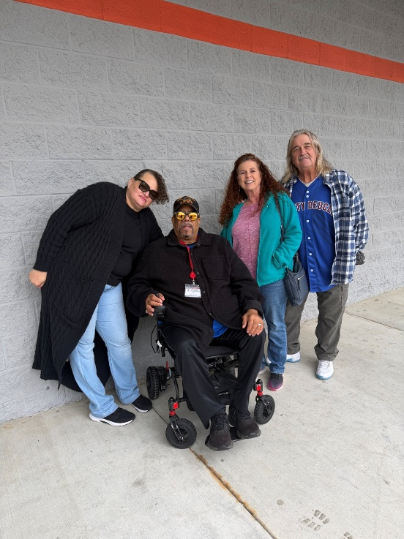
On October 17 (Saturday), the group hosted its White Cane and Mobility Day at the Fort Bragg Harley-Davidson in Fayetteville—a full community day of music, food, resources, and fellowship. Despite the rain, several vendors and participants came through. Technology took center stage: Guiding Eyes Outdoors gave Meta glasses to blinded veterans, and the veterans made videos to be shared on YouTube about what the glasses would and could do for them. The North Carolina Division of Services for the Blind and the Lions Club were there with technology of their own. Having the North Carolina Council of the Blind there also meant a great deal to us.
Congratulations to our food truck winner, Geko's Ice Cream Truck! Our thanks to Harley-Davidson for their corporate sponsorship of the location and their in-kind donation of the food, chips, and drinks we gave away — their second year supporting us — and to the Special Operations Group for helping with the DJ.
We were pleased to have BVA Auxiliary (BVAA) National President Kenneth Witt and Vice President Gail Witt with us, both members of our regional group’s auxiliary and both BVAA National Officers. Their help made the Fayetteville event a success.
A special salute and shoutout also to our BVA members who braved the weather to be there.
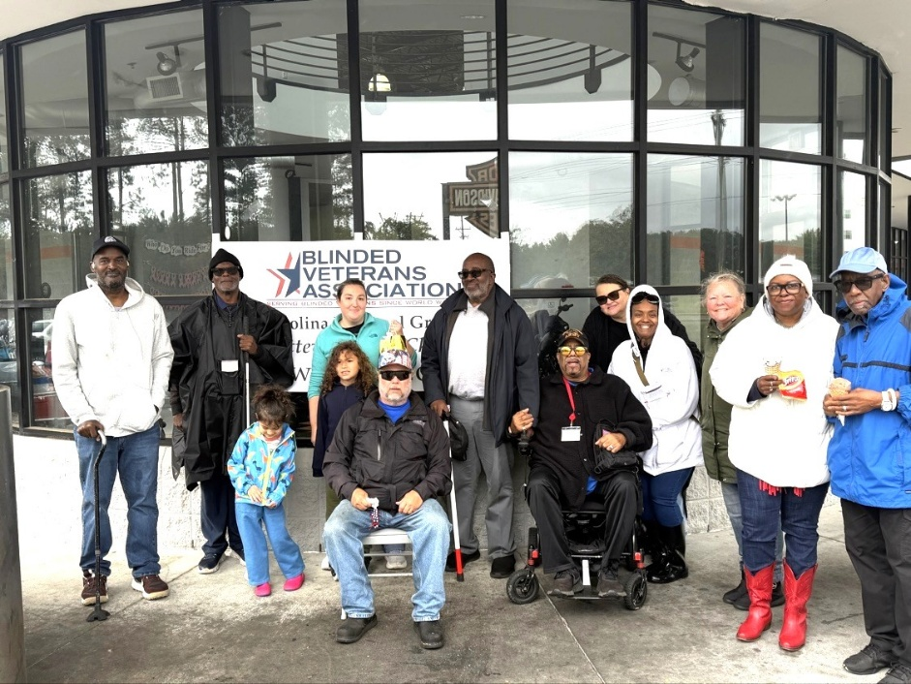
We thank every vendor and partner who signed up for the day, even if the weather ultimately made it impossible for them to attend. They are the following:
- Jive Turkey
- Geko's Ice Cream Truck
- The Boston Slice and More
- Red, White, and Blue BBQ
- Taco Arepa Food Truck
- Division of Services for the Blind
- MobilityWorks
- Veterans Bridge Homes
- SouthLight
- Anna's Beadable Things
- Mrs. Dee Baskets
- Team River Runner
- Kaleo Supports
- Young Living
- Guiding Eyes Outdoors
- Homeward Rise Solutions
- Beverley Designs
- Lions Club
- Pathfinder Relief Solutions
- Monaca Gilmore
- Sandy North
- Vision Resource Center

High Marks for First Biannual District 2 Summit
Photo 1 Caption: Left to right at District 2 Summit Meta glasses distribution: Summit Planning Committee members Calvin Poole (Tennessee Regional Group), Shawntina Gibson (Louisiana/Mississippi Regional Group and Director of District 2), and Robert “Bobby” Fulks (Arkansas Regional Group).
Photo 2 Caption: National Program Director Domonique Lawless provides training to a Memphis area veteran at the October 16 Meta Ray-Ban AI glasses distribution.
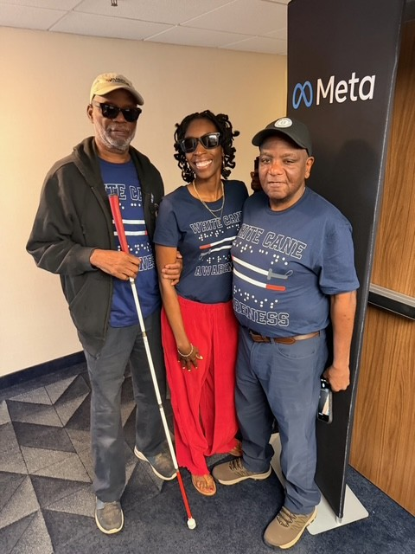
BVA’s District 2 held its first biannual summit in Memphis, Tennessee, October 15–19, 2026. The successful gathering brought together members from regional groups in good standing and those working to become active again, creating opportunities to learn, share experiences, and strengthen connections.
Representatives from active regional groups shared effective practices and offered advice and encouragement to members working to reestablish their groups. These exchanges reinforced the value of cooperation and the shared commitment to serving veterans with sight loss.
District business and leadership training provided participants with opportunities to build their skills and strengthen regional group operations.
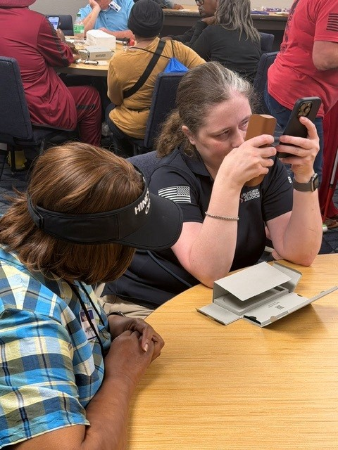
The summit also welcomed BVA Executive Director Lea Rowe, National Program Director Domonique Lawless, and a team from Meta. The Meta glasses were distributed to members, with training also provided to help recipients begin using the relevant technology.
Following district business and leadership training, participants enjoyed a barbecue and adaptive activities at the Tennessee Regional Group complex. The gathering offered time for recreation, conversation, and fellowship while celebrating and learning about the rewards of possible adaptive sports and activities.
Special recognition goes to the Tennessee Regional Group and its Auxiliary members for their outstanding hospitality. Their work preparing meals and transporting participants throughout the summit helped make the event welcoming and successful.
The summit demonstrated the strength of regional groups supporting one another. Participants left with useful knowledge, stronger relationships, and renewed energy to serve blinded veterans in their communities.

Devoted GRG Member and Leader Dennis Darnes Highlighted in Media Segments
BVA’s Georgia Regional Group President Dennis Darnes was featured last week in two different media reports, one an online news article and the other a television segment aired by CBS News Atlanta where he resides. The reports followed a local Atlanta distribution of Meta glasses on White Cane Day. The substance of the reports documents the life-changing impact of the glasses on veterans such as Dennis who have lost their sight to natural causes and BVA’s role in their distribution. The October 15 glasses distribution occurred through the Center for the Visually Impaired in Atlanta. Read the article and view the television spot.
Television: Atlanta Veteran Finds New Independence with Meta Smart Glasses
Online Article: Atlanta Veteran Who Lost Job and Home to Blindness Finds New Eyes in AI Glasses

A Yearly Opportunity to Recognize Deployed Service Members
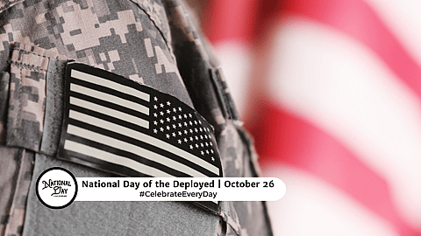
Since 2012, October 26 has been recognized by all 50 states as the National Day of the Deployed, a day dedicated to honoring those past and present who have been deployed throughout the world in U.S. military service. The day also acknowledges the sacrifices that military spouses and family make during deployment.
The first-ever National Day of the Deployed was observed in 2006 when North Dakota announced a proclamation for the day, thanks to the efforts of Shelle Michaels Aberle, who petitioned Governor John Hoevento with the idea. October 26 was chosen for the date in honor of Shelle’s cousin, who had been deployed to Iraq and who celebrated his birthday on that date. Six years later, every state was observing National Day of the Deployed with their own proclamations and other recognitions.
The U.S. Congress has decreed in previous years that 1) October 26 be designated as the “Day of the Deployed,” 2) deployed members of the Armed Forces and their families be recognized and honored on that day, 3) the people of the United States reflect on the service of deployed members of the Armed Forces, wherever they serve—past, present, and future, and that 4) the Day of the Deployed be observed with appropriate ceremonies and activities.
For BVA members, their families, and caregivers desiring to honor those who have been deployed on social media, military.com recommends including hashtag #DayOfTheDeployed in the post.

Additional Veterans Day Posters Available via BVA HQ
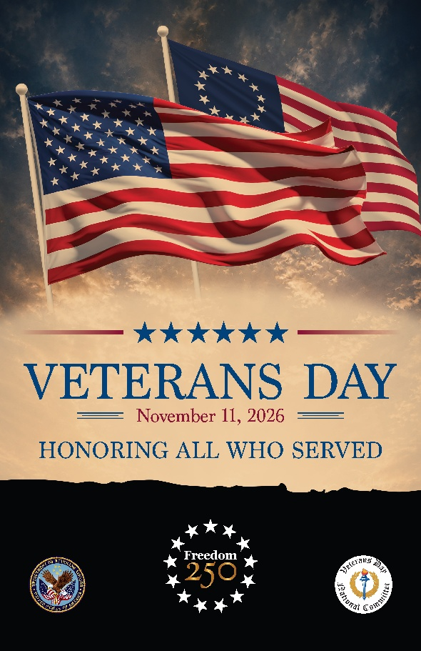
VA has provided BVA National Headquarters with a limited quantity of 2026 Veterans Day printed posters, of which there are a small number remaining, both 11” by 17” and 18” by 24”. If you plan on hosting a Veterans Day activity or can display this year’s poster in a public area of an office, school, or business, please send an email message as soon as possible to info@bva.org. BVA will honor reasonable requests whenever possible, and as supplies remain.
Each year, VA and the Veterans Day National Committee, of which BVA is an original member, work together to select a poster to help tell the story of service, sacrifice, and gratitude on Veterans Day. The poster serves as the visual centerpiece for the Nation’s Veterans Day observance and reflects the pride and patriotism Americans share in honoring those who wore the uniform.
The poster that represents Veterans Day this year brings together the enduring symbols of our Nation’s history with the continued legacy of military service and recognizes America’s 250th anniversary. This year’s design combines the modern American flag with an early American flag, visually connecting the founding of the United States with the generations of veterans who have defended its freedoms.
This year’s printed poster is currently being displayed in VA facilities, military installations, and municipal buildings across America. It will also serve as the cover of the official program for the Veterans Day commemoration at Arlington National Cemetery on November 11, and as the design on lapel pins provided to leaders of Veterans Service Organizations attending that event. It is also available for download online and can be produced by professional printing establishments or retail stores such as FedEx Office, Staples, Office Depot, etc.
Downloadable Veterans Day Poster

Book Club Interest Group to Huddle This Wednesday

The BVA Book Club Interest Group selected Before We Were Yours by Lisa Wingate to read during the last week of September and most of the month of October. The Braille and Audio Reading Download Number (BARD) for Before We Were Yours is DB 88202, and the total reading time is 14:31 (14 hours, 31 minutes).
BARD is a service of the National Library Service for the Blind and Print Disabled (NLS) through which BVA members are eligible to read an almost unlimited library of downloadable books and magazines. There are just five days remaining to read Before We Were Yours before the group meets once again this Wednesday, October 28.
Time permitting, the group will preview the book for November, Bodily Harm by New York Times bestselling author Robert Dugoni. In Bodily Harm, Dugoni offers one of several legal thrillers, a pulse-pounding story of corporate greed, espionage, and the lengths one man is willing to go for justice.

Ambassadog Scoop Series Courtesy of Waymo

A Bond Forever: Teal’s Tribute to BVA Member Rick Olson
I’m Teal, and I had the honor of walking beside Richard “Rick” Olson as his Ambassadog. Rick passed away only recently. From our first days at Guide Dogs for the Blind, I knew Rick was special. He trusted my instincts while I relied on his gentle voice, steady hand, and generous heart. Every walk was an adventure, and quiet moments strengthened our bond. Although our time together was short, our bond is forever. My path now continues with another handler who needs my guidance, yet Rick will always be part of my story.
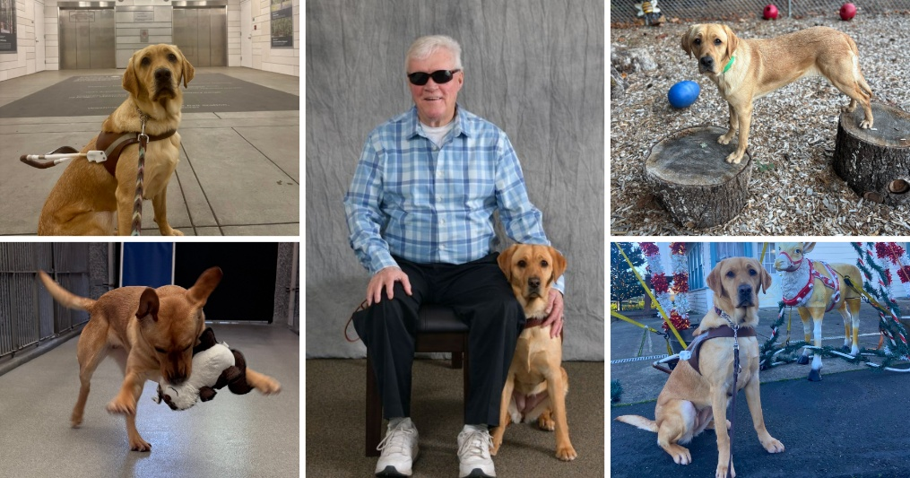
Rick taught me that partnership is built on courage, patience, loyalty, and love. I hope everyone remembers the kindness Rick shared. I will carry him with me, one step and wagging tail at a time as a forever BVA Ambassadog.

VA Insider

Regional Sites Now Set for Veterans Day Observances
VA and the Veterans Day National Committee (VDNC) have selected 48 regional sites in communities and non-profit organizations in 24 states as official partners to hold VA-approved Veterans Day observances this upcoming Veterans Day.
In support of the annual National Veterans Day Observance each November 11 at Arlington National Cemetery and to honor Veterans nationwide, VA and the VDNC encourage communities and nonprofits to hold VA-approved Veterans Day observances.
VA and the VDNC will co-host the 2026 annual National Veterans Day Observance each November 11 at Arlington National Cemetery. The ceremony, which is open to the public, begins at 11:00 am EST, with the Presidential Wreath Laying at the Tomb of the Unknown Soldier, and continues in the Memorial Amphitheater with a parade of colors and remarks from dignitaries.
Each selected regional site receives Veterans Day posters, military ceremonial support from the Department of War, and a certificate from the Secretary of Veterans Affairs for their event.
See the list of Veterans Day regional sites for 2026, VA’s events calendar for ceremonies and parades nationwide, and information on how to apply for your community to become a regional site in 2027.
VA-Recognized Regional Observances and Other Ceremonies and Parades

Self-Care Routines Vital to Achieving Whole Health

Our bodies and minds deserve to be cared for by using at least 15 minutes a day to nurture our health and well-being. Without realizing it, we frequently carry stress around in our heads. Our foreheads are furrowed, our eyes are squinted, or our jaw is clenched. Paying attention to signs of stress such as these gives us the opportunity to take action to relieve that stress.
A head and neck massage, guided by Dr. Sharon M. Weinstein of the Salt Lake City VA Healthcare System, can be followed in the video below. The massage has most veterans relaxed in just 15 minutes. Before watching the video and following Dr. Weinstein’s instructions, prepare yourself and your environment by sitting in a way that allows you to feel well-supported, limiting your digital distractions, hydrating with water and having more water nearby, and washing and drying your hands thoroughly before and after.
Live Whole Health: Is Your Face Giving You Away?

VA Health Care Welcomes 300K-Plus New Veterans
More than 300,000 new veterans have enrolled in VA healthcare thus far in 2026, pointing to improved outreach to veterans who were previously unaware of the benefits and services they have earned because of their willingness to sacrifice for their country. The increases in VA enrollment will save veterans and their families thousands of dollars each year, the announcement stated.
The effort to reach out to veterans during the second Trump administration has led to more than 1.8 million completed or scheduled medical appointments with veterans who joined in 2026. The figure includes more than 420,000 mental health appointments and more than 16,000 emergency care visits.
To learn more about this monumental achievement, read the VA press release of October 21.
Over 300K New Veterans Enroll in VA Healthcare in 2026

Next Week’s Events

Ray-Ban AI Meta Glasses Training
Date and Time: October 26, 2026 (Monday), 3:00pm Eastern Time via Zoom
Meeting ID: 886 5123 3214, Passcode: 1945
The session will explore helpful commands for use of the Ray-Ban glasses and share practical tips for basic troubleshooting. Participants should bring their curiosity, their questions, and their enthusiasm for discovering more of what their glasses can do.

VetTech and Educational Series
Date and Time: October 28, 2026 (Wednesday), 3:00pm Eastern Time via Zoom
Meeting ID: 873 9159 8202, Passcode: 1958
The session will examine the newest model of the National Library Service (NLS) digital audiobook player known as the DA2, released in 2025. Attendees will receive an overview of how to set up the player, the buttons involved in DA2’s operation, and its many capabilities.

Book Club Interest Group
Date and Time: October 28, 2026 (Wednesday), 7:00pm Eastern Time via Zoom
Meeting ID: 8710 860 6539, Passcode: 1945
The session will review Before We Were Yours by Lisa Wingate, a work selected by interest group members in September. The group will also preview Bodily Harm by New York Times bestselling author Robert Dugoni. In Bodily Harm, Dugoni offers one of several legal thrillers, a pulse-pounding story of corporate greed, espionage, and the lengths one man is willing to go for justice.

