Trailblazers of Tomorrow
(TVCC Youth Advisory Council)
(For youth living with disabilities and their siblings ages 16 - 29)

Seeking members for TVCC Youth Council!

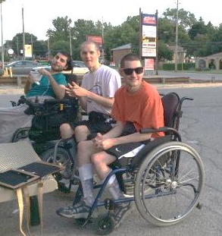
Are you:
- A youth with personal experience of living with a disability and accessing services of a Children’s Treatment Centre
- A sibling of a youth living with a disability
- Interested in providing a youth perspective on programs and issues at TVCC and in the community
- Able to participate in group discussions

What’s involved?
- Attend one meeting per month
- Provide feedback to shape youth services at TVCC and in our communities
- Support youth events and community involvement

What’s in it for me?
- Gain volunteer hours and leadership experience
- Potential to attend relevant youth workshops and conferences
- Hang out with an awesome group of people

When do we meet?
- Monthly meetings – day and time to be determined by the group

Application / Questions:
RSVP to Amanda at volunteer@tvcc.on.ca or call 685-8700 ext. 53452



