TVCC Trailblazers of Tomorrow

Who are we?
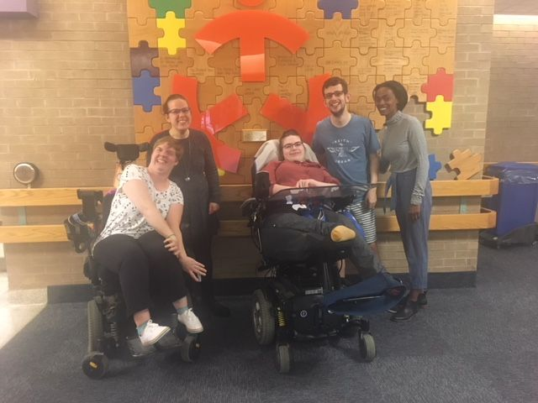

TVCC Trailblazers of Tomorrow are a group of youth and young adults who are current or past clients of TVCC (or other Children’s Treatment Centres) and their siblings.
We are passionate about creating opportunities for youth-led and youth-informed practice and advocacy at TVCC and within the greater community.
Trailblazers of Tomorrow aim to facilitate engagement in community-based youth initiatives and promote an inclusive and aware community.

What do we do?
- Offer feedback and ideas to enhance youth programs and activities at TVCC and in the greater community
- Support TVCC youth events
- Link with community groups in order to advocate for change in areas identified by our Trailblazers, clients and families
- Provide opportunities for youth to share lived experiences and possibilities with families, clients, staff and communities
How often do we meet?
Trailblazers for Tomorrow meet as a group on a monthly basis. Trailblazers also attend community events and can work in small groups to promote awareness and inclusivity in our community.

Who can join?
Trailblazers are registered TVCC volunteers between the ages of 16 -29.
We are:
- youth with personal experience of living with a disability and accessing services of Thames Valley Children’s Centre (or other Children’s Treatment Centre)
- a sibling of a youth living with a disability
- interested in providing a youth perspective on programs and issues at TVCC and in the community
- able to participate in group discussions

Interested in input from Trailblazers or in joining Trailblazers?
For question or more information contact Youth for Youth at youth@tvcc.on.ca or 519-685-8700 ext 53766.
For an application see Amanda Rasmussen at volunteer@tvcc.on.ca or call 519- 685-8700 ext 53452.

