WOOD BUFFALO NATIVE YOUTH HOCKEY CLUB

December 14, 2023

The Wood Buffalo Native Youth Hockey Club (WBNYHC) is a non-profit society established to provide Indigenous youth from the Regional Municipality of Wood Buffalo an opportunity to participate in the Annual Alberta Native Hockey Provincials in Edmonton, Alberta to be held April 4th – 7th, 2024.

With the help of donations or sponsorship we can have our youth represented at the Alberta Native Hockey Provincials

For 2024, we have entered 9 teams from U7 to U18 (2 new teams entered), representing Indigenous youth from Fort Chipewyan, Janvier, Anzac, Conklin, Fort McKay, and Fort McMurray. For many kids, this may be their only opportunity to participate in a tournament of this caliber and represent their community.
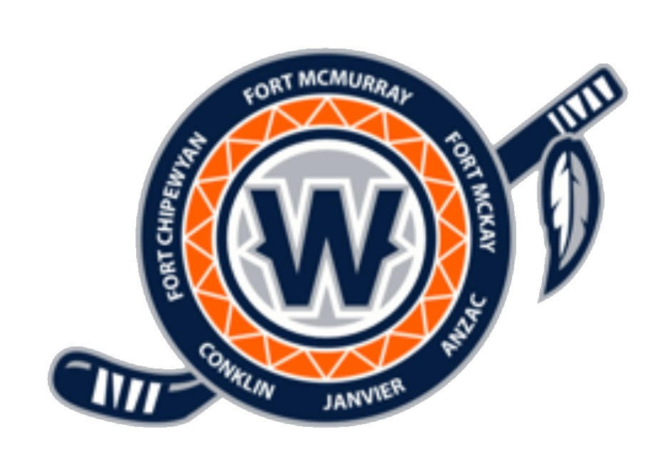
The WBNYHC is seeking your support in 2024. In return for your contribution, your company will be recognized through media recognition and your corporate logo on team banner’s that will be place in many arenas throughout the City of Edmonton. Your contributions go towards, team entry fees, hotel costs for each family, team activity and apparel.
The Wood Buffalo Native Youth Hockey Club thanks you in advance for your support. If you require further information, please feel free to contact us.

Sincerely,

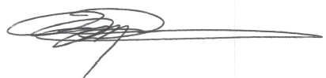

Wood Buffalo Warriors
Native Youth Hockey Club

CC: Mitch Mercredi, President mmercredi1@gmail.com 780-881-6444
Deanna Simard, Treasurer deannasimard@hotmail.com 780-838-2005

