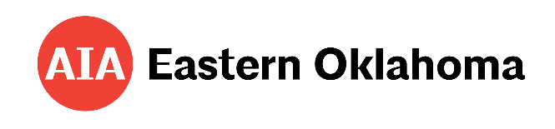

2026 AIA EASTERN OKLAHOMA HONOR AWARDS

Please complete this nomination form for each nominee and accompany it with a PowerPoint
presentation supporting your nomination. The presentation should incorporate pertinent documentation
and include a written justification of approximately 300 words, outlining the reasons why the nominee
deserves to be honored with the award. The file size should be 15 MB or less.

Nominee Data

Name: _______________________________________________________________________

Company: ____________________________________________________________________

Address: ______________________________________________________________________

City / State / Zip:________________________________________________________________

Phone: __________________________________ Fax: ________________________________

Email: ________________________________________________________________________

Nominated by:

Name: _______________________________________________________________________

Company: ____________________________________________________________________

Phone: ___________________________________ Fax: _______________________________

Email: ________________________________________________________________________

Award Category

 Adah Robinson Award (Community Member or Organization)

❒ Emerging Professional Award

❒ Keystone Award (Allied Company or Individual)

❒ Lifetime Achievement Award

❒ Member of the Year

❒ Firm of the Year

Nominations are due no later than Friday, October 9th and uploaded HERE.

