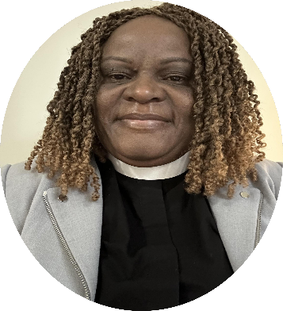
Biography of The Rev. Carolyne. A Adhola
The Rev. Carolyne Adhola is a seasoned priest with more than 15 years of experience in pastoral care, church revitalization, and organizational leadership. Her ministry has spanned diverse contexts, from parish leadership in the Anglican Church of Kenya, to the Episcopal Church in the United States of America. She has guided congregations through seasons of growth and transition, strengthening ministries, empowering lay leadership, and fostering vibrant worship and community life.
After graduating from Carlile School of Theology in Nairobi, Kenya, she was ordained in the Anglican Church of Kenya in 2009, and served as vicar and youth pastor at St. Michael and All Angels Cathedral, in the Diocese of Bondo. Her ministry has also included academic leadership as Lecturer in the School of Theology, assistant chaplain and Administrator at St. Paul’s University, Kenya.
In the United States, she has served as assisting priest both in the Episcopal Diocese of Virginia at Meade Memorial Episcopal Church in Alexandria and in the Episcopal Diocese of Washington, at Trinity Episcopal Church, Piney Branch, Northwest DC. Currently, she is serving as Priest-in-Charge at St. Mary Magdalene Episcopal Church, Silver Spring, Maryland. There she established vestry leadership, revitalized parish ministries, and strengthened congregational life among other achievements.
Beyond parish ministry, Carolyne serves as Director of both the Daughters of Zion Widows Group and the Shalom Orphans Rescue Center in Bondo, Kenya, ministries dedicated to care, empowerment, and advocacy.
With her rich experience in ministry renewal, mission outreach, resource stewardship, and pastoral care across generations, Carolyne embodies the heart of servant leadership. She delights in contextual preaching and teaching, connecting scripture to daily life experience.
She brings to St. Paul’s Batesville a deep commitment to spiritual formation, compassionate pastoral presence, and a vision for building communities rooted in faith, service, and hope.

