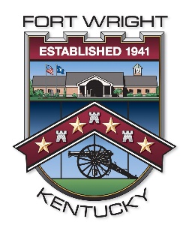
Fort Wright Community Bench Program
Buy a Commemorative Bench - Limited Opportunity

A commemorative bench is the perfect way to beautify and functionally accent our community while providing a special place of acknowledgement for a loved one, or group. Inscribe one of our commemorative benches with a message of kindness, love, recognition, or hope providing a lasting tribute to the special people in your life.
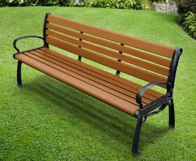
Bench Type: 6ft – Black and Cedar Colored Two-Toned Bench with smoothly contoured seat and backrest. The UV and Moisture resistant bench slats are cedar colored and fabricated of high grade recycled plastic, and they feature a powder coated cast aluminum black frame.

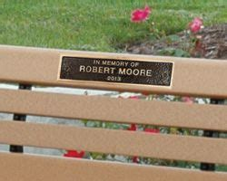
Bench Message: Benches will feature a personalized cast bronze plaque that is durable coated to protect from weather exposure and are 8”w x 2”h that is size restricted by the manufacturer. The message that is placed on the plaque must not include constitutionally prohibited speech, including without limitation “fighting words”, defamatory statements, obscenity, or message that constitute a “clear and present danger”. Plaques may include the name of the individual to be celebrated/memorialized, as well as, dates and a saying or poem.

Installation: Bench orders will be placed in bulk to meet minimum purchasing requirements. Delivery will be based upon manufacturer production and shipping times with installation provided by our Public Works Department upon receipt of product.

Bench Life Span: The bench and plaque will remain the property of the City of Fort Wright at all times. The City will maintain the bench and plaque in proper working order for a period of 10 years. At the end of the 10 year period the City will at its own discretion remove and/or replace the bench and/or plaque.

Bench Purchase Price: $2,500.00; includes concrete base, bench, plaque, 10 year maintenance, delivery, and installation.

Bench Locations: We currently have Nine (9) Commemorative Bench locations remaining for purchase. They are in the vicinity of the following:

- Amsterdam/Fort Henry | - Dixie Hwy/Dunkin | - Dixie Hwy/Trek
- Dixie Hwy/Atlas Fitness | - Highland/City Hall | - Highland/Werner
- Valley Plaza/Texas Roadhouse | - Valley Plaza/BW3 | - West Henry Clay/Kyles
- City Hall/Little Library | - Highland/Nature Center #1 | - Highland/Nature Center #2
- Kyles/Highland | - Kennedy Playground #1 | - Kennedy Playground #2

Fort Wright Community Bench Program
Buy a Commemorative Bench - Limited Opportunity
ORDER FORM

Purchaser’s Information

Name: ________________________________________________________________
Address: _______________________________________________________________
City, State, Zip: _________________________________________________________
Phone Number: _________________________________________________________
Email Address: __________________________________________________________

Commemorative Plaque Message
Please print or type one letter per spot. Spaces and punctuation marks count as one letter. Maximum of 3 lines, 20 letters/characters per line.
_ _ _ _ _ _ _ _ _ _ _ _ _ _ _ _ _ _ _ _
_ _ _ _ _ _ _ _ _ _ _ _ _ _ _ _ _ _ _ _
_ _ _ _ _ _ _ _ _ _ _ _ _ _ _ _ _ _ _ _

Location
Bench locations will be sold on a first come, first paid basis. Please select your preferred location by corresponding number. If your preferred location is not available we will contact you to determine an alternative location or a refund. If you don’t have a preferred location please mark the location “any”.

_____________
Location Number

Payment
Payment in the amount of $2,500 can be paid by cash, check, or credit card. Please make checks payable to the City of Fort Wright and submit payment along with your order form to us at 409 Kyles Lane, Fort Wright, KY, 41011. Thank you!

