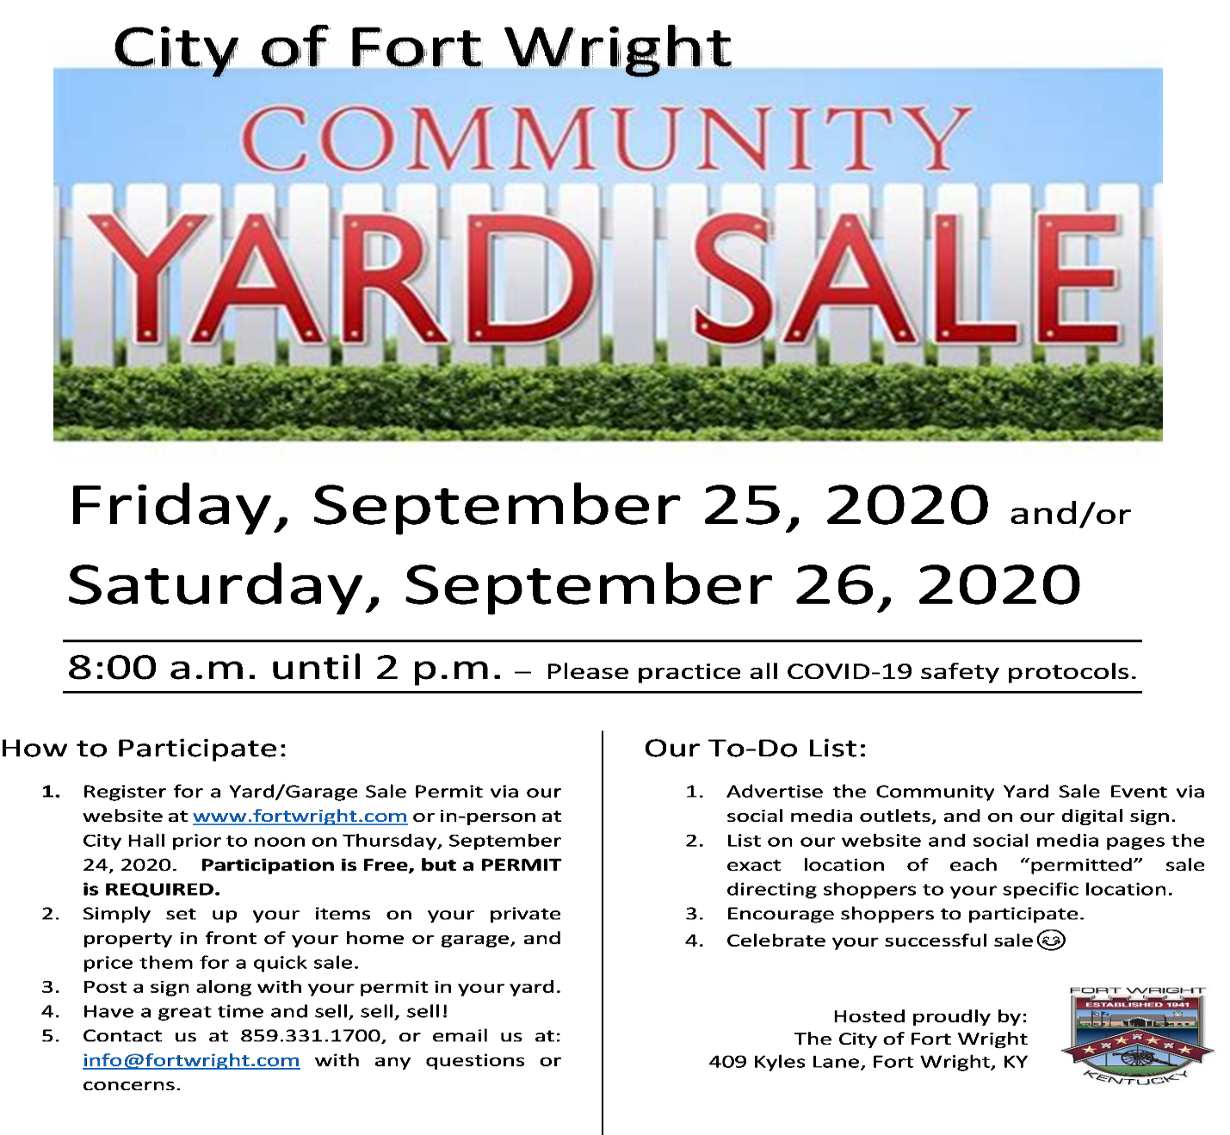
Friday, September 5th, and/or
Saturday, September 6th, 2025

COMMUNITY SALE PERMIT REQUEST
Name: ________________________________________________________________________
Applicant Address: ______________________________________________________________
Applicant Phone Number: ________________________________________________________
Applicant Email Address: _________________________________________________________
I plan to participate in the community sale from 8 am until 2 pm on the following event dates:
Please check only one option.
____ Friday, September 5th ONLY or ____ Saturday, September 6th ONLY
____ BOTH Friday, September 5th, and Saturday, September 6th, 2025.
I understand that my address will be publicly posted as a sale location and have read and understand the conditions of the permit identified below.
Applicant Signature: ____________________________________ Date: ___________________
Conditions of Permit:
Applicant must be a resident of the above listed address.
No signs shall be posted anywhere except on the property of the sale.
Authorized permit must be on display during the sale.

Submit application in person at 409 Kyles Lane or via email prior to noon on September 4th, 2025, to info@fortwrightky.gov.

__________________________________________________________ Date: ________________
Approved by:

