Go to https://www.mypaymentsplus.com/welcome
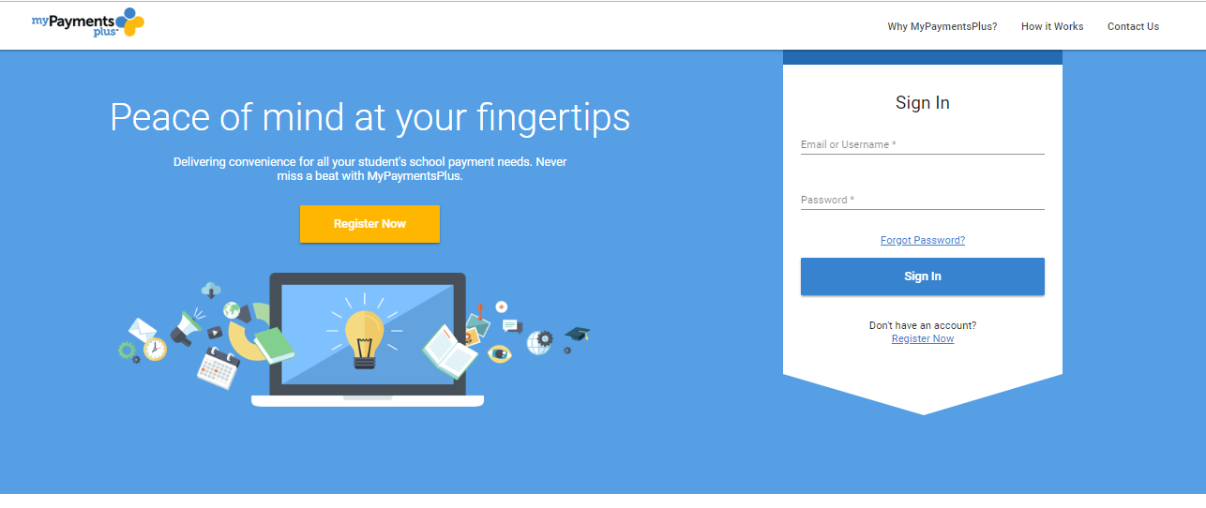
If you already have an account, you’ll enter your username and password. If you don’t have an account, you'll have to create one. 