





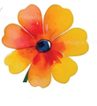

June 6
9-2:00
spring
craft
fair
First Parish Norwell
24 River Street
Norwell
outdoor +indoor vendors
live music
refesments

Contact name
Address
Phone
Email
Description of craft
Desired spot | Outdoor oversized outdoor indoor

There are 18 outdoor spots (6 of which are oversized) and 10 indoor, @8 by8
*WiFi is available and some electricity available provide your own extension cord
*Indoor: 8 foot banquet tables and 2 chairs provided, air is circulated by fans
*Outdoor: bring your own tables/chairs, tents need to be weighted for safety (No in ground spikes allowed)
*Fee: $50. and $65 for oversized spots, check or venmo (please write “craft fair” in the notes) due prior to the event
*Set up: Friday June 5 from 3-7.
*Check in time: Saturday June 6, 7:00, no later than 8:30
For further information or a viewing of the spaces,
please contact Heather Comeau 617-962-6456
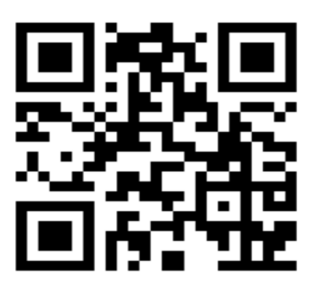
Please make your check out to: First Parish Norwell
Mail or email this form to by May 1, 2026
Heather Comeau
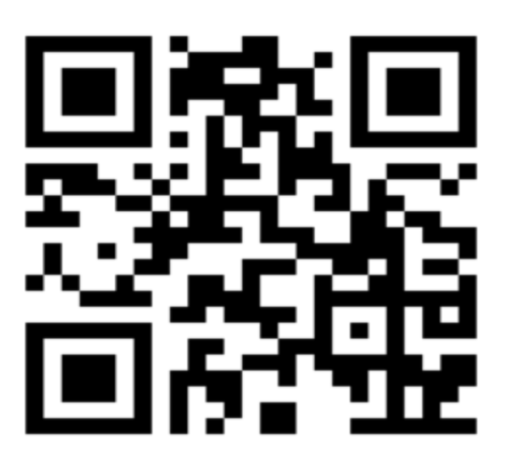
188 Crescent St
Hanson, MA 02341
hjlc@comcast.net

