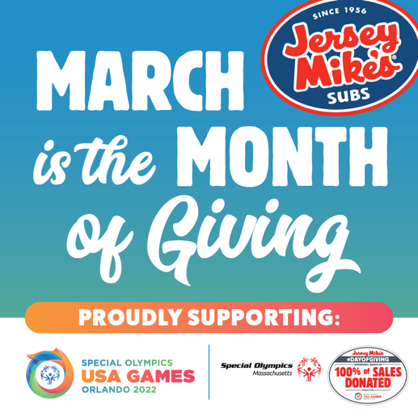
Win a Jersey Mike’s Party!
Get in the spirit of giving with Jersey Mike’s Month of Giving! This year, for the first time, Jersey Mike’s owners and operators are excited to unite behind the 2022 Special Olympics USA Games and Special Olympics Massachusetts athletes.
During the month of March, customers can donate at any Jersey Mike’s restaurant to help the Athletes of Special Olympics Massachusetts.

The Month of Giving campaign will culminate with Jersey Mike’s “Day of Giving” on Wednesday, March 30, when local Jersey Mike’s restaurants will give 100 percent of the day’s sales – not just profit – to the Special Olympics State Programs and the 2022 Special Olympics USA Games.
How you can win a FREE Jersey Mike’s Sub Celebration:
Contest runs Monday, March 14th through Thursday, March 31st.

- Stop by your local Jersey Mike’s (or any location!) to thank them for their support of Special Olympics Massachusetts! Be sure to grab a photo!
- If you don’t have a Jersey Mike’s nearby, you can still participate! Make a poster and snap a selfie with it and post it on social media. See more ideas below.
- For every Thank You visit your school will get one entry into a drawing where we’ll give away 3 Jersey Mike’s parties. Picture required for each visit.
- Examples for how to say thank you
  - Just stop by and say thank you – super easy!
  - Tell them about your Special Olympics experiences
  - Make a sign expressing thanks from your school
  - Write thank you notes for the manager and staff
  - Be creative!
- Official drawing to be held on Friday, April 1st! (No fooling!)
All photos must be submitted to schools@specialolympicsma.org by 3/31/2022

Jersey Mike’s Massachusetts Locations: https://www.jerseymikes.com/locations/MA

