Unified Basketball - In the news
Fall II season
https://thewestfieldnews.com/a-unified-start-for-southwick/
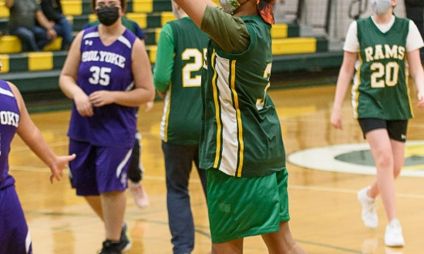 | A Unified Start for Southwick | The Westfield News |April 8, 2021  SOUTHWICK – Southwick Unified Basketball played its first home gave ever, delivering a strong effort but fell just short in losing to Holyoke 44-30. Jordan Jimenez and Samantha Fuller scored eight points apiece to lead Southwick. Rams’ Jayden Martin and Logan Lynch each finished with six points. Ava Crawford scored two points and was extremely […]  thewestfieldnews.com
This is Southwick’s first Unified Sport and they are loving the experience!
Seekonk School News
Seekonk's Martin Elementary School Promotes Inclusivity During Month-Long Inclusion Events - Seekonk School News

Marblehead - Students take the plunge for good cause
https://www.wickedlocal.com/story/marblehead-reporter/2021/03/02/marblehead-students-take-plunge-good-cause/6880521002/

Nashoba Regional HS - Unified Basketball Team Happy to be back
https://stowindependent.com/unified-basketball-team-happy-to-be-back

Whitman Hanson – They’re soaked
http://whitmanhansonexpress.com/theyre-soaked-in-inclusion/

Lynn Tech v. Danvers bball in the sports section just like the other High School Scores https://www.itemlive.com/2021/04/06/school-sports-roundup-lynn-jets-hockey-comes-up-short-against-everett/#:~:text=The%20Lynn%20Jets%20hockey%20team,Veterans%20MDC%20Rink%20in%20Everett.

Greenfield HS Plunges for Special Olympics
https://www.recorder.com/Greenfield-High-School-plunges-for-Special-Olympics-39843473
MIAA, Special Olympics partnership paying dividends as unified sports grows
Tom Angelo admired the scene of Somerset Berkley’s first-ever unified track meet in the spring of 2014, back when he was a first-year athletic director at the school and unified sports was still in…
Apr 6th (350 kB)

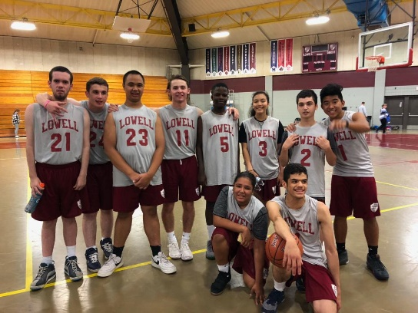

Wahconah Reg. HS and Mt. Greylock Reg. HS
https://www.iberkshires.com/sports/highschool/winter/basketball/boys/story/39/1103/Barnes-Leads-Mount-Greylock-Unified-Squad-Past-Wahconah.html

https://www.iberkshires.com/sports/highschool/winter/basketball/boys/story/39/1104/Wahconah-Unified-Basketball-Edges-Mount-Greylock.html

Haverhill HS
https://www.eagletribune.com/news/haverhill/haverhills-unified-sports-has-disabled-nondisabled-players-on-same-team/article_0624c31d-ee3a-593b-b4d5-736694c26c82.html

